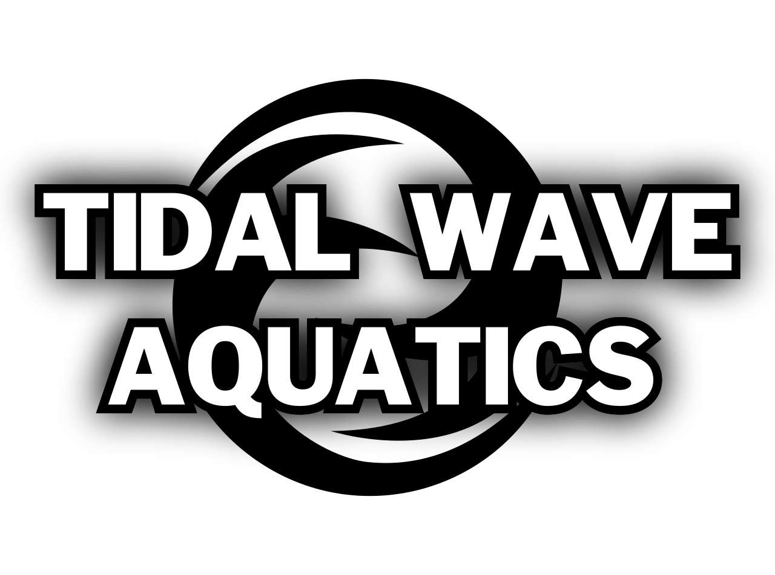 | John Lunsford Memorial Classic Swim Meet  November 1-3, 2024  Held under the sanction of USA Swimming  Sanction #: OH-25SC-31 | Hosted by  Tidal Wave Aquatics (WAVE)

Location: | Kettering Recreation Complex  2900 Glengarry Rd.  Kettering, OH 45420
Facility: | The pool is 25-yard length and is 8 lanes wide with a Colorado timing system and scoreboard. There is adequate spectator viewing. The pool depth at the start wall is 10 feet and at the turn end, the depth is 4 feet.  The host will ensure the required course dimensions.  The pool area is covered by a retractable roof with permanent sidewalls. Free parking available in two large lots adjacent to the facility.
Meet Director: | Holly Beard  holly@parrotsportsgear.com  937-572-3409
Meet Referee: | Doug Speelman  DougSpeelman40@gmail.com
Officials Contact for the Meet: | Margaux Frazee  mfrazee0320@gmail.com  Tidal Wave Aquatics will need the help of your USA Swimming Officials. Please provide the names of your officials on the entry summary form or email the Officials Contact directly.  Officials Meet Sign-up
Visiting Team Timer Requirements | WAVE requires all visiting teams with at least six (6) or more swimmers participating to provide two (2) volunteer timers for each session in which the team has entries submitted. Timer positions may be reduced for teams providing two or more officials who are specified and committed at the time of meet entries submission. If your team can NOT assist with these timing responsibilities, PLEASE EXPLAIN AT TIME OF ENTRY for consideration of exemption.
Entry Chair: | Beth Bourquin  Secretary@tidalwaveaquatics.org
Sanction: | In granting this sanction it is understood and agreed that USA Swimming shall be free from any liabilities or claims for damages arising by reason of injuries to anyone during the conduct of the event.
Meet Type: | Open - This will be an in-person meet. The number of swimmers will not exceed the facility capacity listed in this meet announcement  Tidal Wave Aquatics will be the host team. The host team is responsible for ensuring all the requirements for sanctioning an OSI meet are met. Teams will comply with the current state, local, health and USA Swimming guidelines available on the meet date and should meet or exceed all requirements in their facility during the meet.
# of Sessions: | Six (6)
Medical Supervision Available to Athletes | Lifeguards will be on duty at all times.

Organization Regulations/Waivers
USA Swimming Rules | - At a sanctioned competitive event, all USA Swimming athletes must be under the supervision of a USA Swimming member coach. Arrangements for coach supervision must be made in advance of the meet.  - Any swimmer entered in the meet must be certified by a USA Swimming member-coach as being proficient in performing a racing start or must start each race from within the water without the use of the backstroke ledge. When unaccompanied by a member-coach, it is the responsibility of the swimmer or the swimmer’s legal guardian to ensure compliance with this requirement.  - The use of audio or visual recording devices, including a cell phone, is not permitted in changing areas, rest rooms or locker rooms.  - Use of cameras, cell phones or any other recording device is not permitted immediately behind the starting blocks at either end of the racing course(s) during race starts, competition and warm-ups. Please refer to the Safe Sport section of the Ohio Swimming, Inc. policies and procedures for further information regarding the use of visual recording devices.  - Deck changes are prohibited.  - Operation of a drone, or any other flying apparatus, is prohibited over the venue (pools, athlete/coach areas, spectator areas and open ceiling locker rooms) any time athletes, coaches, officials and/or spectators are present.  - Flash photography is not permitted at the start of any race.  - All applicable adults participating in or associated with this meet acknowledge that they are subject to the provisions of the USA Swimming Minor Athlete Abuse Prevention Policy (MAAPP) and that they understand that compliance with the MAAPP policy is a condition of participation in the conduct of this competition.
Technical Suit Ban | Per USA Swimming Rule 102.8.1F, 12 & Under athletes may not compete in Technical Suits at this meet.  A Technical Suit is one that has the following components:  - Any male or female suit with bonded or taped seams regardless of fabric or silhouette; or  - Any male or female suit with woven fabric extending to the knee or mid-thigh regardless of the seam type.
Ohio State Laws that are applicable to Ohio Swimming sanctioned events | - Ohio’s Return to Play Law (ORC 3313.539 and ORC 3314.03) requires that coaches and referees either (1) complete a free online training once every three (3) years in recognizing the symptoms of concussion or (2) hold a pupil-activity program permit from the Ohio State Board of Education. Free online concussion training is offered through the National Federation of State High School Association and Centers of Disease Control. Training links can be found at www.swimohio.com under Safe Sport>Concussion.  - The required number of certified lifeguard(s) will be on duty at this meet per Ohio Administrative Code 3701-31-04-E-4.

Safe Sport 360 | - The USA Swimming Safe Sport program is USA Swimming’s comprehensive abuse prevention program dedicated to creating a healthy and positive environment free from abuse for all its members. Components of the program include, but are not limited to, providing education and training, enforcing policies (such as the Minor Athlete Abuse Prevention Policy), rules and best practice guidelines, promoting healthy boundaries and mandatory reporting of violations.  - The Minor Athlete Abuse Prevention Policy (MAAPP) prohibits Applicable Adults (as defined) from having one-on-one interactions with minor athletes which are not within an observable and interruptible distance from another adult. Applicable Adults are required to abide by this policy in full during this meet.  - Pursuant to USA Swimming Rules and Regulations and federal law, it is every member’s responsibility to immediately (i.e., within 24 hours) report any incident of child abuse, including physical or sexual abuse, to law enforcement and the U.S. Center for SafeSport. Reporting must occur when an individual has firsthand knowledge of misconduct or where specific and credible information has been received from a victim or knowledgeable third party. A report to the U.S. Center for SafeSport may be made via telephone at 720-531-0340 or online at www.uscenterforsafesport.org/report-a-concern. Various state laws may also require reporting to law enforcement or to a designated child protection agency.  - All athletes aged 18 and older must complete Athlete Protection Training in order to be a USA Swimming registered member in good standing. Any athlete who turns 18 on or after the first day of the start of competition, who has not completed Athlete Protection Training by the first day of competition, will be prohibited from participating in the competition until such time as all membership requirements are completed. Times achieved by an athlete who turns age 18 on or after the first day of competition, who competes in this USA Swimming sanctioned event without completing this membership requirement, will NOT count for qualification or recognition. This includes participation as a member of a relay.

Waiver/Release | - By entering this meet, you are granting permission for the names of any or all of your team’s swimmers to be published on the internet in the form of Psych Sheets, Meet Results, or any other documents associated with the running of this meet.  - All participants agree to be filmed and photographed by the host club approved photographer(s) and videographers and to allow the right to use names and pictures before, during, or after the meet such as in public psych sheets, heat sheets, and results or featured on the host club or OSI website or social media or in public broadcast of the event via television or webcast. Parents and guardians of minor swimmers who do not wish their swimmers to participate in interviews or have individual pictures featured on any media should inform their team’s head coach and the Meet Director prior to the meet.

Entering the Meet
Eligibility: | - All contestants must be verified USA Swimming members. Membership will not be verified at the meet.  - Membership verification deadline is 5 PM EST one (1) business day prior to the first day of the meet. Unverified swimmers will be scratched from the meet after that deadline. There will be no refunds for unverified swimmers scratched from the meet.  - All adult athletes must hold current Athlete Protection Training certification.  - Age on the first day of the meet will determine age for the entire meet.  - Current USA Swimming registration numbers must accompany each entry
Disability Swimmers: | - Ohio Swimming welcomes swimmers with a disability.  - Entry Procedures:  - Enter the USA-S swimmers with a disability electronically or on the paper entry form.  - Provide the grouping the swimmer is identified under (P1, P2, P3) and any necessary accommodations.  - List in the email with the electronic entry (or on the paper entry) the swimmer’s name, entry times, based on grouping (P1, P2, P3) strokes/distances and days/sessions.  - Relay members should accompany your entry but may be changed up to the start of the event. Relays must be made up of swimmers entered in the meet in individual events. If entering more than one relay team in an event, please indicate by "Team A", "Team B" etc.  - Preferred seeding is in the swimmer’s age group entered event at the same distance with their equivalent non-conforming time to ensure seeding in the initial heats.  - See the Ohio Swimming Policy Book for Grouping descriptions (P1, P2, P3).
Entry Limits  Entry Fees: | - Swimmers may swim a maximum of five (5) individual events per day.  - INDIVIDUAL EVENTS $5.00 per event  - RELAYS $8.00 per event  - DECK ENTRIES Individual $10.00 per event  Relays $16.00 per event  - $5 OH LSC surcharge per swimmer.  - $12 Tidal Wave Aquatics Facility Charge per swimmer
Entry Procedures: | - Deadline for receipt of entries is 10PM Sunday, October 22, 2023  - Entries must be submitted in SCY using an electronic meet entry software (Hy-Tek/Team Unify).  - Unattached swimmers (not with a team) are encouraged to use Hytek’s TM Lite for entry submission. Entries not completed through a team software are subject to a $25/swimmer surcharge. These fees are due at the time of the entry submission.  - Send entries via email to: Secretary@tidalwaveaquatics.org  - Please include the names of any Outreach swimmers in the email  - Checks should be made payable to Tidal Wave Aquatics  - “No Time” (NT) entries will be accepted.  - The Meet Director reserves the right to limit entries, if necessary, to manage the timeline and number of competitors and spectators at each session.
Warm-up and Safety Guidelines: | - The meet host will provide a complete schedule of warm-up procedures to include lane assignments and times, which must be adhered to by all participants. This information will be distributed in advance of the meet.  - Warm-ups will be monitored jointly by the Meet Director and Meet Referee (or their special designees).  - Except during supervised racing starts, swimmers must enter the pool feet first in a cautious manner with one hand in contact with the pool deck.  - Ohio LSC Swimming Safety Guidelines and Warn-Up Procedures will be in effect for this meet.
Competition Guidelines: | - This meet will be a timed finals meet.  - This meet will be contested in SCY  - This meet will be pre-seeded. Deck entries are $10/event. Deck entries will be taken for those already in the meet and verified prior to the verification deadline. No additional heats will be added to facilitate deck entries. Deck Entries close 45 minutes before the start of the session.  - Positive Check-in WILL BE REQUIRED for all events that are 500 yards or greater, (500 Freestyle & 1650 Freestyle). All other events will be pre-seeded. Meet Management reserves the right to combine heats to fill empty lanes.  - POSITIVE CHECK IN CLOSES 30 MINUTES BEFORE THE START OF THE FRIDAY NIGHT SESSION FOR THE 500 FREE AND AT 2PM ON SATURDAY FOR THE 1650 FREESTYLE.  - The Meet Referee may choose to combine events and heats at their discretion in order to fill lanes.  - The Meet Referee & Meet Director may choose to use Fly over starts to improve the time line.
Awards: | - Events will be awarded 1st through 8th place according to times. Awards will be given for all relays 1st through 3rd place.  - 13-14 swimmers will be swimming in many 13-Open events. These events will be awarded as 13-14 and Open, with each Age Group receiving awards.  - The 500 & 1650 Freestyle will be awarded as 11-12, 13-14, and Open.  - Results will be posted on Meet Mobile.
General: | - Deck entries will not be in the heat sheets or coaches heat sheets, SWIMMERS MUST INFORM COACH OF HEAT AND LANE ASSIGNMENTS.  - Parking is only available in front of the water park entrance area and out towards the School. There will be no parking next to the Recreation Complex and the Senior Center. This lot will be marked as Senior Center parking only.

Facility Information
Facility Rules and Policies: | All team banners must conform to the 5’ X 8’ size limitation. Commercial logos on banners must not exceed 96 square inches. USA Swimming and the meet host reserve the right to determine banner locations. Banners must be tied, not taped, to the railings and cannot obstruct the view of spectators. Neither the facility nor the meet hosts are responsible for lost or stolen items.  Pool policies: no food on deck and no camp chairs on deck please.  To maximize spectator seating on the pool deck WAVE requests that swimmers put their bags against the wall and refrain from putting them in the stands.
Locker Rooms / Changing | Athletes must arrive and depart in their suits. Locker rooms are for restroom use only and must not be used for changing or showering. Deck changing is prohibited. Restrooms will be monitored by Safety Marshals.
Spectator Limitations and Protocols: | Spectators will be permitted, subject to the maximum capacity stated at the facility. Tidal Wave Aquatics reserves the right to impose limitations on spectators due to changing health and safety circumstances. Advance notice of these changes will be provided to registered swimmers.
Code of Conduct | • Any individual who exhibits a behavior of a threatening, abusive, or derogatory manner toward an official or member of the meet staff is subject to immediate removal and further expulsion from the meet. Coaches will be notified of the actions of their respective teams.  • Good sportsmanship is expected at all times. Bullying or taunting, foul language or derogatory behavior will not be tolerated and will be subject to immediate removal. All volunteers, spectators, coaches, officials and meet staff are expected to be respectful of others.  • The Ohio Swimming Code of Conduct governs this meet. The purpose of the Zero-Tolerance Code of Conduct Policy is to establish consistent expectations across the LSC in the best interest of our Athletes and Sport. Ohio Swimming is committed to creating a safe and fair environment for all of its athlete members. This policy is to be used as a guide to promote a positive environment and good sportsmanship at meets and events conducted in the geographical boundary of Ohio Swimming. The complete Ohio Swimming Code of Conduct can be reviewed on the Ohio Swimming website under Governance> OSI Policy & Procedures Manual, Appendix 18.

*Tidal Wave Aquatics reserves the right to make changes, which may include a change in session times, and limiting attendees and/or spectators, due to changing health and safety circumstances. Any such changes will be communicated in writing to all participating team coaches in advance.
TIDAL WAVE AQUATICS
JOHN LUNSFORD MEMORIAL CLASSIC SWIM MEET

ORDER OF EVENTS

Session 1- Friday Nov 1st

Warm- ups: 5:00pm Start: 6:00pm
mixed | Age | Event
101 | Open | 400 Y Ind. Med.
102 | 12- Under | 200 Y Ind. Med.
103 | 11 & Over | 500 Y Freestyle*

Session 2 – Saturday November 2nd  Warm-ups 7:00-8:00am Start: 8:10am  10 & Under only |  |  |  | Session 3 – Saturday November 2nd  Warm-ups TBD  11-Over
Mixed | Age | Event |  | Mixed | Age | Event
201 | 10- Under | 200 Y Medley Relay |  | 210 | 13 - Over | 200 Y Medley Relay
202 | 8 - Under | 100 Y Medley Relay |  | 211 | 11 - 12 | 200 Y Medley Relay
203 | 10 - Under | 50 Y Butterfly |  | 212 | 13 - Over | 100 Y Backstroke
204 | 8- Under | 25 Y Butterfly |  | 213 | 11 - 12 | 50 Y Backstroke
205 | 10- Under | 50 Y Freestyle |  | 214 | 13 - Over | 50 Y Butterfly
206 | 8 -Under | 25 Y Freestyle |  | 215 | 11 - 12 | 100 Y Butterfly
207 | 10 -Under | 100 Y Ind. Medley |  | 216 | 13- Over | 50 Y Freestyle
208 | 10 - Under | 100 Y Freestyle |  | 217 | 11-12 | 100 Y Ind. Medley
 |  |  |  | 218 | 13-Over | 100 Y Breaststroke
 |  |  |  | 219 | 11-12 | 50 Y Breaststroke
 |  |  |  | 220 | 13-Over | 200 Y Freestyle
 |  |  |  | 221 | 11-12 | 100 Y Freestyle

Session 4 – Saturday Nov 2nd
Warm up/Start: Immediately following Session 3
Mixed | Age | Events
222 | Open | 1650 Y Freestyle

*The 500 Freestyle will be swum as 11 and over, fastest to slowest, for both girls and boys, but will be scored in Age Group format. Swimmers must provide their own counters. The Open 1650 will also be swum fastest to slowest and will alternate between girls and boys heats and will be scored in Age Group format. Swimmers must provide their own counters and timers
Session 5 - Sunday Nov 3rd  Warm-ups 7:00-8:00am Start: 8:10am  10 & Under |  |  |  | Session 6 - Sunday Nov 3rd  Warm-ups TBD  11-Over
Mixed | Age | Event |  | Mixed | Age | Event
301 | 10 - Under | 200 Y Free Relay |  | 310 | 13- over | 200 Y Free Relay
302 | 8 - Under | 100 Y Free Relay |  | 311 | 11-12 | 200 Y Free Relay
303 | 10 - Under | 50 Y Backstroke |  | 312 | 13- Over | 50 Y Backstroke
304 | 8 - Under | 25 Y Backstroke |  | 313 | 11-12 | 100 Y Backstroke
305 | 10- Under | 50 Y Breaststroke |  | 314 | 13 - Over | 100 Y Butterfly
306 | 8- Under | 25 Y Breaststroke |  | 315 | 11-12 | 50 Y Butterfly
307 | 10 - Under | 200 Y Freestyle |  | 316 | 13 - Over | 50 Y Breaststroke
 |  |  |  | 317 | 11-12 | 100 Y Breaststroke
 |  |  |  | 318 | 13 - Over | 100 Y Freestyle
 |  |  |  | 319 | 11-12 | 50 Y Freestyle
 |  |  |  | 320 | 13 - Over | 200 Y Ind. Medley
 |  |  |  | 321 | 11-12 | 200 Y Freestyle

Entry Summary Sheet

Team Name
Club Code
Coach
Coach Phone
Coach Email

Item | Total # | Cost per | Total
Individual Entries |  | $5.00 per event
Relay Entries |  | $8.00 per relay
OSI Swimmer Surcharge |  | $5.00 per swimmer
Wave Facility Charge |  | $12.00 per swimmer
Total Fees Due
Please list outreach athletes:

Total # outreach IEs:(# swimmers x # entries x $5) |  | Total # of Outreach swimmers x $17 surcharge:

Waiver, Acknowledgement and Liability Release:
I, the undersigned coach, or team representative, verify that all the swimmers and coaches listed on the enclosed entry are registered with USA Swimming. I acknowledge that I am familiar with the Safety Rules of USA Swimming, Inc. and Ohio Swimming, Inc. regarding warm-up procedures and meet safety guidelines, and that I shall be responsible for the compliance of my swimmers with those rules during this meet. Tidal Wave Aquatics, the Kettering Recreation Center, Ohio Swimming, Inc., and USA Swimming, Inc., their agents, employees, and coaches shall be held free and harmless from any and all liabilities or claims for damages arising by reason of illness or injury to anyone during the conduct of this meet. I also acknowledge that by entering this meet, I am granting permission for the names of any or all of my team’s swimmers to be published on the internet in the form of Psych Sheets, Meet Results, or any other documents associated with the running of this meet. _____________________________________________________________________________________Signature (Coach or Club Representative) Club Title (Coach etc)
_____________________________________________________________________________________Name of Club Date

