2018 MSSL Championship Meet: T-Shirt Order Form

There will only be 1 screening of the champs shirts @ $12 and a few extra shirts selling @ $15. The 2018 year’s shirt front design and back designs are shown below. Champs t-shirt funds support our MSSL University Scholarships to deserving MSSL athlete/scholars!

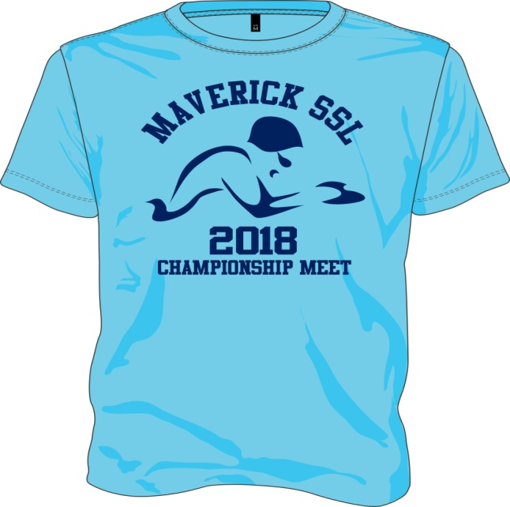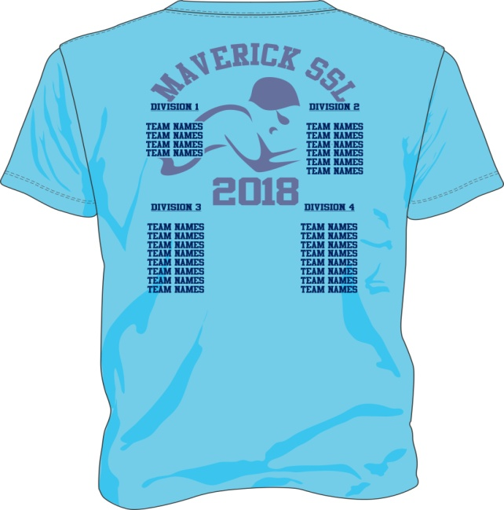

Name _____________________________ Email______________________________
Phone #___________________________ Team Name* ________________________
(*Be sure to give the team name of your subdivision and NOT your MASCOT.)

A colored short-sleeve (Heavy, Pre-shrunk Cotton) shirt: $12.00 or $15 not preordered.
______QTY. Youth Small _______ QTY. Adult Small
______QTY. Youth Medium _______ QTY. Adult Medium
______QTY. Youth Large _______ QTY. Adult Large
______QTY. Youth X-Large _______ QTY. Adult X-Large
_______ QTY. Adult XX-Large
TOTAL $ ___________ _______ QTY. Adult 3X-Large

MAKE CHECKS PAYABLE TO: YOUR TEAM for preorders & the MSSL if not TEAM VOLUNTEER COLLECTS CHECKS/MONEY & T-SHIRT ORDER FORM. ORDERS MUST BE PRE-PAID AND DUE BY: FRIDAY, JUNE 15 @ 11 AM

