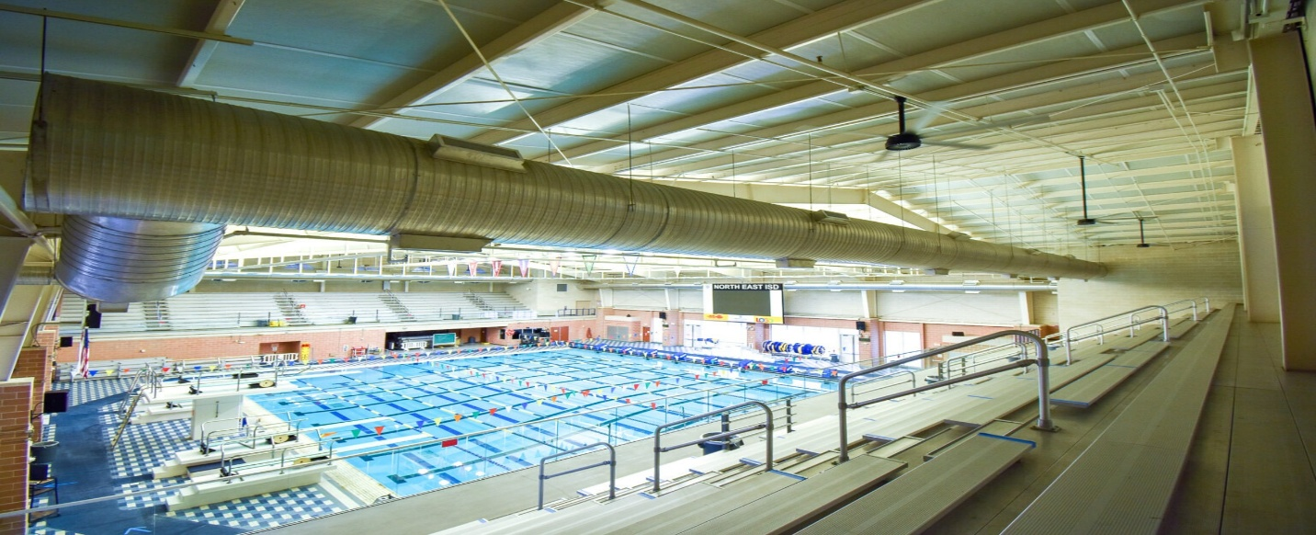

2025 DIVISION 1 CHAMPIONSHIP MEET INFORMATION

Date: Monday Morning, June 30th Location: Josh Davis Natatorium 12002 Jones-Maltsburger., San Antonio 78216 Facility details: 8 lanes by 25 yards Josh Davis Pool used for the meets
Parking: located directly west of the Davis Pool. Additional parking is Southeast of the Natatorium behind the Davis Pool & parking lot by the NEISD Littleton Gym.

Competing Teams: Boerne, Schertz, Sonoma Ranch, & Smithson Valley
Admission: Free (NOT ADVISED FOR ELDERLY OR YOUNG CHILDREN DUE TO STEEP STAIRS & FALLING!)
MSSL MEET DIRECTORS: Kim Terrill & LoGina Vinceslio MSSL HEAD MEET OFFICIALS: Bruce Anderson, Chris Lysinger & Bren Twum NEISD AQUATICS STAFF: Bill Spurgeon, Corey Bolleter & Brittany Thomas
TEAM CHECK-IN: Complete outside before entering the natatorium
LEFT DOOR ENTRANCE @ 7am: Judges, Team Reps, Coaches, Swimmers, & Team volunteers with badges/wristbands. Swimmers are allowed to bring in their pool backpacks. NOTE: EVERYONE will be ‘wanded down’ by NEISD security upon entry. Go through the downstairs pool deck and straight to your assigned team area.

TEAM ASSIGNED POOLSIDE BLEACHER SEATING:
#1 Boerne & half of #2, Schertz half of 2 & #3, Sonoma Ranch #4 & half of 5, Smithson Valley half of #5 & 6
TEAM BANNERS NOT ALLOWED & NO CHAIRS ALLOWED ON DECK!
DOOR MONITORS: Adults without passes will NOT be allowed on deck and must immediately leave without commenting. JUST COMPLY!

RIGHT DOOR SPECTATORS’ ENTRANCE @ 7:30 a.m. EVERYONE will be ‘wanded down’ by NEISD security upon entry. CLEAR BAG POLICY: Spectators are subject to the CLEAR PURSE/BACKPACK NEISD rule. SPECTATORS walk immediately upstairs to the SPECTATOR SEATING AREA. SPECTATOR SEATING: 1,500 UPSTAIRS seats NOTE: Discourage elderly & young children from attending unless they can navigate VERY STEEP STAIRS! NO WAGONS OR STROLLERS due to lack of space. Make other arrangements for small children.
SWIMMERS ARE NOT ALLOWED on the elevators or IN THE SPECTATOR AREA SEATING DUE TO WET SUITS MAKING STAIRS SLIPPERY!

SWIM FREAK: located in the lobby selling swim items at the 4 meets

CONCESSIONS: No NEISD concessions.
MSSL FOOD TRUCKS: The MSSL has contracted with 2 food trucks for the meets. Each truck returns 10% of sales to the league. Food trucks attending: ROOSTERS (focused on chicken dishes) and DADDY O’S COCINA (taco truck). Trucks accept credit cards and CASH & maybe more IMPORTANT NEISD FOOD RULES: ALL FOOD MUST BE EATEN OUTSIDE THE NATATORIUM. ONE BOTTLED WATER PER SPECTATOR IN ITS CLEAR PLASTIC BOTTLE IS ALLOWED IN THE NATATORIUM. NO COFFEE CUPS, YETI, OR STANLEY CUPS ALLOWED IN THE NATATORIUM.
NEISD RULE FOR SWIMMER SNACKS – MUST BE SMALL, HEALTHY ITEMS—NO CHOCOLATE, SPRINKLES, CUPCAKES, OR GUMMY ITEMS. NO SODAS OR STICKY ITEMS!

RULES: LIFEGUARDS: No one is allowed to interfere with the lifeguards on duty in any manner. BUILDING: The MSSL agrees to leave the buildings in good and clean order. NO-NOS: The MSSL agrees that no offensive language, gambling, firearms, weapons, alcohol, controlled substances, other intoxicants of any kind, or tobacco. BEHAVIOR: The MSSL agrees that no disorderly or disruptive behavior takes place at NEISD. NO RUNNING RULE: COACHES will ENFORCE the NO RUNNING safety rule. WALKER POOL: only used for warm-ups. NO ONE ALLOWED otherwise! No GUM or GLASS containers. Only 2 TEAM COOLERS marked with your team’s name containing WATER OR GATORADE are allowed in the natatorium. NO OUTSIDE CHAIRS ALLOWED IN THE NATATORIUM FOR SWIMMERS OR PARENTS! NO HELIUM BALLOONS, NOISE MAKING HORNS, OR CONTFETTI ALLOWED. SPECTATORS SUBJECT TO THE NEISD CLEAR PURSE OR BACKPACK RULE.

