Thank you for considering sponsoring our team! Who we are:
The North Gwinnett High School Swimming and Diving program is comprised of a girls’ varsity
team and a boys’ varsity team with approximately 100 athletes in total. Major team expenses include pool rentals for practices and meets, travel expenses, apparel, and equipment.

Deadline:

The deadline for sponsors who want to be included on the team banner is October 25th. The final deadline for all sponsors is November 30th.
Your donation will help make this our best season yet! Thank you!

If you have any questions, please email us at nghsswimdive@gmail.com.

Sponsorship Benefits | Platinum Sponsor | Gold Sponsor | Silver Sponsor | Bronze Sponsor
Sponsorship amount | $750+ | $500-  $749 | $300-  $499 | $150-  $299
Name of company on Sponsor Banner displayed at Home Meets
Option to include one attachment to home meet programs (coupons, etc.)
Acknowledgment (by announcement) of sponsor at the start of home meets
“Thank You” plaque | 7” x 9” | 5” x 7”
Advertisement in home meet program | Full Page Ad | Quarter Page Ad | Business Card Ad
Logo or name on Team website (https://nghs.swimtopia.com)

*IMPORTANT - Sponsors - Please email a copy of your receipt - along with
your graphic to n ghsswimdive@gmail.com AND tiffanypnelson@att.net.

Step 1 - You have 3 options to pay.

1- Create an account on our website at https://nghsswim.swimtopia.com under the Sponsor tab and pay via credit card.

- - Pay via Venmo, you can use the link shown below. Email us at n ghsswimdive@gmail.com to alert us about your payment.

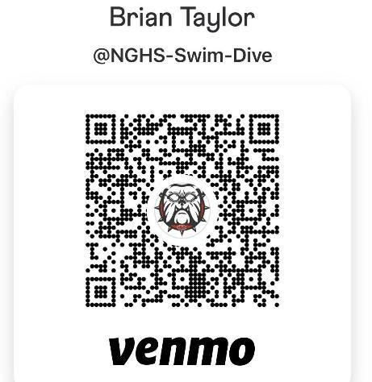
- - Mail a check with form below to :

NGHS Swim & Dive Booster Club c/o Brian Taylor
6138 Eagles Rest Trail Sugar Hill, GA 30518

Step 2 - Fill out the form on the following page.
Step 3 - Each sponsor should also email a high-quality graphic file of the logo you would like to publish on our website and/or the advertisement you want included in our meet
programs. Send the high-resolution graphic you want to use for our website and banner (PNG or JPEG) to nghsswimdive@gmail.com.

*IMPORTANT - Sponsors - Please email your receipt - along with your graphic to nghsswimdive@gmail.com AND tiffanypnelson@att.net.

Please fill out the form and check the level of sponsorship.

Sponsor: Date:
Contact Person:
Website:
Email Address:

Platinum ($750)

Gold ($500 - $749)

Silver ($300 - $499)

Bronze ($150 - $299)

NGHS Athlete Representative: Phone #:

✂

Sponsorship Receipt
(keep this portion for your records)

Sponsor: Date:
Contact Person:
Website:
Email Address:
Circle the Level:
Platinum ($750+) Gold ($500+) Silver ($300+)
Bronze ($150+)

Team / Athlete Representative: Phone #:

