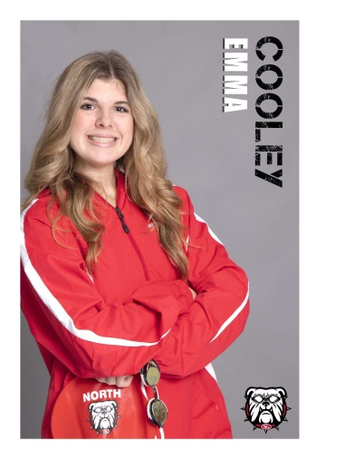
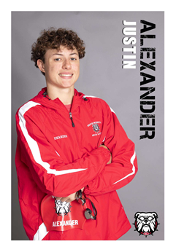
Justin Alexander- Son of Brad and Stacie Alexander
Justin has been a member of the NGHS Swim Team for four years. He has qualified for County all 4 years and qualified for State this year. Justin has been swimming since he was 6 years old with the Morningview Manta Rays and served as an assistant coach this last summer. Justin is involved in Gwinnett Church where he served in the Elementary ministry for 3 years. He was honored to win the Hoss Award from his coaches last year for his perseverance and hard work. Justin looks forward to graduating in the spring and plans to study Mechanical Engineering or Computer Science in the fall at Georgia Southern University.
Emma Cooley- Daughter of Andy and Courtney Cooley
Emma has been a member of the NGHS varsity Swim Team for four years. Emma has lettered and qualified for County and State all four years. She won the Coaches Award her freshman year and the Scholar Athlete Award her Sophomore and Junior years. She started her swimming career with the Morningview Manta Rays at the age of 6 and began swimming year round at Swim Atlanta Sugarloaf when she was 10. She is currently the Mini Manta Head Coach for her summer league team. Emma is a member of the National Honor Society, BETA Club, STUCO, Peer Leading, and Freshmen Mentoring. Outside of school, Emma loves volunteering at Gwinnett Church every Sunday as a room leader for 4 year olds. She plans on continuing her education at Berry College and majoring in Early Childhood Education.
Shaun Deedy- Son of Shaun and Sherry Deedy
Shaun has been a member of the North Gwinnett High School Swim Team for 4 years, and is currently the spirit captain. He has qualified for the County Team for 4 years, and the State Team for the past 2 years. He started his swim career at the age of 5, where he began summer league on the Woods of Parkview Team. He previously swam with Dynamo and Swim Atlanta, but is currently a member of Spartan Aquatics where he has qualified for Senior State. He has also been a member of the Lansmoore Lasers Team since the age of 10. At school, Shaun is a member of the Relay for Life Executive Board, Freshman Mentoring, Latin Club, National Honor Society, and BETA Club. He has also been the principal oboist for the Symphonic Winds for all 4 years. He is an accomplished student who has earned the title of AP Scholar with Distinction and Scholar Athlete. Shaun plans to study Biochemistry on the Pre-Medical track with the goal of becoming a pulmonologist. He is currently undecided on where he will attend college.
Alex Forrand- Son of Adam and Lori Forrand
Alex has been a member of the NGHS Swim and Dive team for 3 years. He has qualified for both County and State and lettered all 3 years. He earned the North Gwinnett Swim and Dive Rookie of the Year his Freshman Year, and was a part of the 2019-2020 State Championship Team. Alex began swimming at the age of 5 with the Lansmoore Lasers, and has been on the team for the last 13 years. Alex has been a coach for the Lasers for the last 2 years and hopes to be a coach again this summer. Alex is a Scholar Athlete, and is an active athlete between swimming and playing center back on the North Varsity Soccer Team for the past 4 years. Alex plans to attend Berry College and continue playing soccer while studying Exercise Science.

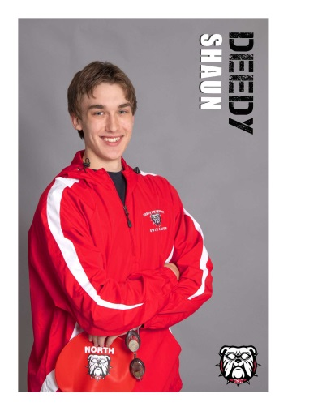
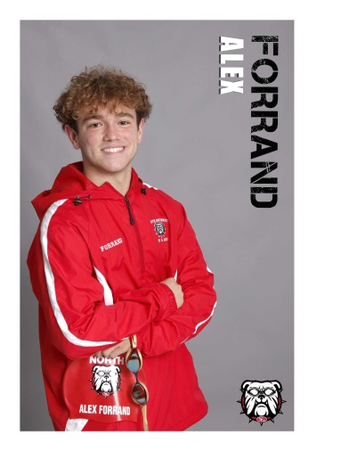
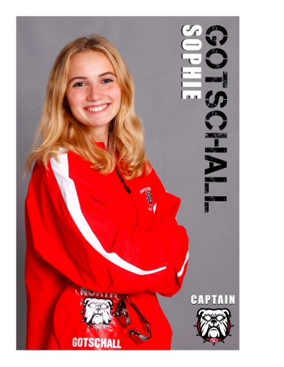
Sophie Gotschall- Daughter of Jason and Shari Gotschall
Sophie has been a member of the NGHS Swim and Dive Team for 4 years and is currently a Captain for the team. She is a four time varsity and academic letter receiver as well as scholar athlete and an AP Scholar with Distinction. She has been a County Qualifier all four years, and a State Qualifier her junior and senior year. Sophie has been on the Morningview Manta Rays Swim Team since she was four years old, and has been coaching there for two years. Sophie has also been a member of the NGHS Track and Field Team for three years and has lettered for two. Academically, Sophie has been a part of the CHARGE North STEM program, and a member of the National Honor Society for the last two years. She plans on attending the University of Georgia in the fall and majoring in environmental engineering.
Perry Luzier- Son of Joseph and Mary Elizabeth Luzier
Perry Luzier has been a member of NGHS Swim and Dive for four years. He has qualified for County his sophomore, junior, and senior seasons and is a State Qualifier in the 100 Butterfly. Perry is also a two time varsity letter recipient and is also recognized as a Scholar Athlete and Copper Dog recipient. In addition, Perry has performed the National Anthem on his trumpet at all home meets for all four seasons. He is also a county qualifier for the Lansmoore Lasers and a 4 year member of Swim Atlanta. Outside of swimming, Perry is an officer in JROTC, Band, and Lunch Bunch, as well as a member of National Honor Society, Beta Club, Student Council, Tri-M Music Honor Society, and Freshman Mentoring. Additionally, he is a distinguished Eagle Scout. Perry would like to thank his various high school coaches- Coach Niemann, Coach Callis, Coach Brown, Coach White, and Coach Daab, as well as his Swim Atlanta coaches Scot and Jordan, for the incredible help they have been in developing him as an athlete and leader. He also wants to thank Coach Rainey for his help on his endeavors with the National Anthem. Perry will take many skills from them and use them in his future endeavors. As a senior, he will graduate with Honors, and is deciding between Kennesaw State, Jacksonville State, and University of Georgia where he will major in Music Education and go on to commission in the U.S. Air Force as an officer.
Elizabeth (Liza Kate) May- Daughter of Katy May and Jeff Woods
Liza Kate has been a member of NGHS Swim Team for 3 years. She has lettered and County qualified since joining. She is honored to be serving as a Team Captain this year as well as receiving the Coaches Award her junior year. Liza Kate started swimming when she was 5 and enjoyed summer swim with the Morningview Manta Rays until the age of 10. During this time, she achieved county Top 10 several times. She left swim for a few years to participate in cycling (road) where she went on to be the Georgia State Champion for 3 years and is a 5 time Junior National Medalist, including a silver medal. Liza Kate is a coach for the Manta Rays and enjoys mentoring young swimmers. She has been accepted to Kennesaw State University and plans to study business in college.

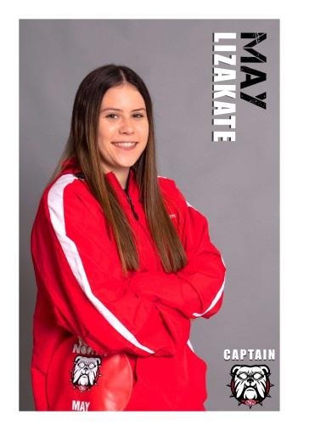
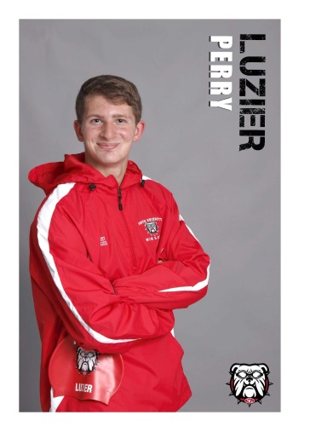
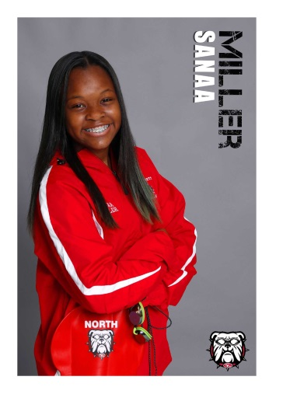
Sanaa Miller- Daughter of Sebastian and Donna Miller
Sanaa has been a member of the NGHS Swim and Dive team for three years. She has qualified for County over the past three years and is currently the Dive Captain. She has lettered and been a scholar athlete all three years. Sanaa is a member of the North Gwinnett Student Leadership Team, Lunch Bunch, and is a Freshman Mentor. She plans to attend Georgia State University and major in criminology.

Luke Nellis- Son of Todd and Mary Nellis
Luke has been a member of the NGHS Swim Team for all 4 years. He has qualified for county every year and qualified for state for the past 3 years. Luke began swimming at 4 years old with the Lansmoore Lasers and swims year round at Swim Atlanta. He is a member of National Honor Society, Fellowship of Christian Athletes, and a Freshman Mentor. Outside of school and swimming he works a soccer referee and is very active at his church. Luke plans to study Computer Science at the University of Georgia or Georgia Tech.
Laney Obermeyer- Daughter of Roger and Amy Obermeyer
Laney Obermeyer has been a member of the North Gwinnett Swim Team all 4 years of high school. She was honored to be chosen to serve as Captain this year. She has earned the Copper Award all 4 years and has qualified for County all 4 years as well. She also qualified for State her sophomore year and is a 4 year varsity letter recipient. Laney received the Most Improved Swimmer Award her sophomore year. She has been swimming since she was 4 years old on the Wild Timber Swim Team. She has been swimming competitively at Swim Atlanta since 4th Grade. She loves coaching at her summer league team and being a role model on the high school team. She plans on studying athletic training and sports management at Samford University, Ohio University, or University of Tennessee in the fall. She is so grateful for this team and the friendships she has made over the years.

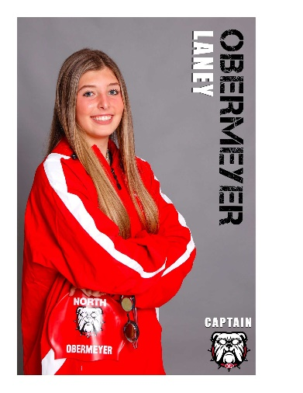
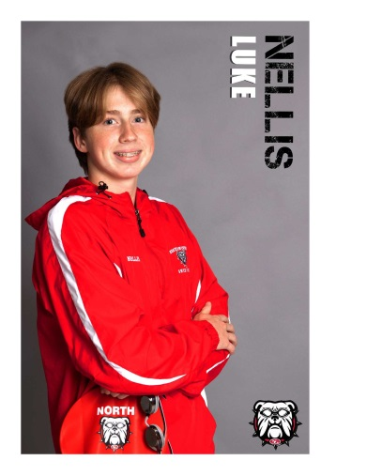
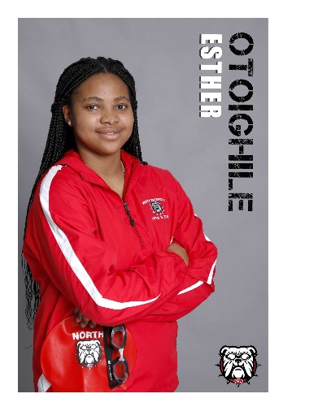
Esther Otoighile- Daughter of Rhonda Otoighile
Esther is a new NGHS Swim Team Manager. She previously swam for one year at Berkmar High School. She is currently an FCCLA officer, a member of the debate club, and Lunch Bunch. Esther joined the team in hopes to be a part of the NGHS community and make new friends. Esther will graduate with Honors from North Gwinnett and plans to major in medicine at Georgia State University.

Ethan Park- Son of Soon Park and Kyung Lee
Ethan Park has been a member of the North Gwinnett Swim and Dive Team for four years. He started swimming as a freshman and is honored to be one of the Captains of the North Gwinnett Swim and Dive Team this year. Besides swimming, he is also President of the Spanish National Honor Society, Executive Secretary for Stuco, Logistics Secretary of Beta, Event Coordinator of AASA (Asian American Student Association), a member of National Honor Society, and an AP Scholar. Ethan received the Copper Dog in his sophomore year and has made the varsity letter cut four years in a row. He plans on studying business in the future.
Isaiah Park- Son of Danny Park and Catherine Lee-Park
Isaiah has been a part of the North Gwinnett Swim Team for 3 years and has been a county qualifier since his sophomore year. He’s been swimming since he was 7 years old on his neighborhood team, the Grandview Wahoos. He aspires to be a mechanical engineer, and is currently undecided where he will attend college in the fall.

Olive Porter- Daughter of Tom Porter & Daphne Anderson
Olive has been a member of the NGHS Swim Team for four years. She has qualified for the county team all four years and hopes to make a state cut this year. Olive has been swimming since she was four years old. She has swum for Wild Timber Team Extreme, Swim Atlanta, and is currently swimming for LifeTime. Outside the pool, Olive is attending The Maxwell School in addition to NGHS and plans to study architecture in college.

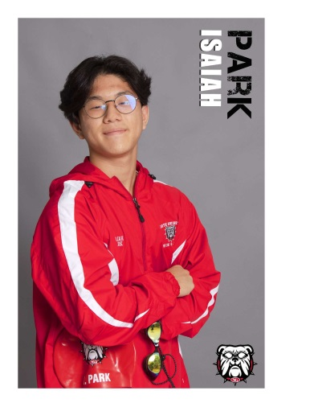
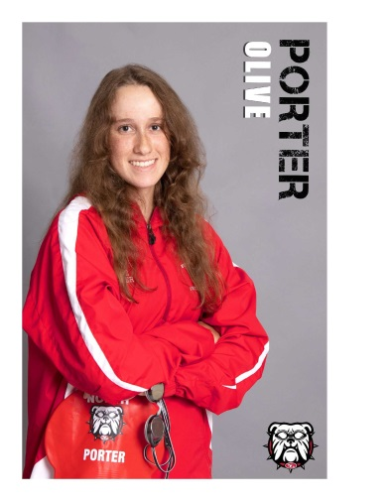
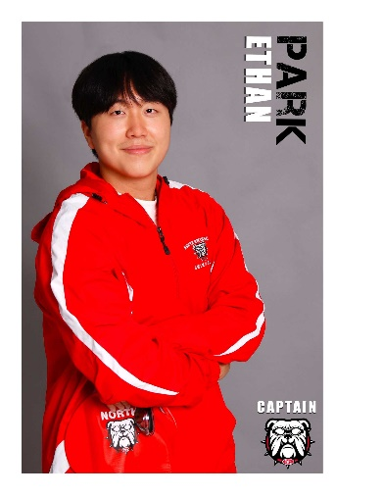
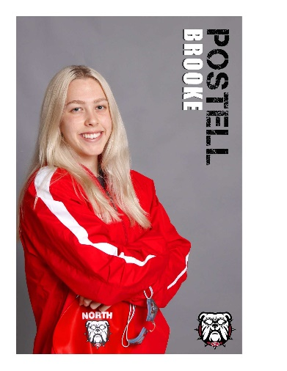
Brooke Postell- Daughter of John and Lisa Postell
Brooke has been a member of the NGHS Swim Team for four years. She has qualified for County, receiving the Copper Dog Award, and State all four years. Brooke is a Scholar Athlete and was named Rookie of the Year as a Freshman. She received All-State Honorable Mention and was named a County All Star in the 2019 and 2020 seasons. She was named an AP Scholar for the 2020-2021 season. Brooke is also a member of National Honor Society, Beta Club, and Spanish National Honor Society. Brooke started swimming competitively when she was five for Wild Timber Team Extreme and joined Swim Atlanta when she was 8. Brooke will continue her swimming career at Rollins College in the fall where she plans to study Biology and pursue a degree in medicine.
Sarah Rummins- Daughter of Eric and Marilyn Rummins
Sarah has been a member of the NGHS Swim Team for four years, and she has qualified for county and lettered each year of her High School career. Sarah is currently the Spirit Captain. She has been swimming with Swim Atlanta or LifeTime Fitness since she was four years old. Outside of school, Sarah loves music and hanging out with friends. She is a small group leader for 2nd graders at Gwinnett Church and in active in InsideOut. Sarah is excited about graduating and looks forward being a “swammer”. Sarah plans on attending Liberty University, where she will major in Exercise Science.

Rylan Surber Paz- Son of Stan and Courtney Paz, brother of Lyla
Rylan has been a member of the North Gwinnett Swim Team for 3 years. He has lettered and qualified for County all 3 years and qualified for State 2 years. He has received the Scholar Athlete Award, the Copper Dog Award, the Hoss Award, and was named Swimmer of the Month in December 2020. This year he was honored to be voted as a Captain by the swim team. He joined the Lansmoore Lasers Swim Team when he was 8 and has coached with the team for 4 years. For the last 2 years he has been swimming club at Swim Atlanta Sugarloaf. Rylan’s other activities at North Gwinnett include Fellowship for Christian Athletes and Freshman Mentoring. He is currently deciding between University of Tennessee Knoxville and the University of Georgia where he will pursue a degree in Exercise Science with a goal of becoming a Physical Therapist. He is so grateful for this team and all his family, friends, and coaches that have pushed him this far.

has
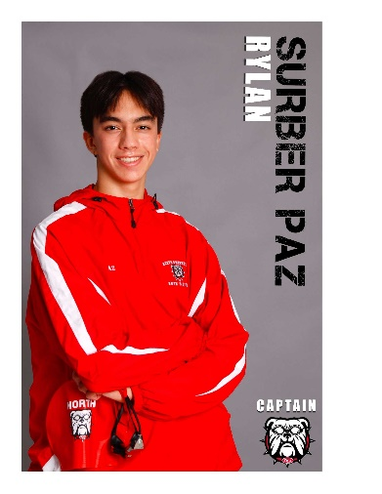
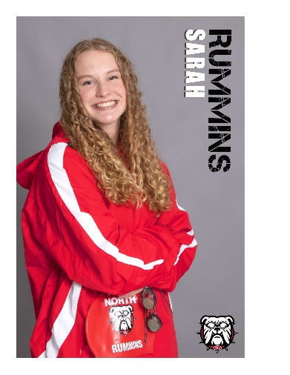
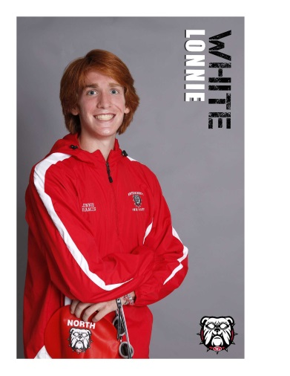
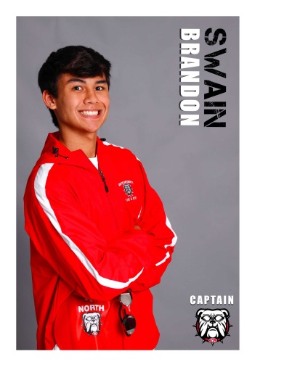
Brandon Swain- Son of Mark and Susan Swain
Brandon is thankful to be a part of this team, and so grateful to his coaches for all their support and encouragement. He has been a member of the North Gwinnett Swim & Dive Team for 3 years. He was honored to be voted as a Captain this year. He lettered and qualified for county all 3 years and qualified for State this year. He has earned the Scholar Athlete Award and Copper Dog Award. Brandon began swimming at Swim Atlanta, and has swam summer league for the Stonebrier Stingrays where he earned high point scorer, and the Morningview Manta Rays where he received the Coach’s Award. He looks forward to coaching for Morningview this summer. Brandon enjoys many other activities at North Gwinnett. He played football for NGHS his freshman year. He is a member of the National Honor Society, BETA Club, Fellowship of Christian Athletes, Freshman Mentoring, and Relay for Life. He is also an AP Scholar with Distinction. Brandon has volunteered with Blaze Sports, an organization for children with disabilities. He has helped teach swimming to kids with dwarfism, and has enjoyed watching his brother swim in the Paralympic circuit. Brandon is excited to be attending Auburn University in the fall, on the Pre-Dental track, as he aspires to be an orthodontist or oral surgeon.
Lonnie White- Son of Lonnie and Erin White
Lonnie has been a member of the NGHS Swim Team for four years. He has qualified for County and earned a varsity letter all four years. Lonnie first qualified for the state team his sophomore year. He has been swimming on the Morningview Manta Rays since he was 7 years old, and has been a Mini Manta Coach and Senior Coach. At school, he is involved in Beta Club and Relay for Life, as well as being a sophomore mentor. Lonnie plans to study Biomolecular Engineering at Georgia Tech in the fall.

