Team suit fitting
November 4th from 3:30-6:00PM
Morganton aquatic center

TYR Hexa Navy/Red
Female: Diamondfit & Trinity Fit $74
Male: Jammer $58

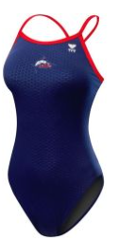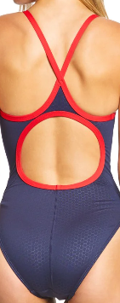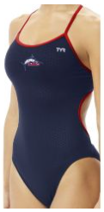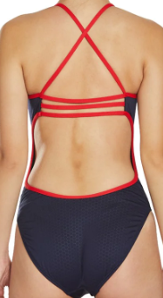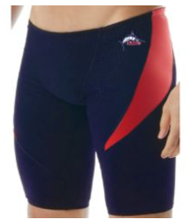
Diamondfit Trinityfit Jammer

Order Online at Kiefer.com

- To order online, visit the team webstore at www.kiefer.com
- Click on TEAM LOGIN in upper right menu bar
- Enter Username: morganton
- Enter Password: swim

All custom suit purchases are final.
Please allow 2 weeks for customization.

