June 18, 2022
vs.
Round Rock Dolphins


Meet Book

Table of Contents

Letter From the Board
Meet Location & Map
Meet Timeline
Meet Preparation
Arm Marking
Meet Facilities & Rules
Merchandise Tent/Concessions
Family Folders
Heat Sheet
2022 Aquadillo Sponsors
Letter From the Board
Hello Dillos!
We are so excited for our first home meet of the season and are looking forward to some great swims! It takes over 100 volunteers to run a home meet and we appreciate each and every one of you! There will be over 400 swimmers at this meet so please be on time so we can ensure a smooth (as possible) start.
Katie Starr Photography will take our 2022 Team Photo after warm ups (6:50am) on Saturday morning. Please make sure your swimmer is wearing their 2022 Team Shirt.
There will be some great concessions for sale this week! We will have Mariachi de Jalisco tacos, Shipley’s donuts, Papa John’s Pizza, Chick-Fil-A, chips, candy, and drinks available for purchase. Also, be sure to grab a cup of coffee with August Beverage Co or a snow cone from Zydeco Ice.
Please remind your swimmers to stay in the pits unless they are at the ready benches or swimming. We will speak with the swimmers about appropriate behavior but please also remind them to always be kind and respectful of their teammates and pit parents.
If you wake up feeling sick or have a sick child, you MUST let us know via email: absence@aquadillos.com That email goes to our head coach, head computer rep, volunteer coordinator, and board president. Please do not show up sick!
Please sign up for Remind. It is the quickest way to get up to date info about meet sign ups, weather delays/cancellations, and other important information.
Please don’t forget to declare for our next home meet on June 25 vs. Anderson Mill Barracudas by 10pm on Sunday, June 19.
Thank you and swim fast!
2022 Aquadillos Board
Meet Location & Map
Georgetown Rec Center
1003 N. Austin Ave. Georgetown, TX 78626

Note: The North Rec Center parking (entrance off of Austin Ave.) is reserved for Rec Center members only, please do not park in this lot. Also, the Chambers of Commerce Parking lot is a no parking area.

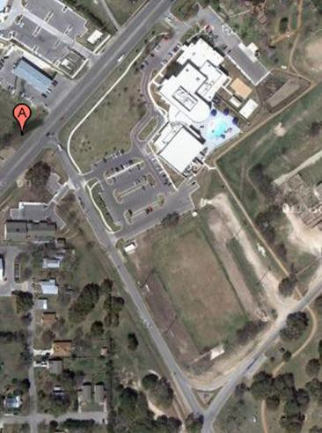

No Parking

Visiting Team parking
Additional Visitor and
Aquadillo parking
Reserved for Visitor and
Aquadillo equipment trailers

***Please note, visitors parking in the
visitors lot must park in marked spaces.

Georgetown police regularly patrol this
parking area and will ticket any cars not
parked within a marked parking spaces.

***Please observe any other signs for parking restrictions around the surrounding park and neighborhood.

Parking
- Please park in the areas marked in green on the periphery of the field where our tents will be located.
- The blue area to the South of the pool is VISITOR and VIP parking only.
- No Parking: The North Rec Center parking (entrance off of Austin Ave.) is reserved for Rec Center members only, please do not park in this lot. Also, the Chambers of Commerce Parking lot is a no parking area.

Meet Timeline
Start Time | End Time | Activity
5:00AM |  | Set Up Crew/Meet Director Arrives
5:00AM |  | All Board Members Arrive
5:20AM |  | Pit Parents Arrive
5:30AM | 6:00AM | Swimmer Check-In (if late you will be scratched from relays.)
5:30AM | 6:00AM | Volunteer Check-In
6:15AM | 6:30AM | 10 & Under Warm Up
6:30AM | 6:45AM | 11 & Up Warm Up
6:50AM |  | Team Picture
7:00AM |  | All meet changes entered and final heat sheets printed
7:10AM |  | First Shift Meetings  Timers/Judges – Meet at east end of the pool (near starting blocks)
7:15AM |  | First Call for Events 1, 2, & 3
7:20AM |  | All first shift volunteers in place
7:28AM |  | National Anthem
7:30AM |  | Meet Begins
 | Appx 12:30PM | Meet Ends
12:00PM |  | Post Meet Clean Up Crew Start Take Down
1:00PM |  | Vacate Pool Area

Meet Facilities & Rules
- Food and drinks (except water) are not allowed inside the Rec Center.
- Entry to the restrooms and spectator area will be allowed through the southwest door of the Rec Center only. Please do not enter the Rec Center lobby, gyms, outdoor splash pool and other onsite facilities. The swim meet area will be clearly marked, and we ask that you respect all signs and directions from volunteers regarding areas we are not allowed to access.
- Swimmers MUST stay in the pits. Please only allow your swimmer to leave the pit if you have picked them up and let their pit parent know.
- The spectator area is limited to viewing races only.
- The shallow end of the indoor pool is closed during the meet. Swimmers will not be allowed to use this area of the pool for warm up/warm down or enter the shallow area of the pool for any reason.
- Please do not bring pets to the meet.
- No photography behind the blocks.

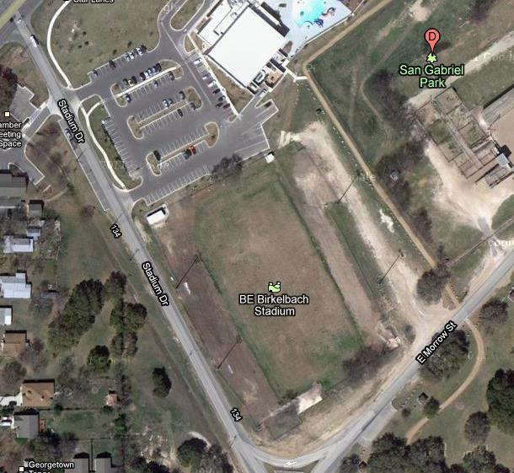
Spectator / Restroom
Entrance and Exit

Spectator/Restroom
Traffic Flow Aquadillo Tents Visiting Team Tents

Swimmer Traffic Flow
`
Concessions /
Aquadillo Merchandise

Volunteer Check-In

Announcer/Speakers

Equipment/Trailer
Parking

Visiting Team Parking

Aquadillo Parking

Merchandise Table
- We will have ALL Aquadillos merchandise available for purchase!
- We will also have goggles available.
- If you did not pick up your merchandise that was ordered at registration, please pick it up at the meet. WE HAVE TEAM PICTURES TODAY AND YOU NEED YOUR SHIRT!

Concessions
- August Beverage Co. will be at the meet with coffee and energy drinks available for purchase.
- We will also have Mariachi de Jalisco tacos, Shipley’s donuts, Papa John’s Pizza, Chick-Fil-A, chips, candy, and drinks available for purchase.
- Zydeco Ice will have delicious snow cones to help you cool off.

Family Folders
- Family Folders will be available at swimmer check in. Please check for ribbons from last week and last season!

Meet Preparation
Packing List
- Team Suit
- Team Cap – Labeled
- Goggles (And extra goggles!)
- Towel(s) - Labeled
- Sunscreen
- Team Shirt – Labeled
- Healthy Snacks
- Water
- Chair(s)
- Sunglasses/Hats
- Entertainment – There may be a lot of time between your swimmers’ events and staying awake and alert helps them swim faster! Please being things that will keep them occupied and happy such as books, colors, paper, tablets/phones, (be careful of them getting wet) board games, etc.
- Sharpie – For Arm Marking - details on next page.
- Parent Tents & Chairs
- Download the SwimTopia App. For live updates and times, you will need to get the Pro Version. There is a 7-day free trail. If you already have the app and need to add the Pro version, click on the meet, then click Favorites in the bottom right corner, and it should prompt you to sign up/renew.
  - Android
  - Apple
- Cheering Voice
Arm Marking
- Use the Heat Sheet or Swimtopia App to find your swimmer(s) name and highlight or circle their events.
- The night before or morning of, mark their LEFT arm with a sharpie. Last name: EHL and their respective numbers based on the heat sheet. Lines are optional.
- DO NOT put sunscreen on that area or it will completely smear!
- DO NOT MARK RELAYS. Skip those, they change too often.

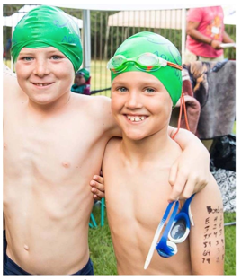 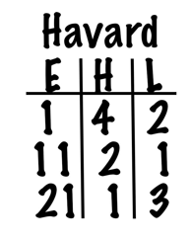
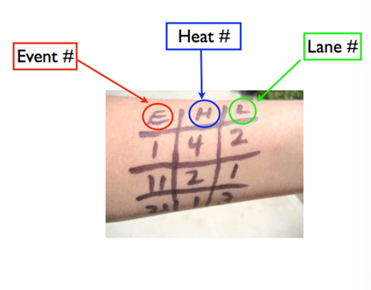

Heat Sheet
The heat sheet is subject to change so please use this as a reference but download the Swimtopia app for the most up to date information.

2022 Aquadillos Sponsors




