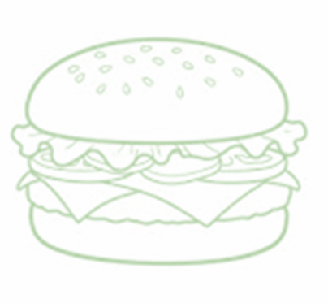
EDGEHILL EEL CONCESSIONS MENU
CASH ONLY- All proceeds go to the team. Thank you so much for your help.
MAIN
- HOTDOG $2
- FRIES $2
- 2 PIECE CHICKEN STRIPS $3
- HAMBURGER $3
(+BACON $1)

- CHEESBURGER $4
(+BACON $1)

$1 SIDES
- PASTA SALAD

- FRUIT (Watermelon -OR- Grapes)
- CHIPS (assorted flavors)
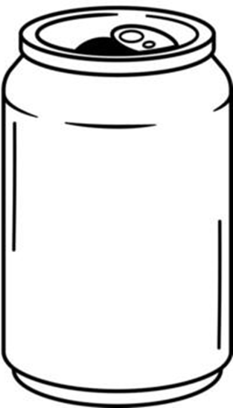
HOMEMADE DESERTS
- $1 or $2 depending on size

BEVERAGES
- WATER $1
- SODA (Coke, Diet Coke, Sprite) $1
- GATORADE $3

EEL MEAL DEALS
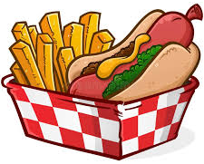  $5 HOT DOG COMBO | - Hot Dog  - Fries  - Soda - OR- Water  - Choice of $1 Side – OR - $1 Dessert
  $5 FRY BASKET | - 2 Chicken Strips  - Fries  - Soda- OR- Water
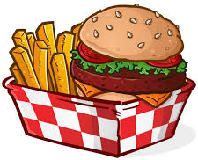  $5 BURGER & FRY MEAL | - Hamburger  - Fries  - Soda – OR - Water
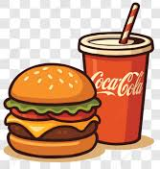  $5 CHEESY EEL MEAL | - Cheeseburger  - Soda - OR- Water  - Choice of $1 Side – OR - Dessert
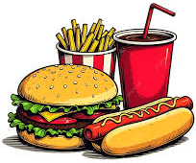  $10 BIG EEL MEAL | - Cheeseburger  - Hotdog  - Fries  - Soda/Water  - Choice of $1 Side  - $1 Dessert

