Fighting Turtle Visitor Information  Murabella Amenity Center Clubhouse  101 W. Positano Avenue  St. Augustine, FL 32092 | 
Meet begins at 8am and Away Warm-Ups begin at 7:20am.

Welcome to the WGV Fighting Turtles! We look forward to hosting your team and having a lot of fun! In order to ensure a relaxed, fun, and positive atmosphere for all, we ask that you please review and respect a few guidelines:
- Parking: Please carpool if possible. There will be parking available in our lot and along the street (one side only). There will be parking attendants to direct you and signs that will indicate No Parking Areas. Please do not park on the bridge, in the circle at the Amenity Center or at the mail kiosk. Also, please avoid the few spaces reserved for Murabella residents (adjacent to the Playground.)
- Visitor Set Up- Our deck space is limited, but we will be able to accommodate teams outside the side gate by the volleyball court. Please see the yellow marked areas in the map. You can bring chairs and tents for your families to set. Please remind your swimmers to stop by the foot washer before entering the pool deck. The playground and pool are for Murabella residents only. Please know the park is gated so in order to get back out to parking lot, you will need to go through the pool deckDon't forget sunscreen and bug spray!
- Pool Layout: Parents may not enter any areas marked in light green. This is reserved for coaches and volunteers running the meet. Our ready bench area is marked in green and feeds in from the area marked in light green. Please drop off your swimmers here. For 25yd events, we start from the road side of the pool. We do not have blocks, but we do allow shallow dives. You can cheer on all swimmers from the shallow end of the pool or from the side opposite the areas marked in purple. NO pictures will be allowed behind starts(light green area).

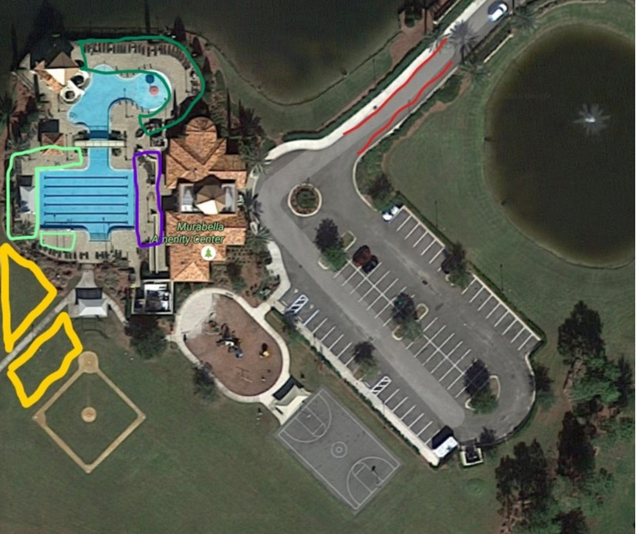
- Care and Feeding: Your swimmers will be hungry (you may be too!). We will have concessions available within the pool area serving cold drinks and snacks (please bring cash). Please ensure you and your swimmers are properly hydrated - bring water. CHICK-FIL-A BISQUIT $4.00
CHICK-FIL-A SANDWICH $5.00
COFFEE $2.00
CHIPS $1.00
CANDY $1.00
WATER $1.00
RING POPS 2/$1
- Volunteers: Please check in before the meet with your volunteer coordinator and be aware of
the announcements when it’s your time to go. We appreciate your help - this would not be
possible without you! Please remember that everyone is a volunteer, so patience and grace is appreciated.
- Ready Bench- Please have your swimmers marked to assist with ready bench and swimmer identification. Speakers will be set up outside gate so our visitors can hear the announcer call for ready bench. Even with the speakers, please pay attention to the event and heat flip charts. We will start events when ready, even if your swimmer is not present.
- ALL HEAT WINNERS CAN TAKE THEIR RIBBONS TO CONCESSIONS FOR A FREE ICE-POP!
- Finally, have FUN!- Please cheer for all swimmers, especially those who struggle. We are a recreational league and want our meets to be enjoyable and for every swimmer to feel accomplished.

Thank you!

