We are looking forward to welcoming the South Hampton Hurricanes to our pool on July 9th. Below is some
important information about our upcoming meet.
Pool Address: 370 Heritage Landing Parkway St. Augustine, FL 32092
Upon arrival, please check in with your coach and volunteer coordinator if you are signed up to volunteer. Timeline:
6:40am — HLH swimmers arrive (8 and under Hammerheads can opt to not warm up and arrive at
7:00) 6:50am - HLH Warm up
7:20am — 7:50am - Hurricanes Warm up
8:00am — Meet Begins
Volunteer Meetings:
If you are signed up for either of the following positions: Stroke and Turn or Timer you will need to attend a short meeting prior to the start of the meet. An announcement will be made before the meetings start.
All volunteers should be in place no later than 7:50am. This will ensure that the meet will start promptly at 8:00 am.
Food Trucks:
The following food trucks will be available:
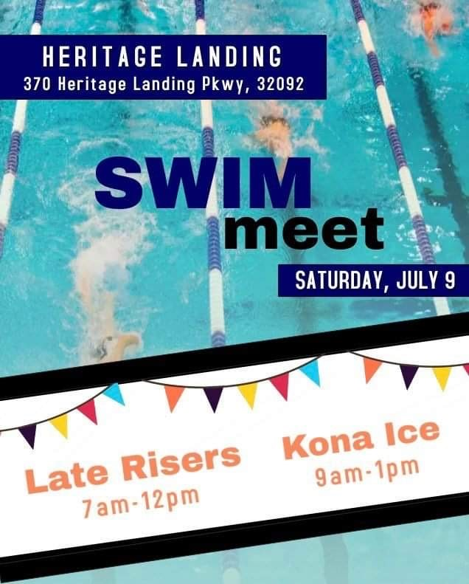
Food Trucks will be in the parking lot at the entrance to the pool.
Parking:
Parking will be limited. We are requesting that all Hammerhead families drive their gear to the amenities center then drive home and walk to the meet. If you decide on driving, we ask that all Hammerhead and Hurricane families carpool if possible. Parking is available in the following locations: Steamboat Landing Dr (the first street to the left when entering Heritage Landing); the amenities center parking lot; and the overflow parking lot located further down Heritage Landing Pkwy on both sides. Please see the map below for specifics. All areas will have signs and an attendant present to assist.
Tent City: Please see map below for details.
The recreation pool with the slide is closed during swim meets. Please make sure that all children and swimmers waiting for their events stay out of this pool.
The sand volleyball court is closed as well. Please keep children and swimmers out of the sand.
If you have any questions, please contact HLH President Megan Bastow at m3kids02@gmail.com or
856-498-8911
We look forward to having you!

Parking Information
As parking is limited, carpooling is encouraged if possible. Please familiarize yourself with the available parking
areas designated in red on the map below.
Continuing past the amenities center, overflow parking is located on the right side of Heritage Landing Pkwy near the power lines. A meet marshal will be present to help direct parking at this location. Feel free to drop your gear off at the amenity center before driving to this location to park.
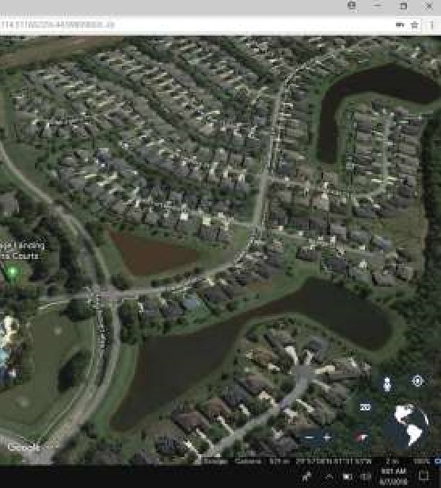
There are parking places in the amenities center parking lot. Please be respectful when parking here. Parking on the grass and in the mulched areas is not allowed. Cars must be parked in a parking spot. There are 4 parking spots reserved for residents using the amenities. Theses spots are located near the entrance to the pool and are clearly marked.

Driving into Heritage Landing from entrance on Heritage Landing Parkway, Steamboat Landing Dr is the first street on the left when driving into Heritage Landing from the entrance. Limited parking is available along the first stretch of Steamboat Landing Dr. Parking is only allowed on the side of the street that is closest to the amenity center. A meet marshal will be present to give clear direction on where parking will be permitted and not permitted on this street. If you are parked in an area that is not permitted, you will be asked to move your vehicle.

Tent City

Visiting Team Tent City
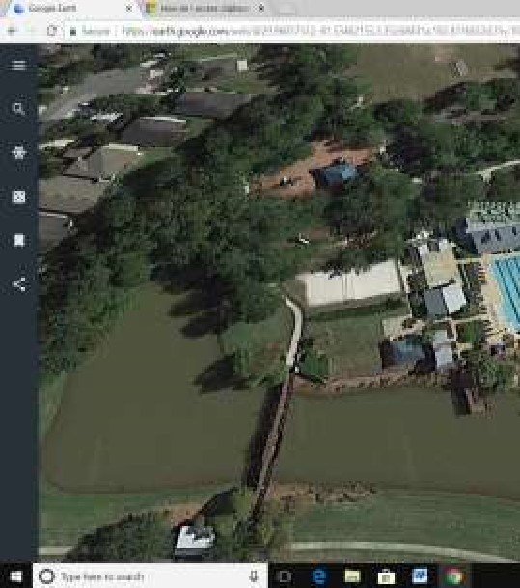
Heritage Landing Hammerhead Tent City

Tent City for the Hammerheads is located behind ready bench near the volleyball court.
Tent City for the visiting team is located outside the fence near the fire pit. Swimmers can access the pool through the gate that leads to the volleyball court.

- There is no seating provided. Please make sure to bring your own chairs. Only standing spectating is allowed on deck and on the patio behind the starting blocks.

