We are looking forward to welcoming you to our pool on Saturday, June 3rd.
Your warm up time will be 7:20-7:50am and the meet will start at 8:00am.
Parking:
We have reserved parking spots for your Head Coach (1) and your Stroke and Turn Judges (4) working at the meet. These spots will be marked near the entrance of our pool. We have quite a bit of parking in the lot adjacent to the pool for your families. Other open spots are first come, first served, except for the spots marked “NON JCP SWIM MEET.” Please leave those open for regular residents to use during the meet.

Team Areas:
We have an area on our pool deck reserved for your team. It will be the canopy area at the bottom of the ramp. You are also welcome to use any of the other grass and deck areas open and available. Personal pop up tents and folding chairs are permitted.

Volunteers:
We would appreciate assistance from your team with the following volunteer positions:

- Meet Official (HMO) to assist with relays
- Stroke and Turn Judges (4 total, 2 per session)
- Timers (6 timers per session)
- Ready Bench (2 per session)

The times of all volunteer meetings will be announced on deck prior to the meet. Please have all Stroke and Turn Judges and Timers (both sessions) attend the meetings to receive instructions for the meet.

Ready Bench Information:
The ready bench entrance is located next to the wading pool near the starter blocks side of the pool. Please ask your swimmers to have their last names, along with team initials written on their shoulders. We also suggest that our swimmers write all Events, Heats, Lanes and Strokes on their forearms. This information is very important especially for the younger swimmers and helps the Ready Bench significantly.

Concessions:
We will have concessions open with coffee, drinks and snacks.

Restrooms:
Restrooms are located near the inside entrance of the pool, they are on the right side as you walk in.

Photography area:
There is NO photography allowed from behind the blocks—including from the raised area at the end of the ready bench. We have set aside a photography area next to the Starter’s tent for those wishing to take pictures of their swimmers coming off the blocks.
Additionally, the flying of any drone, remote controlled aircraft, or similar item is prohibited.
Family Pool:
The family pool is closed! There are showers on deck or in the rest rooms for cooling off.

Please let us know if you have any questions! We are looking forward to a great meet!
Kristen Vlaun, Porpoises President
kkvlaun@gmail.com
717-448-9312



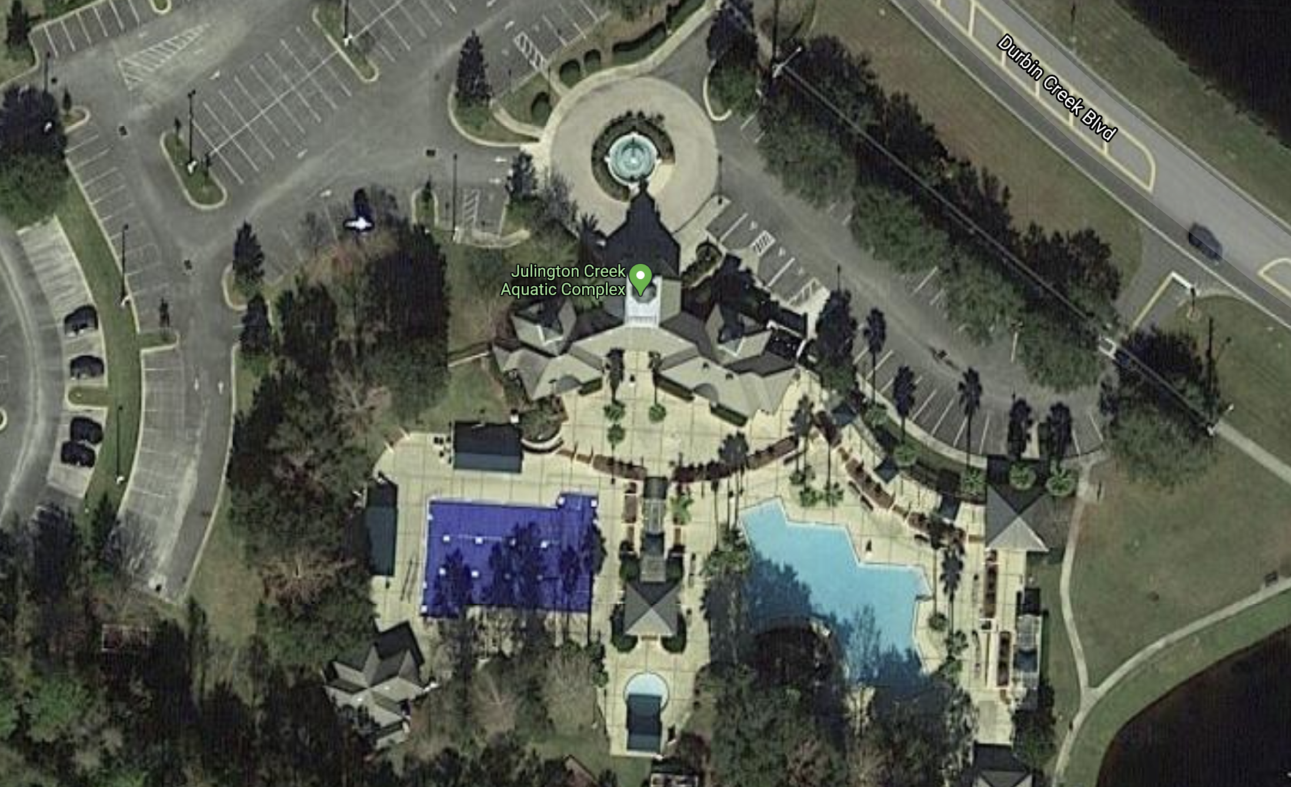
Red is the visitor sitting area
Yellow is the ready bench (entrance by the round wading pool)
Blue is the reserved parking area (Coaches, S&Ts)

