
Welcome to the RiverTown Amenity Center
156 Landing Street, Saint Johns, FL 32259

We are looking forward to welcoming you to our pool on Saturday!

Your warm-up time will be 7:20-7:50am and the meet will start at 8:00am.

Parking:
Please park in the parking lot adjacent to the pool and parking spots on Riverwalk Blvd and Kendall Crossing. Open spots are first come, first served. See the parking lot attendant to assist you with parking. Please do not park on any grass areas.

Team Areas:
We have a grassy area adjacent to the pool reserved for your team. There is a grass area outside the pool gate for potential overflow. Personal pop-up tents and folding chairs are permitted.

Volunteers:
We would appreciate assistance from your team with the following volunteer positions:

- Head Meet Official (HMO) to assist with relays
- Stroke and Turn Judges (4 total, 2 per session)
- Timers (12 total, 6 per session)
- Ready Bench (4 total, 2 per session)

The times of all volunteer meetings will be announced on deck prior to the meet. Please have
all Stroke and Turn Judges and Timers (both sessions) attend the meetings to receive
instructions for the meet.

Ready Bench Information:
The ready bench entrance is located at the grassy area adjacent to the pool. Please ask your
swimmers to have their last names, along with team initials written on their shoulders. We also suggest that swimmers write all Events, Heats, Lanes and Strokes on their forearms. This information is very important especially for the younger swimmers and helps the Ready Bench significantly.

Concessions:
We will have food trucks available throughout the meet in the parking lot roundabout with food and drinks for purchase.

Restrooms:
Restrooms are located near the entrance of the pool, they are on the left side down the path as you walk in.

Photography area:
There is NO photography allowed from behind the blocks. You can take pictures of your swimmer from the sides of the pool.

Additional Information
The family pool is only available to residents not participating in the swim meet. Please keep your swimmers out of this pool. There are showers on deck or in the rest rooms for cooling off.

Additionally, the flying of any drone, remote controlled aircraft, or similar item is prohibited.

Please let us know if you have any questions! We are looking forward to a great meet!

Karina Ringdahl, RipTides President Katie Okerberg, RipTides VP
rivertownriptidespresident@gmail.com rivertownriptidesvp@gmail.com
619-796-9969 847-772-1214

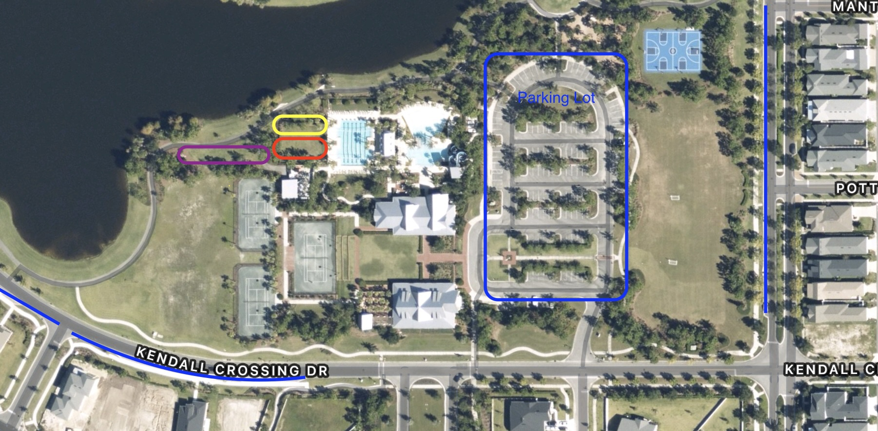

Red is the visitor sitting area Yellow is ready bench
Purple is overflow sitting area Blue is the parking lot and street parking

