
St. Johns Stingrays Visitor Information
Welcome to the St. Johns Stingrays pool! We are excited to have you as our guests and hope that you enjoy our facilities as much as we do. In order to ensure a fun and positive atmosphere for all, we ask that you please review and respect a few guidelines:
Pool Address: 205 St Johns Golf Drive, St Augustine, FL 32092
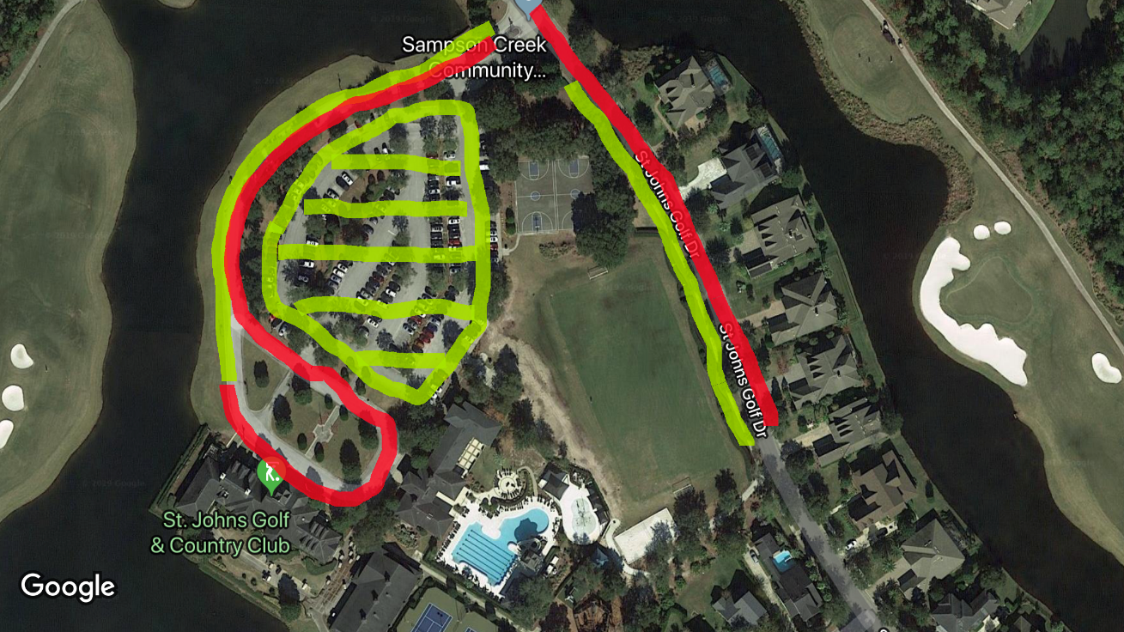
Parking: We share parking with the Golf Club which is very busy on the weekends. We ask that you please respect the golfers and residents accessing other amenities. Parking is available in the main lot or along the right side (as you enter) of the roadways designated in green. Please do not park in the red areas or on the grass.

Visitor Seating: We should be able to accommodate most visiting teams within the pool area marked in green. If overflow seating is required, you may use the areas marked in orange. Access to the pool deck is indicated with a

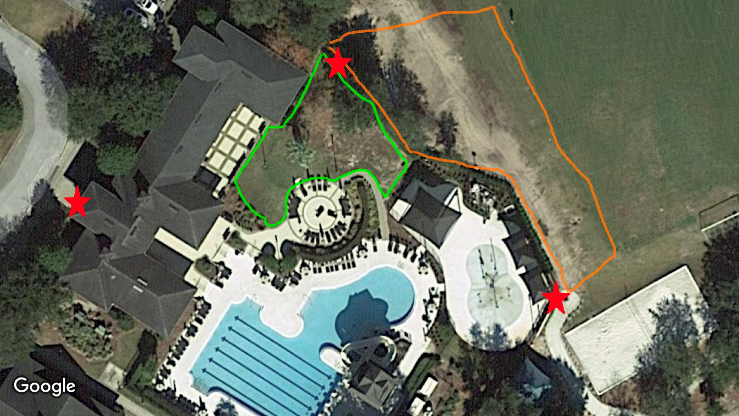

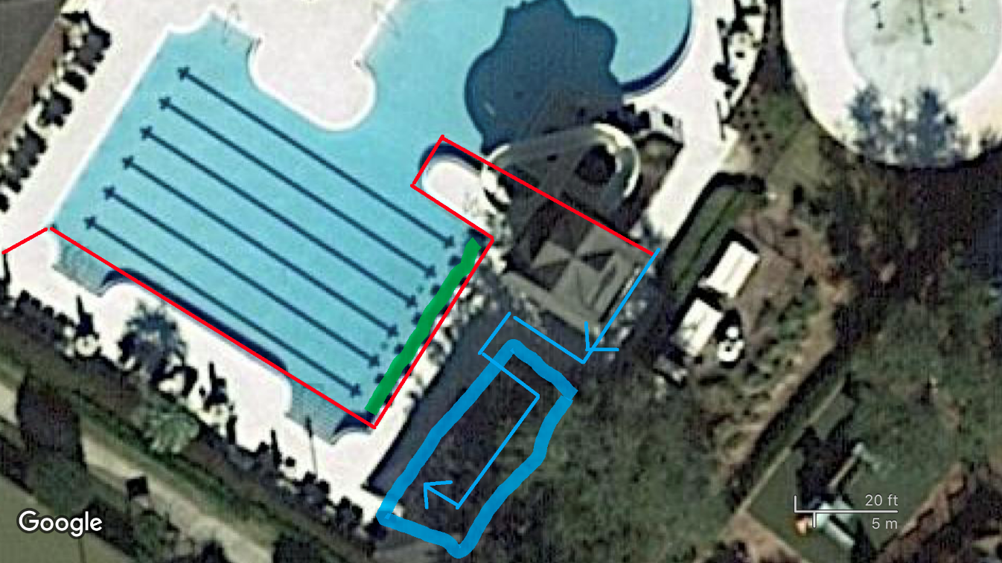
Pool Layout: Parents may not enter any areas marked in red. This is reserved for coaches and volunteers running the meet. Our ready bench area is marked in blue and feeds in from the area marked with the - please drop off your swimmers here. You can cheer on all swimmers from the shallow end of the pool or from the side opposite the areas marked in red. NO pictures will be allowed behind starts.

Concessions: We will have concessions available within the pool area serving cold drinks and snacks (please bring cash). All heat winners can take their ribbons to the concessions in exchange for a free ice pop.

Volunteers: Please check-in before the meet with your volunteer coordinator and be aware of the announcements when it’s your time to go. We appreciate your help - this would not be possible without you!

Other info:

- Please keep your swimmers out of the playground and splash pad area (it will not be on).
- The recreational pool area is closed and may not be used by swimmers.

Tentative Timeline:
- 6:40 AM – Junior Coaches arrive
- 6:45 AM - Arrive at pool and set up in Tent City - both team volunteers please check-in at the volunteer table with Burton Jones.
- 6:50 AM -Team stretch
- 6:55 AM - 10 & Unders warm-up
- 7:05 AM - 11 & Ups warm-up
- 7:20 AM - Visiting Team warm-up
- 7:45 AM - ALL Stroke and turn judges and timers for both sessions report to Starters Table for Meeting
- 7:50 AM -Team Cheer
- 7:55 AM - Events 1-6 report to Clerk of Course
- 8:00 AM - Meet Starts

