SJSSL

South Hampton Hurricanes
Vs.
Bartram Springs Barracudas

June 8st, 2024

Meet Program


2024 Hurricane Sponsors

 | 

 |  | 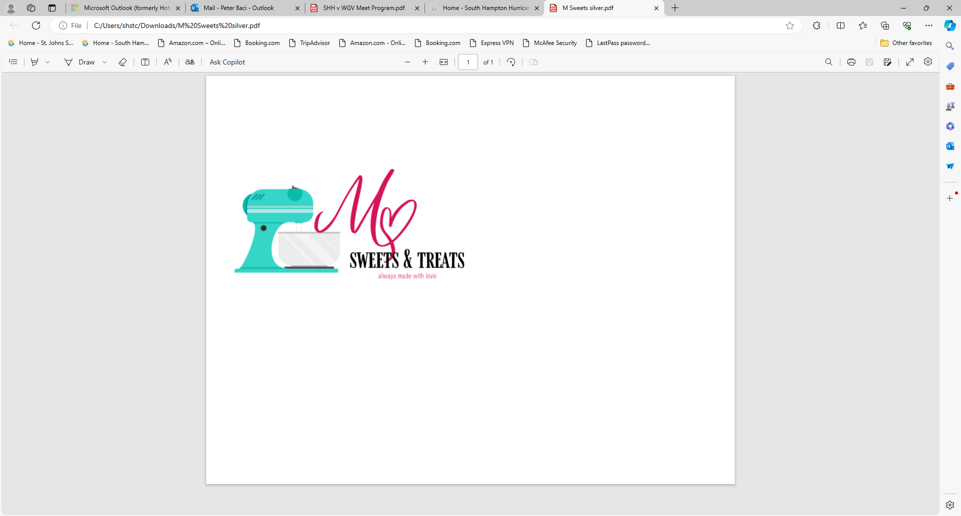

 |  | 

South Hampton Hurricanes Facilities Information

Facilities Information:

• Pool address: 140 S. Hampton Club Way, St. Augustine, FL 32092
• The splash park and playground are off limit to swimmers and siblings.
• Parking may be a concern; it is best to carpool.
• The parking lot is reserved for our visiting team.

Visiting Team Tent City:
• The visiting team can set up their tents on the soccer fields.

Please DO Park in one of these areas (Marked in BLUE)
• The pool parking lot
• Along the North side of South Hampton Club Way
• Along the NE side of Garrison Drive
• In the business lot next to Watson Reality
• Where one of our parking attendants directs you

Please DO NOT park (Marked in RED)
• Any roped off areas or areas marked in RED below
• On the grass, as it will damage the irrigation system and we will need to pay the HOA repairs
• On the opposing side of any street where we have approved parking (SJSO will ticket)
• At any businesses located adjacent to the pool other than Baptist or Tutor Time(cars will be towed)

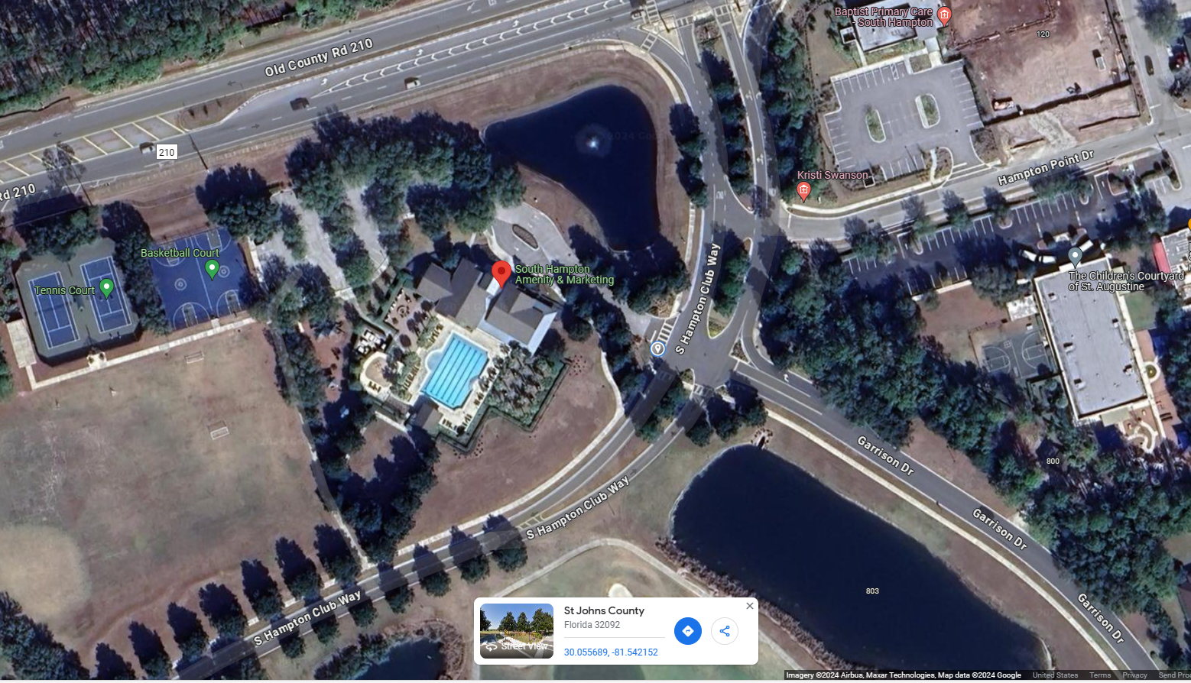


Breakfast Items
Whataburger Breakfast Taquitos with cheese
$4

Whataburger Breakfast Honey Butter Chicken Biscuit
$4

Other Concession Items
Gatorade $2
Coke/Sprite/Diet Coke $2
Water $1
Chips $1
Fresh Baked Muffins $3
Coffee $1 (free refills/fill your own cup)
Full Size Candy $2
Ring Pops $1

Heat Ribbon winners will receive a free freeze pop in our concession!
One per ribbon

Hurricane Fanwear will also be for sale!!!

.
Cash and Venmo Accepted
(South Hampton Hurricanes Swim Team @SH-Hurricanes)
TIMELINE:

6:45 AM – Home team arrive at pool and set up in Tent City - Volunteers please check in with volunteer coordinator at the volunteer table.
6:50 AM -Hurricane Team Stretch
6:55 AM – South Hampton 10 & Under warm-up
7:05 AM – South Hampton 11 & Up warm up
7:20 AM - Visiting Team warm up
7:45 AM - ALL Stroke and turn judges and timers for both sessions report to Starters Table for Meeting
7:50 AM -Hurricane Team Cheer
7:55 AM - Events 1-6 report to Clerk of Course
8:00 AM - Meet Starts

VISITING TEAM VOLUNTEER POSITIONS NEEDED:
Stroke & Turn- 4 total, 2 per shift
Timers- 12 total, 6 per shift
Ready Bench- 4 total, 2 per shift
Team Area Parent- 4 total, 2 per shift
SHST Volunteer Coordinator- Jennifer Matthew 423-580-2336

