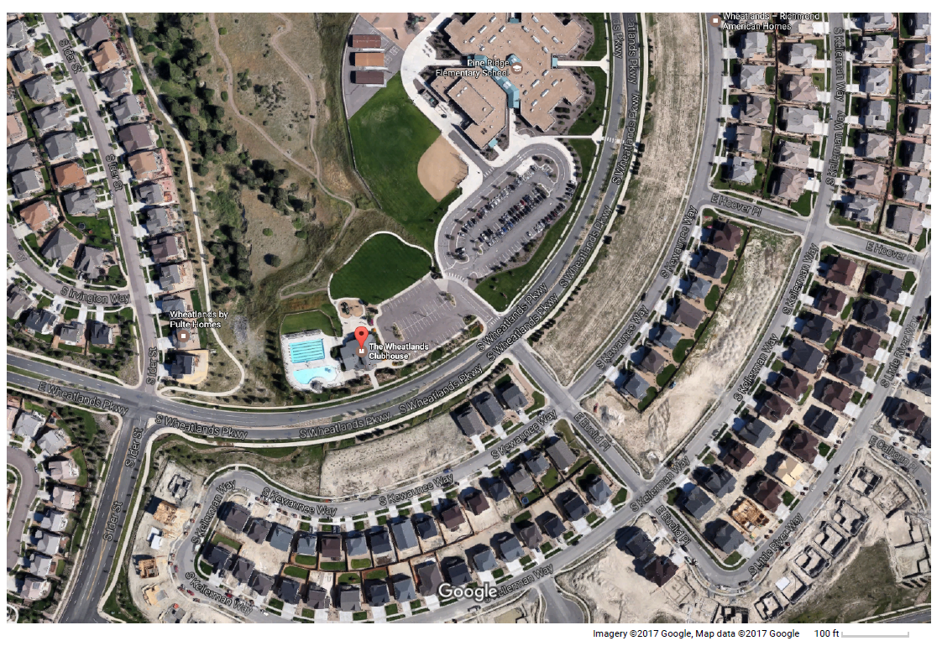

Please park in the pool parking lot or the school parking lot. Street parking is available on Wheatlands Pkwy PAST Euclid Place ONLY to the North (as denoted by the green hearts). Do not park on ANY side streets off Wheatlands Pkwy (as marked with a red circle).

**Parent Tent Set up**