CIMST Swordfish

Spirit Night!

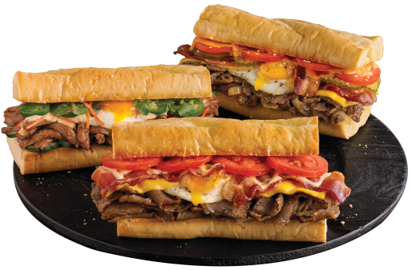

351 S Mason Rd.

12:00 – 9:00

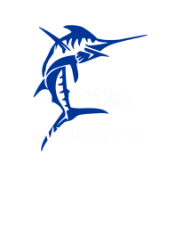

Thursday May17th

**come**

**friends!!**

**bring**

**hungry!**