Operating Procedure for Swimmer’s Event/Heat/Lane
Below are the step-by-step instructions for how to determine and manage your swimmer(s) Events, Heats, and Lanes during a swim meet.
It is important for you to know and help manage your swimmer(s) events during a swim meet. When the swimmers are where they need to be, when they need to be there, and know what stroke they are swimming, it makes the swim meet run smoothly.
Before each swim meet, you should receive a Heat Sheet via email. The email will be titled Waterstone vs. Other Team Heat Sheet. This document is a break down of every event for every registered swimmer during the scheduled swim meet.
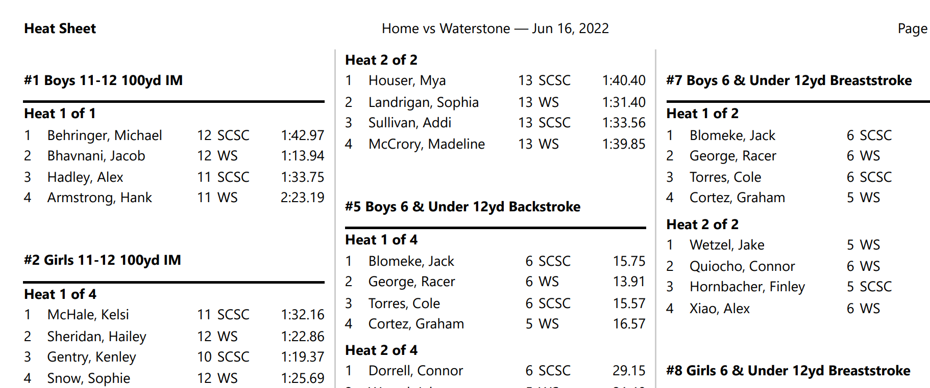
- There are a total of 58 events. There are 16 Relay events and 42 Individual events. Each individual event can have a maximum of 5 heats and relay events have 3 heats. (Heat maximum does not apply to 6 & Under age group).
  - Events #1 - #4 – Individual Medley (IM) – one swimmer will swim 100 meters demonstrating each of the four swim strokes.
  - Events #5 - #10 – 6 & Under events – swimmers swim ½ the pool length demonstrating three swim strokes (backstroke, breaststroke, freestyle) in separate events.
  - Events #11 - #18 – Medley Relays – teams of 4 swimmers will partner during these relays. Each swimmer will demonstrate a specific stroke. 1st swimmer swims Backstroke, 2nd swimmer Breaststroke, 3rd swimmer Butterfly, 4th swimmer Freestyle.
  - Events #19 - #50 – Individual events
  - Events #51 - #58 – Freestyle Relays – team of 4 swimmers will partner and all swimmers will swim the freestyle stroke.
  - NOTE: Dependent on the number of swimmers in an age group and restricted by the number of heats per event, swimmers may not be seeded to swim in every event.
  - NOTE: Some age groups may have too few swimmers registered for the swim meet. In this situation it effects the relay events. We will “SWIM UP” a younger swimmer to complete the relay team.

- The Heat Sheet is separated by a numbered Event (i.e. #5 Boys 6 & Under 12yd Backstroke)
  - Sub-categories of each Heat (i.e. Heat 1 of 4)
    - Further broken down into Lane Assignments for each swimmer (i.e. 2 George, Racer 6 WS)
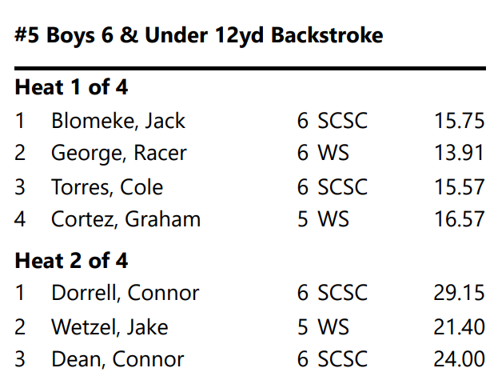
- The parent should review the Heat Sheet for all of the events their swimmer(s) may be seeded in. NOTE: Be sure to review Event age categories 1 – 2 ages older than your swimmer(s) in the event that they have been seeded to “SWIM UP”.
- The SwimTopia mobile app will provide a list of Events that your swimmer(s) are seeded in. Be cautious when using the app, it may not list all of your swimmer’s seeded relay events.

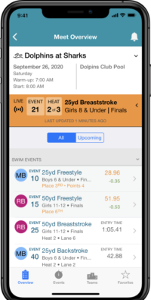

- To help the coaches and volunteers (Clerk of Course, Timers, etc.) identify a swimmer during a swim meet, parents need to write the LAST NAME of the swimmer on his/her shoulder blade. We have over 200 swimmers on the pool deck during a swim meet and most volunteers do not know each swimmer by name.
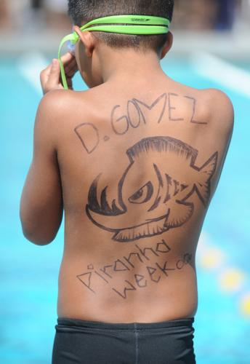

- To help your swimmer manage their events, it is helpful to write each Event/Heat/Lane/Stroke on your swimmer’s arm or leg.
