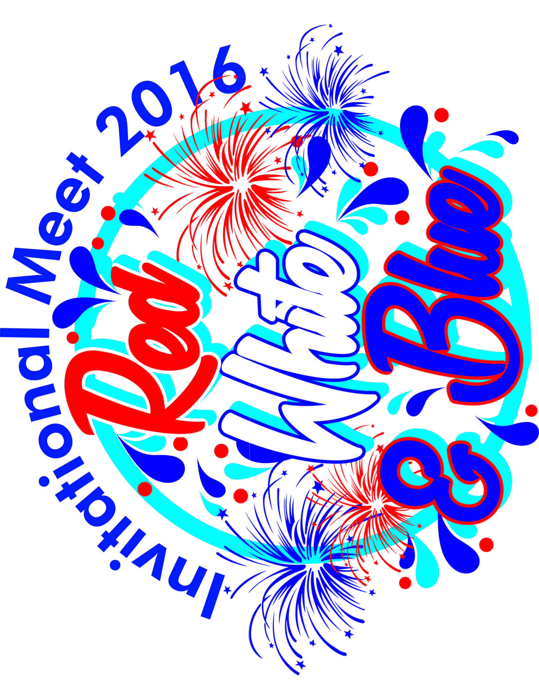

FRIDAY WARM UP ASSIGNMENTS
5:00-5:25

LANE 1 | LANE 2 | LANE 3 | LANE 4 | LANE 5 | LANE 6 | LANE 7 | LANE 8
CYP | CYP  GWF | LSL | LSL | FF | FF  SCF | COLE | COLE  WFST

5:20 – 5:40
LANE 1 | LANE 2 | LANE 3 | LANE 4 | LANE 5 | LANE 6 | LANE 7 | LANE 8
GLEN | GLEN  INF | CBST | CBST  CYC | COPP | COPP  RAVE | BRLD | BRLD  FOST

5:40 – 6:00
LANE 1 | LANE 2 | LANE 3 | LANE 4 | LANE 5 | LANE 6 | LANE 7 | LANE 8
BRY | BRY | DFV | HST-ZC | NSST | CGC  LEEC | CHTS-US | SCST

6:00 – 6:20
LANE 1 | LANE 2 | LANE 3 | LANE 4 | LANE 5 | LANE 6 | LANE 7 | LANE 8
NOR  TWNL | STC  BCB | WSG  EHC | BSST  HWD | EVM  RF | LWF  FXWD | NORP  NAV | OAKS  CPS

SATURDAY WARM-UP ASSIGNMENTS

7:10-7:30
LANE 1 | LANE 2 | LANE 3 | LANE 4 | LANE 5 | LANE 6 | LANE 7 | LANE 8
FOST | FOST  SCF | STC  RF | TWNL | BCB | BCB  EVM | BSST | LWF  CYC

7:30-7:50
LANE 1 | LANE 2 | LANE 3 | LANE 4 | LANE 5 | LANE 6 | LANE 7 | LANE 8
COLE | COLE | COLE  CHTS | NORP | NORP | BRY | SCST | SCST

7:50-8:10
LANE 1 | LANE 2 | LANE 3 | LANE 4 | LANE 5 | LANE 6 | LANE 7 | LANE 8
BRLD | BRLD | BRLD  RVX | CYP | GWF | COPP | COPP | COPP  RAVE

8:10-8:30
LANE 1 | LANE 2 | LANE 3 | LANE 4 | LANE 5 | LANE 6 | LANE 7 | LANE 8
DFV | DFV  CBST | CGC | INF | GLEN  LEEC | LSL | HST | OAKS

8:30-8:50
LANE 1 | LANE 2 | LANE 3 | LANE 4 | LANE 5 | LANE 6 | LANE 7 | LANE 8
NSST  NAV | HWD | HWD  WSG | FF | FF  CPS | NOR | NOR  EHC | WFST

SUNDAY WARM-UP ASSIGNMENTS

7:10-7:30
LANE 1 | LANE 2 | LANE 3 | LANE 4 | LANE 5 | LANE 6 | LANE 7 | LANE 8
NORP | NORP  RAVE | COPP | COPP | BRLD | BRLD  RVX | GLEN | GLEN

7:30-7:50
LANE 1 | LANE 2 | LANE 3 | LANE 4 | LANE 5 | LANE 6 | LANE 7 | LANE 8
STC | STC  RF  SCF | BSST | CGC | EVM | FOST | FOST  GWF | NOR

7:50-8:10
LANE 1 | LANE 2 | LANE 3 | LANE 4 | LANE 5 | LANE 6 | LANE 7 | LANE 8
NSST | NSST  BCB  HWD | CBST | CBST  FXWD | FF | FF  EHC | SCST | SCST  OAKS

8:10-8:30
LANE 1 | LANE 2 | LANE 3 | LANE 4 | LANE 5 | LANE 6 | LANE 7 | LANE 8
LWF | LWF  TWNL | COLE | COLE | COLE  WFST  CPS | WSG  LEEC | CYP | CYP  NAV

8:30-8:50
LANE 1 | LANE 2 | LANE 3 | LANE 4 | LANE 5 | LANE 6 | LANE 7 | LANE 8
LSL | LSL | BRY | BRY  CYC | DFV | DFV  CHTS | HST | HST  INF


TIMING ASSIGNMENTS

FRIDAY SESSION
6:30 – End of Meet
LANE 1 | LANE 2 | LANE 3 | LANE 4 | LANE 5 | LANE 6 | LANE 7 | LANE 8
BRY  BRY | BRY  LIV | LIV  LIV | FF  FF | FF  COLE | COLE  COLE | GLEN  GLEN | CBST  CBST

SATURDAY SESSION
9:00-11:15
LANE 1 | LANE 2 | LANE 3 | LANE 4 | LANE 5 | LANE 6 | LANE 7 | LANE 8
BRLD  BRLD | BRLD  BSST | COLE  COLE | COLE  INF | COPP  COPP | COPP  CGC | NORP  NORP | SCST  SCST

11:15 –End of Meet
LANE 1 | LANE 2 | LANE 3 | LANE 4 | LANE 5 | LANE 6 | LANE 7 | LANE 8
FF  FF | NOR  NOR | FOST  FOST | HWD  HWD | BCB  BCB | DFV  DFV | SCST  SCST | SCST  BBST

SUNDAY SESSION
9:00-11:15
LANE 1 | LANE 2 | LANE 3 | LANE 4 | LANE 5 | LANE 6 | LANE 7 | LANE 8
COLE  COLE | COLE  LSL | LSL  LSL | COPP  COPP | COPP  GLEN | GLEN  GLEN | BRLD  BRLD | BRLD  WSG

11:15 – 1:15
LANE 1 | LANE 2 | LANE 3 | LANE 4 | LANE 5 | LANE 6 | LANE 7 | LANE 8
FF  FF | LWF  LWF | STC  STC | FOST  FOST | NSST  NSST | BRY  BRY | DFV  DFV | NORP  NORP
1:15 – End of Meet
LANE 1 | LANE 2 | LANE 3 | LANE 4 | LANE 5 | LANE 6 | LANE 7 | LANE 8
CBST  CBST | SCST  SCST | CYP  CYP | HST  HST | NOR  NOR | BSST  CGC | EVM  INF | NAV  OAKS

