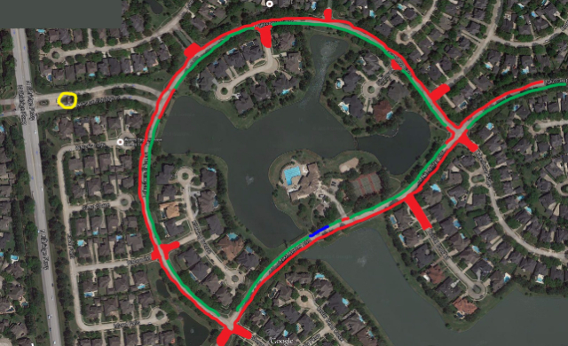

Pool and Clubhouse Address*: 12750 Lake Center Run, Houston TX 77041
*IMPORTANT NOTE ABOUT PARKING: The Lakes on Eldridge Homeowners Association is pleased to host our swim team. However, they are concerned that congestion is minimized for residents and that safety is maximized for everyone in the development.
Therefore, please park in designated areas only. See the map above with the arteries marked in green where parking is available and in red where it is not. Parking is allowed on the LAKE SIDE portion of Lake Center Run and Lakeshore Ridge only (leaving the other lane for cars to drive on). During swim meets, the recreation center parking lot is limited to parking pass holders only. Do not park within 15 feet of fire hydrants, 20 feet or a crosswalk or intersection, or within 30 feet of a stop sign - these are all standard Texas laws. Please observe the 25 MPH speed limit please. We will allow you entrance through the Visitor lane (left side) of the LOE main gate off Eldridge (circled in Yellow) on meet days - please inform the guard that you are participating in the swim meet if asked.
A "Drop Off Zone" is available for you near the pool (dark blue area along curb near pool) to allow you to unload your gear before parking.
Parking is not allowed on side streets. Cars may be towed if parked in the red "No Parking" zone.
Parking Map

