May 15th 2021, FAST vs. Coles (10 & Under)
Central Park Pool, 15015 Heath Green Circle Cypress, Texas 77433
Welcome!
We are looking forward to this weekend’s meet at our pool.
Parking:
Parking is available on the side streets near the pool. Please obey all posted No Parking signs and watch for pedestrians. For more details, please review the parking map below. Due to construction, the parking lot will be used for tent setup. No parking in the parking lot.

Pool:
Our pool is an 8-lane regulation 25-yard pool. We use a Dolphin starter and manual stopwatches. We will provide all stopwatches for the meet. Starting blocks are located at the deep end of the pool. Coaches’ tents are located on the far-left side of the pool, closest to lane 1 and computers. Please adhere to the one-way system for entry and exit. The restrooms are located in the breezeway. Results will be posted on result boards near the pool area.

Timeline:
Home team swimmers should arrive at the pool by 6:45am. Circle in by 7am (no later). Home warm-ups start at 7:10am. Visiting team warm-ups start at 7:40 am. The meet is scheduled to start at 8:30am. Please have all volunteers in place to allow for a prompt start to the meet.

Swimmers:
Please be sure to bring your positive attitude and winning spirit!

Parents may drop off swimmers at the pool in the designated drop-off area (see attached maps) along Heath Green Circle.

Upon arrival to the pool, please Circle In/Highlight your name and the events you will be swimming for the day on your team Circle-In board near the pool area. If you are unable to swim an event (including Relays), please don’t highlight that event, instead cross out the event(s). Afterwards, take a picture of your name and events, then step away from the area so others may also have access to the sheets. It is highly recommended that novice swimmers and younger swimmers have their events, heat and lane written clearly on their arm (using Sharpie markers) for other volunteers to assist in getting them to their event. If you are running late, call a friend to request them to circle in for you. If you are not circled in by 7:00am, you will be removed from the meet. Those who do not circle in by 7am and/or miss warmups will be removed from the 1st set of relays (if applicable) or first event, and possibly scratched from the meet. Be sure to check in & check out with your age group tent parent so he/she can effectively communicate with the Coaches and Ready Bench, as needs arise.

Scratches need to be presented by your Clerk of Course to Computers by 7:05 am, therefore, the sheets will be promptly removed and given to the Home team’s Clerk of Course as well as, the Visiting team’s Clerk of Course. The results from this sheet will be used to create the most updated Heat Sheets and allow both Team’s Coaches to make necessary changes to the Relay teams. Your attention to this matter is necessary for a timely and delay-free meet. Those who do not circle in by 7am and/or miss WU will be removed from the 1st set of relays (if applicable) or 1st event, and possibly scratched from the meet. Swimmers should NOT leave the meet early, unless previously communicated with a Coach. Even if the swimmer is not scheduled to be in the ending relays, he/she should stay until all relay members have been confirmed. When confirmed, please check-out with your tent parent prior to leaving. Remember, this year’s meet is 1/2 the time of a regular meet and should be done around 11am.

The Fairfield HOA has requested all swimmers wear a mask when in the pool areas, however, with the shortage of volunteers and limited funds, it is not feasible to acquire additional volunteers to monitor and patrol the usage of masks. Please be mindful of the health and safety of others, do your part. Swimmers will need to provide their own baggie labeled with their full name and age. In case of emergency, masks and baggies will be available to purchase at concessions.

Be sure to talk to your Coach after each race. He/She will give immediate feedback on your race. Remember to give compliments to others, even if they are not on your team. Also acknowledge your achievements, find something you do correctly today and think of ways you can improve for your following races.

Don’t forget to bring your team swimsuit, swim cap, googles, sharpie marker, sandals, chair, 2 towels, sanitizer, sunscreen, bug repellent entertainment, mask, plastic baggie, favorite snacks, beverages, and money for concessions.

Tent Set-up:
Due to construction, our normal tent area will be moved. The Visiting team’s age group tents & Home team’s age group tents will be in the parking lot. The Visiting team’s family tent area will be adjacent to this area. The Home team’s family tent area will be located (TBD). We will make every effort to keep the Family and Age group tents distant and limited, as much as possible. Please see attached Tent Set map. Please bring your personal tent, chair, sunscreen, mask and cash or credit card for concessions.

Clerk of Course/Computers:
Exchange will occur via the Swimtopia website per NWAL rules. Please contact our Clerk of Course, Josh Penrod for details. We would like the Visiting team to bring their computer, starter and stopwatches (as a backup to ours).

Officials:
We typically have our officials meeting at 7:30am in the breezeway of the clubhouse. The Head referee will work with all officials to ensure good coverage during the meet. Water/Gatorade and 1 meal will be provided courtesy of FAST.

Volunteers:
Summer swim league is solely reliant on voluntary parent participation. Our Board members also are volunteers and have full time jobs and families too. No negativity, we are one swim family working for a common goal for all our children in the community. The only under paid positions are our Coaches. Please be mindful of this at the swim meets. Please pitch in where needed! Remember, the required posted amount of volunteer hours is a minimum needed to run a successful swim season not the maximum. We are all part of Summer Swim league to watch our kids make friends, draw on themselves and of course swim. The meets cannot function without the entire Pod of dedicated parents. Please pitch in and share the workload so we can all have an enjoyable experience.

Volunteer sign in sheets will be located in the breezeway. Please arrive at your shift on time according to your sign up. All volunteers must maintain objectivity and impartiality in their volunteer position.

The Fairfield HOA has requested all attendees wear a mask when in the pool areas, however, with the shortage of volunteers, it is not feasible to acquire additional volunteers to monitor and patrol the usage of mask. Please be mindful of other’s health and safety. In case of emergency, masks will be available to purchase at concessions.

Please bring your personal water bottles to your volunteer stations. There will also be water and other beverages available for purchase in the concession area.

Due to our shortened meets this season, the FAST team will only have 1 shift. If the visiting team decides to split their volunteer shifts, we ask for the shift change to occur seamlessly and without stoppage of the meet. If there is a need for the Visiting team to have a volunteer shift change, it will be announced by the DJ. Please don’t have other volunteers track you down, it will only delay the meet and cause everyone to stay later than needed.

Some positions require advance training the day of the meet while others are self-explanatory. If you are unsure of the requirements of your job, please visit with an experienced parent and/or find any Board member to help you.

Volunteer trainings are held prior to the beginning of the meet.
* 8:00am: Timers/Scribes meeting near computer area, held by Head Timer & Clerk of Course
* 8:00am: Ready Bench & On-Deck Volunteers, held by Head Ready Bench
We requiring the visiting team to provide the following volunteers for the meet:
· Timers/Scribes: 8 per shift: one per lane (1-8),
· Head Timer
· Ribbon Writer: 1 per shift
· Meet Runner: 1 per shift
· Time Verifier: 1 per shift
· Ready Bench: 2 per shift
· 1 Deck Assistant: per shift
· 4 Officials- (1) Meet Referee, (1) STR, (2) SNT
Heat Sheets:
Heat sheets will be available for purchase across from the Concessions Stand.

Concessions:
Due to COVID restrictions, and shorter meet times, our concession options will be reduced. We will be open for breakfast and snacks throughout the meet. Our concessions items can be purchased with cash, or card only.

Hospitality:
Due to NWAL COVID rules, only Coaches, Officials and Clerk of Course will be provided with water during the meet. Please bring your personal water bottles to your volunteer stations. There will also be water and other beverages available for purchase in the concession area.

COVID safety:
All swimmers and volunteers are requested to wear masks within the pool areas. Swimmers are asked to provide their own personal baggie to put their mask in while swimming. There will be enhanced hygiene/sanitation throughout the meet.

By attending FAST meets, you acknowledge that there are no guarantees that NWAL nor FAST or Visiting team can completely prevent you and/or your children from becoming exposed to COVID-19. By attending our meets, you acknowledge that your team membership accepts that an inherent risk of exposure to COVID-19 exists in any public place where people are present. Your attendance attests that your team members’ participation in any NWAL activity is voluntary and that your team members assume all risks regarding COVID-19 and releases NWAL and your team from any and all liability with respect to COVID-19, now and going forward.

Prior to coming to the pool for any NWAL activity, everyone (swimmers, parents, guardians, volunteers….anyone) should self-screen by answering the following questions. If you answered YES to ANY question below, you should not come to the pool.
• Do I feel sick in any way, dizzy, have a cough, have shortness of breath or difficulty breathing?
• Do I have a fever, sore throat, chills, headache, loss of taste or smell or diarrhea?
• Have I been in close contact with anyone known to have tested positive for COVID-19?

We make every effort to have a fair and efficiently run swim meet. If you have any questions, concerns or suggestions, please feel free to reach out to one of our team board members.

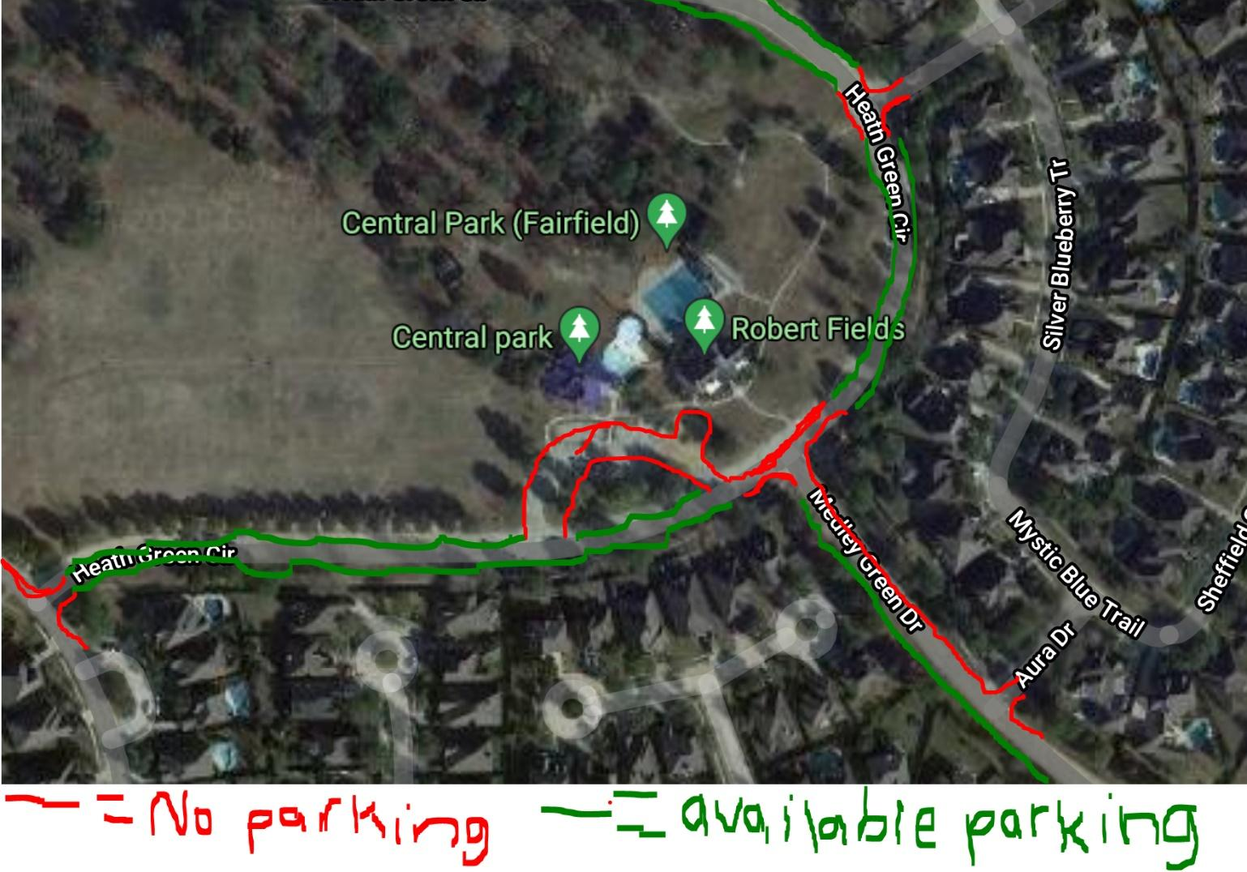
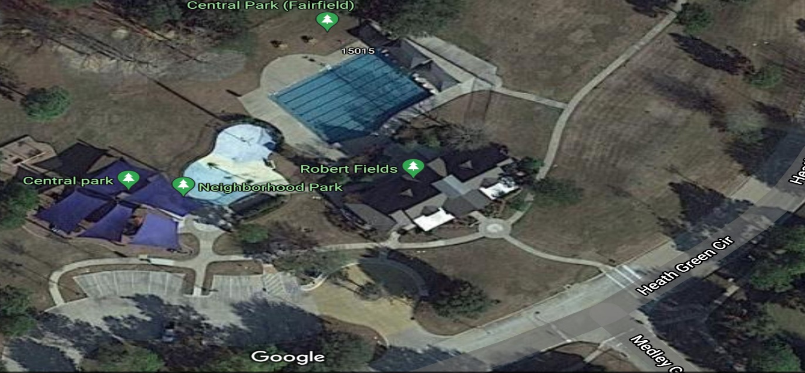

No Swimmers allowed on Playground.

Splash pad will be turned off.
Tent Set Up
Area
Construction Area
No swimmers or setup allowed
Ready Bench Area
Tent Set Up
Tent Set Up available
Age group Tents
FAST Parking Map
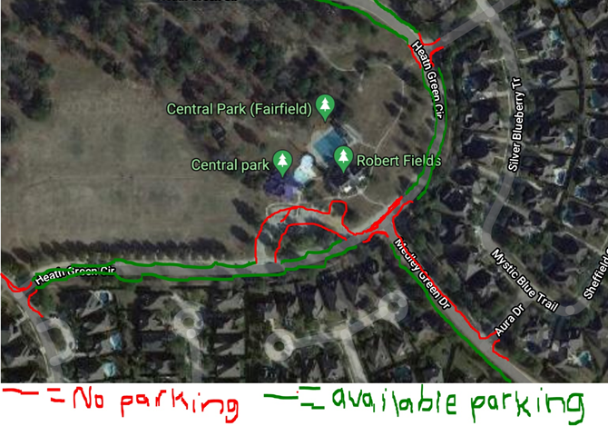
FAST Ready Bench Set Up & Restricted Areas
