2019 Divisional Swim Meet Planning & Execution Document

The purpose of this document is to ensure mutually agreed consensus between the teams regarding team assignments and responsibilities.

TABLE OF CONTENTS:

DATE AND LOCATION 2
PARTICIPATION 2
MEET PLANNING & EXECUTION 2
OFFICIALS 2
CLERK OF COURSE/ENTRIES/DATA EXCHANGE 3
SCRATCHES/SCRATCH MEETING 4
COMPUTER OPERATIONS 5
TIMERS/SCRIBES 6
AWARDS/RIBBON WRITERS AND MEDAL/TROPHY PROCESSING 6
READY BENCHES 7
TEAM REPS 8
CONCESSIONS 8
WATER FOR VOLUNTEERS 8
HEAT SHEET PRINTING/SALES 9
T-SHIRT DESIGN AND PRINTING 9
HOSPITALITY SUITE 9
ANNOUNCING SYSTEM/ANNOUNCERS 9
STARTER SYSTEMS 9
FIRST AID/EMS/LIFEGUARDS 10
SITE CLEAN-UP 10
WARM-UPS 11
FACILITY LOGISTICS 11
OTHER LOGISTICS 12
Attachment 1 – Officials & Official Positions Map To Be determined by Meet Ref 13
Attachment 2 – Computer Operations & Runners 14
Attachment 3 – Head Timers, Timers, Scribes, & Block Movers 15
Attachment 4 – Ribbon Writers, Place Medals and Heat Ribbons 16
Attachment 5 – Ready Bench 17
Attachment 6 – Concessions 18
Attachment 7 – Security/Access Control 19
Attachment 8 – Team Representatives 20
Attachment 9 – Team Summary 21
Attachment 10 – Facility/Pool Map/Parking 23
Attachment 11 – Notes to Share with your Team for Divisionals 24

DATE AND LOCATION

- DATE: Saturday, June 22, 2019

- PLACE: Klein Highschool

16715 Stuebner Airline Rd.
Klein, TX 77379

- TIME: 8:30

- FACILITY: Klein Highschool Natatorium- Please respect all posted rules and regulations.

PARTICIPATION

- TEAMS: All NWAL Division RED 3 Teams:

- Shenandoah (SHEN)
- Spring Cypress (SCST)
- Northpoint (NORP)
- Oak Ridge North (ORN)
- Windrose (WNDR)

- RULES: The Division RED 3 Divisional Swim Meet will be executed in compliance with all 2019 NWAL rules, along with mutually agreed divisional rules as documented herein.

MEET PLANNING & EXECUTION

- PLANNING COMMITTEE & LOGISTICS EXECUTION: The Meet Planning Committee is made up of the team’s Team Reps and the Divisional Meet Referee and is responsible for agreeing on the information in the Divisional Meet Planning and Execution Document, coordination of volunteers, scheduling all meetings and planning sessions prior to the Divisional Meet and ensuring the efficient operation of the Divisional Meet.

- SWIM MEET EXECUTION: The Divisional Meet Referee and the designated on-deck officials will be responsible for the actual meet officiating.

OFFICIALS

- DIVISIONAL MEET REFEREE – Chuck Shelton
- Phone: 832-613-5528
- E-mail: chuck_shelton21@yahoo.com

- DECK REFEREES & STARTERS: See Attachment 1 for assignments.

- OTHER ASSIGNMENTS: Each team is required to provide their list of Officials by June 15 which will be used by the Meet Referee to fill the assignment sheet shown in Attachment 1. The Divisional Meet Referee will adjust assignments on the day as needed.

- Deck Uniform: All Officials who will be working during the meet shall be wearing NWAL’s approved uniform white collared shirt over navy shorts, pants or skirt as appropriate.

- DUAL CONFIRMATION: All relays will require dual confirmation by the designated officials for disqualification.

- SWIMMER STARTS: The timers and scribes will change ends during of the meet since swimmers are able to start at both ends of the pool.

- OFFICIALS MEETING will be held at __8:00_ am, by the Divisional Meet Referee (hereinafter “meet referee”). All specific instructions and assignments will be made at this time. The Officials meeting will be held by the warm up pool.

- RADIOS: The Divisional Meet Referee will determine whether radios are to be used to report disqualifications. The use of radios does not relieve an official of the obligation to raise a hand to signify a disqualification at the appropriate time.
- OFFICIAL’S EVENT RESULT VERIFICATION: In the event a result is disputed by a team’s representative, the meet referee will have the final authority to resolve such matters according to 2019 NWAL rules.

CLERK OF COURSE/ENTRIES/DATA EXCHANGE

- HEAD CLERK OF COURSE: No Head clerk of course is required for the ready benches. The three (6) shift Ready Bench Movers will coordinate their duties. It is the responsibility of the Head Ready bench to promptly notify the Computer Operations of any changes.

- CARDLESS MEET: The meet will be conducted card-less, apart from relays, where cards will be used.

- LIMITED ENTRIES: A swimmer may be entered in no more than three (3) individual events and no more than two (2) relay events.

- RELAYS: Each team may enter only one (1) relay team for each relay event.

- ENTRY TIMES for the Divisional meets shall be official times (as designated in the NWAL rulebook ) obtained during an NWAL dual meet or sanctioned invitational meet. The seed time for relays shall be established by adding the fastest official times of the individual swimmers for the stroke they are swimming in the relay. Entries submitted with no times (N/T) or time from the practice meet will not be allowed.

- DIVISIONAL ELIGIBILITY: ALL swimmers MUST participate in two NWAL Certified Dual Meets to be eligible to take part in the Divisional meet. Swimmers must swim 25 yards in 1:30 or less to be entered.

- ACCURATE ENTRIES: Each team must only enter swimmers that they truly believe will be attending the divisional meet. This will avoid excessive scratches in the morning of the meet, however if you have a swimmer that “may attend” or is “unsure” it is better to enter them and then scratch them on the meet day if necessary. No “we had a change of plans” excuses will be allowed after the Divisional Meet Exchange, which includes the day of the meet. No adjustments will be made to allow a swimmer to change events after the Divisional Meet Exchange. Adjustments to relays do not constitute a change of events, however, a swimmer that is moved up age groups to fill an older age group relay shall scratch in accordance with the NWAL Rulebook.

- DIVISONAL EXCHANGE MEETING: Each Team’s head Computer Representative and Team Representative will meet at:

- The Divisional Operations Coordinator (Danielle Woody) will be present to accept entries from each team and will merge each team’s data at the meeting. After the entries are merged the meet will be seeded, and each team’s Clerk of Course or Team Rep will be provided with a copy of the merged data for the entire Divisional Swim Meet. A meet exception report will be run at that time and discrepancies resolved prior to finalizing the entries.

- Each team will be responsible for providing accurate meet entries from the online SwimTopia by bringing 5 copies and a pdf file of their teams Meet Entry Details showing proof of time to all other team reps at the exchange meeting at 6:30 on Wednesday June 19th. Please take time to verify these files as they are the official entry for each team.

- We will meet June 19th at Mary Pat Case Municipal Pool, Shenandoah at 6:30 for the exchange. The merge will take place at that time.

- Each team is to bring one ream of paper to the Divisional Exchange Meeting. One box of labels will also be provided by each team.

- GOVERNING ENTRIES: The PDF files are considered the official entry for each team and shall govern should any dispute arise.

SCRATCHES/SCRATCH MEETING

- All 2019 NWAL Scratch Meeting rules (section III-F) will be strictly enforced.

- PRE-MEET SCRATCHES: So as to avoid undue meet delays (i.e. trying to find absent swimmers), every effort must be made to be as accurate as possible with swimmer scratches. Each team is responsible for ascertaining why a swimmer has not checked in at the meet (i.e. are they arriving late, not coming, ill or at the meet already?). Scratches and early relay changes are DUE 45 minutes prior to the start of the meet.

- TEAM ROSTER: Each team’s Computer person will be provided with a team roster of their entered swimmers, on the morning of the meet, for their Computer person to make pre-meet scratches and also to mark swimmers that will arrive late/leave early. The team roster with scratches must be returned to the Divisional Operations Coordinator prior to the Scratch Meeting which will be held 45 minutes prior to the start of the morning meet on meet day in the Hospitality room. All swimmers entered in the meet but known to be not attending the meet will be scratched from their events. Please Remember: A scratched swimmer can be entered into the event again should they arrive at the meet and are on time for the their event except for relays in which a swimmer was moved up in age group at the Scratch Meeting. In this situation the Clerk of Course on duty or the designated team rep must immediately make the Computer Operations Coordinator aware of the swimmers arrival at the meet. Please review the clarified NWAL Scratch Rules (Section III-E prior to the morning of the scratch meeting to assure consistent application of the rules.

- MEET SCRATCHES/ARRIVALS: It is a team’s responsibility via the Head Coach or Team Rep ONLY to notify the Ready Bench supervisor AND Computer Operations Coordinator of scratches during the meet. Swimmers arriving late/leaving early will be scratched from individual events that they will miss.

- MEET ROSTER: The Ready Bench movers, will be provided with a full list of all swimmers entered in the meet “before scratches”. This will be a form of reference if a swimmer arrives at the ready benches to swim but is not on the ready bench event paperwork. Ready bench event paperwork will be printed throughout the day, this will allow for scratch updates to be performed before paperwork gets to the ready bench.

- SCRATCH BENCH: There will be no designated scratch bench. Swimmers will be allowed to swim if they can make it to the starting blocks “on time”. “On time” is defined in the 2019 NWAL rulebook (page 22) as, being at the starting blocks prior to the referee giving the clearance signal to the starter. (Note: Can’t find on page 22 or through scanning other sections of rule book.)

COMPUTER OPERATIONS

- COMPUTER OPERATIONS COORINDATOR will be Mike McLeod. The responsibilities of the Computer Operations Coordinator are to verify and oversee the scoring of the meet and provide paperwork to the Referee, Starter, Ready Benches and Scribes.
- Phone: 936-718-5597
- Assisted by Joe Shueder
- LOCATION: Computer and printing operations will be set up in the computer room.

- COMPUTERS: Each team is responsible for providing a computer, and an experienced NWAL certified computer person. Some computers will be used during the meet to process results and paperwork as needed. One (1) will be used to create paperwork. Three (3) will be used to process results. The others will be spares in case of problems. Only individuals who are NWAL certified for computer will be allowed to interact with the computers. Please bring your certificate

- PRINTERS with a spare ink cartridge, printer cables and printer driver CDs will be provided by:

  - SCST
  - SHEN
  - WNDR

Each team is encouraged to bring their printer, if it is portable. All teams will bring their surge protectors.

- EVENT RESULT CIRCLING & VERFICATION: Non-computer volunteers will be need to verify event times. Duties include:
- Circle the median time from the scribe result sheets
- Verify that the computer times match the scribe sheet times
- Verifiers must also check to make sure entered DQs match the DQ on the scribe sheet

- COMPUTER RESULT PROCESSING: Experienced NWAL certified computer volunteer will be needed to enter results. Duties include:
- Result data entry into computer
- Printing of results for Volunteer and NWAL Official verification (using the referee order of finish paperwork)
- We will enter all three times from scribe sheet
- We will enter all times, even in the case of DQ

- SCORING for each event will follow the 5-team scoring regulations found in the 2018 NWAL rules book. The scoring for a 5-team meet is Individual Events: 14-12-10-9-8-7-6-5-4-3-2-1 (1st through 12th place respectively). 5 Team Divisional Relays: 14-10-7-5-3 for all events.

- COMPUTER PAPERWORK PROCESSING duties will be provided by/coordinated by the Computer Operations Coordinator. Duties include:
- Entering scratches
- Reseeding Events
- Printing Referee, Starter, Ready Bench and Scribe’s paperwork
- Printing of labels for award medals and ribbons

- ASSIGNMENTS for computer volunteers and runners are shown in Attachment 2.

- TABLES AND CHAIRS will be available in the designated computer area for computer work.

TIMERS/SCRIBES

- MEET HEAD TIMER: No Meet Head Timer is required. There will be two (2) Head Timers per shift. One will cover lanes 1 thru 4, while the other will cover lanes 5 thru 8. The Head Timers will coordinate their duties. Assignments are shown in Attachment 3.

- HEAD TIMER DUTIES: The Head Timers will coordinate with the Meet and Deck Referee and also provide spare watches to all on-deck timers.

- ASSIGNMENTS: Multiple timers and one scribe are needed from each team for each of three (3) shifts. Volunteer schedules including shift and lane assignments are shown in Attachment 3.

- TIMER & SCRIBE MEETING: The Timers & Scribes meeting will be held at 8:15 am, by the Meet Ref. All specific instructions and assignments will be made at this time. This meeting will be held in the pool area.

- SCRIBE CHAIRS: Eight (8) scribe chairs will be provided by SCST and set up at the deep end of the pool.

- STOP WATCHES: SHEN & ORN will provide timers for the meet. Spare stop watches for the meet will be kept in a box (supplied by NORP ) by the Head Timer area and are to be used if any Timer has a problem with their own stop watch. Please ensure all stop watches are labeled with the team name to ensure that they can be returned to the correct team at the end of the meet. It will be the responsibility of each team’s Head Timer to collect their own watches at the end of the meet.

- SCRIBE BOARDS: ORN will provide eight scribe boards each (for a total of 8 scribe board) for the meet .

AWARDS/RIBBON WRITERS AND MEDAL/TROPHY PROCESSING

- ORDERING AWARDS: SHEN will be responsible for ordering and providing the meet medals, ribbons and trophies.

- INDIVIDUAL EVENT AWARDS will be 1st through 12 places. 1st through 8th place will be awarded medals. 9th through 12th will be awarded ribbons.

- RELAY AWARDS will be 1st through 3rd place will be awarded medals and 4th through 5th place will be awarded ribbons. Each individual relay member will be awarded a medal or ribbon.

- TEAM PLACEMENT AWARDS: Team trophies will be awarded for order of placement at the Divisional Meet for 5 teams.

- HEAD RIBBON WRITER: 2nd shift Lisa Swanner 3rd shift Lisa Swanner will be responsible organizing the event place medal and ribbon writers.

- ASSIGNMENTS: Each team will provide volunteers for ribbon. Volunteer assignments and schedules for medals/ribbon writers are shown in Attachment 4. The medal/ribbons writers will be located in the computer room.

- RIBBON LABELS: Computer Operations will print labels for use on award ribbons and medals. Labels will be printed after events are verified. Labels will be printed after event 18, event 42, event 70 and at the end of the meet.

- AWARD COLLECTION: Team Reps are responsible for collecting medals and ribbons at the end of the meet and must sign for their receipt.

- AWARD BOX: Each team will provide a box/container to take the medals and the place ribbons away after the meet.

- AWARDS CEREMONY: An Awards ceremony, to present the team trophies, will be held at the announcer’s tables as soon as the final results are known. Each team must have a Team Rep, Coach or Board Member available to accept the trophy.

READY BENCHES

- HEAD READY BENCH: ORN

- READY BENCH POSITIONS: The Ready Bench will require five volunteer (5) people per shift:
- Corral Checker: One (1) person to check-in swimmers as they arrive at the ready benches. This person will run to the announcer/radio the announcer if swimmers are missing from team X for event Y. Individual swimmer names WILL NOT be announced if they are missing from the ready bench area.
- Name Caller: One (1) person to call out the swimmer’s name and lane number at the front of the corrals, give the swimmer their heat/lane card and show them where to sit.
- Bench Control: One (1) person to help keep the swimmers in order on the benches.
- Move to Seats: Two (2) people to move the swimmers from the benches to the chairs and to help keep the swimmers in order at the chairs. They will take the swimmers heat/lane card off them and restack these ready for reuse.

- ASSIGNMENTS: Ready Bench volunteer schedules are shown in Attachment 5.

- SEATING CARDS: ORN will supply colored and numbered cards to be used for seating the younger swimmers and helping to keep them in the correct heat and lane while moving between ready benches/chairs.

- Cones: Small cones will be used to identify open lanes. 8 kick boards will be provided by SHEN.

- READY BENCH TABLE: SCST to be used for receiving new paperwork and managing the seating cards etc.

- READY BENCH: Ready bench will be located In hall way that goes into poll area.
- 9 Benches will be provided by PACK.
- 16 Chairs each to be provided by SCST for 2 row seating behind blocks on deep end of pool.
- Staging corrals will be provided by everyone who has cones or some sort of rope holder. (I don’t think this was needed last year)

- TIMELY APPEARANCE: Each team is responsible for getting their swimmers to the correct ready bench area on time.

- BULL HORNS: While announcement speakers will be provided for each team area, it often is difficult for some people to hear the announcements. If your team cannot hear the announcements then each team must find someone to relay the events being called by the announcer to their team area. Each team must find volunteers and bring their own bull-horn/load speaker for this purpose.

- TEAM CORRAL AREAS will be provided at each ready bench area to aid the seating of swimmers at the ready benches.

- SWIMMER ORDER: To aid the processing of swimmers in the ready bench area, each team should bring their swimmers into the corral area with the slowest swimmers at the front of the line and the fastest swimmers at the back of the line. This order can be found in the psych sheets. Each team is responsible for printing psych sheets for their team prior to the meet.

- READY BENCH MEETING: A Ready Bench meeting for volunteers and Clerks of Course will be held at 8:15. This meeting will be held at the ready bench area in the commons by ORN

TEAM REPS

- MEET DAY TEAM REPS are listed in Attachment 7.

- DUTIES: To calmly discuss a parent, swimmer or coach issue, regarding a race, with the Divisional Meet Referee.

- ELIGIBILITY: The Meet Day Team Reps must be available at all times during the meet. If the team reap is an Official, they must have a backup representative while they are officiating. Each Team is responsible for nominating their Meet Day Team Rep ahead of time and also for providing a backup Team Rep should the first be unavailable. Team Reps and their back-ups should knowledgeable of the NWAL rules and regulations. Each team is responsible for ensuring that their own parents know who the Team Rep and back-up person is.

CONCESSIONS

- HEAD CONCESSIONS will be Food Trucks

- CONCESSIONS will be provided by FOOD TRUCKS ONLY for the swim meet. Concessions will be located outside back door of commons area. See Attachment 9 for location of concessions.

- MENU: A description of the planned concession offerings is provided in Attachment 6.

- SALES: No Sales will be made by the division. Food Trucks donating food for hospitality and will keep all profits made.

- COSTS: All costs associated with the purchase of food will be incurred by food trucks

WATER FOR VOLUNTEERS

- WATER: Each team will provide 100 bottles of 16.9 oz. water, stored in marked coolers with ice.

- LOCATION: One cooler will be located at each end of the pool to be used as needed by on-duty volunteers throughout the meet. The other 3 coolers will be in the hospitality room.

HEAT SHEETS

- Heat sheets will be provided by each team in which ever fashion they desire (printed/email) .
- If a team decides to sell heat sheets to their team they may do that prior to the meet

T-SHIRT DESIGN AND PRINTING

- T-SHIRT PRINTING will be done by TMB Screen Printing – Phone: 281-477-6909
- PRICE: Pre-meet Sales of T-shirt only for $15
- SALES: Proceeds from the sales of the T-Shirts will go to All Teams.

HOSPITALITY SUITE

- HOSPITALITY SUITE will be organized by SHEN. This will take the place of teams providing lunch tickets. The food trucks will provide sandwich trays to hospitality. SHEN will provide chips, snacks, etc. Each team will provide at least 24 sodas for hospitality. Each Team will provide one volunteer to replenish Hospitality trays and such though out the day.
- RESTRICTED ACCESS: Hospitality Suite is to provide refreshments to the NWAL Officials, Coaches, Team Reps, Clerks of Course and Computer volunteers. All other volunteers are kindly asked to respect this restriction.

- COST: Each team will contribute $50 to SHEN to go towards chips, snacks, etc.

- LOCATION: The hospitality suite will be in the designated room located on the pool deck. See Attachment 9 for its location.

ANNOUNCING SYSTEM/ANNOUNCERS

- SOUND SYSTEM #1: ORN will be responsible for the set-up of the speakers, microphone(s) and sound system at the Commons

- Back up SOUND SYSTEM: WNDR will bring in case something happens to other sound system.

- ANNOUNCER

  - ORN

  - WNDR

- THE NATIONAL ANTHEM will be played at the beginning of the Divisional Swim Meet recording to be provided by ORN.

STARTER SYSTEMS

- PRIMARY STARTER SYSTEM: WNDR will provide the primary starting system.

- BACKUP STARTER SYSTEM: SCST will bring their backup starter system as a backup and ensure that the starter systems are adequately charged prior to the meet day.

- EXTERNAL SPEAKER: SCST will provide one additional external speaker for use at the opposite end of the pool from the starter.

FIRST AID/EMS/LIFEGUARDS – Provided by ORN

- FIRST AID: A basic first aid kit will be provided by SCST, and will be available at the first aid table during the entire meet. See Attachment 10 for the location of the first aid table.

- LIFEGUARDS will not be needed.

SITE CLEAN-UP

- TEAM AREAS: Each Team will be responsible for the site clean-up of their own team’s set-up area.

- COMMON AREAS: Each Team is responsible for providing volunteers to assist with site clean-up of the common areas such as the pool area, walkways and parking areas.

- TRASH BINS/COLLECTION: H.S. Custodial staff will monitor and empty trash bins as needed.

Rugs and Runners

- SCST to provide runners for hallway to keep safe from slipping.

- ORN to provide 40 - 3’x10’ rugs for same purpose.
- WARM-UPS

- WARM UP SHIFTS: Team warm-ups will be done in 3 shifts according to the following schedule:

Group 1 | Lanes | Start | End
NORP | 1-8 | 6:45 | 7:05
Group 2 | Lanes | Start | End
SHEN | 1-4 | 7:05 | 7:35
WNDR | 5-8 | 7:05 | 7:35
Group 3 | Lanes | Start | End
ORN | 1-4 | 7:35 | 8:10
SCST | 5-8 | 7:35 | 8:10

FACILITY LOGISTICS

- POOL: The Klein Highschool pool is comprised of a 25 Yard, 8-lane pool. A rough outline of the pool is shown Attachment 10.

- POOL AREA ACCESS: The Pool area can be accessed by NWAL Certified Officials, volunteers, or timers and scribes for their shift only. Swimmers will enter through the door closest to lane 8 and exit through the door on opposite side when they are finished.

- BATHROOMS are available in both hallways leading to pool area.

OTHER LOGISTICS

- SET-UP AREAS: Teams will mutually agree for team set-up areas. See Attachment 10 for facility layout. Teams will determine the location of their set-up at the Friday pre-meet set-up. If markings are needed, markings will be made by painters tape only, NO Masking Tape Allowed. ONLY BLUE PAINTERS TAPE. Tape will be applied before the meet, except for in the gym.

- FRIDAY NIGHT SET-UP: Each team may set-up between 4pm and 6pm on June 21 .

- MAP/DIRECTIONS to Klein HS can be found in Attachment 10.

- MARKED DROP OFF ZONES & PARKING SIGNS will not be employed as there is sufficient signage and parking adjacent to natatorium entrances.

- COACHES AREAS: The coaches’ areas will be set up by Draw for the inner side of the pool. The Draw will occur at Exchange Meeting on Wednesday June 19th. The window side is first come, first serve.

- COACHING: Each team is responsible for reminding the parents and coaches that they are only spectators at the Divisional Meet. No coaching is allowed from the ends of the pool.

- CODE OF CONDUCT: Each team is responsible for reminding all team meet attendees (parents, swimmers, coaches, officials, etc..) that should they have an issue with regards to a race that calm and restraint must be observed at all times, as per the NWAL Code of Conduct. Additionally, such issues must be directed to their Team Rep and NOT to an official or volunteer. It is the Team Rep’s responsibility to then discuss the issue, calmly, with the Divisional Meet Referee. The Divisional Meet Referee’s ruling is final.

- SPECTATORS: Please do not “camp-out” on the bleachers but watch your swimmer’s race and then leave allowing other parents to view their swimmer’s race.

- NO CHAIRS IN THE POOL AREA: Parents are not allowed to bring chairs inside the pool area.

- MEET DAY SECURITY: Klein HS will have a security officer on the premises.

- ROPED OFF AREAS: All Teams will provide painters tape; All Teams rope, rope buckets, or other devices as appropriate to indicate walkways, official’s areas, coach’s areas, team staging areas, swimmer and audience movement routes, etc.

- ON-DECK AREA: A 5-foot walkway will be provided around the entire perimeter of the pool/diving area for the use of the officials, timers, scribes, runners, etc… Each team is responsible for ensuring that all Swimmers and Coaches are made aware of this area and police this area to ensure the efficient running of the meet.

- ON DECK ACCESS: Volunteers on duty only will be allowed on deck

- TEAM SUMMARY: A summary of what each team is to provide is include in Attachment 9.

Attachment 1 – Officials & Official Positions Map To Be determined by Meet Ref

Each team should submit to the Meet Ref a list of their officials available for Divisionals. Each team should submit the following:

Official Name | Team | Position | Years | Proficiency | Comments

The Meet Ref will develop an Officials Position Map once this information is supplied for the following Shifts.

First Shift – Events 1 through 30

Team | Deck Referee | Starter | Finish Judge  (Referee) | Stroke & Turn | Stroke & Turn | Turn Official/Writer | Take off Official

Second Shift – Events 31 – 50

Team | Deck Referee | Starter | Finish Judge  (Referee) | Stroke & Turn | Stroke & Turn | Turn Official/Writer

Third Shift – Events 51 – 80p
Team | Deck Referee | Starter | Finish Judge  (Referee) | Stroke & Turn | Stroke & Turn (Referee) | Turn Official/Writer | Take off Official

OFFICIAL RESPONSIBILITIES: It is the responsibility of the in-shift person to not leave until their replacement arrives. It is the responsibility of the leaving-shift person to ensure that the new-shift person understands their duties.

Attachment 2 – Computer Operations & Runners

It is the responsibility of the in-shift person to not leave until their replacement arrives. It is the responsibility of the leaving-shift person to ensure that the new-shift person understands their duties.

First Shift – Events 1 through 30

Team | Paperwork Runner | Result Circling & Verification | Computer Results Entry
NORP
ORN
SHEN
SCST
WNDR

Second Shift – Events 31 – 50

Team | Deliver Paperwork Runner | Result Circling & Verification | Computer Results Entry
NORP
ORN
SHEN
SCST
WNDR

Third Shift – Events 51 – 80

Team | Deliver Paperwork Runner | Result Circling & Verification | Computer Results Entry
NORP
ORN
SHEN
SCST
WNDR

Attachment 3 – Head Timers, Timers, Scribes, & Block Movers

Head Timers (HT), Timers (T)* and Scribes (S) are scheduled in 3 shifts as shown below.

It is the responsibility of the in-shift person to not leave until their replacement arrives. It is the responsibility of the leaving-shift person to ensure that the new-shift person understands their duties.

First Shift – Events 1 through 30

Team | Lane 1 | Lane 2 | Lane 3 | Lane 4 | Lane 5 | Lane 6 | Lane 7 | Lane 8 | Head Timer
NORP | S |  | T | T | T | T |  | T | HT
ORN | T | S |  | T | T |  | T | S
SHEN | T | T | S |  | T | T | S | T
SCST | T | T | T | S |  | S | T
WNDR |  | T | T | T | S | T | T | T | HT

Second Shift – Events 31 – 50

Team | Lane 1 | Lane 2 | Lane 3 | Lane 4 | Lane 5 | Lane 6 | Lane 7 | Lane 8 | Head Timer
NORP | T | T | T | T | T | T |  | S
ORN | S |  | T | T | T |  | S | T | HT
SHEN | T | S |  | T |  | S | T | T
SCST | T | T | S |  | S | T | T | T | HT
WNDR |  | T | T | S | T | T | T

Third Shift – Events 51 – 80

Team | Lane 1 | Lane 2 | Lane 3 | Lane 4 | Lane 5 | Lane 6 | Lane 7 | Lane 8 | Head Timer
NORP | T | T |  | T |  | T | S | T
ORN | T | T | T |  | T | S | T | S
SHEN | S |  | T | T | S |  | T | T | HT
SCST |  | S | T | S | T | T | T
WNDR | T | T | S | T | T | T |  | T | HT

*Each team is to provide (1) additional relief timer / scribe as needed for each shift.

Attachment 4 – Ribbon Writers, Place Medals and Heat Ribbons

It is the responsibility of the in-shift person to not leave until their replacement arrives. It is the responsibility of the leaving-shift person to ensure that the new-shift person understands their duties.

First Shift – Events 1 through 30

Team | Award Ribbon and Medal Writers
No first shift

Second Shift – Events 31 – 50

Team | Award Ribbon and Medal Writers
NORP | 1
ORN | 1
SHEN | 1
SCST | 1
WNDR | 1

Third Shift – Events 51 – 80

Team | Award Ribbon and Medal Writers
NORP | 1
ORN | 1
SHEN | 1
SCST | 1
WNDR | 1

Attachment 5 – Ready Bench

It is the responsibility of the in-shift person to not leave until their replacement arrives. It is the responsibility of the leaving-shift person to ensure that the new-shift person understands their duties.

First Shift – Events 1 through 30

Team | Corral Checker | Name Caller | Bench Control | Move to Seats  Lanes 1,2,3,4 | Move to Seats  Lanes 5,6,7,8
NORP | 1
ORN |  | 1
SHEN |  |  | 1
SCST |  |  |  | 1
WNDR |  |  |  |  | 1

Second Shift – Events 31 – 50

Team | Corral Checker | Name Caller | Bench Control | Move to Seats  Lanes 1,2,3,4 | Move to Seats  Lanes 5,6,7,8
NORP |  |  |  |  | 1
ORN | 1
SHEN |  |  |  | 1
SCST |  |  | 1
WNDR |  | 1

Third Shift – Events 51 – 80

Team | Corral Checker | Name Caller | Bench Control | Move to Seats  Lanes 1,2,3,4 | Move to Seats  Lanes 5,6,7,8
NORP |  |  | 1
ORN |  | 1
SHEN |  |  |  | 1
SCST | 1
WNDR |  |  |  |  | 1

Attachment 6 – Concessions

No concession stand will be used. We have the following food trucks to provide meals during the meet.

Curbside Grillerz - CHEFAGARCIA2@YAHOO.COM - 832-250-9024

GooRoos Wood Fire Pizza – 903-536-3047 – To provide Breakfast and Lunch

KAOW Kajun Asian on Wheels – Ann Dick – 281-948-3668

Wylie St Tacos – Mary Gutierrez – 832-495-3047

Tiki Shaved Iced

Families need to be aware of this so they may bring drinks, snacks, ect.

Menus attached below and should be sent to families after exchange along with heat sheets

Handcrafted pizza cooked in a brick oven with only the freshest ingredients.
Pizza dough is made daily, and fermented for 24-36 hours, for less gluten.
All Pizzas are a 10-inch pie and will feed 2 people.

Breakfast Menu ( Not served after 11)
Breakfast Sand-which- Fried egg with bacon and cheese placed on a toasted bun. $3
Breakfast Pizza- choice of breakfast sausage or bacon, 3 fried eggs with mushrooms, onions, and spinach. $10

Pizzas
Pesto Chicken – Basil Pesto sauce, fresh organic spinach, seasoned chicken, fresh mushrooms and fresh mozzarella. $12
Greek Pizza – Homemade white sauce, feta cheese, fresh organic spinach, sweet red onions, Kalamata olives, sun dried tomatoes, topped with EVOO. $12
Muffuletta – Olive salad, shredded mozzarella/provolone cheese blend, Genoa Salami, Italian Mortadella, Capicola, topped with pepperoncini. $12
Chicken Feta – Homemade white sauce, feta cheese, seasoned chicken, sweet red onions drizzled with balsamic glaze. $12
Hungry Man – Fresh Pizza sauce, shredded mozzarella/ provolone cheese blend, Capicola (Italian ham), pepperoni, and crumbled Italian sausage. $12
Pizza Margherita – Pizza sauce, fresh mozzarella, and fresh basil. $11
Pepperoni pizza $11
Cheese $10

Keto Friendly Menu:
Strawberry & Pecan Salad - Autumn Harvest Salad with feta cheese, strawberries and pecans with balsamic vinaigrette dressing. $7

Mobster Meatballs - Made with ground beef, Italian sausage, onion powder, and minced garlic. Topped with melted mozzarella cheese and fresh basil. $9

Italian Sweets
Choice of Tiramisu (Coffee-flavored Italian dessert), or Chocolate Mousse Cup. $3.50

Beverages:
Bottle Soda, $2 Bottle water $1, Fresh Brewed Tea (Sweet or Unsweet) & Fresh Squeezed Lemonade.
24 oz $2 32 oz $3

Attachment 7 – Security/Access Control

It is the responsibility of the in-shift person to not leave until their replacement arrives. It is the responsibility of the leaving-shift person to ensure that the new-shift person understands their duties.

First Shift – Events1 through 30

Team | Stands Patrol | Pool Access
NORP | 1
ORN
SHEN |  | 1
SCST
WNDR | 1

Second Shift – Events 31 - 50
Team | Stands Patrol | Pool Access
NORP
ORN |  | 1
SHEN | 1
SCST | 1
WNDR

Third Shift – Events 51 – 80
Team | Stands Patrol | Pool Access
NORP |  | 1
ORN
SHEN
SCST | 1
WNDR | 1

1 per shift 1 for pool entrance access and 2 for stands patrol to assure no set-up or coolers in the stands. 1 during am warmup to control pool access/egress at Pool Entrance, wet swimmers must exit far side of the pool NO PARENTS ON DECK during warm up.

Attachment 8 – Team Representatives

Oak Ridge North
Name: Misty Millwee
Phone: 281-748-7217
Email: mistymillwee@yahoo.com

Back-Up:

Spring Cypress
Name: Jason Mangold
Phone: 281-928-5946
Email: jasonmangold@hotmail.com

Back-Up:

North Point
Name: Tawnya Burch
Phone: 281-685-7724
Email: ctawnya@aol.com
Back-Up: Nicole Devens – 713-409-1200

Windrose
Name: Brian Horak
Phone: 281-794-6941
Email: brian.horak@gmail.com

Back-Up:

Shenandoah
Name: Lisa Worthman
Phone: 832-326-3520
Email: lisaworthman15@gmail.com

Back-Up: Danielle Woody 281-451-9443

Attachment 9 – Team Summary

Items needed at the Divisional Exchange Meeting from Each Team:
- Experienced Computer Person-
- Clerk of Course (optional)-
- Team Rep-
- Computer with Meet & Team database
- Thumb/USB drive with meet entries
- One paper copy of: Team Manager meet entries report “by name” including “proof of times”
- One paper copy of: Team Manager “meets attended” since 13th May 2017
- Six paper copies of: Coach’s “entry paperwork”
- One ream of paper
- One box of Avery 1 x 2 5/8 “ ribbon labels

Items needed for the Divisional meet from Each Team:
- Computer with Team database
- One (1) box/container, to take medals/place ribbons away from meet
- 100 bottles of 16.7oz. water in iced down coolers
- Surge Protectors
- Pre-sold Divisional T-Shirts (if not already distributed)
- Painters tape for marking of team areas in commons.
- Sodas for hospitality (24ct)

Items needed for the Divisional meet from designated teams:
- Tables and/or Chairs for:
  - Ribbons writers (2 long tables, one short table, 3 chairs)—_SHEN_
  - Announcer (1 short table, 1 chair)—_SHEN__
  - First Aid (1 long table, 2-3 chairs)—_SCST__
  - On-deck Chairs (16 chairs each for swimmers)—_SCST_
  - Scribe Chairs(8 chairs each)—_SCST_
- Scribe Boards 8 — NORP
- Painter’s Tape—_All Teams
- Ropes, Robe Buckets, or other devises to indicate walkways All Teams
- Printers, spare ink cartridge, printer cables, and printer driver CD’s—SHEN
- Stop Watches—_SHEN/ORN___
- Back up Starter System—_SCST_
- First Aid Kit—_SCST__
- External Speaker—_SCST__
- Hospitality Suite refreshments—_SHEN__
- Sound System—_ORN & WNDR__
- Team Trophies—_SCST_
- Medals & place ribbons—_SHEN_
- Event BOARD—_ALL TEAMS__
- Cones for blocks—__SHEN____

People/Roles for the Entire Divisional Meet
- Computer Operations Coordinator—Danielle Woody
- Announcer—Oak Ridge/Windrose
- Meet Referee— Chuck Shelton
- Team Reps—Each Team
People Required by Team by Shift for the Divisional Meet
1 warm up security per team during their warm up

TEAM | Shift 1 | Shift 2 | Shift 3
NORP | 1 Result Circling & Verification  1 Corral Checker  1 Scribe  5 Timers  1 Head Timer  1 Stands Patrol  1 hospitality helper (all day or 3 shifts) | 1 Runner  1 Scribe  6 Timers  1 Ribbon Writer  1 Move to Seats 5 to 8 | 1 Result Circling & Verification  1 Scribes  5 Timers  1 Ribbon Writer  1 Bench Control  1 Pool Access Patrol  2 Team Clean up Area
ORN | 1 Computer Results Entry  2 Scribe  4 Timers  1 Name Caller  1 Announcer thru Event 40  1 Head Ready bench  1 hospitality helper (all day or 3 shifts) | 1 Comp. Result Entry  2 Scribe  4 Timers,  1 Head Timer  1 Ribbon Writer  1 Corral Checker  1 Pool Access | 1 Computer Results Entry  2 Scribes  5 Timers  1 Ribbon Writer  1 Name Caller  2 Team Clean up Area
SHEN | 1 Head Computer  1 Computer Results Entry  2 Scribe  5 Timers  1 Bench Control  1 Pool Access Patrol  1 hospitality helper (all day or 3 shifts) | 1 Computer Results Entry  2 Scribe  4 Timers  1 Head Ribbon Writer  1 Move to Seats lanes 1 to 4  1 Stands Patrol | 1 Comp. Results Entry  2 Scribes  4 Timers  1 Head Timer  1 Head Ribbon Writer  1 Move to Seats 1 to 4  2 Team Clean up Area
SCST | 1 Result Circling & Verification  2 Scribes  4 Timers  1 Moves to Seats 1 to 4  1 hospitality helper (all day or 3 shifts) | 1 Results Circling & Verify  2 Scribe  5 Timers  1 Head Timer  1 Ribbon Writer  1 Bench Control  1 Stands Patrol | 1 Runner  2 Scribes  4 Timers  1 Ribbon Writer  1 Corral Checker  1 Stands Patrol  2 Team Clean up Area
WNDR | 1 Runner  1 Scribes  6 Timers  1 Head Timer  1 Move to Seats lanes 5 to 8  1 Stands Patrol  1 hospitality helper (all day or 3 shifts) | 1 Result Circling & Verification  1 Scribe  5 Timers  1 Ribbon Writer  1 Name Caller  1 Announcer start Event 41 thru end | 1 Result Circling & Verification  1 Scribes  6 Timers  1 Ribbon Writer  1 Move to Seats lanes 5 to 8  2 Team Clean up Area  1 Head Timer  1 Stands Patrol

Attachment 10 – Facility/Pool Map/Parking

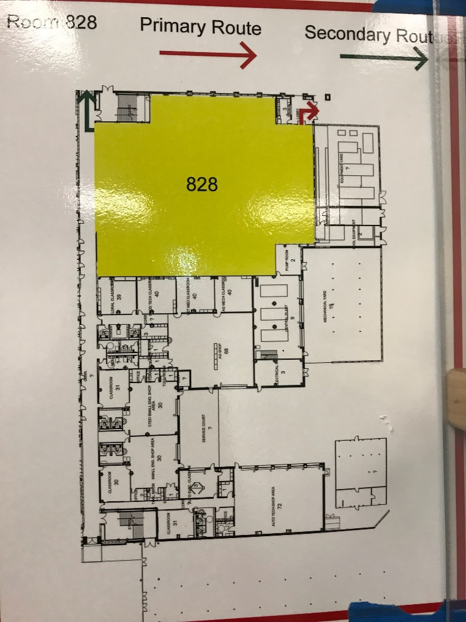
NOTE: Parking is off of Lyons School Rd. No Drop zone for swimmers. Front doors of school to remained locked.

Directions: 16715 Stuebner Airline Rd, Klein, TX 77379

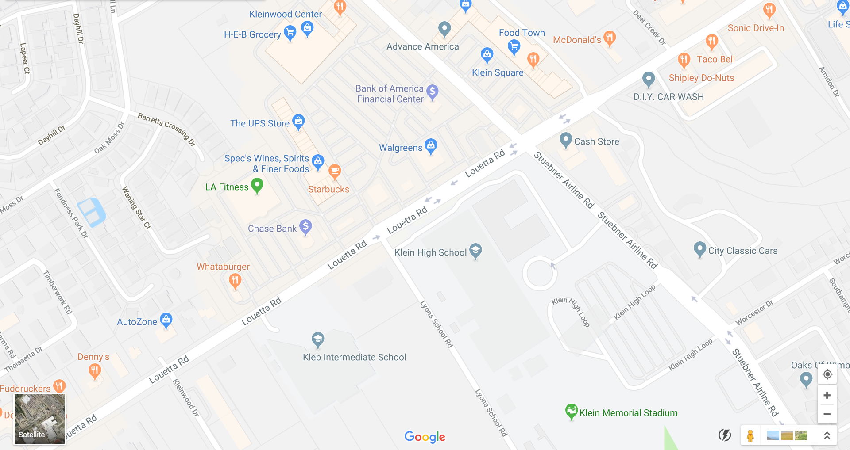

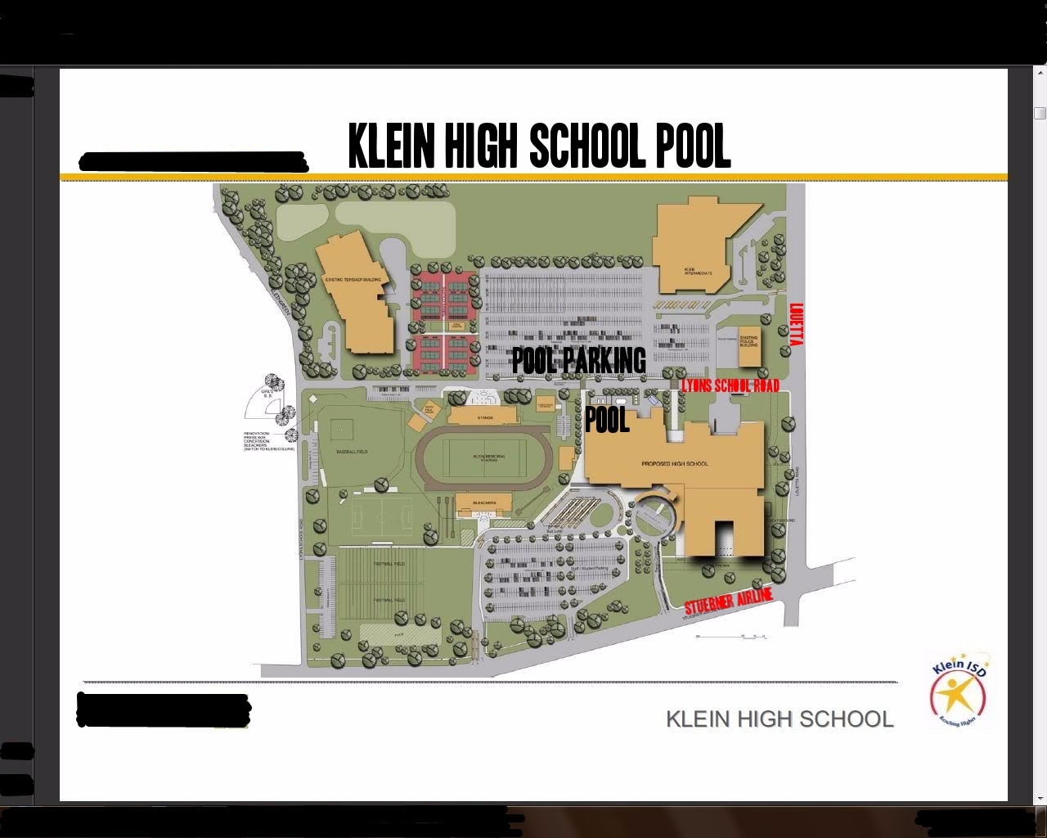

Attachment 11 – Notes to Share with your Team for 2019 Divisionals

- No setup in the stands.
- No standing at the balcony rail.
- Coolers are not permitted in the stands.
- Only authorized swimmers and personnel allowed on deck.
- No tents allowed inside the building.
- Heat sheets are available at the Concession Stand $5.00 each.
- If swimmer is late, report to team rep/coach immediately so swimmer can be seeded in the meet appropriately.
- Please report to you Volunteer positions promptly.
- Please do not leave your Volunteer position until your replacement arrives and you have shared duty information.
- Please know who your Team Rep is and their alternates.
- Refer any protests to the Team Rep or designee.
- Please keep team areas clean and aisle ways clear.
- First Aid will be at the first aid table just outside the pool entrance.
- No parents on deck during warm-ups
- Swimmer exit on far side of pool and reenter at hallway glass doors near concessions.

