Greater Peninsula Swimming Association



SwimTopia Guidelines

Table of Contents
Table of Contents 2
People 4
Swimmer / Parent Account Deletion 4
Roles 4
League Shared Roles 4
Registration 5
Team Waiver 5
GPSA Code of Conduct and City Meet Waiver 7
Payment 7
Schedule 8
Meet Schedule 8
Meet Templates 8
Job Templates 8
Creating Record Books 10
Importing City Meet Qualifying Times 10
Team Website 10
Meet Setup 11
Swimmer Entries 14
Point Swimmers 14
Declare Exhibition Swimmers 15
Swimming a Swimmer “Up” 16
Bonus Entry for Small Teams 16
Building a Relay Team 16
Entries Matrix 17
Color Indicators 17
Other Indicators 17
Entry Reports 19
Meet Entries by Athlete 19
Meet Entries by Event 19
Merge Entries 20
Various Pool Configurations 22
Adding Record Book and Qualifying Times to the Meet 23
Creating Heat Sheets 25
Running the Meet 26
Keeping the Score Blind 26
Manual Timing System 28
Semi-Automatic Timing System 28
Meet Ref Role 28
Starter Role 28
Timer Role 29
Stroke and Turn Role 29
Sweep Judge Role 29
Runner Role 29
Scorekeeper Role 30
Ribbon Writer / Labeler 33
Flow of an Event 35
Export Meet Results to Teams Repository 36

People
Managing Your People/Roster – SwimTopia Help Center

Swimmer / Parent Account Deletion
If a swimmer leaves your pool, you will need to email to help@swimtopia.com asking they remove the team association with the necessary email accounts.

Roles
The main purpose of Roles is to allow for efficient communication to groups of people and to manage access within the Manage Team area based on permissions. Any parent or athlete on your team can be assigned to a role, so that you can group the people on your team, from assigning meet jobs to sending group emails. (Defining Roles)

League Shared Roles
Some roles are created and shared from the League level. This allows league administrators to also be able to send targeted communications to each group if required. While the name of these roles cannot be changed, the other attributes can be modified locally in your team site.
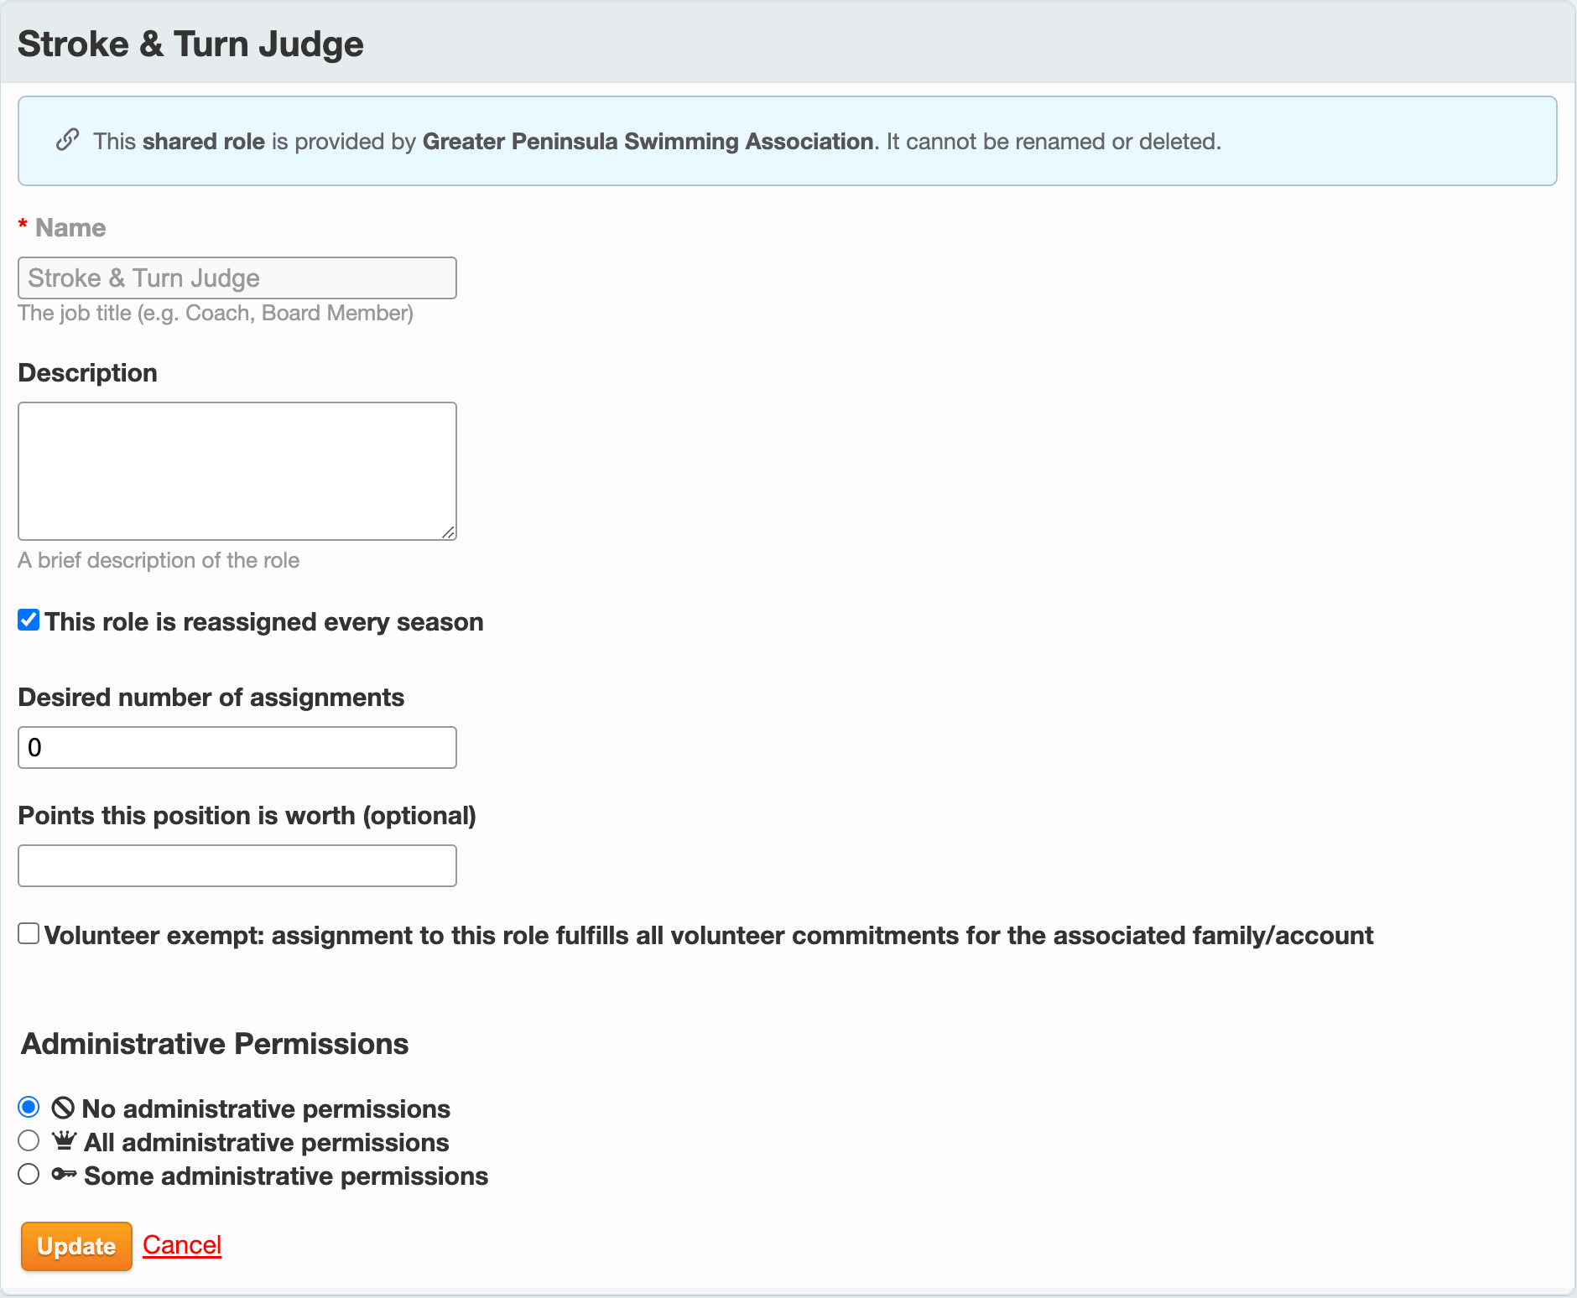

Registration
Registration – SwimTopia Help Center

Team Waiver
Click on the Registration header. Select your team registration form (i.e. ‘2022 RMMR Swim Team Registration’).

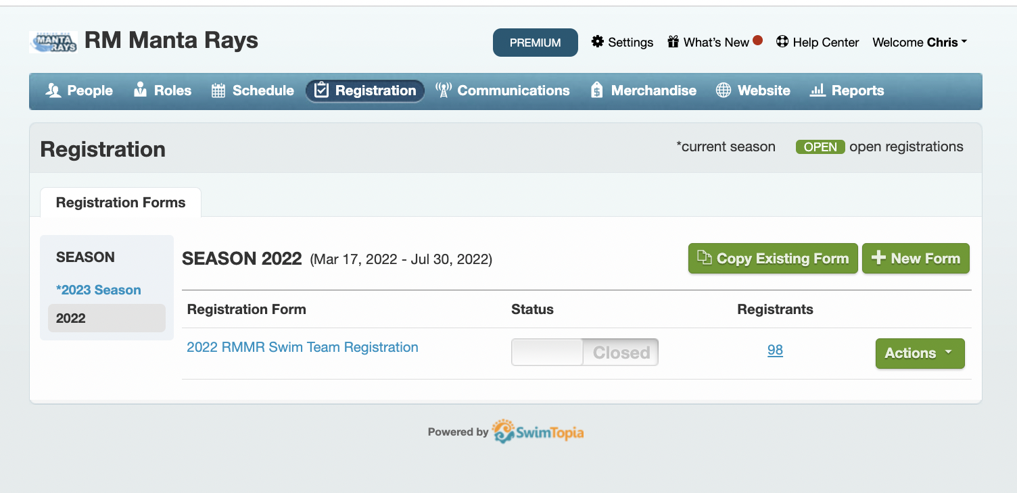

Scroll down to the Acknowledgments section. You can create any Team Acknowledgment document to include in your registration form.

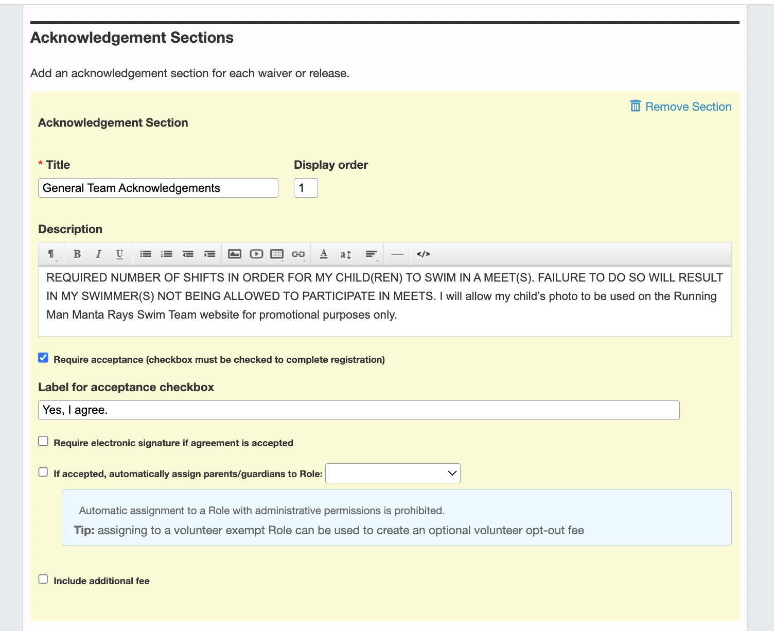

GPSA Code of Conduct and City Meet Waiver

The GPSA Code of Conduct and City Meet Waiver can be imported in the Registration form, Acknowledgments section.

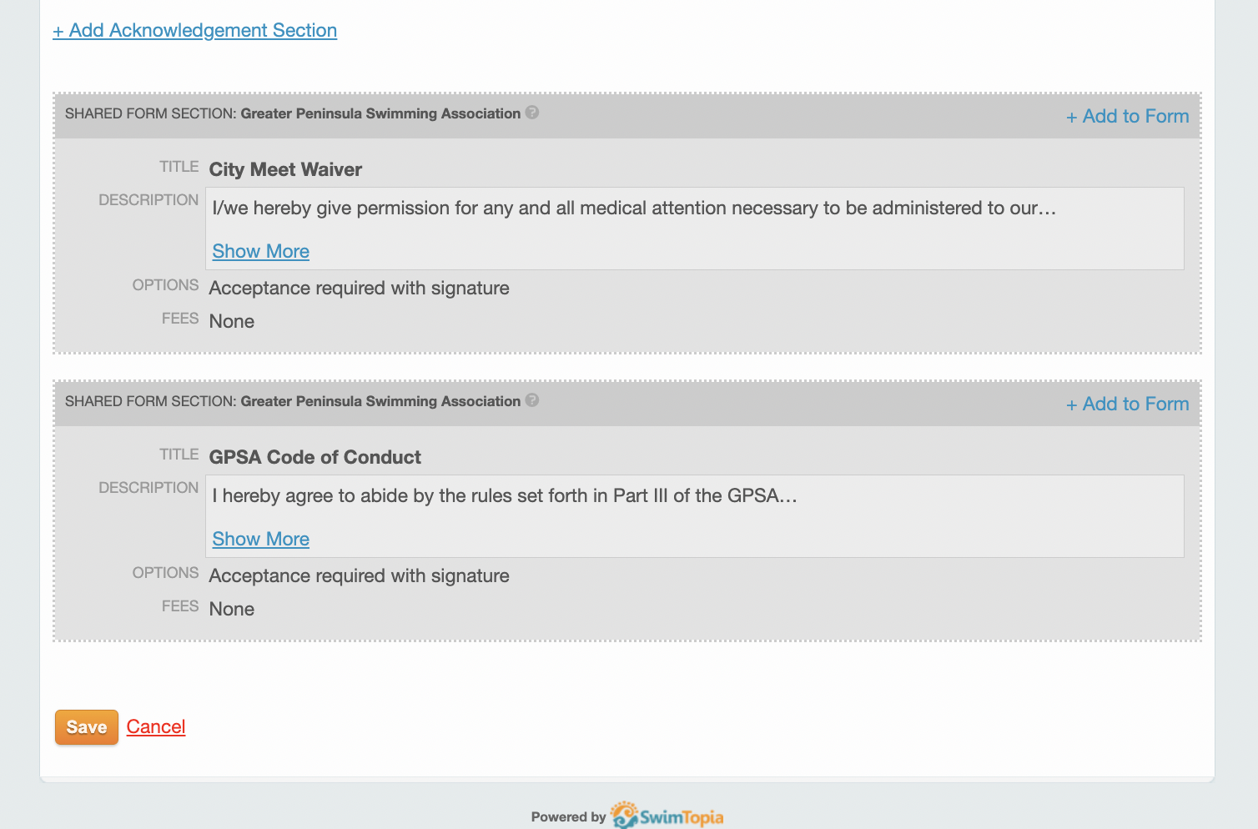

Payment
https://help.swimtopia.com/hc/en-us/articles/4413543731483-Stripe-Account-Setup

Schedule

Meet Schedule
The league will submit the approved division schedules to SwimTopia to be automatically created into each team’s schedule.

Meet Templates
The league will share the necessary meet templates for all GPSA official meets. If you have the need for a custom meet template you may create one yourself. If you will be swimming against multiple GPSA pools and would like a league shared template for each team to use please reach out to the webmaster with the specific details.

Job Templates
Click on Schedule. Click on the Job Templates tab. You can define Job Templates for Home and Away meets.

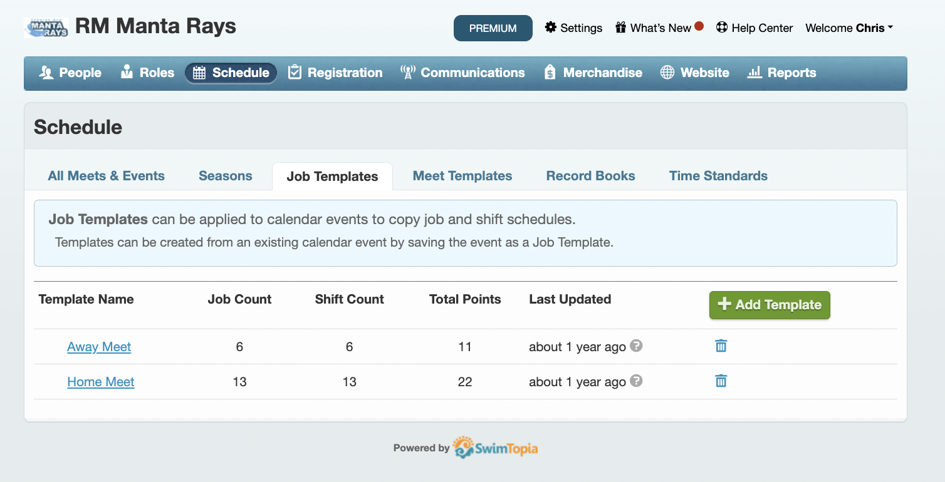

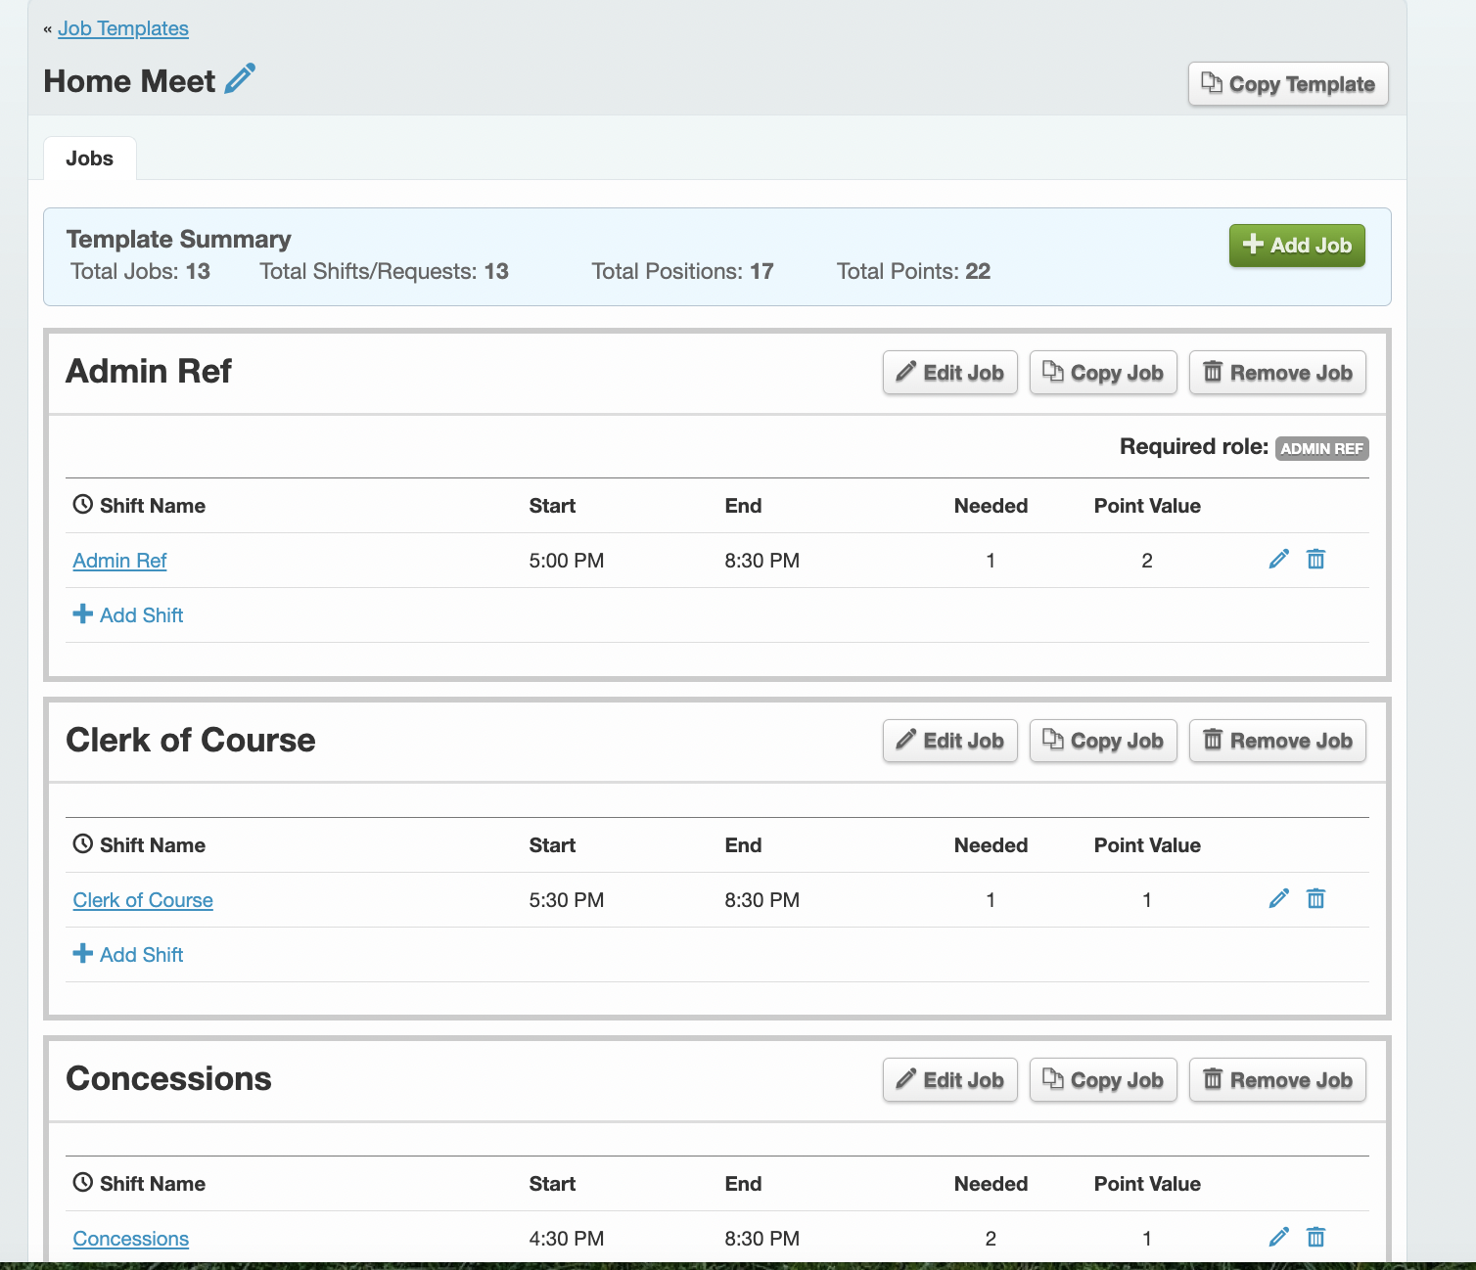
Home Meets will typically include the following roles:

Meet Ref
Admin Ref
Starter
Timers
Head Timer
Runner
Concessions
Clerk of Course
Ribbon Writer
Scorekeeper
Stroke and Turn Judges
Sweep Judge

Away Meets will typically require:

Clerk of Course
Ribbon Writer
Scorekeeper
Timers
Stroke and Turn Judges
Sweep Judge

Creating Record Books
Creating a Record Book – SwimTopia Help Center
Managing a Record Book – SwimTopia Help Center

Importing City Meet Qualifying Times
City Meet Qualifying Times will be published from the league to all teams.
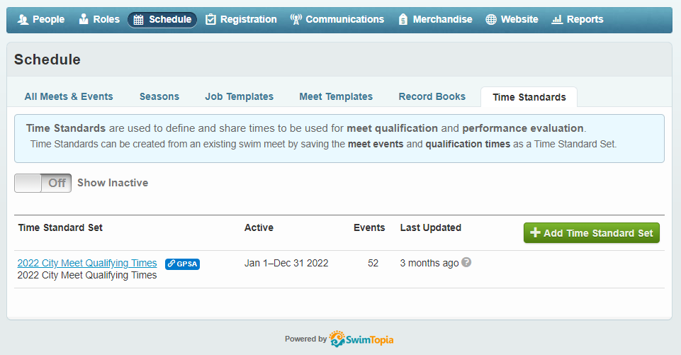

Team Website
Website Management – SwimTopia Help Center

Meet Setup
Regular season meets will be submitted to SwimTopia and automatically linked to your team schedule. To create a time-trial, mock-meet, or B-meet follow the below steps.

- On the Schedule screen select Add Swim Meet and then New (Empty) Swim Meet
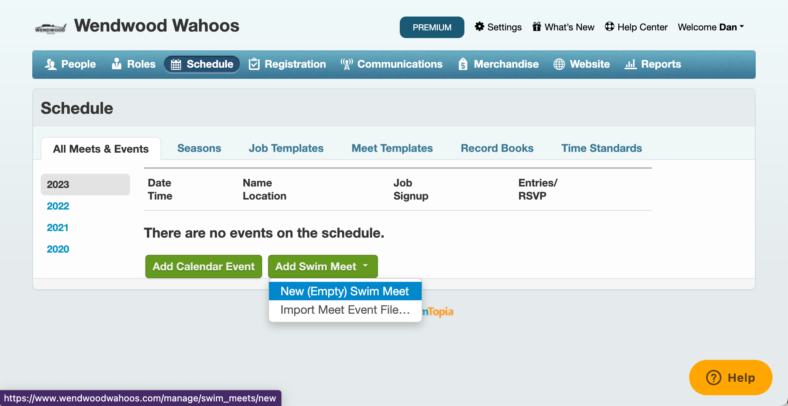

- Enter the Meet Details
  - Meet Name
  - Start, End, & Warm-up (Date/Time)
  - Location
  - Description
  - Hide from Public Calendar
  - Age-Up Date
  - Course (pool length)
  - Entry Time Conversion
- Edit Swimmer Entry Signup and Job Signup. You can establish signup dates for swimmer entries and volunteer roles for each meet.
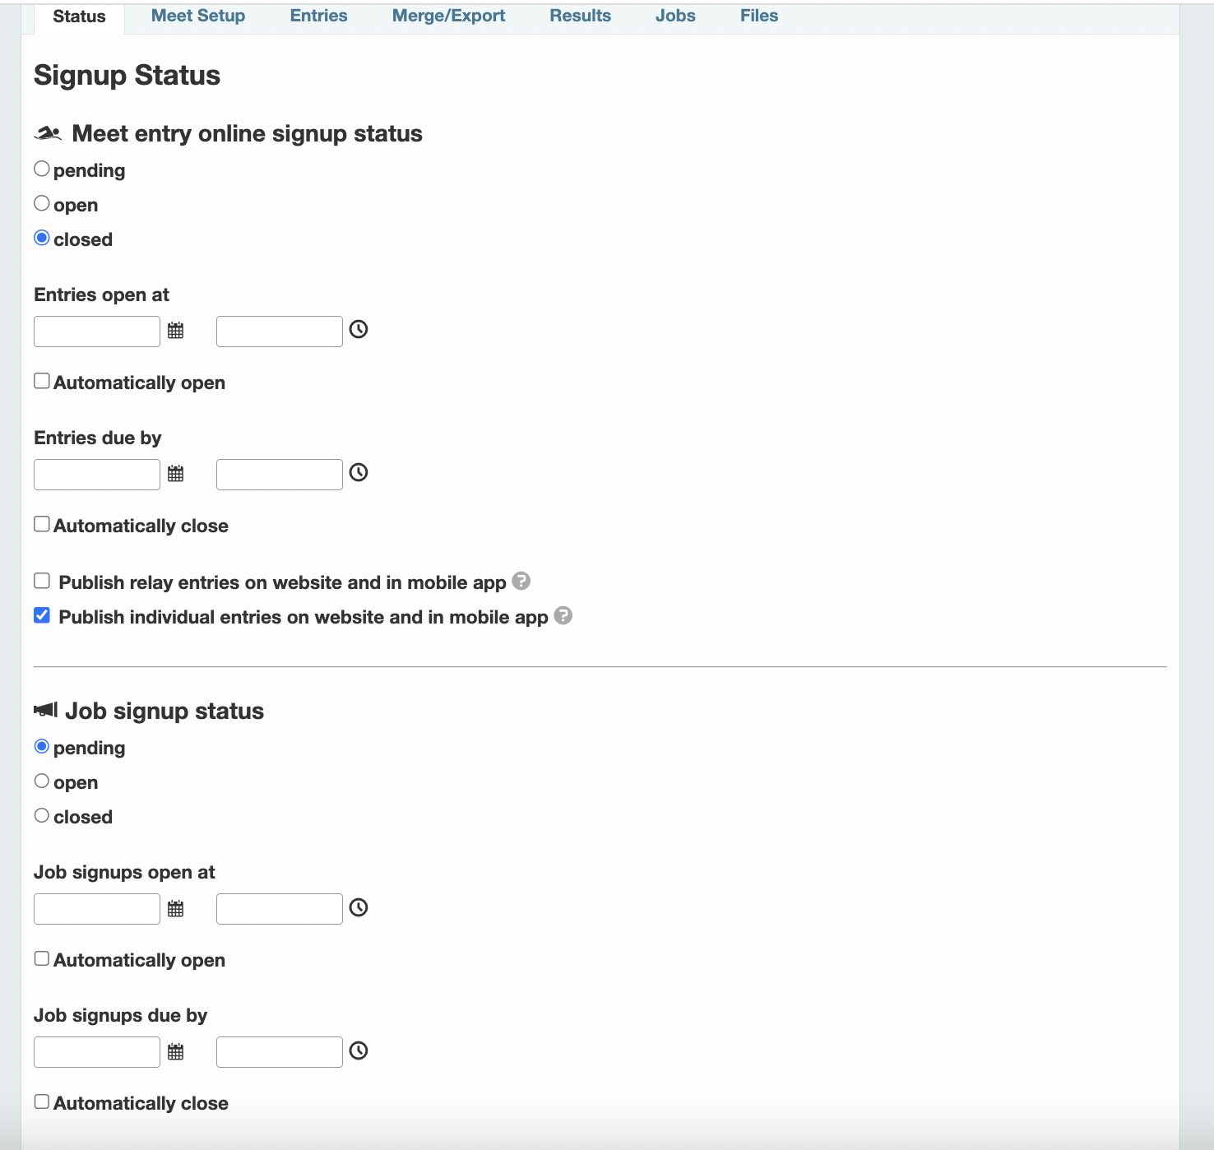

- Apply Meet Template. Under Meet Setup-Entries, Click ‘Apply Template’. Select [GPSA] 2023 GPSA Dual Meet (56 Events).

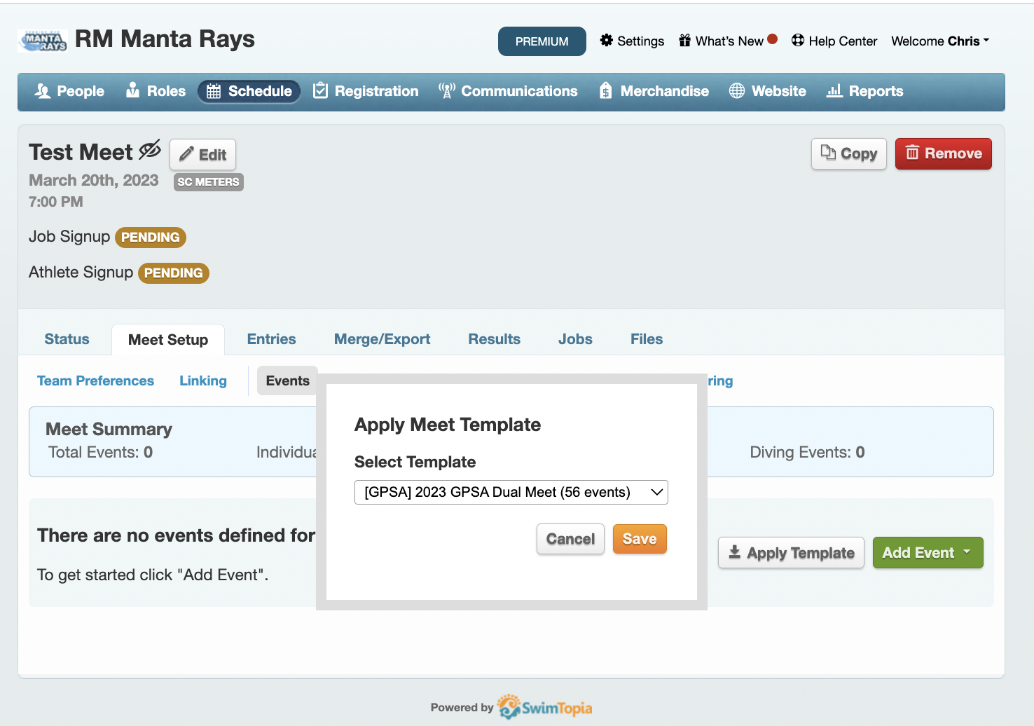

Swimmer Entries

Point Swimmers
Swimmer entries can be completed by clicking the pencil icon next to each swimmer’s name and checking the box for each event.
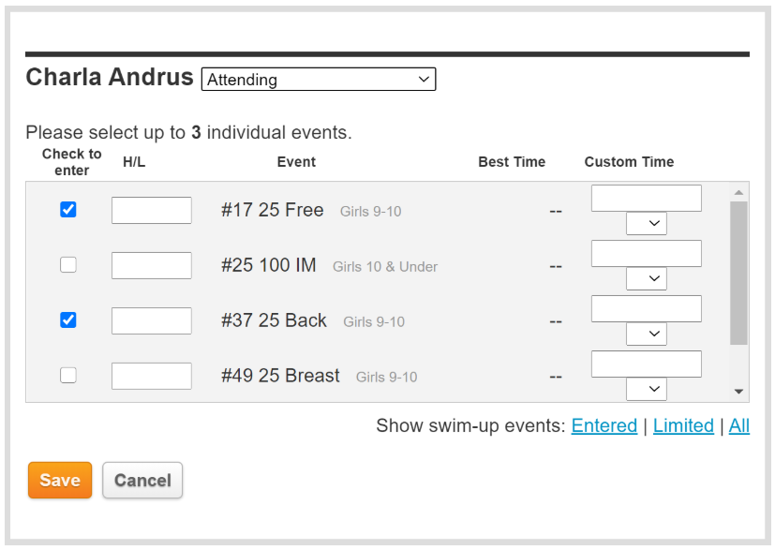

Bulk entries can be completed by clicking Edit Entries in the upper right hand corner.
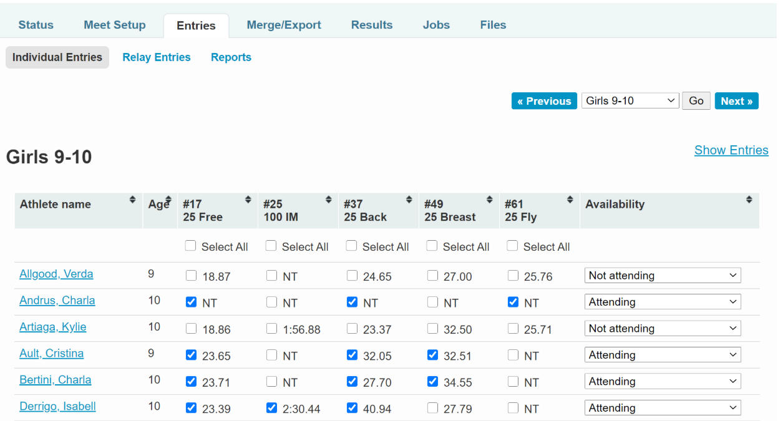

Declare Exhibition Swimmers
To aid in the automatic scoring of the meet using Meet Maestro, exhibition swimmers must be declared during the entry selection process. This is accomplished using the Exh checkbox during swimmer entry selection as demonstrated below. (SwimTopia Help Article) (If performed in Meet Maestro on deck)

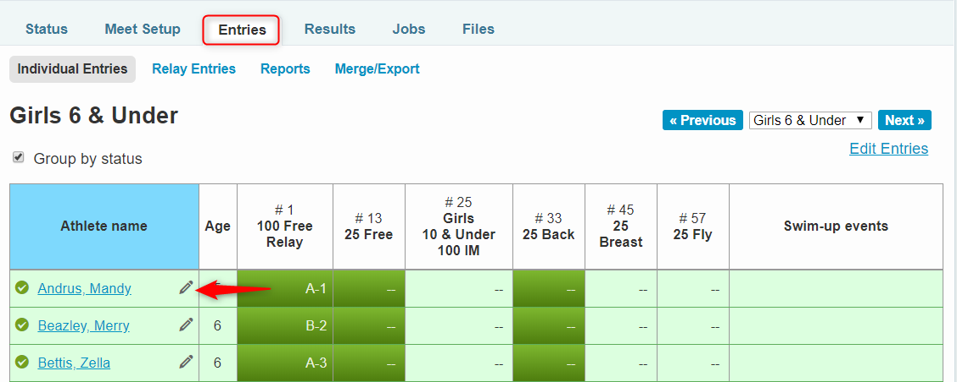

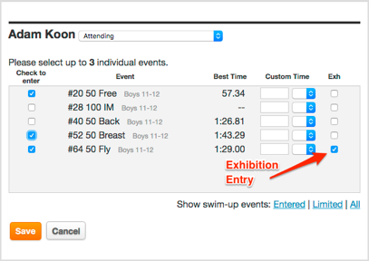

Swimming a Swimmer “Up”
When in the detailed view of a swimmer selecting the All URL in the bottom right will show all events the swimmer is eligible to swim-up in.
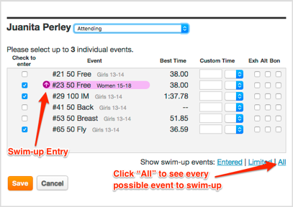

Bonus Entry for Small Teams
To keep all teams using the same meet template, any team that meets the requirements to allow swimmers to swim in 4 individual events can do so by using the Bon checkbox. It is the responsibility of the GPSA rep and coach to ensure bonus entries are only used when permitted by GPSA rules.

Building a Relay Team
Relay teams can be edited to add/remove swimmers (and specify swim-up ages), change the relay order, rearrange swimmers within the relay, enter custom seed times, and to mark a relay as an exhibition entry if necessary. (Edit Relay Teams)
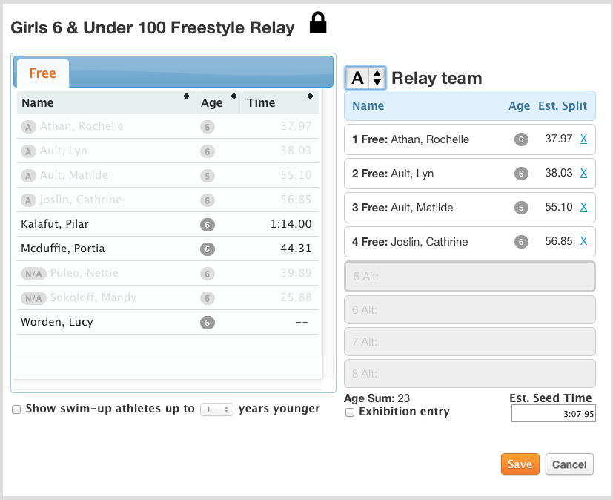

Entries Matrix
The Entries Matrix uses the below indicators and colors to indicate the status of a swimmer.

Color Indicators
- Light green indicates “Declared to be attending” but not necessarily entered in specific events
- Dark green indicates the Athlete is entered into that event
- Grey indicates not eligible—for reasons ranging from not attending or not qualified (when you see the red circle with the line through it) to being declared to be arriving late or leaving early (Cora Taft and Lorri Tart in the above example)
- Orange indicates entered but not qualified

Other Indicators
- “X” for Exhibition Swim
- “A” for Alternate
- “B” for Bonus (doesn't count against entry limits)
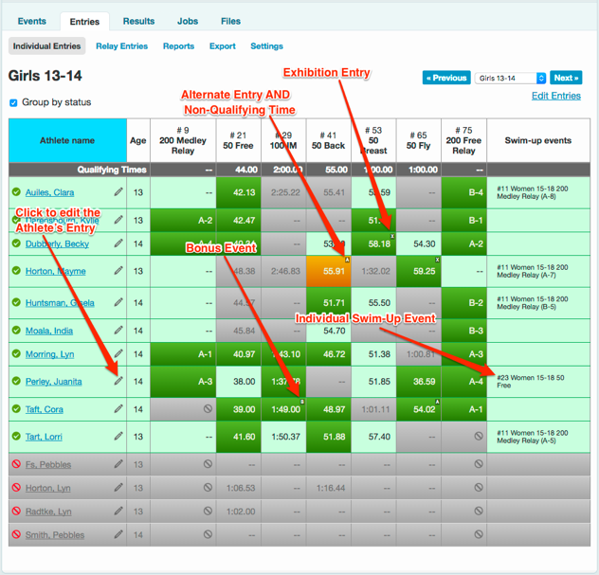

Entry Reports

Meet Entries by Athlete
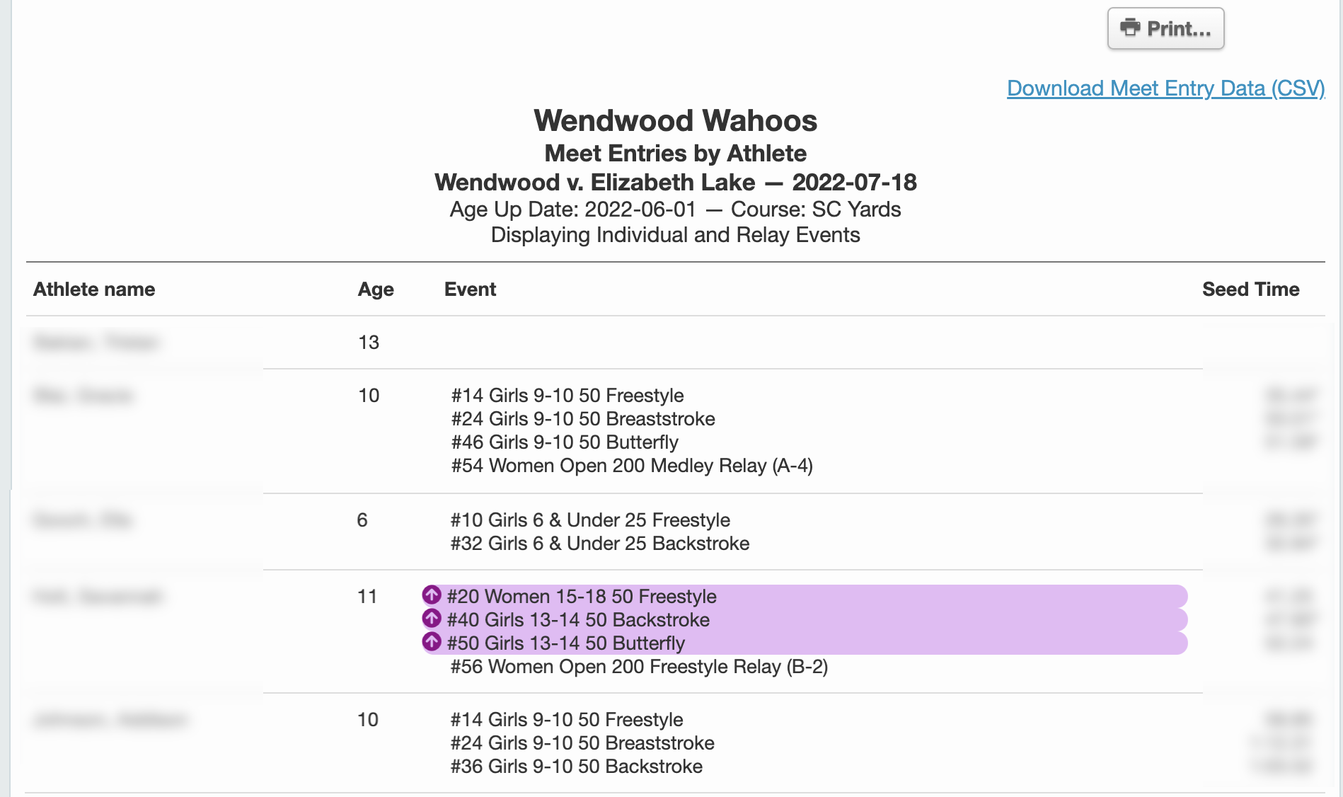
This report is helpful to validate the number of entries per swimmer. Age up swimmers are identified by the highlighting.

Meet Entries by Event
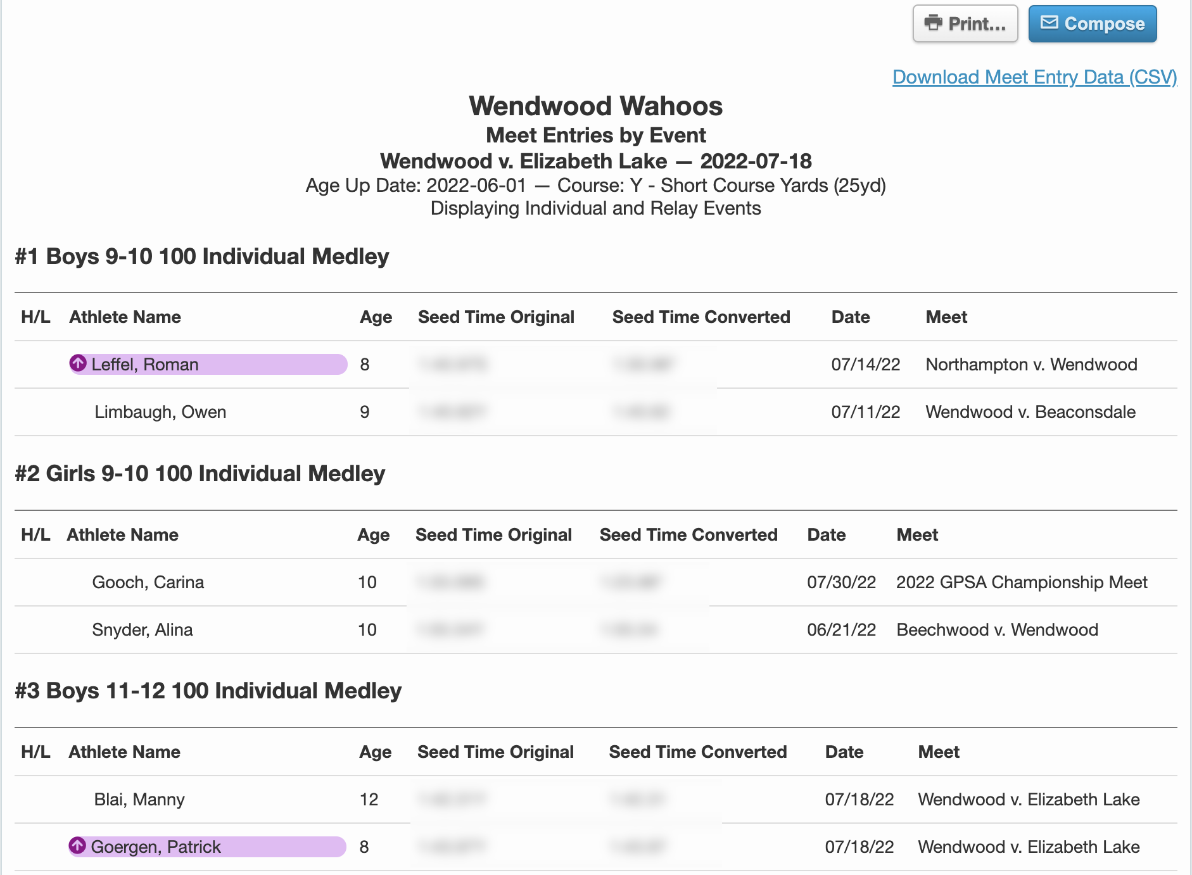
This report is helpful to ensure every event has the proper number of point swimmers. Age up swimmers are identified by the highlighting.

Merge Entries
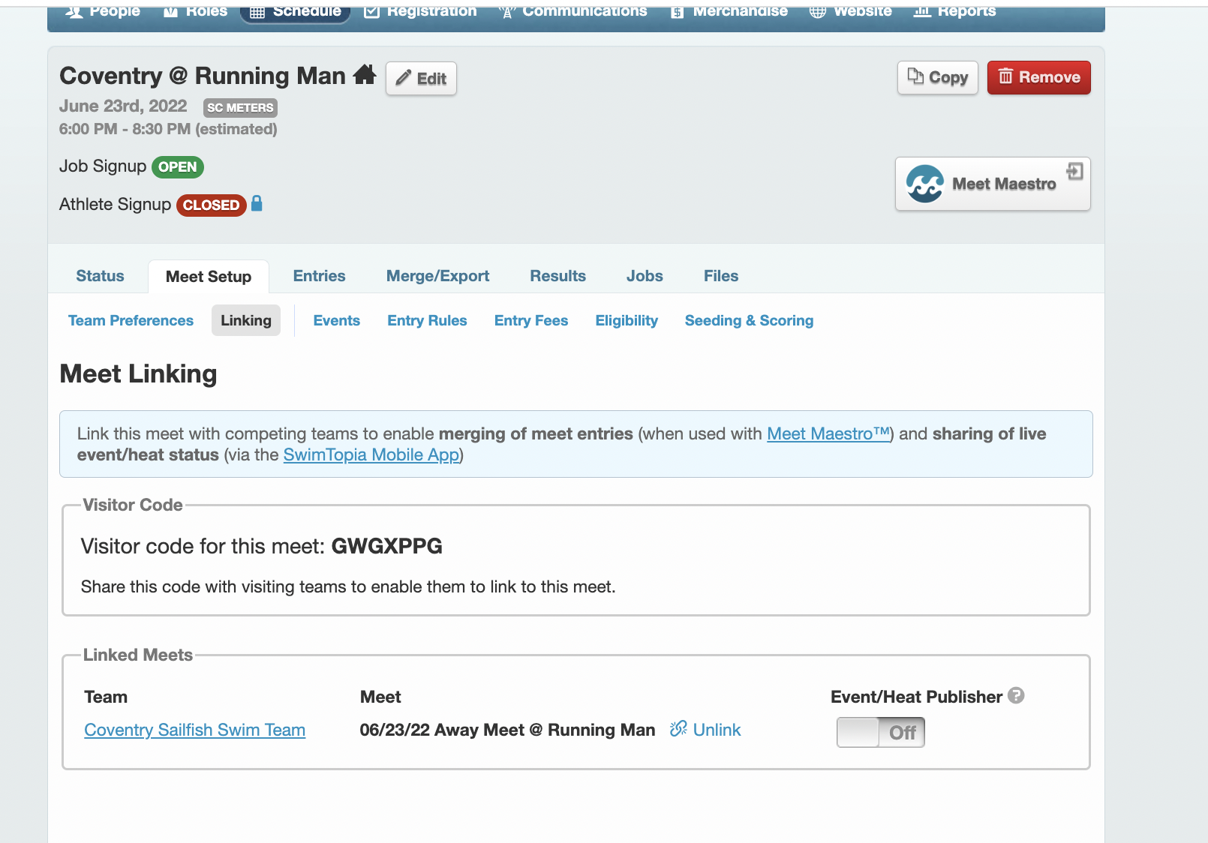

Select a meet from the Schedule. Click on the ‘Meet Setup’ tab. Click on the ‘Linking’ subheader. The home team should share the meet code with the visiting team.

The visiting team will need to select the specific meet from the Schedule. Click on the ‘Meet Setup’ tab. Click on the ‘Linking’ subheader. Enter the visitor code that was shared with you by the home team.

Once both teams have completed all swimmer entries, select the ‘Merge/Export’ tab. Click the slider beside your team’s name to indicate you are ready for merge. Once both teams have submitted as ready, the home team will be able merge the entries and build the meet in Meet Maestro.

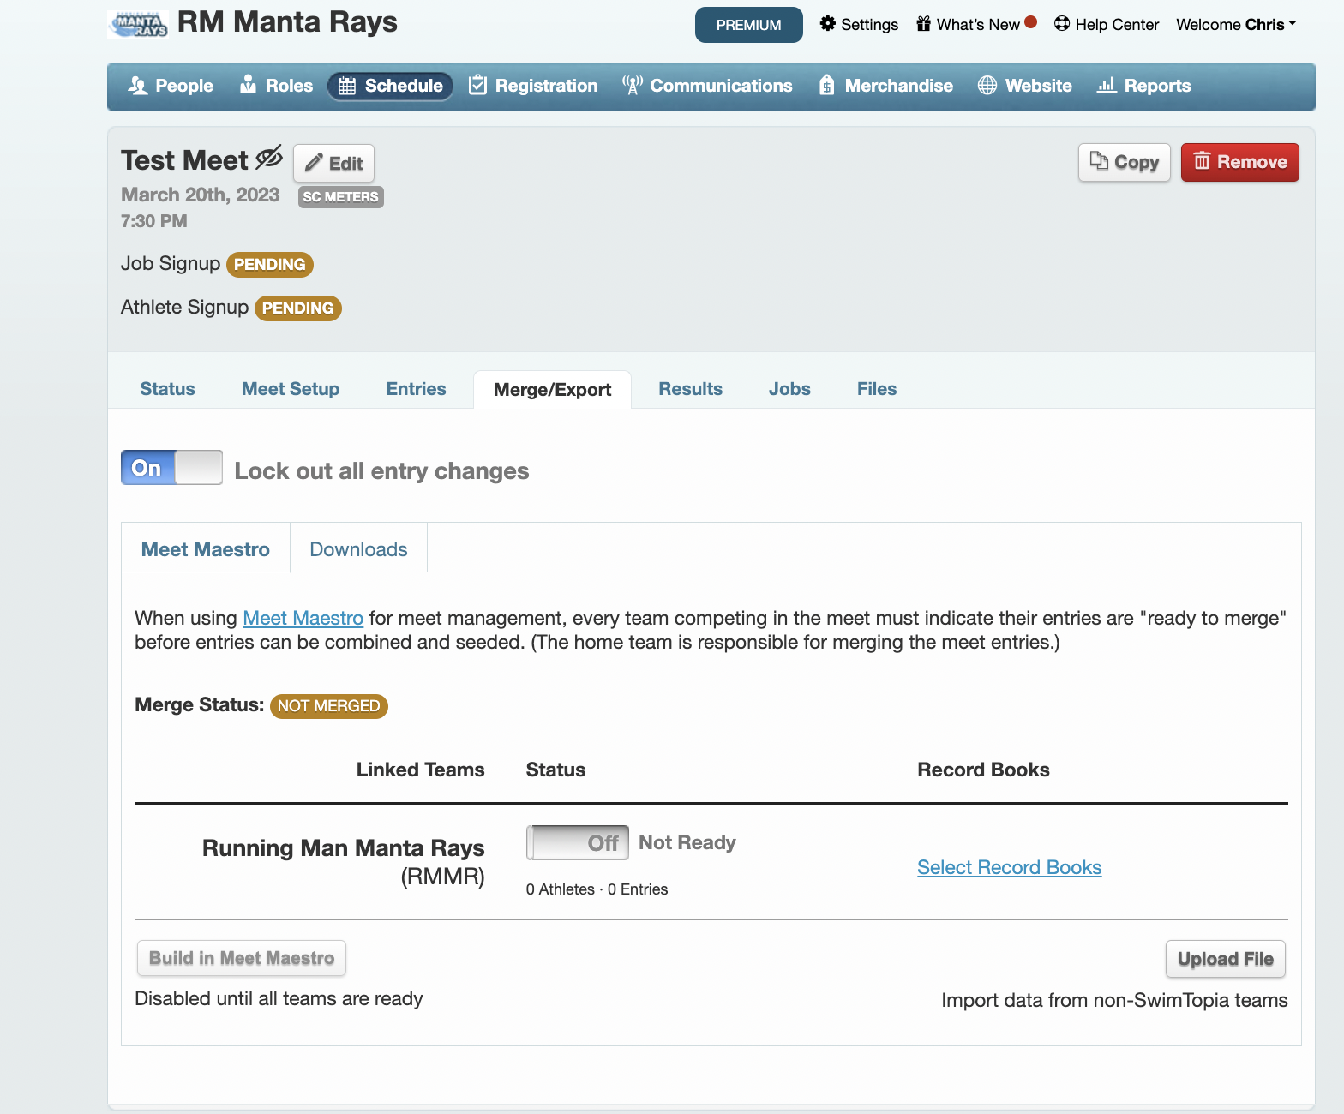

Various Pool Configurations
In GPSA, we have pools with 4, 5, 6, and 8 lanes. For pools with 4, 5, and 6 lanes, lanes 1-4 will be used for scoring lanes in heat 1. For the 8 lane pool, the middle 4 lanes should be used for the scoring lanes in heat 1. The configuration setting for number of lanes can be found in Meet Maestro, under the Gear Settings - Meet Setup in the ‘Pool Configuration’ box, as shown below.

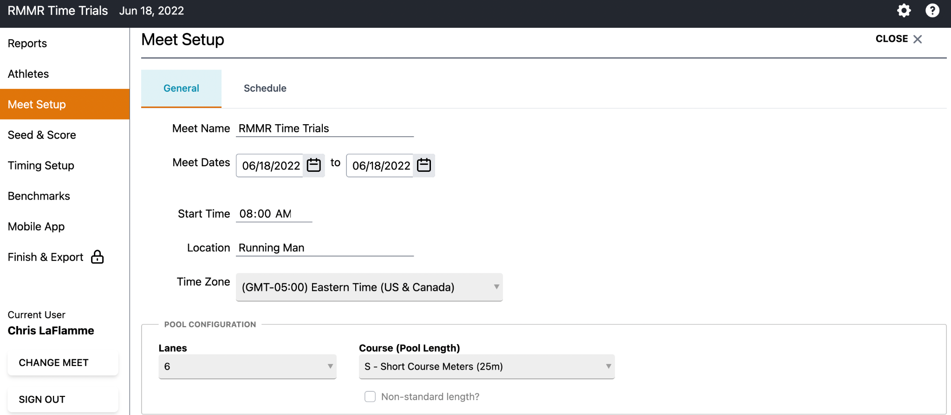

Adding Record Book and Qualifying Times to the Meet

To add Team and Pool records to a meet, first select the meet from the Schedule. Click on ‘Merge/Export’ tab. Click on ‘Select Record Books’. Check each record book you wish to apply to this meet.

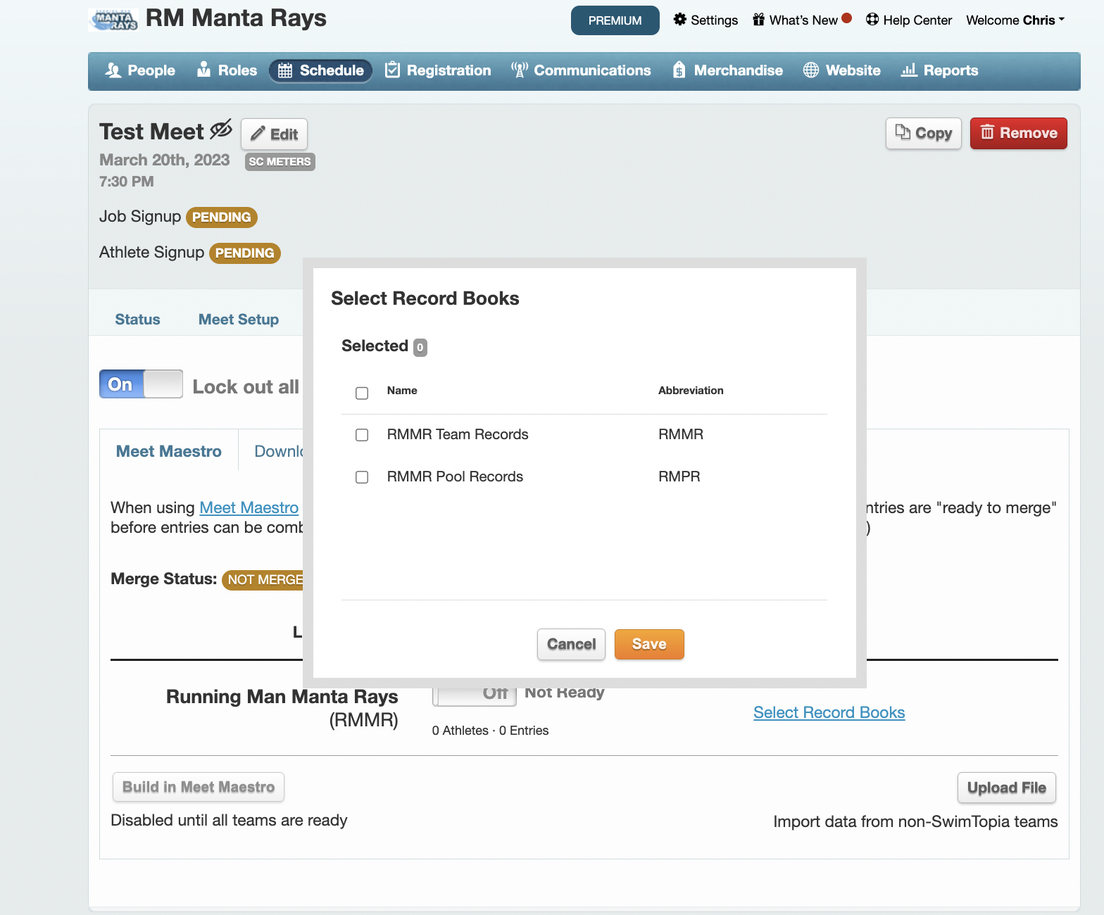

To add the City Meet Qualifying to a meet, first launch Meet Maestro. Click on the ‘Settings Gear’ on the top right. Select ‘Benchmarks’ from the left side menu. Click the ‘Add Time Standard’ button. Select the listed City Meet Qualifying Times.

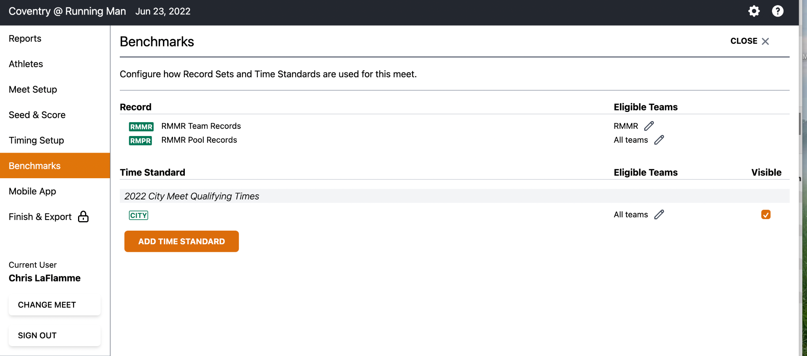

Creating Heat Sheets
In Meet Maestro, click on the Settings Gear on the top right. Select ‘Reports’ from the left side menu. Click on ‘Heat Sheet’.

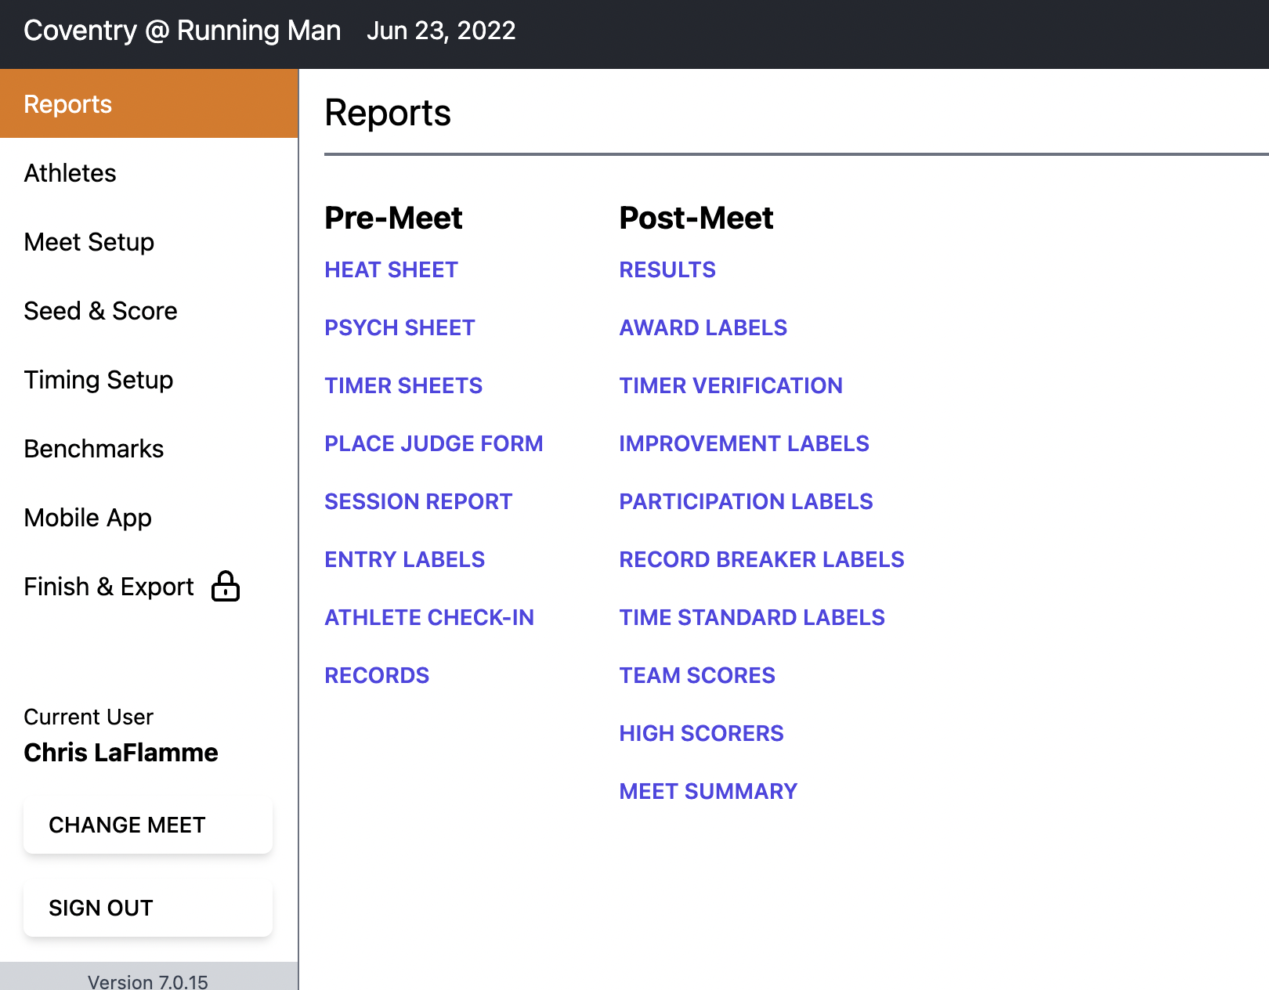

Running the Meet

Keeping the Score Blind
Once a meet has been merged, a link to Meet Maestro will appear on the upper right portion of the screen. Click the Meet Maestro button to access the Meet.

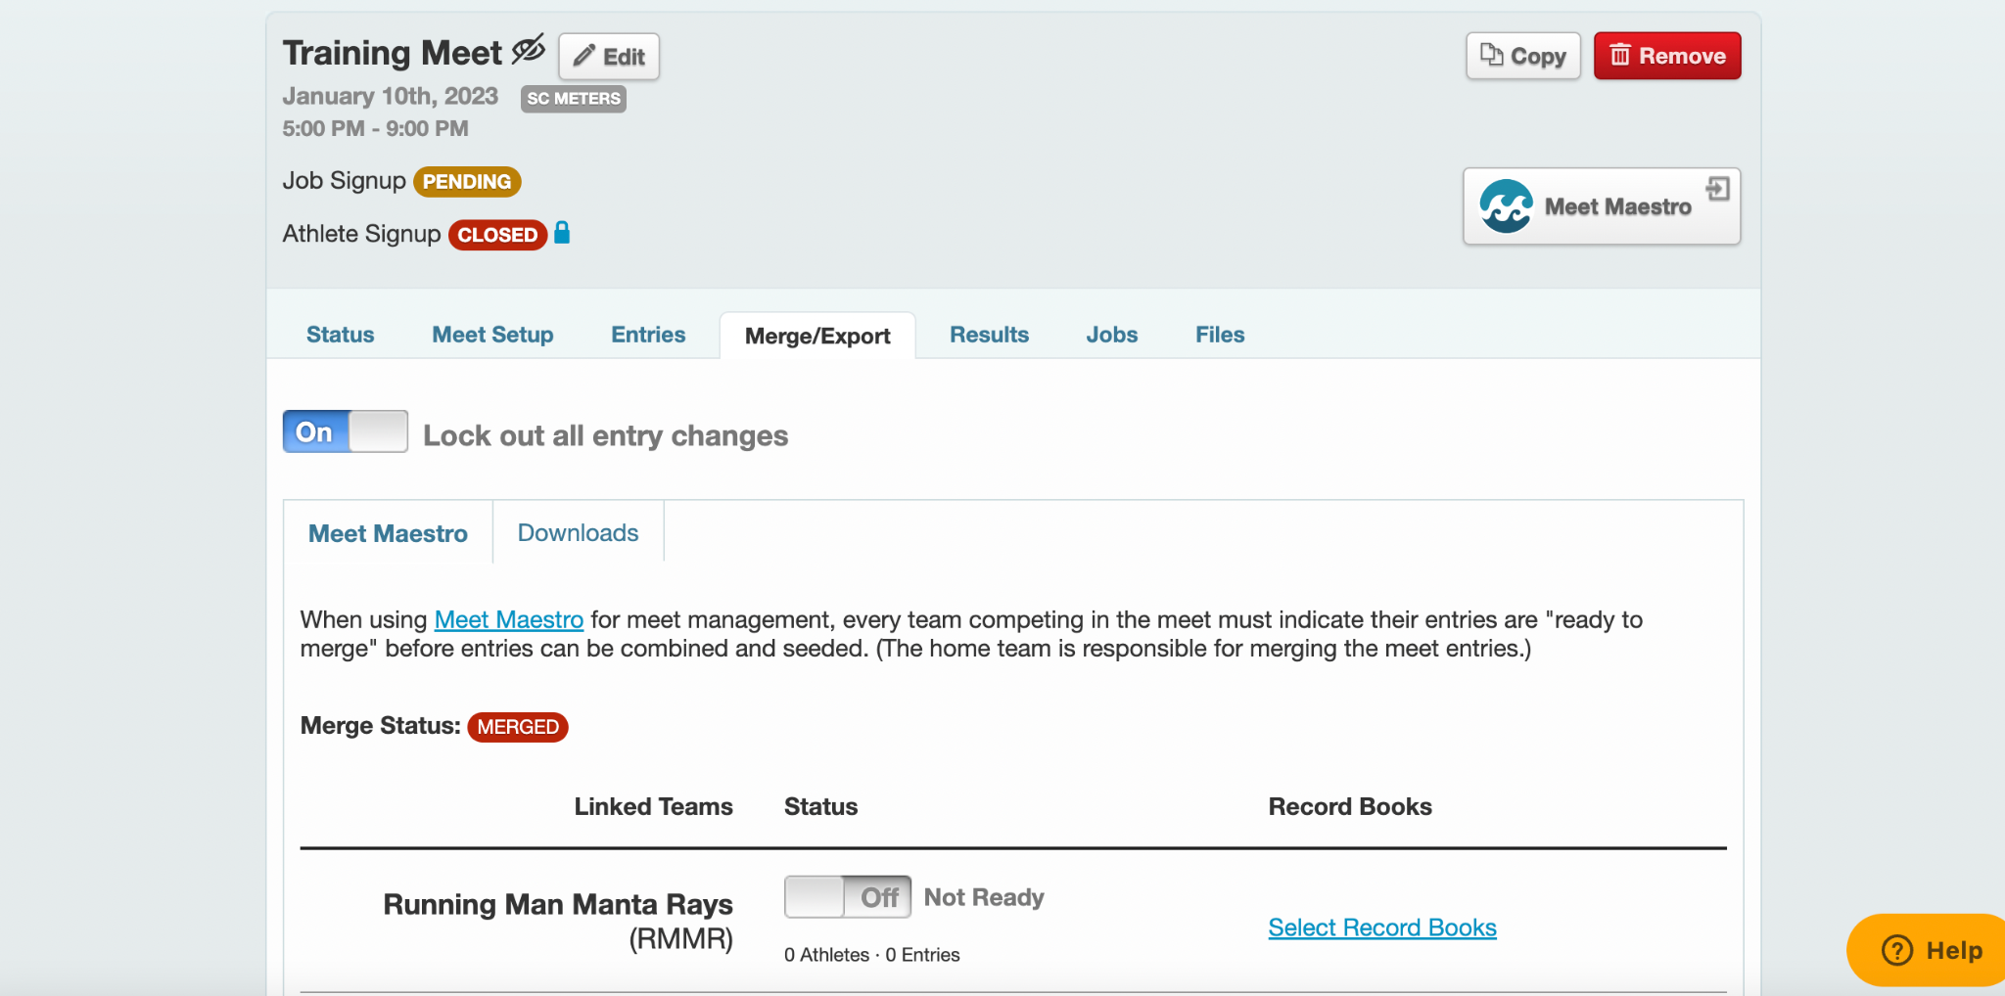

Once in Meet Maestro, click on the ‘Settings Gear’ on the upper right portion of the screen. This will take you into the meet settings.

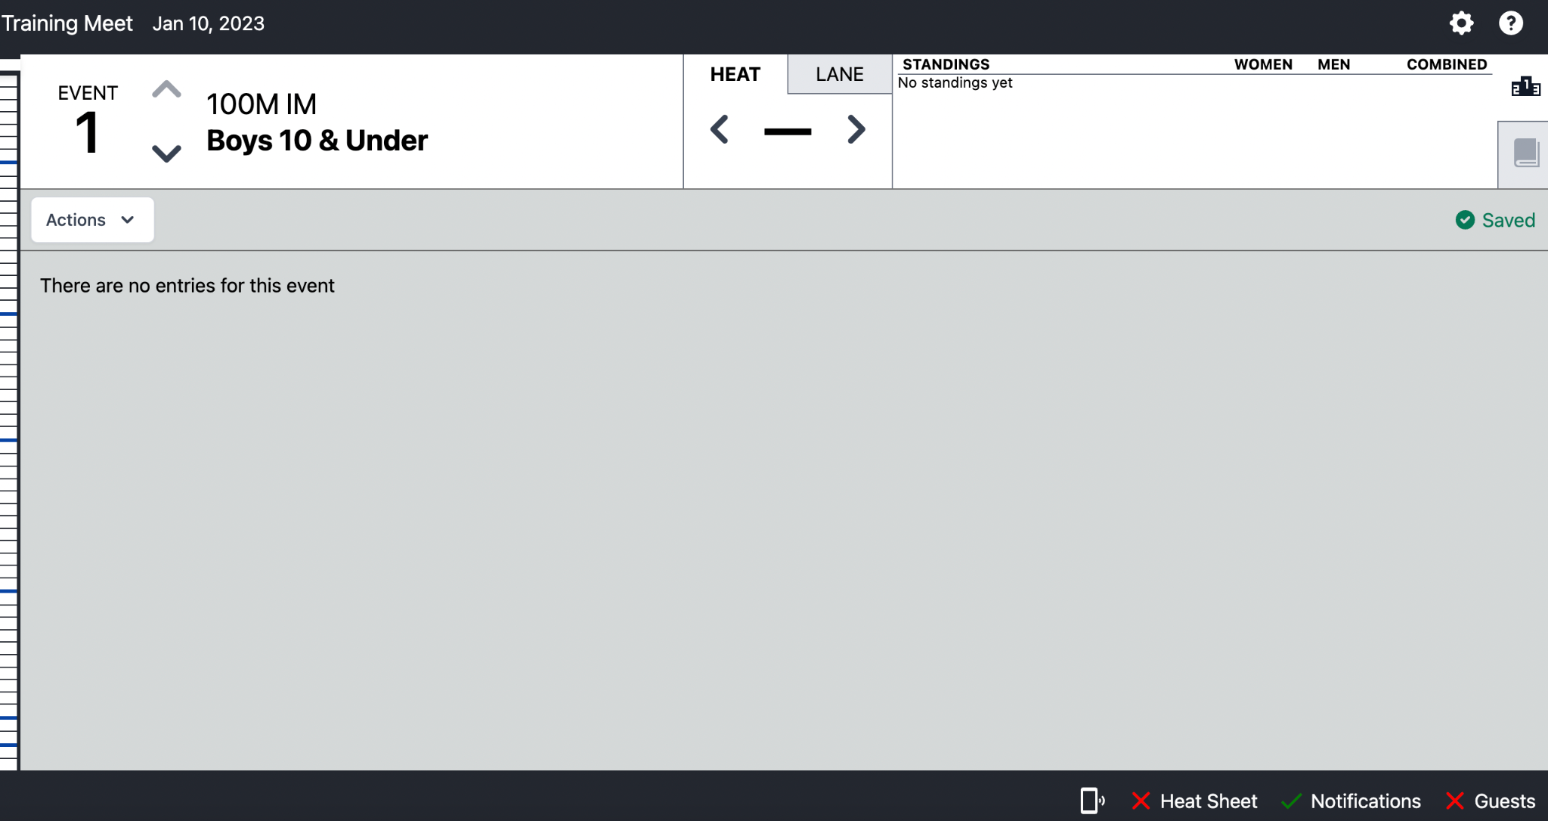

Once in the Settings menu, click on the Mobile App subheader on the far left. In the middle of the screen, there will be sliding options (Score Display) to turn Combined/Men/Women scoring off. This will prevent any scoring from displaying on the mobile app.

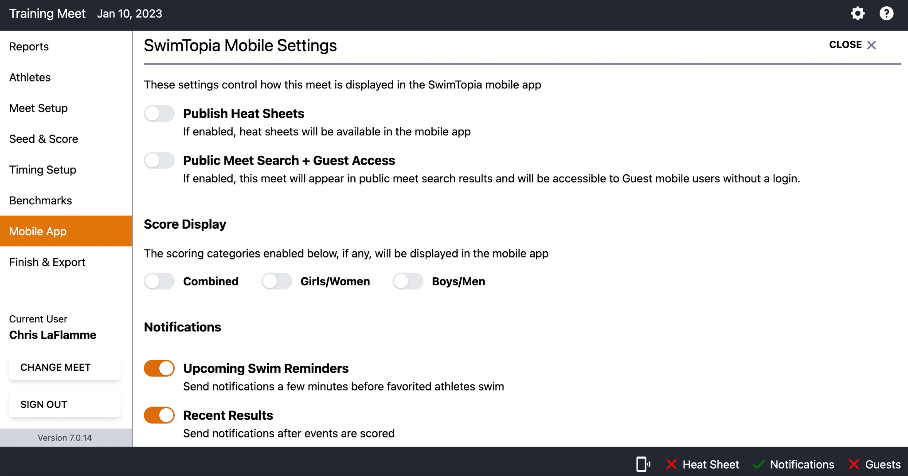

Manual Timing System
Manual timing is equivalent to using stopwatches (battery operated, digital read-out) to record the duration of the individual swim. The watch is started at the instant of observing the visual starting signal. If the visual starting signal is not observed, the watch shall be started upon hearing the starting signal. The watch is stopped when any part of the swimmer touches the wall at the completion of the distance of the event. Times are recorded to the hundredths place (two decimals) with no rounding.

Each lane should be manned with a minimum of one timer. The recorded time with one timer is the official time. If a lane is manned with two timers, the recorded times should be averaged to determine the official time. If a lane is manned with three timers, the intermediate time should be identified and used as the official time.

Semi-Automatic Timing System
A Semi-Automatic Timing System begins automatically with an electronic signal from the starting unit and ends manually when the timer pushes his/her button at the finish of the race. The button of the timing device is pressed when any part of the swimmer touches the wall at the completion of the distance of the event. Times are automatically transmitted to a central system integrated with Meet Maestro.

Each lane should be manned with a minimum of one timer. The recorded time with one timer is the official time. If a lane is manned with two timers, the recorded times should be averaged to determine the official time. If a lane is manned with three timers, the intermediate time should be identified and used as the official time.

Meet Ref Role
See https://www.usaswimming.org/docs/default-source/rules-regulations/2023-rulebook.pdf

Reference Article 102.11

Additional material on the Meet Ref role can be found here:

https://www.teamunify.com/team/va/page/officials/official-training

Starter Role
See https://www.usaswimming.org/docs/default-source/rules-regulations/2023-rulebook.pdf

Reference Article 102.12

Additional material on the Starter role can be found here:

https://www.teamunify.com/team/va/page/officials/official-training

Timer Role
See https://www.usaswimming.org/docs/default-source/rules-regulations/2023-rulebook.pdf

Reference Article 102.16

Stroke and Turn Role

See https://www.usaswimming.org/docs/default-source/rules-regulations/2023-rulebook.pdf

Reference Article 101 in its entirety.

Reference Article 102.13.

Additional material on the S&T Judge role can be found here:

https://www.teamunify.com/team/va/page/officials/official-training

Sweep Judge Role

See https://www.usaswimming.org/docs/default-source/rules-regulations/2023-rulebook.pdf

Reference Article 102.13.2.

Each team will provide a Sweep Judge and each will independently record the Order of Finish across the 4 scoring lanes, using this form:

https://drive.google.com/file/d/1qF-M9VYFpAfvxB6xZ2-HMnbI2uz9_fGK/view?usp=sharing

If judges do not agree on the order of finish, please see GPSA rules (https://drive.google.com/file/d/1Wh39Z_TIjtHMR5Rcxmbd5r3es-hDWB5f/view?pli=1), specifically Article XV.A.6. Referee may settle the order of finish if personally observed or declare a tie.

Runner Role
The Runner is responsible for collecting all lane slips from the timers and delivering them to the Sweep Judges for review. The Runner is also responsible for collecting DQ slips from Stroke and Turn Judges and delivering to the Meet Ref. After the Meet Ref has reviewed lane slips and DQ slips for a particular event, the Runner may be asked to deliver those artifacts to the Scoring Table for processing.

Scorekeeper Role
Each team will provide a scorekeeper. The scorekeepers will perform two functions: (1) record the official time collected by the timer on to the scoresheet or exhibition sheet; (2) record the placement for the 4 swimmers competing in scoring lanes and apply the appropriate points per placement (1st - 5, 2nd - 3, 3rd - 1).

Scoring lanes are typically lanes 1-4 and will always be Heat 1. Times, placement, and points should be recorded on this form:

https://drive.google.com/file/d/1f12DyNQzNhFZ65NH4JG8ufRRWgtVd1Yz/view?usp=sharing

Exhibition lanes are any other lanes for Heat 1 other than lanes 1-4. All additional heats of a particular event are considered exhibition. Times for exhibition swims should be recorded on this form:

https://drive.google.com/file/d/1s_nLbwtojmXikG2O0AHcD04hnq1fVgs-/view?usp=sharing

The scorekeeper for each team will independently complete their own score sheet. Once completed, the two sets should be compared for accuracy. Once the scorekeepers agree on the results, the Meet Ref will review and signoff.

If Swimtopia is used for scorekeeping, the scorekeepers will do the following:

- Select the appropriate meet from the Schedule.

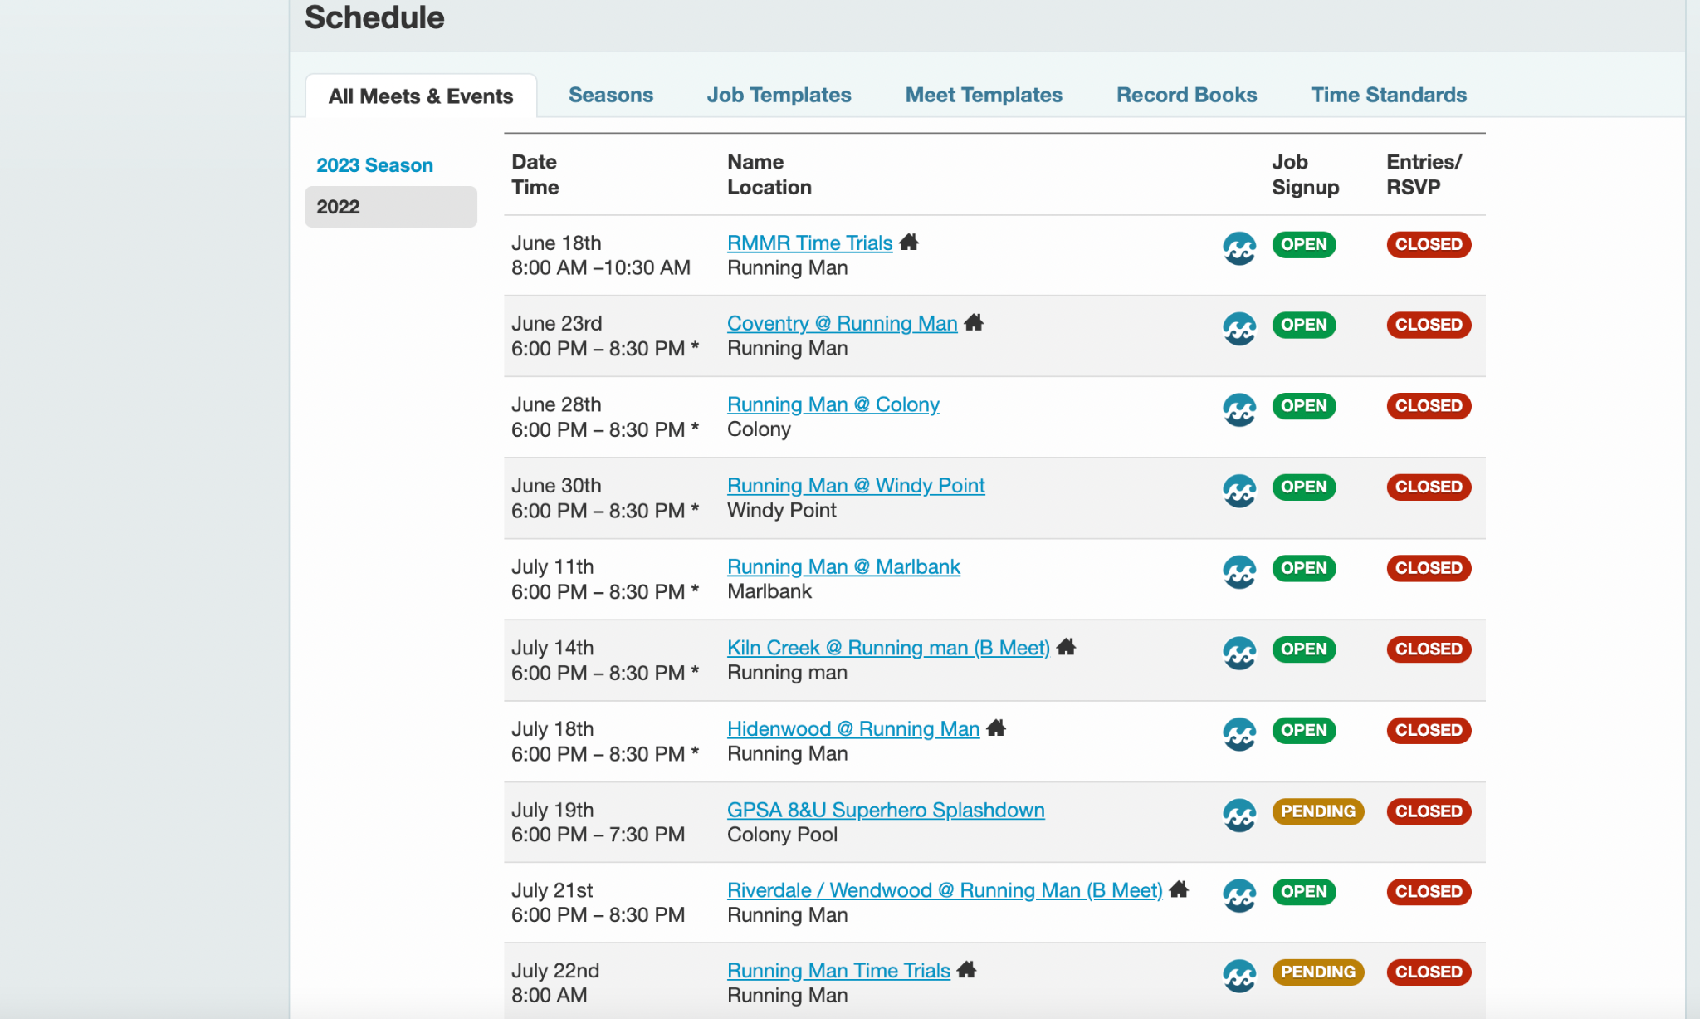

- Click the Meet Maestro button to actively manage the meet.

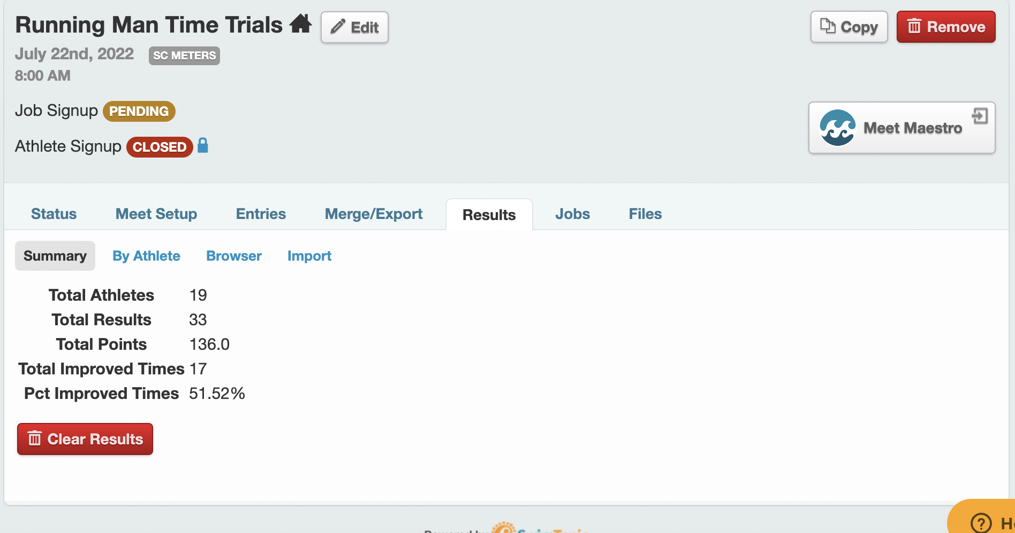

- Once in Meet Maestro, the scorekeepers will be able to navigate heat to heat, event to event, using the left and right arrows at the top-middle of the screen. The scorekeepers will receive a collection of lane slips for each event from the Meet Ref or the Runner. Match the lane slip to the entry in Meet Maestro. The swimmer’s name, team, heat, and lane should all match. Record the time collected on the lane slip into the box labeled ‘Timer 1’. Denote the placement in the placement column. The associated points will populate automatically. Exhibition lanes should already be marked. If there is a DQ slip attached to the lane slip, mark the DQ column and select the code checked on the DQ slip.

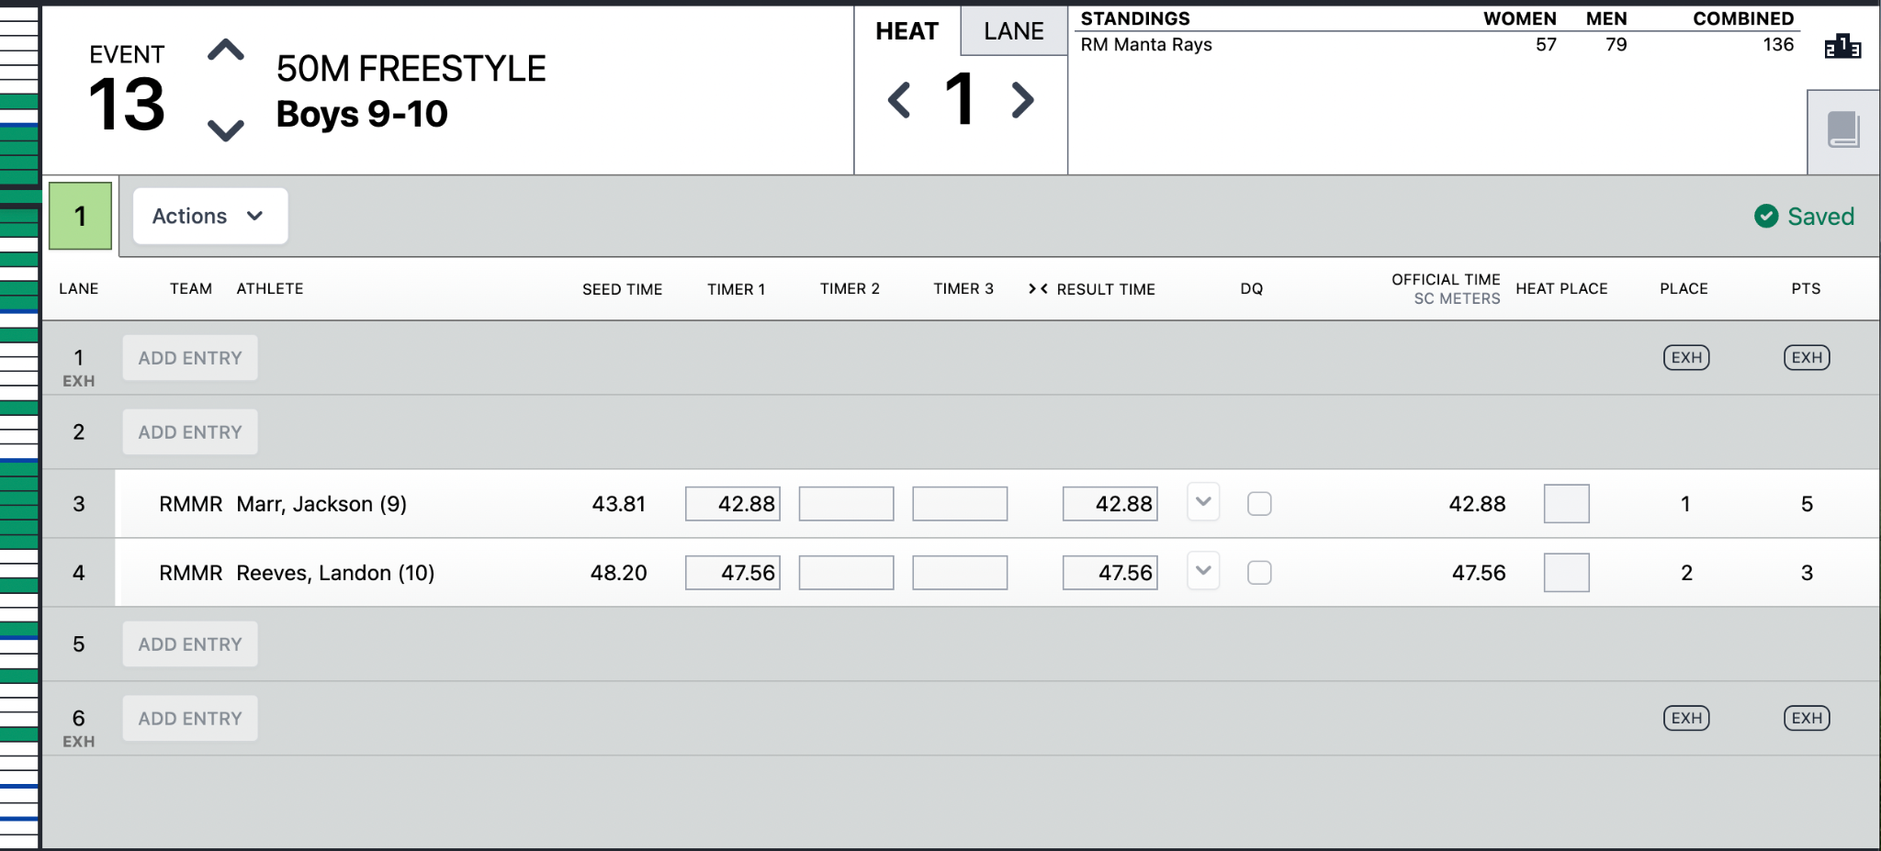

- Once all entries have been completed, review the collection of events with the Meet Ref who will sign off on the meet.

Ribbon Writer / Labeler
Each team will provide a Ribbon Writer for the meet. Once the Scorekeepers have completed their time entries for a particular event, they will hand the associated lane slips to the Ribbon Writers to label the award ribbons accordingly. These can be written manually or labels can be generated from Meet Maestro. To generate labels, launch Meet Maestro for the active meet and click the Settings Gear on the top right of the screen.

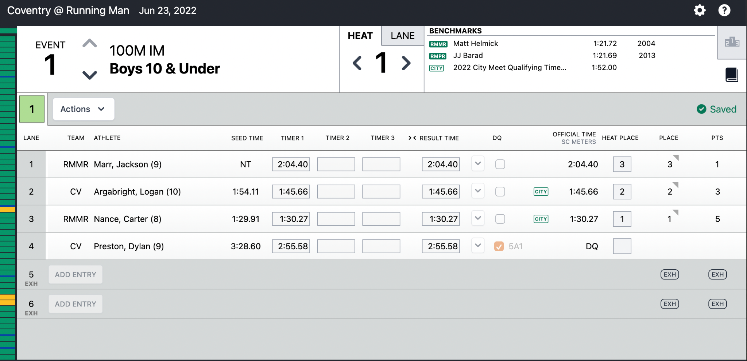

Once in the Settings, select the Reports tab on the left side of the screen.

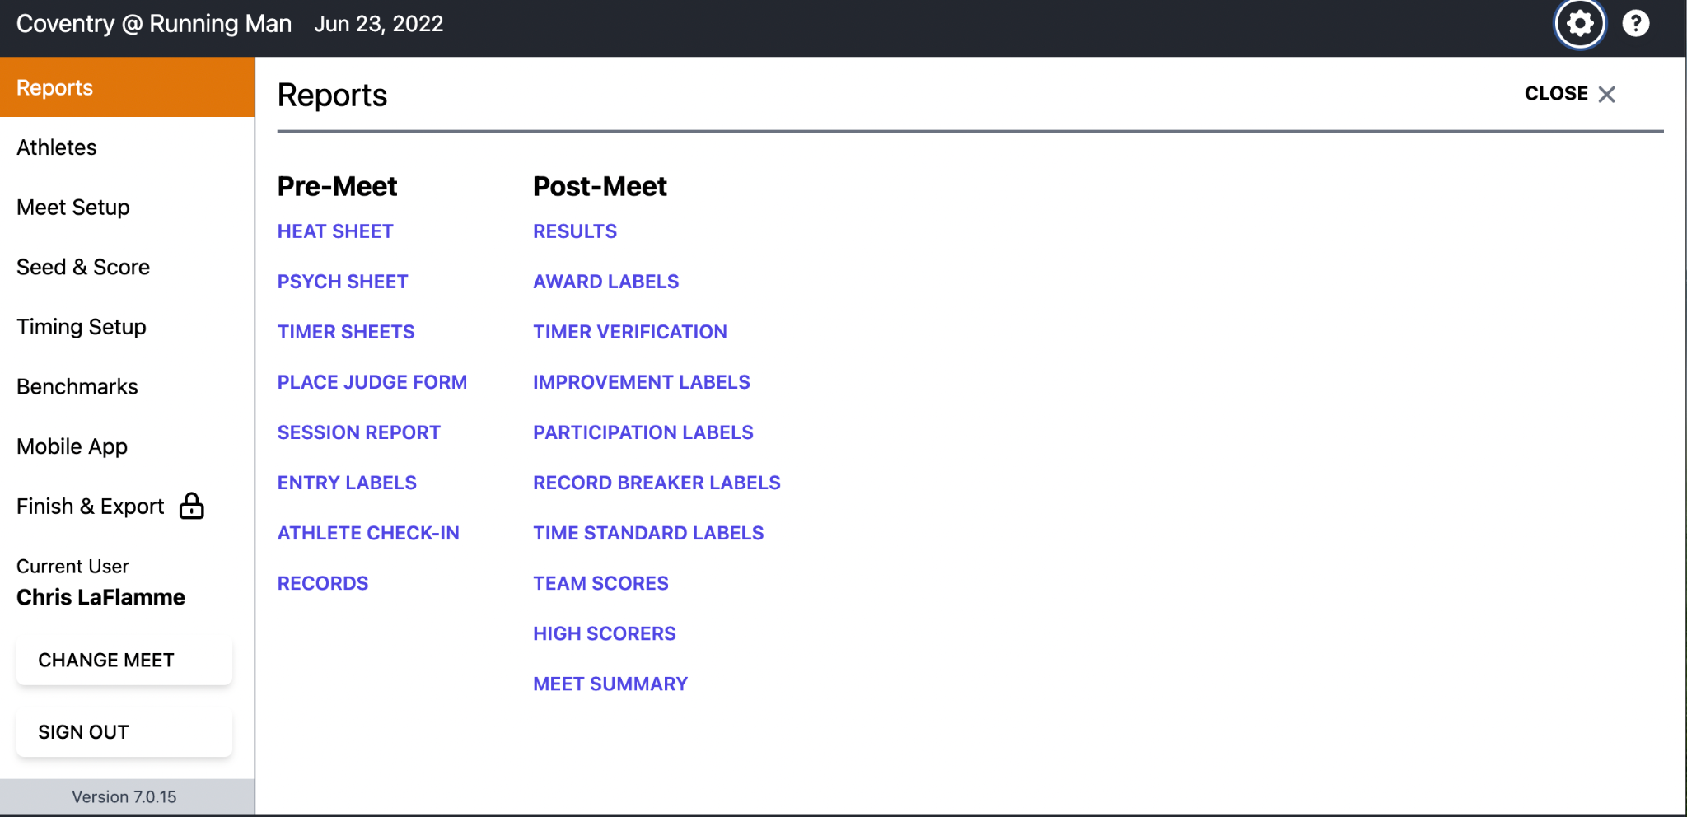

Click on Award Labels. Select Award Type as ‘Heat Place’. Set Heats to be 1 of 1. Set Individual Places to be 1 to 4. This will generate Award Labels for Heat 1 placement only. Once the report is generated, you can click the Printer icon to send to the Printer. Use Avery 8160 for inkjet printers or Avery 5160 for laser printers.

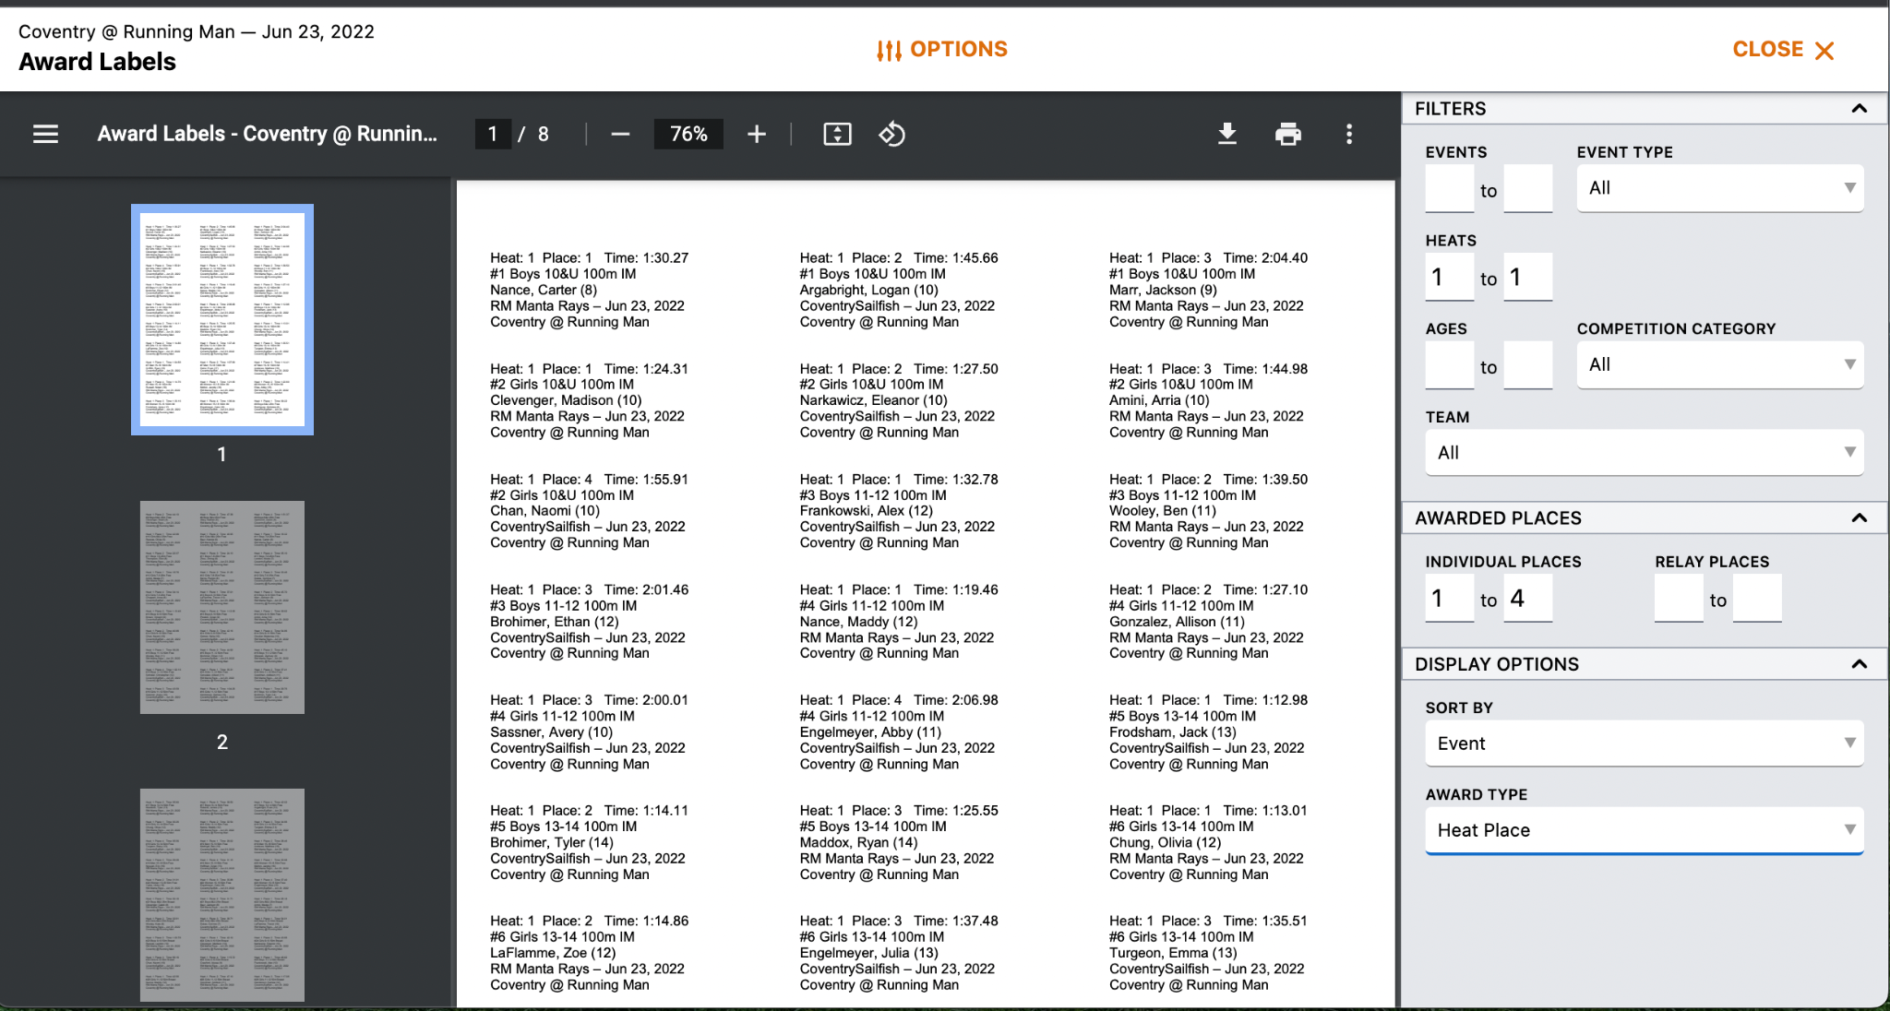

Next, click on the CLOSE link on the top right to return to Reports. Click on Participation Labels. Select ‘Exhibition / Non-Placing Only’. This will generate all the Exhibition labels. Once the report is generated, click the Printer icon to send to the Printer. Use Avery 8160 for inkjet printers or Avery 5160 for laser printers.

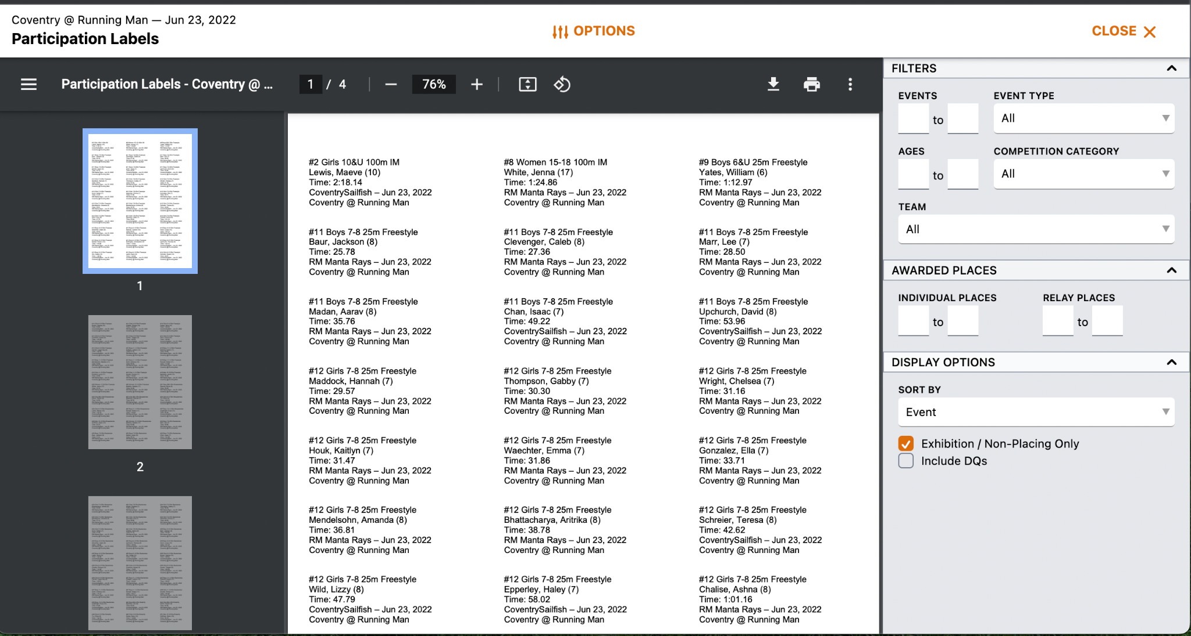

Flow of an Event

→ The Meet Ref will issue a series of 4-5 short whistles, signaling the swimmers behind the block to get ready for the next heat.

→ Announcer/Starter will announce the event/heat.

→ Once the Meet Ref can see that the swimmers are behind the block and ready, the Meet Ref will blow 1 long whistle inviting the swimmers to step up on the block.

→ Once the swimmers are on the block, the Meet Ref will extend his/her arm, clearly visible to the Starter. This action hands the control of the heat to the Starter.

→ The Starter will invite the swimmers to ‘Take Your Marks’. Once each swimmer has obtained a set position, the Starter will engage the starting unit, thus beginning the heat.

→ As the swimmers approach the wall for the completion of the swim, the timers should position themselves such that they can clearly observe the swimmer touching the wall. At the moment the swimmer touches the wall, the timer should stop their watch or press the button on the Time Drops device. Record the time to the nearest hundredths.

→ The Meet Ref will issue a series of 4-5 short whistles, signaling the start of the next heat/event. This action will start this process over again for the subsequent heat/event.

→ The Runner should collect all lane slips and deliver them to the Sweep Judges, who will collectively determine the ‘Order of Finish’.if lane slips are used

→ If the Runner has any DQ slips collected from the Stroke and Turn Judges, they should be delivered to the Meet Ref for final adjudication.

→ The Sweep Judges will hand over the ‘ordered’ lane slips to the Meet Ref. The Meet Ref will flag any lane slips with any accompanying DQ. This may change the order of finish depending on the disqualified participants. (For example, if the second place swimmer is disqualified, the third and fourth place finishers will be promoted in the order of finish accordingly).

→ The Meet Ref, or Runner if directed by the Meet Ref, will deliver the ordered lane slips* with accompanying DQ slips to the Scorekeepers for processing.* - if used; OR order of finish cards/slips will be turned in

→ The Scorekeepers will record the times and placement (for scoring heats) on the scoresheet or directly in Swimtopia. DQs should be denoted as well. If the lane slips are for an exhibition swim, the times should be recorded on the exhibition sheet or denoted as exhibition within Swimtopia.

→ The Scorekeepers will hand the lane slips to the Ribbon Writers for processing.

Export Meet Results to Teams Repository

In Meet Maestro, click on the ‘Settings’ gear located on the top right of the screen.

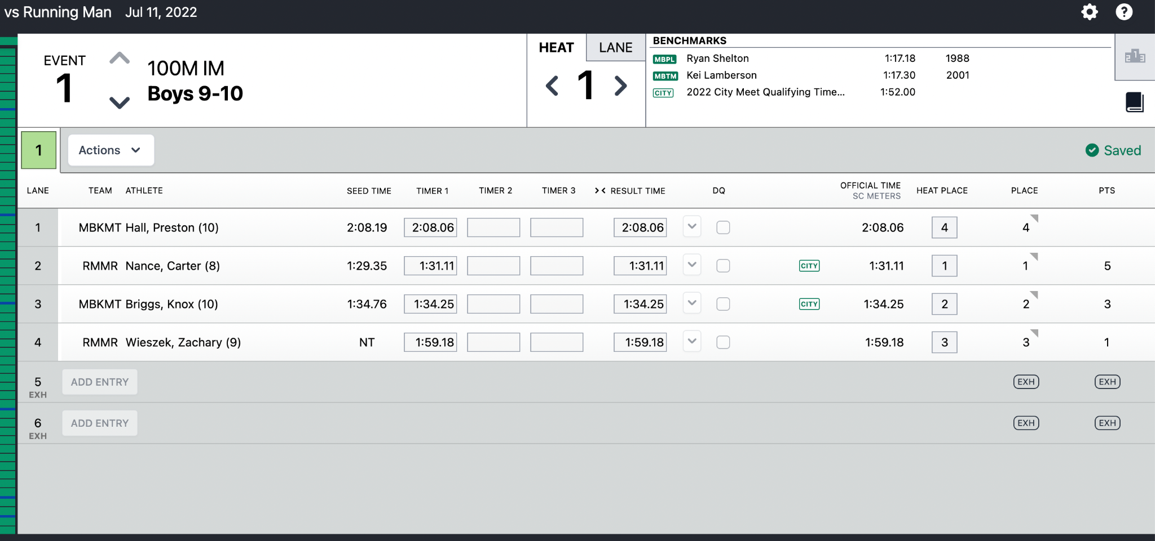

Next, click on ‘Finish and Export’ on the left side menu panel. This screen will allow you to transfer meet results to each team by clicking on the ‘Transfer Results’ button.

