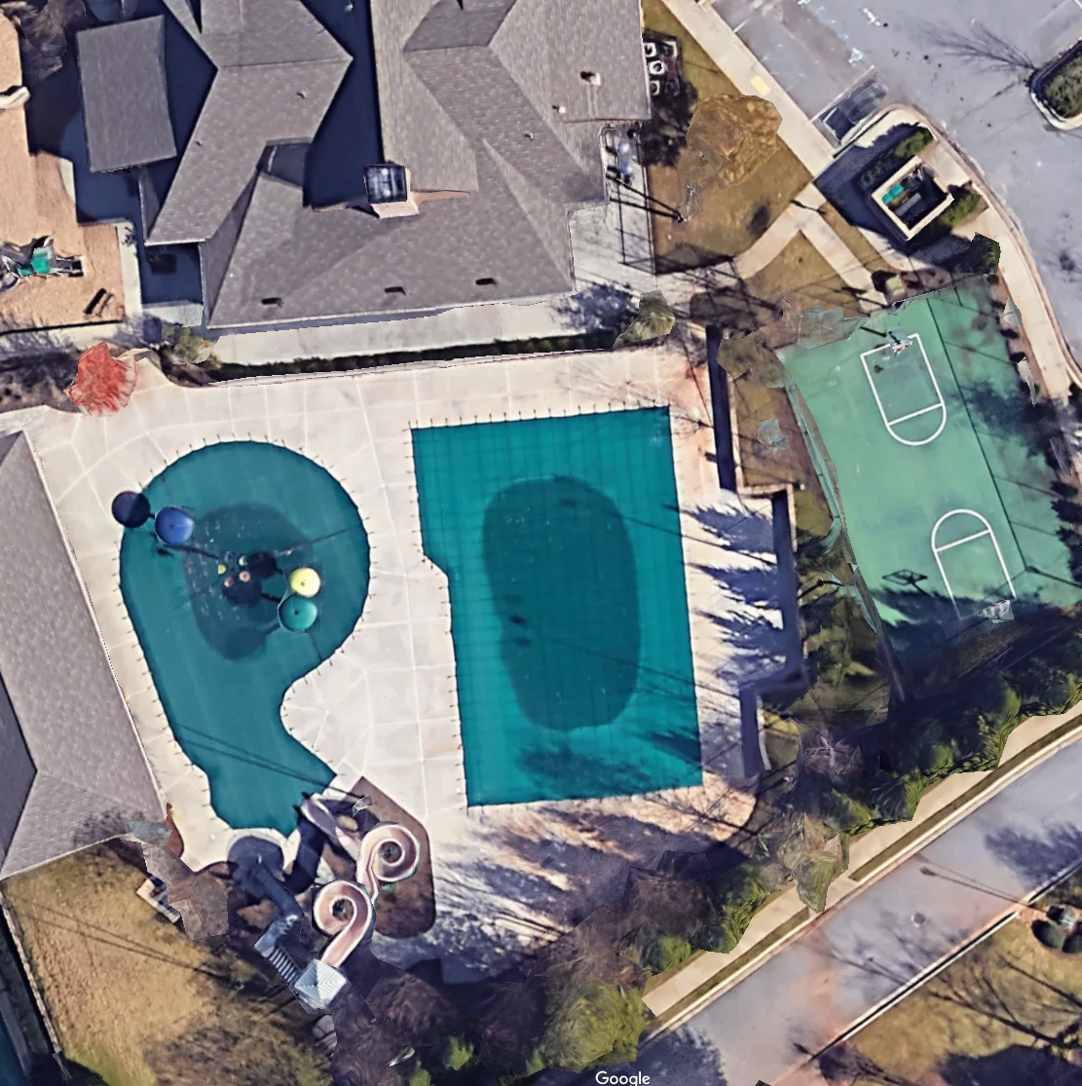
Start End of Pool
Away Team Setup
Megan Melchiors – Volunteer Coordinator
Computer Person

