How to declare your swimmer for a meet through Swimtopia
** Reminder- you must complete for each swimmer no later than 12 NOON the day BEFORE the meet. If you already know your summer schedule, go ahead and complete for the season. If you have declared as “attending this meet” and an emergency comes up, please text Coach Beeler so he knows you will not make it after all. 706-280-4848 (we worry when someone has declared and doesn’t make it, especially when it’s an away meet)
- Select meet and click on MEET ENTRY
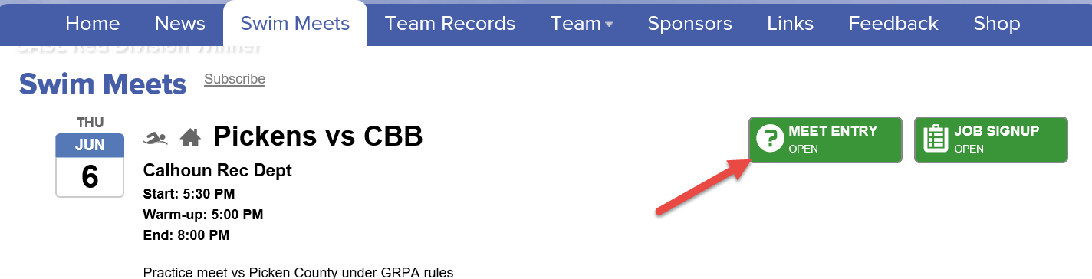
- Click “Edit” below swimmer(s) name
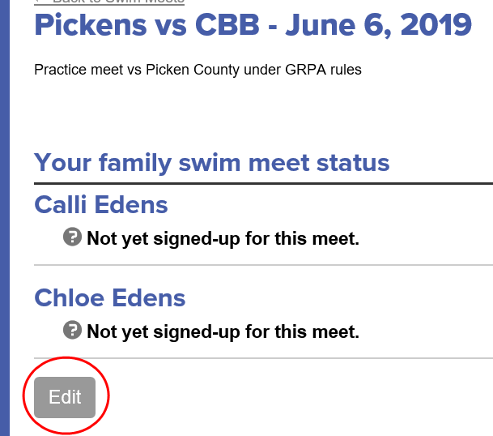

- From the drop down- select availabilty for the meet, and “SAVE”
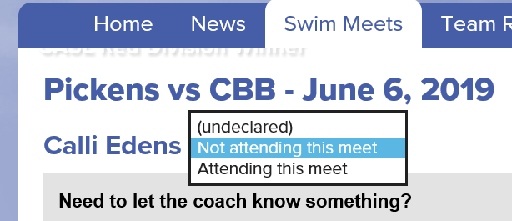
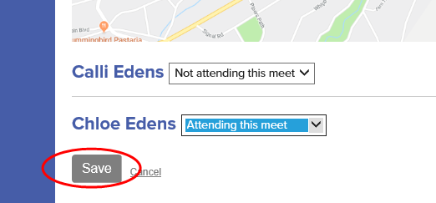
Volunteer Opportunities
** We cannot stress enough how important and vital it is to have parental help for each meet, especially home meets. The total bodies needed for a home meet is 36. (many roles take more than 1 person) If we can get enough volunteers, you can share assignments with a friend so that you can each make sure you get to watch your swimmer free of distraction. Below is a quick “how to” for signing up, followed by a description of each role.
- Select meet and click on “JOB SIGNUP”
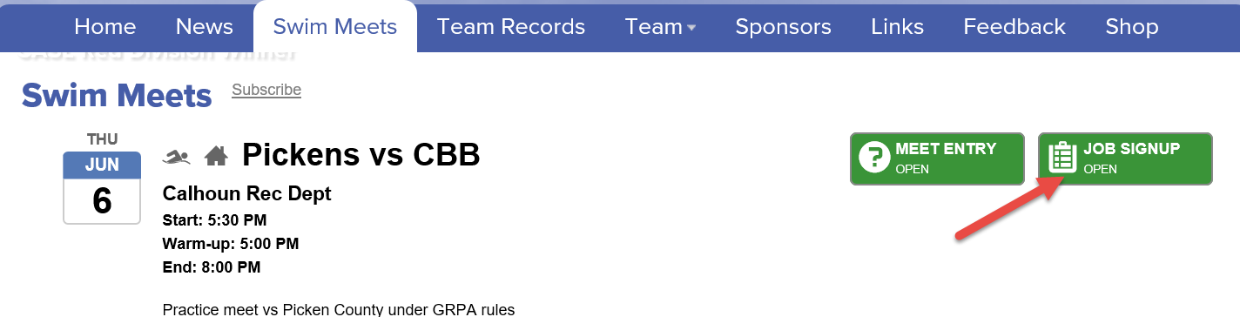
- Click on “Sign up for Jobs”
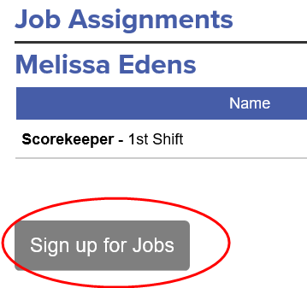
- Select job and click “SAVE ASSIGNMENTS”
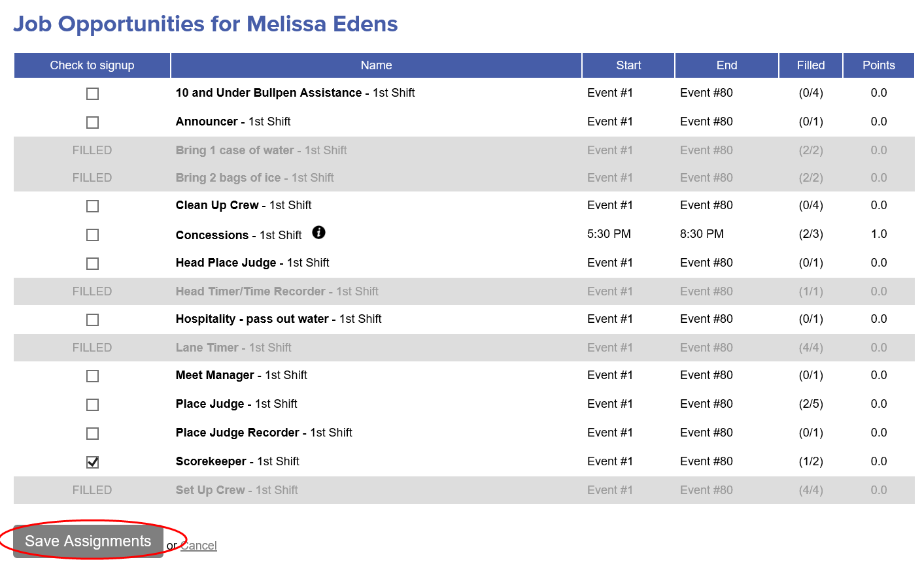

Description for volunteer roles

- 10 and Under Bullpen Assistance (4 volunteers):
  - Parents will ensure their swimmer reports to the bullpen area (corner of pool deck closest to baseball fields) 3-4 events prior to their own event. The bullpen assistant will check swimmers off on heat sheet once they are present and take them to starting area before his/her event.

- Announcer (1 volunteer):
  - Call for event numbers prior to each swim as well as announcing swimmers in each event over the PA system.

- Bring Case of water/ Bring bag of ice (2 volunteers for each):
  - Just as it reads, bring items- we will ice down water to be given to volunteers throughout the meet.

- Clean up Crew (at least 4 volunteers):
  - Take down tables, PA system, pick up trash, etc… The more that help, the faster it goes!

- Concessions (3 volunteers):
  - New this season! We will have a grill for burgers/hot dogs/chips/drinks. Need grill master and others to help with orders and as cashier

- Head place judge (1 volunteer):
  - This person will look to each of the place judges for lane assignment per place

- Head Timer/Time recorder (1 volunteer):
  - Write down stop-watch time given by timers for CBB lanes. (for every swimmer and every event)

- Hospitality (1 volunteer):
  - Hand out water to volunteers throughout the meet(timers, place judges, announcer, CASL officials, etc…)

- Lane Timer (4 volunteers):
  - Each timer will be given a stopwatch and assigned to a lane. You will time each event if there is a swimmer in your assigned lane.

- Meet Manager (1 volunteer):
  - Make sure we have everything to run meet and coordinate volunteers (usually the CASL rep)

- Place judge (5 volunteers):
  - As each event ends, watch swimmers give the head place judge the lane that has the swimmer for the place number you are assigned.

- Place Judge Recorder (1 volunteer):
  - Works with the head place judge and writes down the given lane for each place. (we really do need one person to receive/give number verbally and another to write it down. Meets go quickly and there is not a lot of time between events)

- Scorekeeper (2 volunteers):
  - Receives the sheets from the place judge recorder and enters them into the computer system.

- Set up Crew (4 volunteers):
  - Set up tents, tables, PA system, concessions, etc. Again, the more that pitch in, the faster it goes.

