Marking your swimmer
** if you have a younger swimmer (10 and under), it helps to have his/her age written on outside of upper arm. It’s hard to know age groups/names and helps the bullpen assistants get the swimmers in the correct age group. Many also write the swimmer’s name above or below age.
Find your swimmer’s information on the heat sheet:
Red = Event #
Blue= Heat
Green = lane #s
Orange= Event stroke

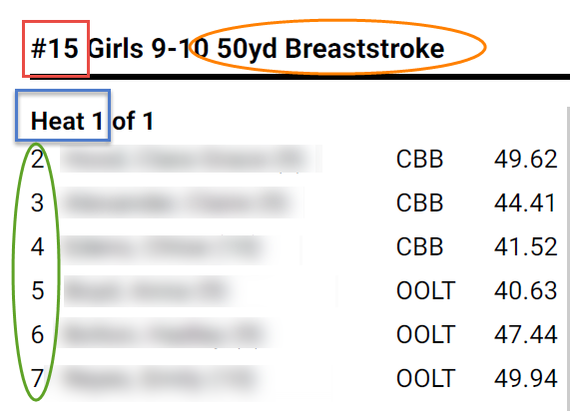

Using a Sharpie or other brand marker:
Draw a grid on forearm or upper thigh: write entries for each event- example for above event:
E | H | L | S
15 | 1 | 3 | breast

Once you have all events for your swimmer- it looks something like this…

