How to Mark your Athlete
With Sharpie
Please write their last name on their right shoulder
On their arm or leg please write their Event, Heat and Lane
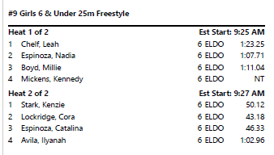
It should look like this

So in the above example Heat sheet example Millie will have the below (you can add the stroke at the end if needed)

If using the Athlete check in sheet you can read it the same way # Is the Event then Heat/Lane
