2019 South Briar Barracudas Swim-a-Long
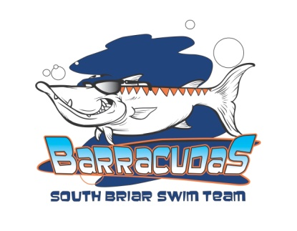

What: The Swim-a-Long is our annual fundraiser where the swimmers swim laps to raise money to donate to a worthy non-profit organization. This year we are raising money to replace our outdated equipment.

Why: To raise a donation for a good cause and give back to our community! 100% of the proceeds will go to improving our pool.

Who: All South Briar swimmers are encouraged to participate. We would LOVE 100% participation!

Where: At the South Briar pool.

When: Monday, June 24, 2019 during regular practice times.

How: Each swimmer will sign up "sponsors" before the Swim-a-Long. Sponsors can be mom, dad, grandparents, aunts, uncles, friends or neighbors. Sponsors make a one-time donation or a pledge for each lap. Sign up your sponsors before the Swim-a-Long! Turn in all pledges by Friday, June 28th. Make checks payable to South Briar Swim Team. A sponsor sheet is attached.

Prizes: Each swimmer who raises at least $25 will get a South Briar Barracuda swim bag! A grand prize will be awarded to the child who raises the most funds as well as the boy and girl who swim the most laps in each age group.

Parents: You haven’t been left out of the fun! To make the event a success we need volunteers to be lap counters at the event.

Questions: Amy Hulsey and Lee-Ann Hall, Swim-a-Long Coordinators
sbbarracudas@gmail.com
See you at the pool!!
SOUTH BRIAR BARRACUDAS
2019 Swim-a-Long Charity Event
Benefiting the South Briar Swimming Pool
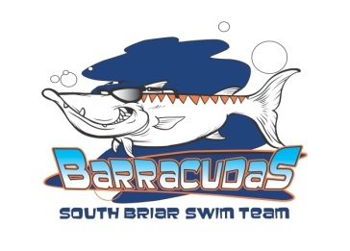
Swimmer’s Name: ______________________________________
Swimmer’s Age: ___________
Number of laps swam: ______________

Name of Donor | Phone Number | One Time Donation ($) | Donation Per Lap ($) | Total Donation ($)

Total amount collected $ ____________________
- Swim-a-Long event happens Monday, June 24th during practice
- All pledges must be collected and turned in by Friday, June 28th.
- Make checks payable to the South Briar Swim Team.
- 100% of the donation will go directly to improving our pool!
- Each swimmer who raises $25 or more will receive a South Briar Barracuda swim bag.
- A grand prize will be awarded to the overall top fundraiser in addition to the boy and girl in each age group that swims the most laps.

