Optional Spirit Wear Order ready for Divisionals

This year Divisionals falls the week of July 4th, so we thought we would celebrate
with some festive spirit wear. Orders due by MONDAY JUNE 18th.
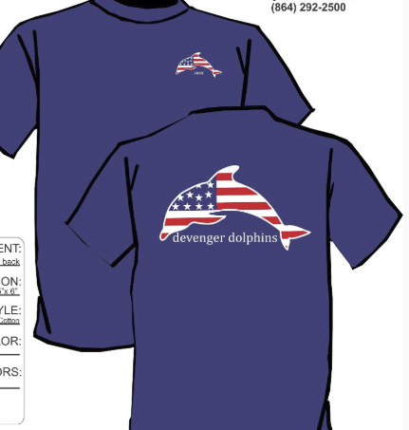
Checks Payable to DEVENGER SWIM TEAM
Price $12.50 YS- AXL
$15.50 2XL/3XL

Swimmer’s Name____________________________________________________________________________

Phone_____________________________________________________________________________________

Size (s) Youth Small-XL and Adult XS- Adult 3XL_____________________________________________________

Total Owed__________________________________________________________________________________

Total Quanity________________________________________________________________________________

Any Questions please contact Amy Penny @ 320-1085 or amybpenny @bellsouth.net or Erika Barr @ priceerika@bellsouth.net

