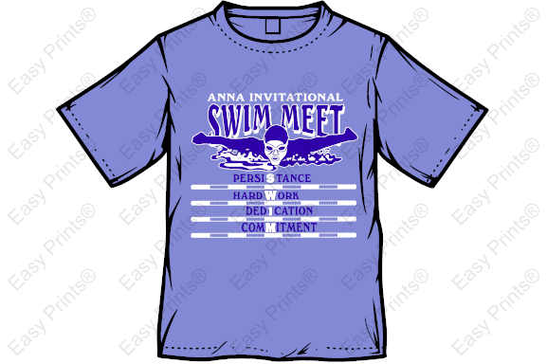
Shirts will be light blue with dark blue and white print

 | Y/S | Y/M | Y/L | Small | Medium | Large | X-Large | 2XL | 3XL | Cost | Total
Light Blue |  |  |  |  |  |  |  |  |  | $10.00
 |  |  |  |  |  |  |  |  | 2XL items add $3 each
 |  |  |  |  |  |  |  |  | 3XL items add $3 each
 |  |  |  |  |  |  |  |  | ORDER TOTAL

Orders and Payment are due by June 4th. Thank You!

Swimmer’s Name _________________________________________________

Parent’s Name ____________________________________________________

Phone # ___________________________________

Amount Enclosed _____________ Cash Check - Please make checks payable to Anna Blue Dolphins

