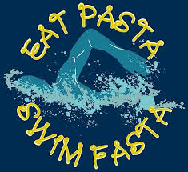

District Meet Pasta Dinner
Sunday, October 27th
5:00pm
Panariello House
1122 Garrison Drive
South Hampton development

Pasta/Meatballs/Salad will be provided and remainder of the menu will be contributions by the team:

Freshmen – Dessert
Sophomores – Cut fruit, veggies or chips
Juniors – Italian bread or dinner rolls
Seniors – Drinks

