GDSA Computer Scorer
Directions Running a Meet
Using Meet Maestro

Last Updated: July 29, 2020

Table of Contents
Getting Started with Meet Maestro 1
Prior to Meet 2
Entry Merge 2
Running the Meet 6
Individual Swimmer Event Changes 7
“Add Entry” Individual Event 8
Editing Individual Entries 9
“Add Entry” Relay Event 11
Editing and Deleting Relay Entries 12
Reports 15
During Meet 18
Meet Maestro Interface 18
Timing Entry 20
Data Entry Warnings 22
Disqualifications (DQ) 24
Point Scoring and Standings 26
Printing Labels 27
After Meet 28
Appendix A -- Setting Up an Intersquad Meet 30

Getting Started with Meet Maestro
To use Meet Maestro or your Swimtopia Team Website, you will need the following:
- URL / Website of your Team. Note: all GDSA team websites are listed at https://www.gdsaswim.com/ under the Teams tab.
- You will need a user login (email / password) for your team site. If you do not have or know this contact your team’s website administrator.
- Your account must have permissions to access to manage meets.
Login with email address and password. You need to click on the “Welcome <your name>” at the top of the screen to select / click on “Manage Team” menu. This will bring up a new screen and menu bar and you should be able to select “Schedule” to view and update meet entries. If you do not see “Manager Team” or “Schedule” contact your website administrator to change your account permissions to gain access.

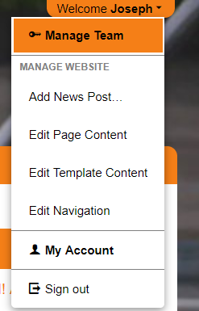

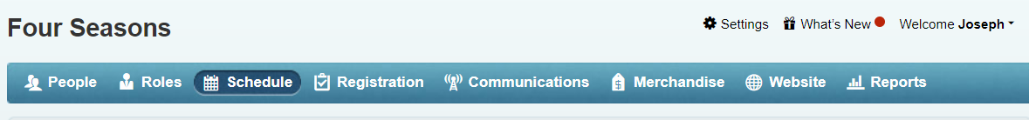

Prior to Meet

Entry Merge
After all meet entries are completed, it’s time to close entries and signal that you’re ready to merge.
Login to Team Website. Go to Manage Team(Upper Right Click on “Welcome [Name]”)> Schedule > [meet name]
Steps 1 – 4 will be executed by the Home Team.
- Go to Entries > Merge/Export and set “Lock out all entry changes” to On. This will prevent anyone from making any changes to the meet entries.

After locking entries, 2. Using the slider insure the home team is set to "Ready"
All teams in the meet must be “Ready for Merge” before the “Merge Meet Entries” button is enabled (button will only display for the Home team).
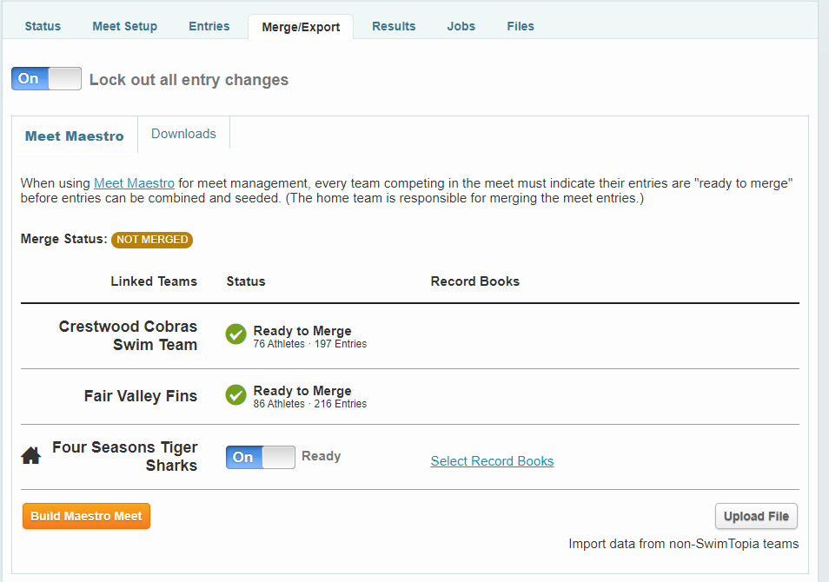
Clicking the “Merge Meet Entries” button opens a dialog with options for the Merge (some of these options will be disabled, based on the league’s Meet Template “Seeding & Scoring” settings.

- Check Virtual Meet and Pool Configuration.
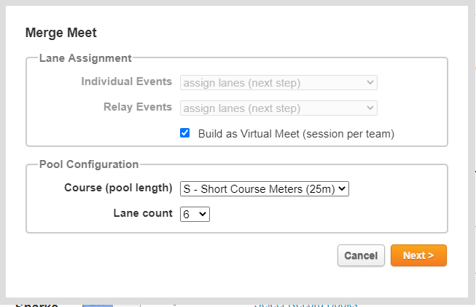

If the meet is Virtual you must check the “Build as Virtual Meet” check box. This will create a separate session for each team so their meet can be ran an entered independent of the other teams. Course should be S – Short Course 25m and Lane count should be 6.

- Enter Lane Assignments for each team.

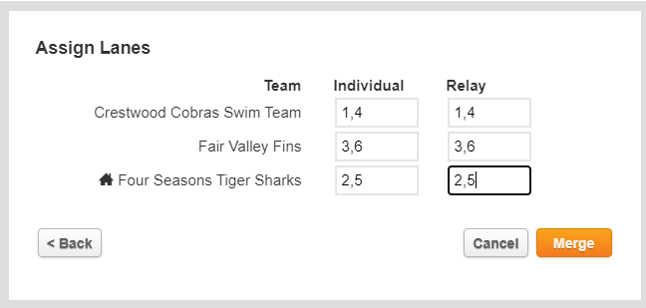

Enter the lane assignment for each of the teams. Home team is always lanes 2 and 5. First team listed is lanes 1 and 4 the third team is lanes 3 and 6. Press the merge button. The following screen will appear indicating merge in process.

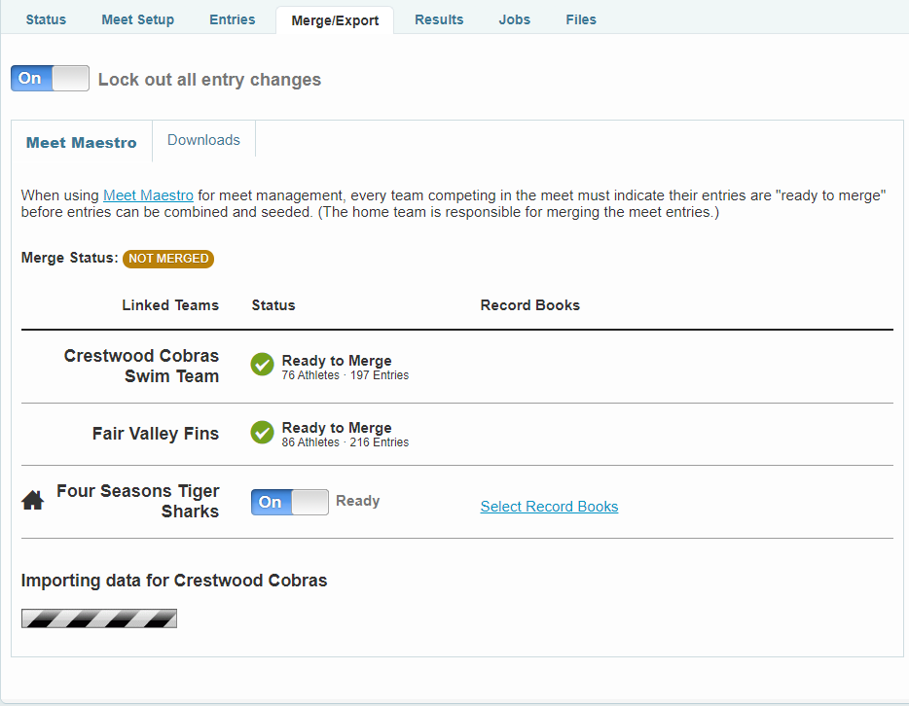

Once complete you will see the following screen with the Meet Maestro button present.

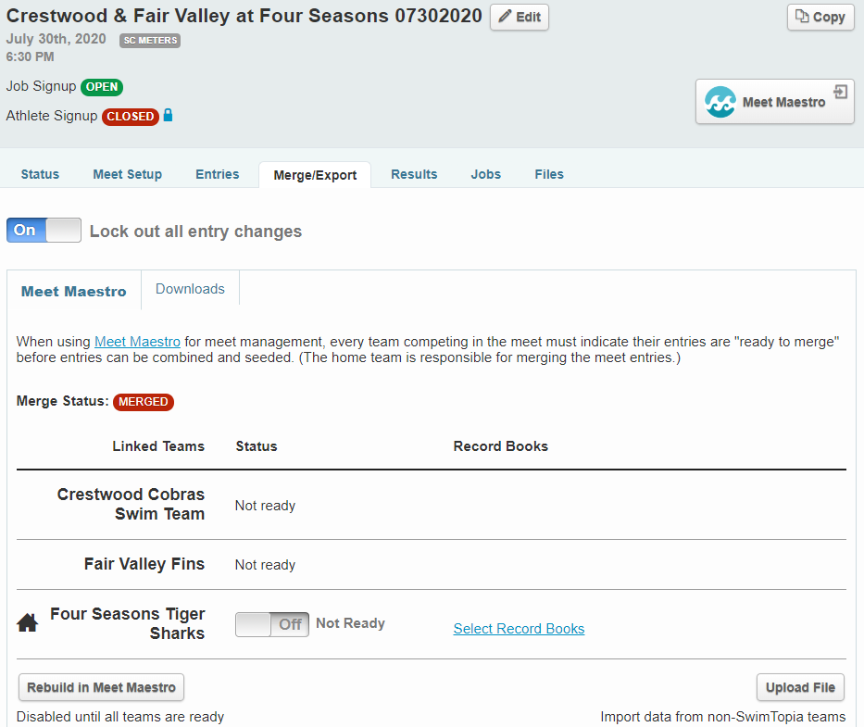

Once the home team merges the entries for the meet, all "Ready to Merge" checkboxes are automatically unchecked – this is to prevent the home team from re-merging without the visiting team’s consent.

- The “Meet Maestro” button is now enabled. Clicking on this button will launch Meet Maestro in a new window (we suggest using a Chrome browser).

For Virtual Meets prior to running reports and running the meet each team will need to go into Meet Maestro and change the lane assignments to the lanes that will be used during their session (e.g. Lanes 2 and 5).

Running the Meet
In order to Run a meet, you must Login into your Team’s website and your team must be the Home team for the meet. Chrome should be used to bring up the website and run the meet. Meet Maestro is NOT compatible with the web browser Internet Explorer. We suggest running Meet Maestro in Chrome.Schedule->Click on the meet name->Entries->Merge/Export-> Meet Maestro button. The Meet Maestro button will bring up a new window and you will need to login again with your username and password.

Note: Multiple users, including admins on any of the participating teams, may then click “Meet Maestro” to see the meet in Meet Maestro and run reports. The meet may be open in multiple browsers concurrently.
Connection: You will need a live internet connection to use Meet Maestro. A phone hotspot can be used if there are connection issues. If internet connection is lost. Timing results can still be entered. Meet Maestro will keep these results in pending status until internet connection restored. Once internet connection restored, Meet Maestro will automatically save pending results to the cloud.

Concurrent Data Entry: Multiple team admins, from any of the participating teams, can click on “Meet Maestro” to open the meet on multiple computers for concurrent data entry. It is not recommended to have multiple people entering data in the same event at the same time, but, for example, having one computer open to enter boys’ event times and one open to enter girls’ event times could be helpful.

Re-Accessing the Meet: If you close your browser or tab and need to return to your meet in Meet Maestro you can do that by checking “Run Meet” again in SwimTopia (do NOT re-merge the meet, or this will create a new blank meet).
Product Updates: We are continually making updates to Meet Maestro. If you see a “Download New Version” button on your dashboard, click on this button to receive the latest updates (you will not lose data).

If performing a virtual meet you must select your team’s session when you enter Meet Maestro
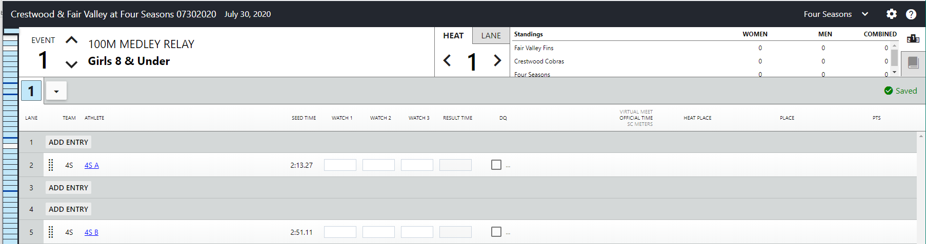
Note: When running reports you also need to select your team and session prior to running the report.

Individual Swimmer Event Changes
Athlete update options are found under Meet Maestro Settings (gear icon).
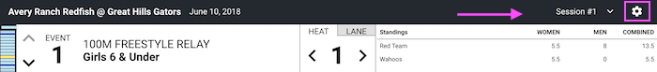
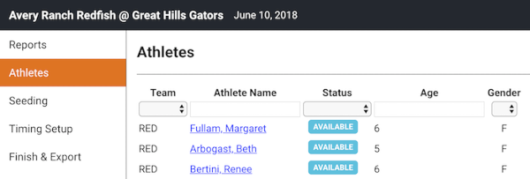
The Athletes tab allows you to search for athletes by:
- Team
- Athlete Name
- Status/Attendance
- Age
- Gender
- or any combination of those

When you click on an athlete's name here, or anywhere else within Meet Maestro, you will see an athlete information box, where you can:
- Scratch the athlete from events individually
- Scratch the athlete from all events at once
- Change the athlete's Heat and/or Lane
- Change the athlete's Entry Time
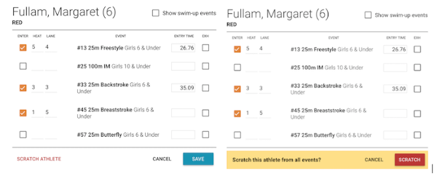
Scratching Athletes From All Events: Clicking “Scratch Athlete” reveals a confirmation box to make sure you want to scratch the athlete from all entered events.

“Add Entry” Individual Event
Clicking the “Add Entry” button in any open lane within a heat opens a window to quickly add a swimmer to that heat and lane. In this window, select the desired team, then the desired athlete, input an entry time and click Save.
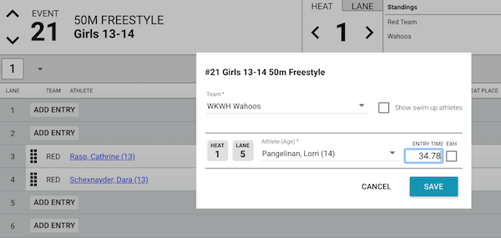
Note: when you “Add Entry,” it’s expected that the computer operator has a specific athlete to enter in mind. Meet Maestro currently allows adding any swimmer on the roster, without regard to attendance selections in SwimTopia, participation in another heat/lane in the same event, or eligibility for participation. To cross-check a swimmer's attendance/participation and seed times, you can either have another browser window open to each team’s meet entries matrix screen in SwimTopia, or have the printed Meet Entry Matrix report handy.

Editing Individual Entries
To edit any or all of the entries for any athlete, including adding or removing swimmers to/from events, click the linked Athlete Name. In the opened window check the box to ENTER an event, input desired heat, lane and entry time, then click Save.
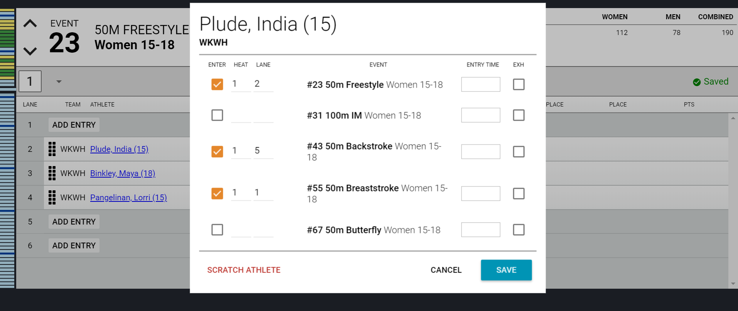
Unchecking the box next to an event will remove the athlete from that event, and “Scratch Athlete” at the bottom of the box will scratch the athlete from all events in the meet.

Clicking “Scratch Athlete” reveals a confirmation box to make sure you really mean to scratch the athlete.
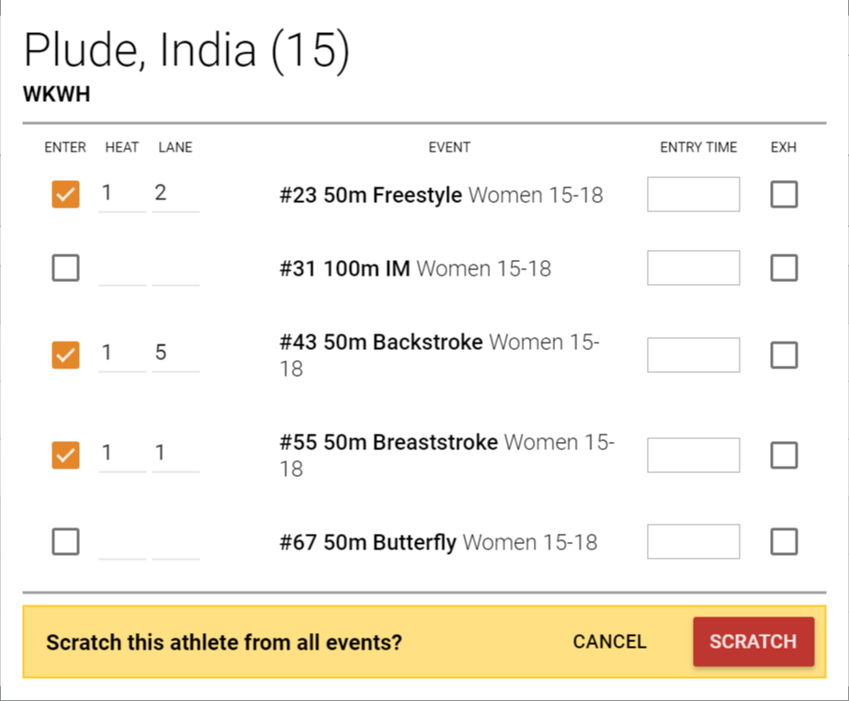

“Add Entry” Relay Event
When clicking the “Add Entry” in a relay event, you are prompted to select a team on the first screen.
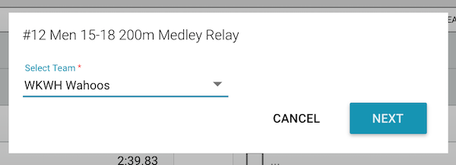

In the second step of Adding a Relay, select the Relay Team letter (e.g. A, B or C) and the Relay Athlete for each Leg. Input an Entry Time and click Save.
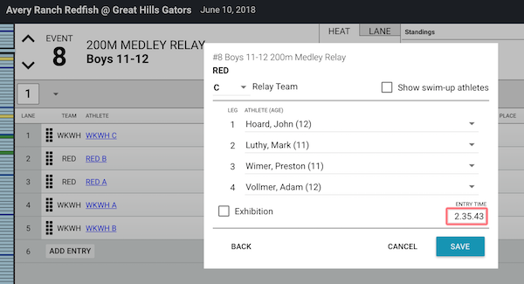
Tip: Hovering your mouse over the name of the Relay Team will display the names and ages of all relay athletes in leg order.
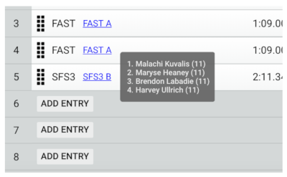
Note: when you “Add Entry,” it’s expected that the computer operator has specific athletes to enter in mind. Meet Maestro currently allows adding all swimmers on the roster, without regard to attendance selections in SwimTopia, participation in another relay in the same event, or eligibility for participation. To cross-check a swimmer's attendance/participation and seed times, you can either have another browser window open to each team’s meet entries matrix screen in SwimTopia, or have the printed Meet Entry Matrix report handy.

Editing and Deleting Relay Entries
Clicking the Relay Team name opens the Edit Relay interface.
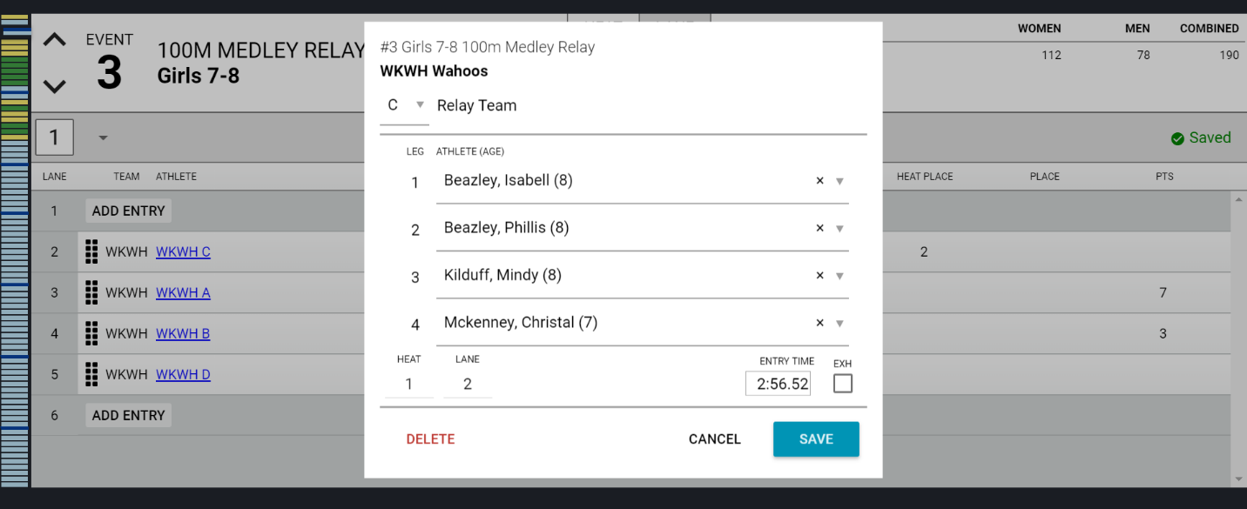

The Edit Relay interface makes it easy to switch out any of the relay team members or move teams to another heat/lane (example - diving board blocking lanes). The Heat/Lane fields are editable.
To delete the Relay, click the “Delete” button. Clicking “Delete” reveals a confirmation box to make sure you really mean to delete the relay.
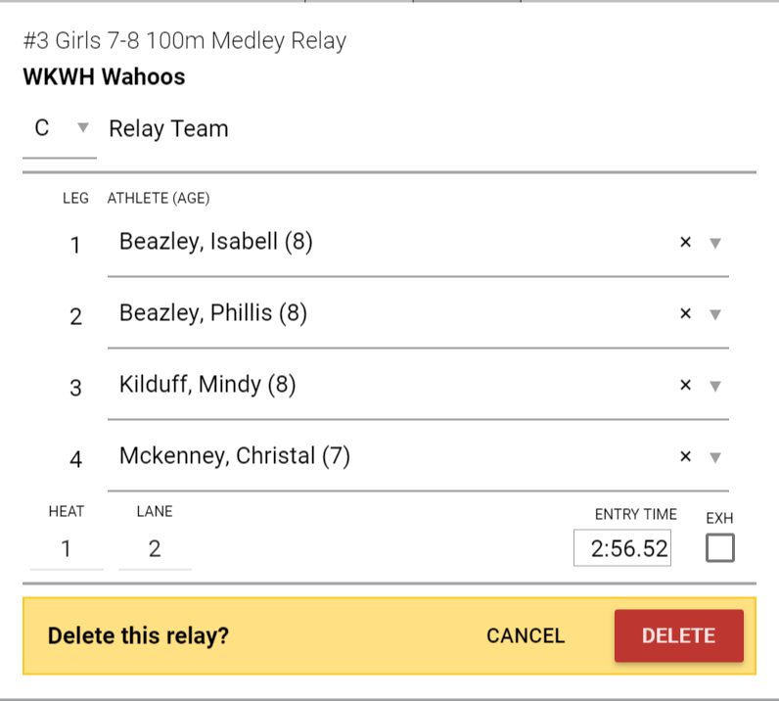

Deck Change Notification
If an admin makes a meaningful change to an entry, such as adding a new entry, making a lane change, or changing to exhibition, the record/row will be marked with a 'red' dogear on the right side.
Heat Actions Dropdown Menu
Use the drop down menu at the end of the list of heats to Add Heat, Remove Empty Heats, Re-score Event or Print Results for that one event.
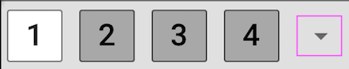
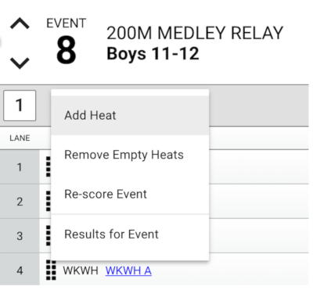
Re-score Event Tip: Normally your events will score automatically as soon as all data is input for all scoring heats in the event. If for any reason, your event is stuck in a “partial” update (yellow) state even though all the data is input, the re-score event option will force the event to score if it failed to do so automatically (it’s rare, but can happen in some scenarios).

Reports
Pre-Meet Reports are found under Meet Maestro Settings (gear icon).

Generate necessary reports, like the heat sheet, by clicking on the report headings. Pre-meet reports are in the left hand column. Each report will provide Sort & Display Options, and can be downloaded and/or printed.
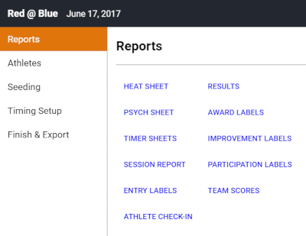

Note for Virtual Meets you need to select your team and session before printing the reports.
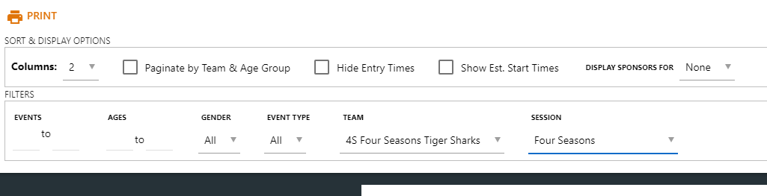

TIMER SHEETS: Print timer sheets for each lane. Choose 1 or 2 events per page. Note for Virtual Meets you only need to printer your two lanes (e.g. Lanes 2 and 5).
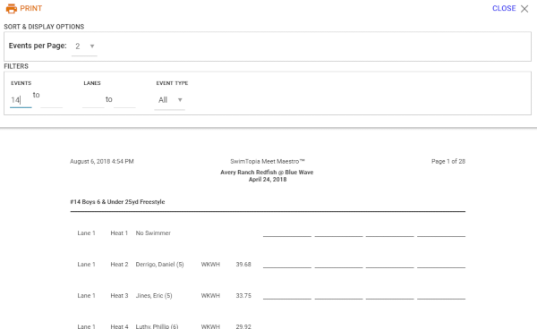
HEAT SHEETS: Print enough heat sheet sets for officials, coaches, and announcer (roughly 16). Choose either 2 or 3 columns.
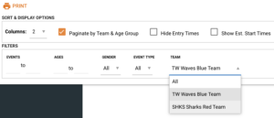
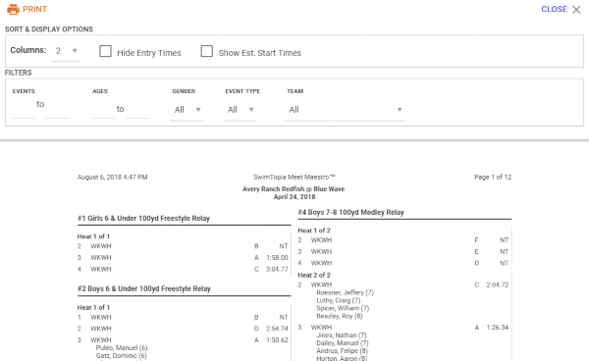
Printing Tips
1. Best printing results occur when using Chrome.
2. Ensure your zoom level is 100%. Do NOT check “Fit to Page.”
3. Be sure your report has finished loading before printing or saving as a PDF. Depending on computer and connection speeds, the first pages may be loaded, but the rest of the report may not finish for a few more seconds.
4. For larger reports, like the Timer Sheets, it can be helpful to print smaller ranges.
5. When Printing results check the “Include DQ Reasons” to have DQ descriptions included on printout
6. To save as PDF, bring up the report and press the Print button. Change the Destination to “Save as PDF”. It will remember this setting to send to printer you will need to change the Destination back.

During Meet

Meet Maestro Interface
Event Status Bar
The left sidebar in Meet Maestro provides an at-a-glance summary of the event status in the meet. Each colored cell represents a single event (for example “Boys 11-12 50yd Backstroke”).
The dark blue lines between cells are a visual indicator of a change in the stroke or event type (e.g. there is a dark blue bar between relays and freestyle events, then there is another blue bar between the freestyle and backstroke events, etc.).
- Green cells indicate events that are “scored” (all data used for scoring has been entered).
- Yellow cells indicate events with partially complete data (be sure to click the cursor away from all time entry boxes when you’ve finished entering each heat or lane so the event status cell turns green when all times for an event have been entered).
- Yellow Green indicates a virtual meet and your team has entered its entries but other teams have not.
- Blue cells indicate seeded events have not yet started.
- White cells indicate an “unseeded” event with no entries (rare).
Tip: Hovering your mouse over an Event Status Bar cell will reveal more details about the corresponding event, including the event name, status, and the number of heats and entries.
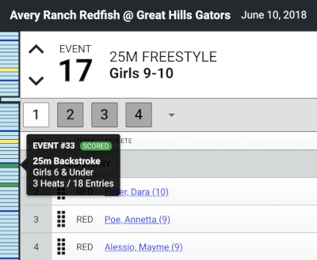
You can click on any of the cells to go directly to that event. The event number is shown prominently in the upper left corner of the screen. You can use the up/down arrows to the left of the event number to progress forward or backwards through the events. Keyboard shortcuts: “Command” (Mac) or “Control” (PC) plus the up/down arrow keys.

Heat View and Lane View
You choose to display your event in either Heat View or Lane View by selecting the Heat or Lane tab at the top of your screen.

Heat View:
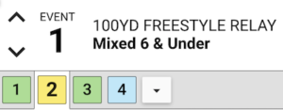
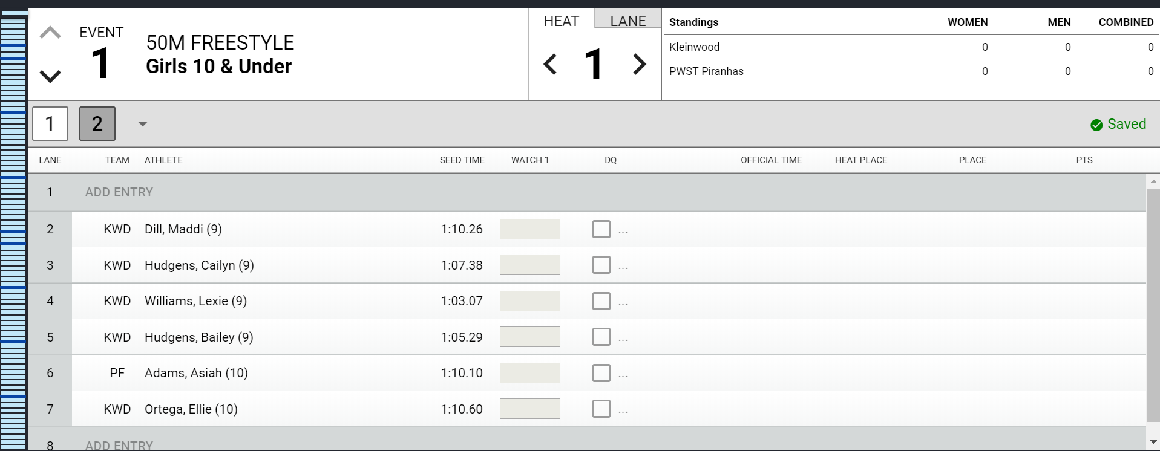
- Heat number is displayed in the Heat tab.
- Heats are shown in boxes below the event number.
- Each row displays the swimmers assigned to each lane for that heat.
- Easily move swimmers to different lanes within that heat by dragging and dropping the row to a new lane (hover over the left side of the row until your cursor looks like a cross).
- Move between heats by clicking the left/right arrows next to the heat indicator in the Heat tab, or by hitting “Command” (Mac) or “Control” (PC) and the left/right arrow keys.
- If on the last heat, arrowing to the "next" heat will automatically take you to the next event.
Lane View:
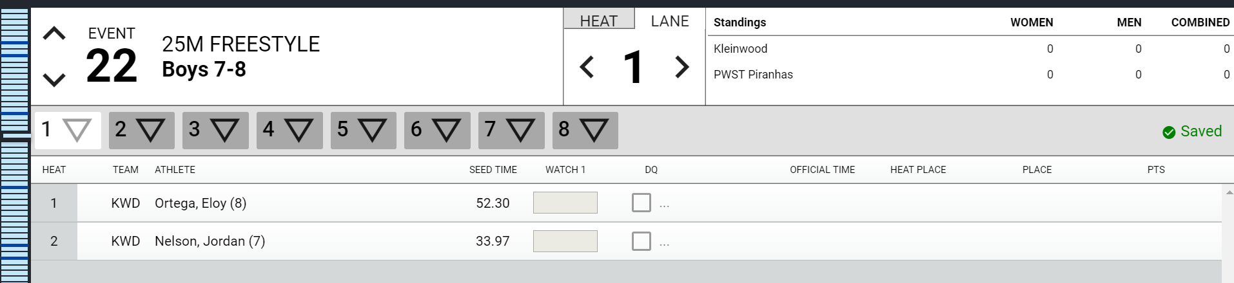
- Lane number is displayed in the Lane tab.
- All lanes are shown next to triangles (flags) below the event number.
- Each row displays the swimmers assigned to each heat within that lane.
- If timer sheets are printed by lane, this view will provide an efficient way to enter times as the timer sheets come in to the computer table.
- Move between lanes by clicking the left/right arrows next to the lane indicator in the Lane tab, or by hitting “Command” (Mac) or “Control” (PC) and the left/right arrow keys.
- If on the last lane, arrowing to the "next" lane will take you to the next event.

Timing Entry
Timing Setup options are found under Meet Maestro Settings (gear icon).
The meet can be configured to run with 1 to 3 watches.
Stop Watch Options:
- When in 1-watch mode, only an “Official time” will be entered.
- When 2-3 watches are active, the “Official time” is calculated automatically, following league-specified rules that are set in the Meet Template.

Continuous Auto-Save
All changes made in Meet Maestro are automatically saved as you go. You’ll notice saving activity indicated in the heat/lane bar. When you see a green “Saved” checkmark, you can be assured your data is saved and up-to-date.

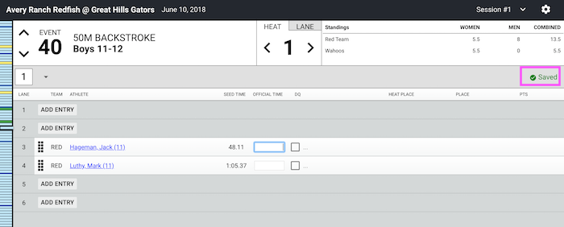
Data Entry Shortcuts/Tips
- When inputting times you don't need to type punctuation: e.g. typing '12345' will turn into "1:23.45". Typing incorrect punctuation will automatically correct (e.g. “104.56” auto-translates to “1:04.56").
- Hitting 'enter' or ‘tab’ on the number keypad will go to the next input field.
- Once you’ve finished entering data for a full heat or lane (depending on the mode you’re using), you can move to the next heat or lane by hitting “Command” (Mac) or “Control” (PC) and the left/right arrow keys.
- You can move between events on the schedule by hitting “Command” (Mac) or “Control” (PC) and the up/down arrow keys.
- Inputting "DQ" or even just “D” or "Q" will trigger the DQ entry window (not case sensitive).
- Enter N or NS for “No Show,” F or DNF for “Did Not Finish,” and S or SCR for “Scratch” (not case sensitive).
- If there is a blue outline around a time entry box, the system thinks you are still editing that time. Be sure to click the cursor out of a time entry box when you’ve finished entering a heat or lane so the event is considered complete.
- If you don’t enter a time or code for a swimmer, the event won’t be considered complete and will not be scored. To complete an event, every swimmer must have either a time or a code (NS, DQ etc.).

Data Entry Warnings
Invalid Time: If the time entered is considered invalid, the software highlights the time box to alert the admin to make an edit.
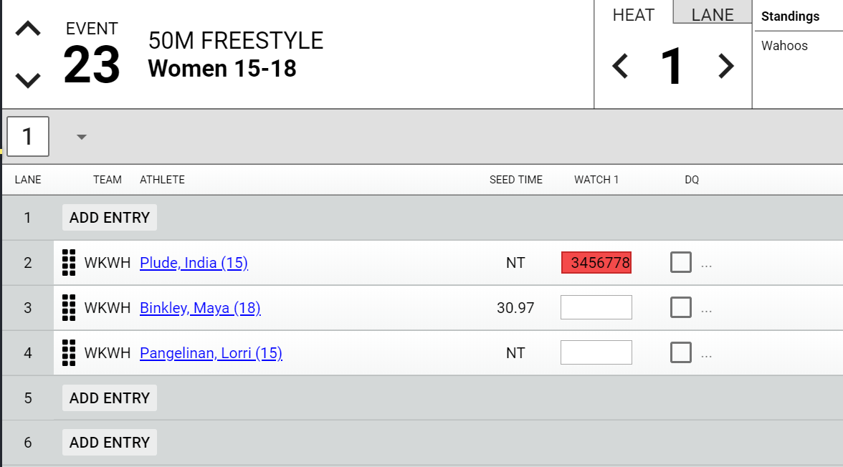
Display Warning or Discard Times: When entering times in “3 Watches” mode, the “official time” is calculated based on the league rules in the Seeding and Scoring Rules section of the Meet Template.
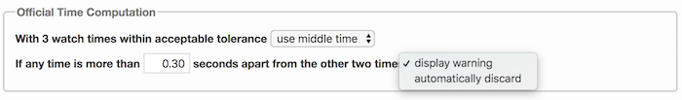
If “Display Warning” is selected in the template, the software will place an orange background in the box with the time that is out of acceptable tolerance, but the official time will continue to follow the rules outlined in the template. An admin can then decide how to edit or delete the time that is out of tolerance.

Tip: Hovering over the box will display a warning message to explain the issue.
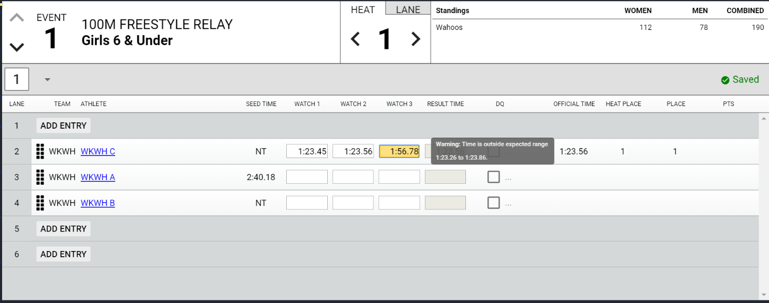
If “Automatically Discard” is selected in the template, the software will place a grey background in the box with the time that is discarded for being out of the acceptable tolerance, and the official time will be the average of the other two watches.
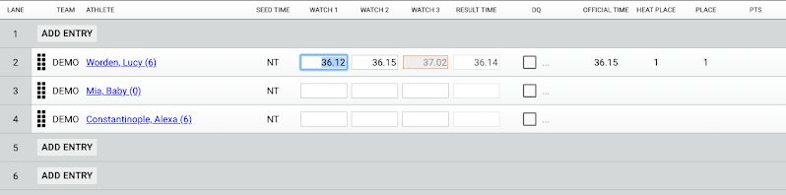
Hidden Times: Sometimes teams switch how many watches they use to enter times during the meet. If an official time was calculated using more watches than are visible in the interface, the software will display an exclamation mark next to the Watch 1 time. The exclamation point highlights a possible discrepancy between the Watch 1 time displayed and the official time (which is used for results, and placing/scoring as dictated by the league’s scoring rules).
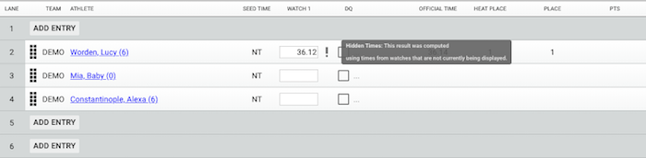

Disqualifications (DQ)
Checking the “DQ” box next to the time entry interface opens a window to check the DQ Reason.
Tip: You can also type either DQ , D or Q (not case sensitive) in the “official time” box, then hit enter (or click elsewhere on the screen), and the window to check the DQ Reason will open.
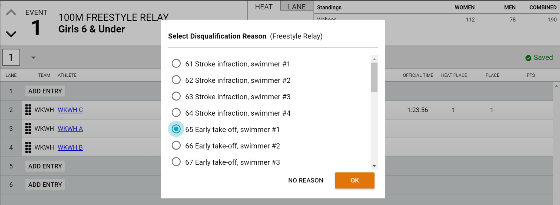
Select the DQ Reason (or click the “No Reason” button if no reason is specified), then click “OK” to save the DQ.
When entering a DQ for a multi-leg event such as a Relay or the Individual Medley, if a leg-specific stroke infraction is selected, you will be prompted to enter a secondary DQ Reason for that leg.
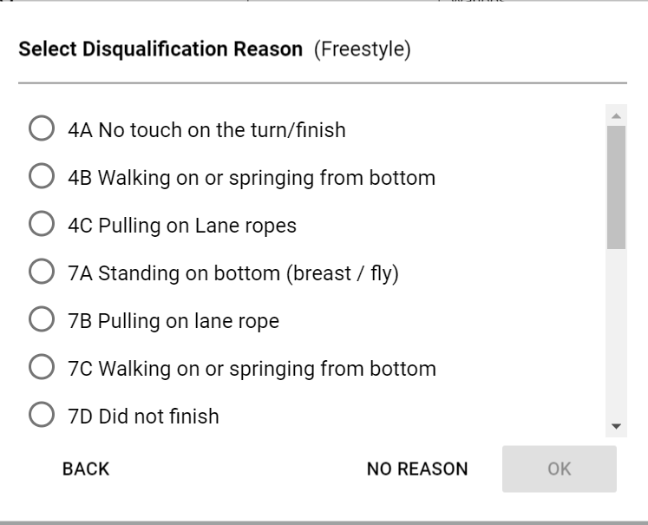
Tip: Hovering your mouse over the DQ checkbox or DQ Code, will display a pop-up summary listing all selected DQ Reasons.
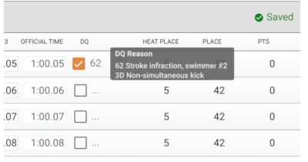
Deck Change Notification
If an admin makes a meaningful change to an entry, such as adding a new entry, making a lane change, or changing to exhibition, the record/row will be marked with a 'red' dogear on the right side.
Heat Actions Dropdown Menu
Use the drop down menu at the end of the list of heats to Add Heat, Remove Empty Heats, Re-score Event or Print Results for that one event.
Re-score Event Tip: Normally your events will score automatically as soon as all data is input for all scoring heats in the event. If for any reason, your event is stuck in a “partial” update (yellow) state even though all the data is input, the re-score event option will force the event to score if it failed to do so automatically (it’s rare, but can happen in some scenarios).

Point Scoring and Standings
As times are entered for each entry, the Heat Place, Place, and Points are automatically updated, based on the league rules in the Seeding and Scoring Rules section of the Meet Template. Once the event is complete (meaning times or DQs have been entered for all heats and entries in the event), overall standings (women, men, total) will be updated.
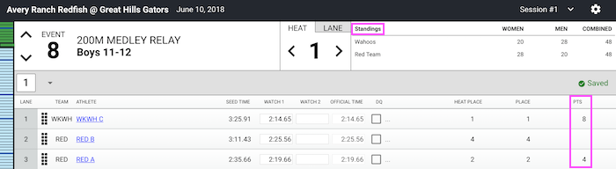

Printing Labels
Labels: Avery 8160 for inkjet, or Avery 5160 for laser printers (can be another brand)
Label Size: 1" X 2 5/8"
Sheet Size: 8 1/2" X 11"
Labels per Sheet: 30
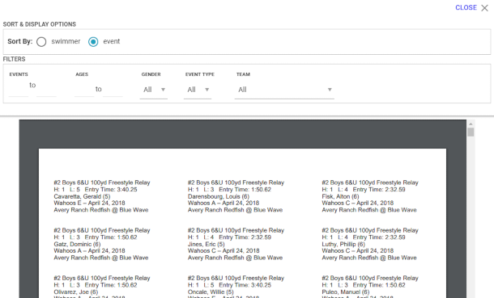

After Meet
Note: For Virtual Meets you should not do the following steps until all teams have entered their results. This is usually done the next day following the meet.

Once you’ve finished entering all data for the meet, you’ll go to the Finish & Export tab, found under the Meet Maestro Settings (gear icon).
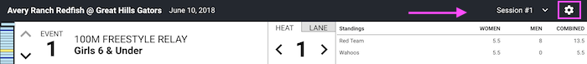
Tip: Before exporting results, ensure that all events are complete and scored (i.e. there are no “yellow” bars on your Event Status Bar). Once your Event Status Bar is all “green” you can Export Results to each team.
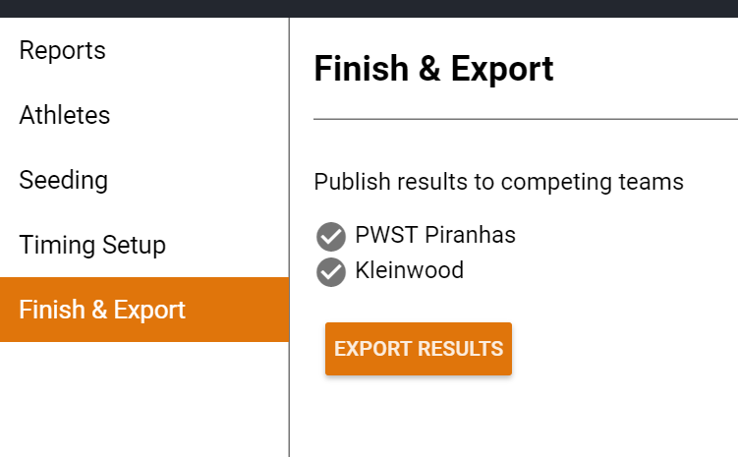
Note: The dialogue box does not show when the export is complete, but after a minute or so it will be complete and you can check your SwimTopia team site for the results.
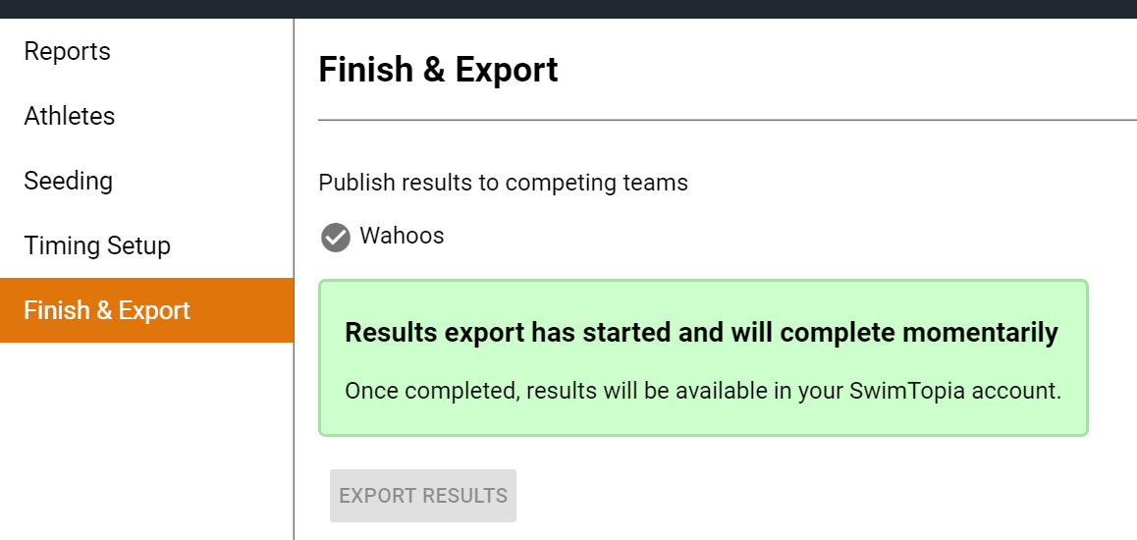
Tip: If you click “Export Results” a second time all results in each team’s SwimTopia sites will be updated with any edits made in Meet Maestro in the interim. If result edits were made in a team’s SwimTopia site under Results > Edit, those edits will be replaced by the exported results.
Tip: Once you close the meet in Meet Maestro you can return to the same meet from your SwimTopia team site via Schedule > Select Meet Name > Entries > Merge/Export and then re-clicking the “Run Meet” button. Do NOT re-merge the meet.

Results (including scores) will automatically upload to:
- Each team’s Results tab of the corresponding meet on their SwimTopia site.
- The Athlete Performance reports (Reports tab within SwimTopia).
- The per-family “My Account” swimmer time history pages within SwimTopia.

Appendix A -- Setting Up an Intersquad Meet

You can use Meet Maestro to setup and run your teams’ intersquad meets. This can be useful to obtain times etc…

To setup a meet the following steps can be performed.
- Schedule->Scroll down and press Add Swim Meet button -> New (Empty) Swim meet.
- Enter Name, date etc. You may want to select Hide from public calendar so parents cannot see this in the meet list on the website. Select Home meet.
- Press Save button on the Team Preferences
- Press the Events Tab->Apply Template Button->Select GDSA Regular Season Meets Unofficial for Mock (74 Events)
- You can now go to the Events tab and enter athletes into events.
- After events are entered, Entries -> Merge/Export->Lock Entries change toggle switch->Check “Ready for Merge”->Save
- Press Merge Meet Entries button->Press Merge button on pop-up.
- The Run Meet button should now be visible to run meet via Meet Maestro.
Note: To delete a meet click on Schedule->Click on the Meet name->Press the Remove button->Press OK on delete confirmation pop-up.

