VHS Tri-Meet
Westwood vs McNeil vs Vandegrift
Friday, September 25, 2020

Location: Bella Mar Community Center Pool (in Steiner Ranch)
12401 Bella Mar Trail
Austin, TX 78732

Meet Format: This will be a tri-meet between Vandegrift, Westwood, and McNeil. The events will be standard high school events, no diving. Entries will be seeded slowest to fastest by entry time.

There will be a 15-minute break after the men’s 50 Free, and a 10-minute break after the 200 Free Relay.

Time and Date: Friday 9/25/20

Timeline: Home Team Warmup: 7:00 – 7:40
Westwood Warmup: 7:40 – 8:00 (8 lanes), 8:00 – 8:20 (4 lanes)
McNeil Warmup: 8:00 – 8:20 (4 lanes), 8:20 – 8:40 (8 lanes)
Coach’s Meeting: 8:45
Officals/Timers meeting: 8:50
National Anthem: 8:55
Meet Start: 9:00

Rules: 2019-20 National Federation Rules Meet Referee: Ron Orris
Meet Director: Yvette Yung: yyung925@gmail.com, 512-350-4792 (cell)
Officials: We ask that each team supply one UIL or USA certified official if possible. Please contact our Meet Director in advance with name of official.

Entries: Please email your team entries to lisa.denison@leanderisd.org by Tuesday, September 22 by noon using Hy-Tek Meet Manager software.
Entry Deadline: 9/22/20 by noon.
Entry Limits: Each swimmer will be allowed to enter two relays and two individual
events, or one individual event and three relays, but not three individual events and one relay.

Teams may enter A-D relays for relay events, 4 per event for the 200 IM and 500 Free. Unlimited entries for all other events.

Scoring: Standard 8-place scoring will apply, relays will be double.
Timers: We ask that each team supply 4 timers and stopwatches.

Facility Info: 8-lane, 25-yard competition pool. No warm-up/cool down lanes will be available during the meet (all 8 lanes will be used for competition)

Each team will need to provide their own tents (and chairs) for their swimmer’s comfort. There are no chairs at the facility other than those provided behind the starting blocks for swimmers.

Parking: Buses should be parked along Bella Mar Trail (as indicated on the attached map), without blocking the traffic circle just past the Community Center.

For any questions: Please contact:
Lisa Denison
Vandegrift High School – Head Swim Coach
512-739-1976 (mb)
Lisa.denison@leanderisd.org

Covid-19 Specific Protocols:
SEE SPECIFIC ENCLOSED RULES to comply with CDC and Leander ISD guidelines for conducting safe competition during covid-19.

**** The Viper Swim & Dive Booster Club will be live streaming this event. The link to watch the event will be shared with all teams in advance to provide to family members, friends, and interested parties who cannot attend.

Girls | Order of Events | Boys
1 | 200 Medley Relay | 2
3 | 200 Freestyle | 4
5 | 200 IM | 6
7 | 50 Freestyle | 8
15 Minute Break
11 100 Fly 12
13 100 Freestyle 14
15 500 Freestyle 16
17 200 Freestyle Relay 18
10 Minute Break
19 100 Backstroke 20
21 100 Breaststroke 22
23 400 Freestyle Relay 24

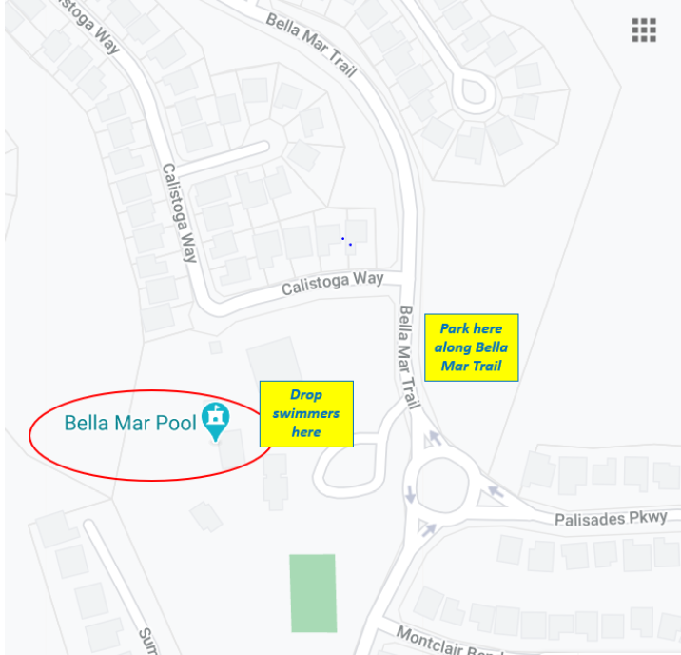
Close up Map of Bella Mar Pool Facility:

