

2023 LEE’S SUMMIT
SUBURBAN SWIM LEAGUE CHAMPIONSHIPS

Longview Community Center
3801 SW Longview Rd.
Lee’s Summit, MO 64081

Saturday, July 15, 2023
10 & under events begin at 8AM
11 & older events begin at 3PM

Meet information prepared by: 2023 SSL Board

Welcome to the 2023 Lee’s Summit Suburban Swim League Championships! Please read the following document carefully for important meet information from the SSL Board.

WARM UP TIMES: Please note the following warm-up schedule for the meet.

10&Under
7:00-7:15am Winterset, Bent Tree, Windsboro
7:15-7:30am Oak Tree, New Longview, Raintree
7:30-7:45am Lasers, Cruisers

11&Up
2:00-2:15pm Raintree, Oak Tree, New Longview
2:15-2:30pm Winterset, Bent Tree, Lasers
2:30-2:45pm Windsboro, Cruisers

PARKING: Spectator parking is available in parking lots around the Community Center. There is no parking in the circle drive. Coaches and League Reps will have designated parking in front of the building. Please follow directions of parking lot volunteers and do not part in areas reserved for people using Community Center facilities who are not part of the Swim League.

GENERAL POOL: Please abide by the rules regarding the Longview Community Center and surrounding areas. The Community Center will remain open to its members during the meet. Swimmers and families are not allowed on fitness equipment or basketball courts, etc. Please remain in the pool area and related facilities.

POOL DECK: NO crashing is allowed on the pool deck. Coaches will have seating along the pool edge. Swimmers should not crash around the coaches. Spectators are asked to watch their swimmers event and then leave the pool deck. Swimmers should plan to crash with their friends in the designated team/spectator crash areas outside in the grass.

VENDORS: The SSL is excited to be working with Fine Designs on the apparel for the 2023 SSL Championships. Fine Designs has you covered: Sweatshirts, t-shirts, performance apparel and more! Stop by during either session of the 2023 SSL Championships; they will be printing custom meet apparel including champions and finalist add-ons!

HEAT SHEETS: The heat sheet will be emailed to each team’s league reps for email distribution to their teams. Please print a heat sheet before you come to the meet as heat sheets will not be available for sale.

INFO SPECIFIC TO 10 & under SWIMMERS: Please write your 10 & under swimmer’s last name on their upper left arm. On their lower left arm, please write their events in the following format: Event/Heat/Lane/Stroke Please see the photo below.

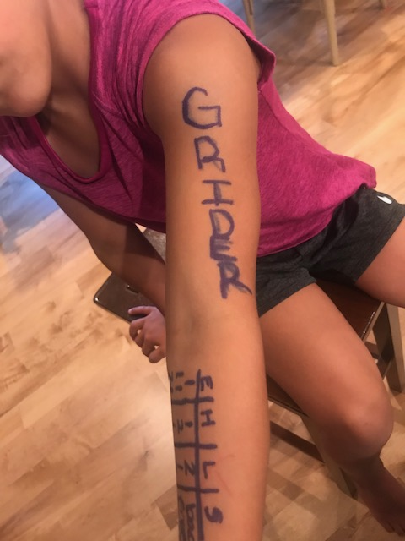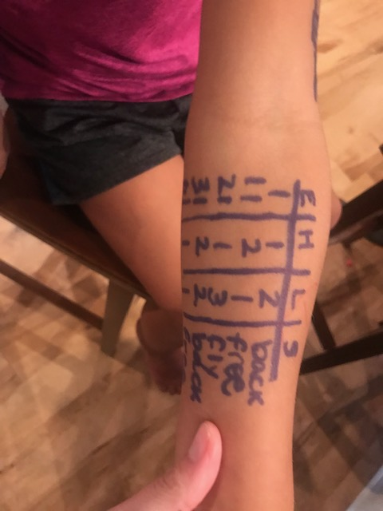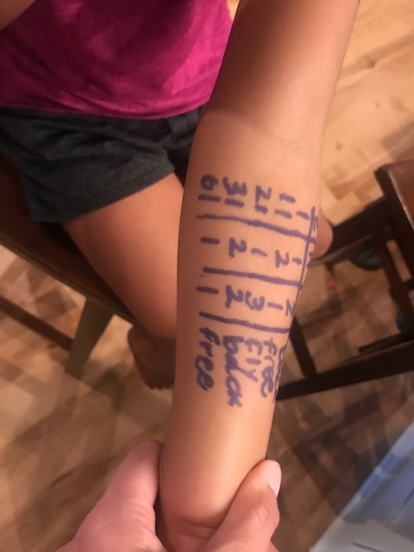

CONCESSIONS: The following food vendors are looking forward to serving Champs families. Vendors will be on site unless noted. NOTE: This list of vendors may change due to circumstances beyond the control of SSL or LSPR.
- Chick-fil-a: Available all day. AM-will provide free coffee with the purchase of breakfast biscuit. PM-normal swim meet offerings. We may also preorder trays that can be picked up at the tent for anyone that wants to do that. See your team rep for details.
- DBA Hungry Gator - Available all day: AM-pancakes / bacon, egg mcmuffins, etc.
PM- grill food in the afternoon / evening.
- Coaches Kettle Corn - offers kettle corn and frozen lemonade
- Ohana's - Evening
- Taste of Aloha (Shaved Ice) - 4:30 - 8:30 pm
- Baam Foods – Funnel cakes & grill items
- Gusto – **In store only** offering a 10% discount to anyone that mentions they are with the swim championship that day!
There is also an area east of the Community center where you will find Gusto Coffee, Longbell Pizza, Subway, and Longview Nutrition (until 2:00 pm). Chipotle, McDonalds, and Taco Bell are also nearby.
VOLUNTEER CHECK-IN AND INFORMATION: The volunteer check in table for all teams will be located outside of the main entrance of the community center. Please check-in and get your name tag no later than 20 minutes before your scheduled shift start time. The role of volunteers is critical to insuring a great meet for all swimmers. We appreciate you giving your role your undivided attention during the meet. Please limit the use of cell phones while volunteering during the meet.

STROKE & TURN JUDGE AND TIMER MEETINGS: There will be informational meetings for both Stroke & Turn Judges and Timers approximately 15 minutes prior to the start of each volunteer session. These are mandatory meetings so please be listening for an announcement for your meeting location and time.

STROKE & TURN JUDGE INFORMATION: We will use a total of six (6) S&T judges in order to provide fair and impartial stroke and turn judging. One will be located at each of the four corners of the pool. The new positions are one S&T judge will be located between lanes four and five on the turn walls. Please allow the judges ample space to move along the edges of the pool as they fulfill their role. Additionally, if you have a question regarding the S&T judge’s decision, please consult your team’s league rep(s) with any questions or concerns. Neither spectators nor swimmers should directly contact an S&T judge regarding a decision they have made.

PHONE APPS: Meet information will be available via SwimTopia.

SWIMSUITS: In keeping with our purpose as a recreational swim league please be advised that tech suits and fast suits of any kind are prohibited. Any swimmer wearing any “performance enhancing swimsuit” will be asked to change.

ZOO AREA: Only swimmers and zoo volunteers are allowed in the zoo area. There is no crashing allowed in the zoo area. Each team will have a designated canopy set up along the south wall so swimmers can wait nearby before entering the Zoo. Swimmers should stay in their team space once they check in. See the attached map for where the Zoo is located.

INCLEMENT WEATHER: In the instance of inclement weather, we will move forward with the meet unless power goes out. If weather precludes outdoor crashing, only swimmers can crash in designated areas inside the Aquatic Center and parents will have to follow along from the parking lot. You can only enter the center to watch your child’s event and then you will be asked to return to the parking lot.

SPECTATOR CRASH AREA: Spectators are allowed to set up canopies and tents in the grassy areas outside the Community Center. Items allowed are: lawn chairs, small folding tables, coolers, blankets, etc. The following items are not allowed: alcohol, glass containers of any kind, BBQ grills (gas or charcoal). Please be advised all SSL-sanctioned events are non-alcoholic and alcohol will not be allowed.

Attached is a map of the designated crash areas for each team. Please know you can crash wherever you want outside of the building, but we recommend staying by your team so it is easier to find missing swimmers, and IT’S SO MUCH FUN!!

Longview Community Center Map

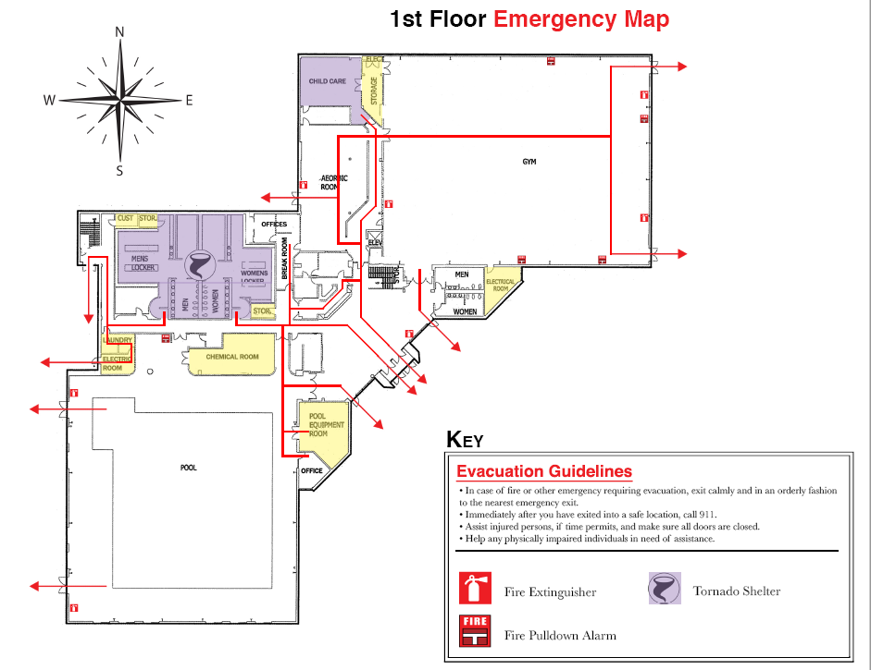

Spectator Outdoor Crash Areas
