**2018 MCSL DIVISION A T-Shirt ORDER FORM**

Division A is commemorating 60 years of MCSL swimming with a vintage styled design and logo t-shirt. Two shirt styles available – a youth and adult unisex t-shirt, and a women’s jersey muscle tank.

**COST**: $15 per T-Shirt Pre-Order; $18 per T-Shirt at Divisionals

$18 tank Top Pre-Order; $20 per Tank Top at Divisionals

**!!!LIMITED EXTRAS WILL BE ORDERED!!!**

**PRE-ORDERS:** ONE ORDER PER TEAM. DUE BY **SATURDAY, JULY 14th**, 8 p.m. Please email team order to Lumpoange Thomas at [lumpoangethomas@gmail.com](mailto:lumpoangethomas@gmail.com)

**PAYMENT:** **ONE** check made payable to the **Tilden Woods Swim Team** delivered at the Divisional Planning Meeting, no later than the Divisional Meet. Tilden Woods will distribute T-shirts at the Divisional Meet.

Please indicate quantity of shirts in the space provided below.

Team Name:

**UNISEX T-SHIRTS**

|  |  |  |  |  |  |
| --- | --- | --- | --- | --- | --- |
| **YOUTH**  **(Unisex)** | SMALL | MEDIUM | LARGE |  |  |
| **ADULT**  **(Unisex)** | SMALL | MEDIUM | LARGE | EXTRA LARGE | XXL |

**TANK TOP** (Adult XS is equivalent to Youth Large for girls ages 10 and older)

|  |  |  |  |  |  |
| --- | --- | --- | --- | --- | --- |
| **WOMEN’S** | EXTRA-SMALL | SMALL | MEDIUM | LARGE | EXTRA LARGE |

DESIGN MOCK-UP

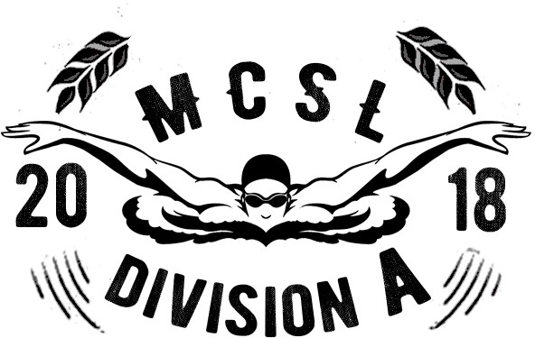FRONT

BACK

