Greater Annapolis Swim League
2023 Gold Meet at Bay Ridge

Sunday, July 23, 2023 at 8:30am
(warm ups begin @ 6:45am)

Host Pool – Bay Ridge Pool Association 2 Herndon Ave., Annapolis MD 21403
Starter – Matt Soltis, Indian Landing (relief Brad Hersey – Davidsonville)
Lead Official – Kevin Avery, Indian Hills (relief Brent Canaday – Indian Landing)
Meet Director – Erin Jaeger, Bay Ridge (240) 463-6557

Volunteer Assignments

- Volunteer Check-in
  - The volunteer table/tech room is upstairs in the Club House.
  - Teams can pick up their meet programs, meet entries, coach concession vouchers, relay change cards and name tags.
  - All volunteer assignments are for the duration of the meet unless otherwise indicated.
*** relief requests should be directed to your respective GASL League Rep.***

- Timer & Stroke and Turn Meeting
  - The timer meeting will take place at 7:30am upstairs in the clubhouse.
  - Stroke and Turn meeting will take place at 7:30 upstairs in the clubhouse lead by, Kevin Avery.

Timers - 18 Total for 6 Lanes + Head Timer

Head Timer - Davidsonville
Lane 1 – Admiral Heights, Bay Hills, Harting Farm
Lane 2 – Chase Creek, Indian Hills, Cape St. Clare
Lane 3 – Indian Landing, Davidsonville, Hunt Meadow
Lane 4 – Bay Ridge, South River, Hillsmere
Lane 5 – Ulmstead, Harting Farm, Truxton
Lane 6 – Severn River, Chase Creek, Downs

*** Host Team will provide stopwatches ***

Stroke and turn:

Jamie Baxter – Bay Ridge
Chet Goudy – Severn River
Jack Deppe – Davidsonville
Jonathan VerMerris – Admiral Heights
Michelle Barrett - Bay Hills
Mark McGonigle - Chase Creek
Brian Corcoran – Cape St. Clare
Adam Harris – Cape St. Clare
Sarah McGrath – South River Colony

Additional Volunteers

 | First Half | Second Half
Tech/Computer Room | Bay Ridge | Bay Ridge
 | Indian Landing | Indian Landing
 | Hillsmere | Hillsmere
Ribbons | Walden  Evergreen | Davidsonville  Ulmstead
Lane Organizer/Clerk of Course | Indian Landing | Davidsonville
 | Chase Creek | Bay Hills
 | Indian Hills | Hunt Meadow
 | Harting Farm | Severn river
Sheet Runner – Timer Sheets | South River | Chase Creek
Sheet RUnner – DQ Sheets | South Down | Cape St. Clare
Heat Winner | Hillsmere | Harting Farm

*** Lane organizers may pick up programs in the clubhouse

Warm-up assignments:

 | Lane 1 | Lane 2 | Lane 3 | Lane 4 | Lane 5 | Lane 6
6:45-7:00 | BR | BR | AHST | HILL | HILL | HILL
7:00-7:15 | DST | DST | DST | DST | TPST | TPST
7:15-7:30 | IHST | IHST | IHST | HMST | HMST | HMST
7:30-7:45 | HF | HF | CCST | CCST | ULM | EVG
7:45-8:00 | DOWNS/SD | SRSC | SRSC | BHST | BHST | WALD
8:00-8:15 | CAPE | CAPE | ILBC | ILBC | SRCST | SRCST
8:15-8:25 | SPRINT | SPRINT | SPRINT | SPRINT | SPRINT | SPRINT
(BR: Bay Ridge, AHST: Admiral Heights Swim Team, HILL: Hillsmere, DST: Davidsonville Swim Team, TPST: Truxton Park Swim Team, IHST: Indian Hills Swim Team, HMST: Hunt Meadow Swim Team, HF: Harting Farm Swim Team, CCST: Chase Creek Swim Team, ULM: Ulmstead Swim Team, EVG: Evergreen Swim Team, DOWNS: Downs Swim Team, SD: South Down Swim Team, SRSC: Severn River Swim Club, BHST: Bay Hills Swim Team, WALD: Walden Swim Club, CAPE: Cape St. Clare Swim Team, ILBC: Indian Landing Beach Club, SRCST: South River Colony Swim Team)

Starting/Lineup Area:

- The starting area will be at the deep end of the pool closest to the clubhouse.
- The Clerk of Course will be behind the diving well, to the left of the Clubhouse.
- Please let all parents know that only volunteers and coaches are allowed in this area.
- It is suggested that all teams have a kid finder.

Athlete/Relay Changes:

Late scratches and relays changes (that are consistent with GASL rule 4.6.6(c)) will be
accepted until 7:30am. Deck seeds will not be accepted per GASL rules. Changes will
be reprinted for officials only.

.
Parking:

Parking is allowed in the Bay Ridge Pool Association Lot only. Overflow parking will be
in the Chesapeake Bay Foundation Lot. Please follow the direction of the parking
attendants wearing yellow vests!

Concessions:

Concessions will open at 7:45am. We will be accepting cash and Venmo!

Team Areas:

- Please see the attached map for designated team areas.
- Please bring your own chairs and sit in your designated team area. Feel free to bring tents if you would like. Coaches may bring chairs to sit on by the side of the pool.
- All teams should be seated off the pool deck to keep clear for viewing the meet.
- The diving well and baby pool are closed during the meet.

General Rules:

- The Bay Ridge Beach is strictly off limits to all participants and spectators of the Gold Meet.
- Bay Ridge is a non-smoking property.
- Please drive with caution when entering the Bay Ridge Community
- There is to be no cell phone use behind the blocks.
- Siblings and young swimmers should be supervised at all times – the property is surrounded by water.

Charitable Focus:


We will be hosting a food drive to support the Light House Shelter in Annapolis. Please consider donating canned food items to this organization who help so many throughout the Annapolis community. There will be bins by the entrance to the pool.

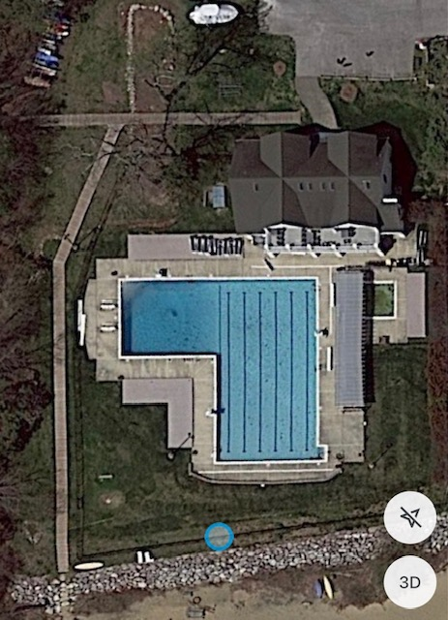
CHASE CREEK
BAY RIDGE
ADMIRAL HEIGHTS
ULMSTEAD
HARTING FARM
INDIAN LANDING
DAVIDSONVILLE
HUNT MEADOW
INDIAN HILLS
SOUTH RIVER
HILLSMERE
WALDEN
SEVERN RIVER
DOWNS
EVERGREEN
TRUXTON PARK
CAPE
SOUTHDOWNS
BAY HILLS
CLERK OF COURSE

