2023 RSL Battlefield Division Championship Meet

Who: The Battlefield Division
- Hampton Oaks (Host)
- Curtis Park
- Fawn Lake
- Leeland Station
- Massad YMCA
- Woodland Wahoos

What: 2023 RSL Championship Meet

Where: Jeff Rouse Swim and Sport Center – 8 Lanes – 25 yards
1600 Mine Road, Stafford, VA 22554

When: Saturday, July 22, 2023 starting @ 8:00 AM to completion

1st Session Warm-up Schedule (10 & Under Swimmers)
Curtis Park | 7:00-7:15 AM | Lanes 1-3
Fawn Lake | 7:00-7:15 AM | Lanes 4-6
Hampton Oaks | 7:15-7: 30 AM | Lanes 1-3
Leeland Station | 7:15-7: 30 AM | Lanes 4-6
Massad YMCA | 7:30-7:45 AM | Lanes 1-3
Woodland Wahoos | 7:30-7:45 AM | Lanes 4-6

7:50 am National Anthem
8:00 am Session 1 Starts: Events 1-24

2nd and 3rd Session Warm-up Schedule (11 & Over Swimmers)
Curtis Park | 11:00-11:15 AM | Lanes 1-3
Fawn Lake | 11:00-11:15 AM | Lanes 4-6
Hampton Oaks | 11:15-11:30 AM | Lanes 1-3
Leeland Station | 11:15-11:30 AM | Lanes 4-6
Massad YMCA | 11:30 -11:45 AM | Lanes 1-3
Woodland Wahoos | 11:30 -11:45 AM | Lanes 4-6

12:00 pm Session 2 Starts: Events 25-38
2:10 pm Session 3 Starts: Events 39-68

Jeff Rouse Pool Layout for RSL Championship Meet – Battlefield Division
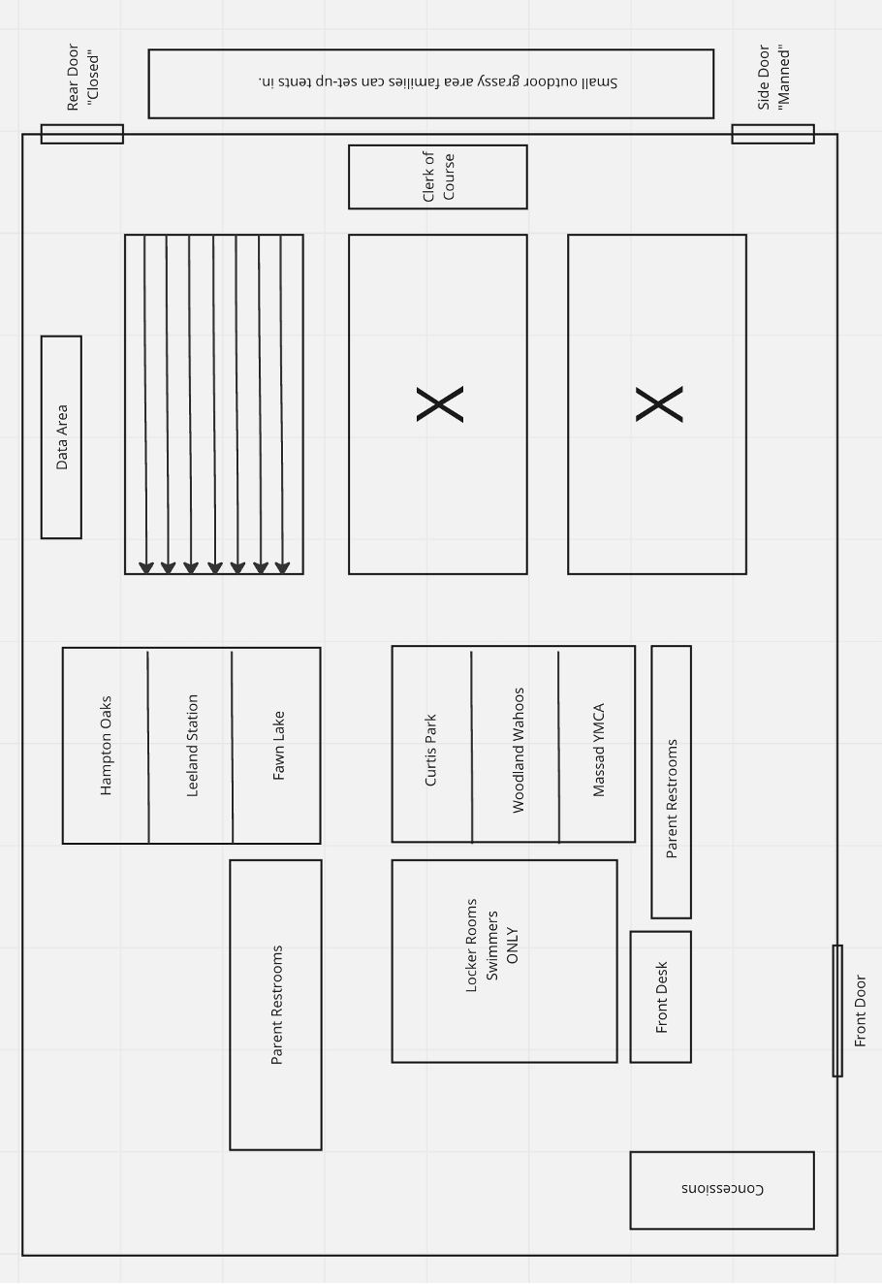

Concessions available at Jeff Rouse Snack Bar
Rouse is prepared for our large numbers and will be ready to quickly serve you.
The Rouse Center does NOT allow outside food and drinks to be brought into the facility. Please plan accordingly.

BREAKFAST
$6.99 Breakfast Burrito with Egg, Sausage and Cheese
$3.00 Assorted muffins
$4.99 Sausage/Bacon Egg and Cheese Biscuit
$1.25 Yogurt
$1.00 Assorted fruit (bananas, apples, grapes)
$7.99 Smoothie
$3.49 Orange/Apple juice
$2.49 Coffee
$2.00 Bottled water

LUNCH Combos (includes fries and Fountain drink)
$9.99 Sandwich Wrap with Turkey and Cheese Combo
$9.99 Cheese Burger Combo
$9.99 Chicken Strips
$8.99 Hot dog Combo
$9.99 Grilled Chicken Salad (vegetarian option)
$2.49/3.82 small/large Gatorade
$1.99 Bottled water
$1.81 Chips

They will also have other snacks/Candy and drinks available.

