2024 RSL Championships: Patriot Division
First Session (10 and under) Events 1- 24

Warmup times:
- 6:35 am - 6:55 am Lake of the Woods Lanes 1, 2, 3
Fawn Lake Lanes 4, 5, 6
- 7:00 am- 7:20 am Austin Ridge Lanes 1, 2, 3
Leeland Station Lanes 4, 5, 6
- 7:25 am- 7:45 am Aquia Harbour Lanes 1, 2, 3
Ferry Farm Lanes 4, 5, 6
Second Session Events 25-38 and Third Session Events 39-68
*******CORRECTED WARMUP TIMES*******************
Warmup times:
- 10:10 am - 10:15 am Lake of the Woods Lanes 1, 2, 3
Fawn Lake Lanes 4, 5, 6
- 10:20 am - 10:35 am Austin Ridge Lanes 1, 2, 3
Leeland Station Lanes 4, 5, 6
- 10:40 am - 10:55 am Aquia Harbour Lanes 1, 2, 3
Ferry Farm Lanes 4, 5, 6
Location: Dixon Park- Doris E. Buffet Pool - July 20, 2024
General Pool Information:
- Located at 1300 Dixon Street (near Route 2 & 17 across from Fredericksburg Fairgrounds).
- Outdoor Swimming Pool
- Glass bottles or alcoholic beverages are not permitted in or around the pool facility.
- Smoking is prohibited anywhere in the aquatic facility or adjacent to the pool.
- No grills allowed.
- Canopies can be no larger than 20 by 40. Each Canopy needs to be a foot apart. No stakes or rebar permitted due to underground sprinkler pipes. Canopies weights are encouraged.
- NO using the baby pool/splash area of the pool.
The pool area will be open starting at 6 am. Teams need to set up in their designated area (see map). Canopies for shade need to be provided by each team and set up on the grass only.
Parking:
There are 3 available parking lots near the pool. Please park in designated spots not along the roadways or grass. There is an area where swimmers/gear can be dropped off, please see the map.
Food will be available for purchase at the concessions area, they will be taking cards and cash.

Officials/RSL/Coaches/Timers Meeting Timeline
Morning First Session
7:00 am – RSL Reps Meeting in the Clerk of Course area near the slide
7:20 am – Stroke & Turn Officials’ Meeting in the Clerk of Course area near the slide
7:25 am – Assemble Timers
7:30 am – Lane Timers Meeting with Head Timer on the pool deck near the outside entrance to the women’s restroom
7:45 am – Coaches meeting with Referee in the corner of the pool deck across from the slide
7:50 am – Call the Clerk of Course for the first events
Afternoon Second Session
11:30 am - RSL Reps Meeting near clerk of course
11:30 am – Assemble Timers/Data folks
11:30 am – Stroke & Turn Officials’ Meeting
11:40 am – Lane Timers Meeting with Head Timer
11:50 am – Call to Clerk of Course
Information
- Unless assigned a deck location, all seating will be on the grass. The pool deck area is only for spectators to “watch and go”.
- No canopies can be used on the pool deck.
- Please respect the pool property and keep your area clean and damage-free.
- Food and drinks are allowed in the team areas.
- Dixon Park will be providing the lifeguards. Please remember that we are to abide by their rules.
- First aid will be handled by the lifeguards. Please report to the lifeguard office in the pool area if any needs arise.
- Please utilize trash cans for disposing of your garbage.
- All rules of the Rappahannock Swim League (RSL) are in effect.
- A manually operated Starter System will be used.
- Athletes with a disability are welcomed and shall provide notice of desired accommodations to the host team meet personnel. The athlete (or athlete’s coach) is also responsible for notifying the Head Referee of any disability or accommodation before the start of the meet.
- Data for the meet will be run using the Meet Maestro/SwimTopia platform
- No photos or videos of any kind are permitted behind the blocks at any time.
- Swimmer/Spectator Conduct: Each team is responsible for supervising the conduct of coaches, swimmers, and spectators. Raise any concerns to the RSL Rep or Head referee.

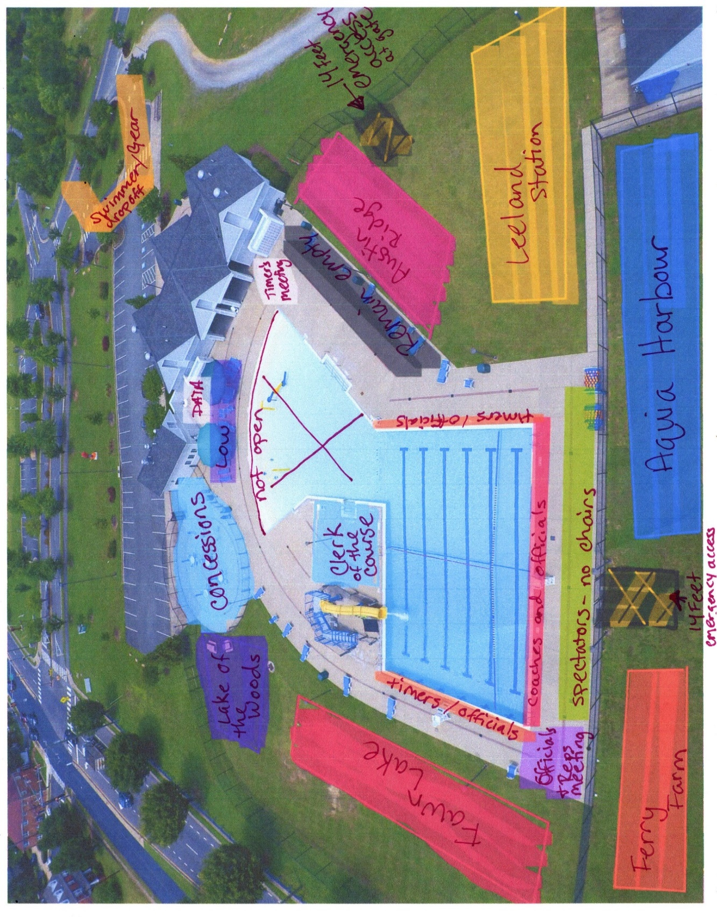
Concessions Menu
Breakfast-
Coffee
Fruit
Granola Bars
Breakfast entree

Lunch-
Hotdogs
Pulled pork
Pulled chicken
Pizza

Extras-
Sodas
Waters
Gatorade
Chips
Candy

