Spirit Signs
Hello, Cyclones! This year we are going to be starting our season off strong by making spirit signs! These will be displayed proudly at meets throughout the season to show off our Cyclones pride and cheer each other on! Please bring your completed signs (and tape for hanging) to as many swim meets as possible (packing tape around the edges helps reinforce their structure through the hanging and removal cycle). I can’t wait to see everyone’s creativity and team spirit side by side!

When making spirit signs, sky is the limit! You can use catchy phrases (“Eat My Bubbles”), use stickers and trace designs, draw cyclones fan art, or even make a photo stand-in board of a swimmer in a team suit! With our team colors being black and white, I recommend either a white poster board and a black sharpie or a black posterboard and a white paint pen as the most cost-effective options. Below is a sample spirit sign I made for the year, using a black posterboard, a white paint pen, clear craft glue, and glitter. *

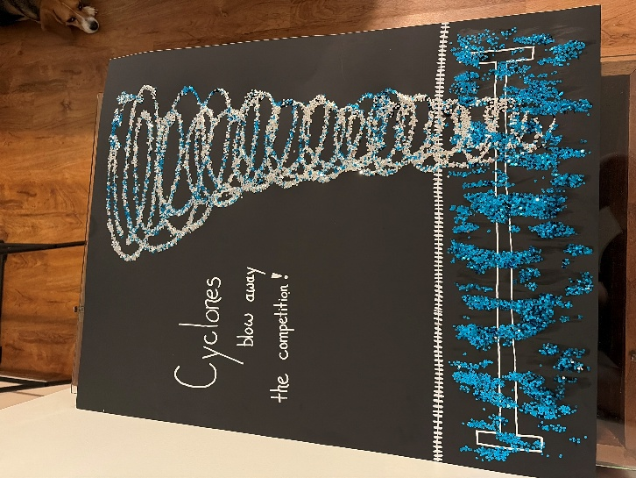

*Note: Signs need to be designed in good faith to promote respect, team spirit, and FUN within our team and the league as a whole. Any signs targeting a specific team with smack talk, using inappropriate language, etc. will be removed from the event and disposed of.

