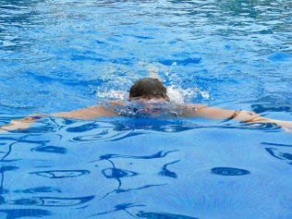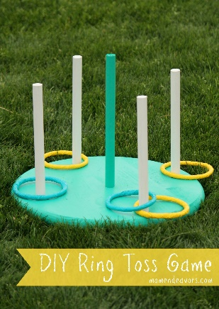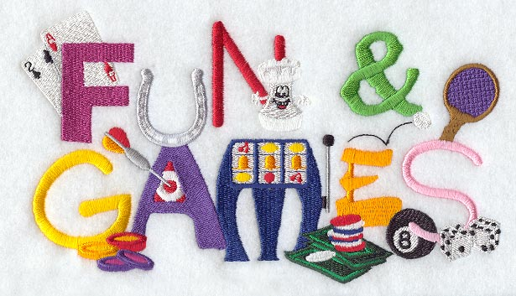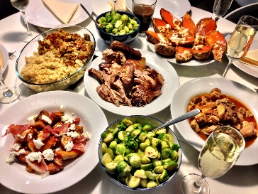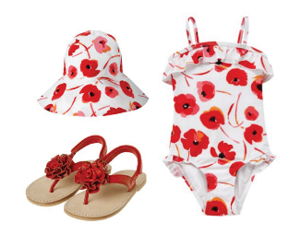

* When- Saturday July 7, 2018
* Where- Pinole Swim Center
* Time- 10am- 2pm
* R.S.V.P. –by July 1st so we have an accurate head count
* We willhave games, lots of good food and celebrating another awesome swim year planned!
* Make sure to bring your bathing suit, towel, sunscreen & flip flops to go swimming.
* Sign up for an item to share and some other needs from families.

http://bit.ly/2sO6tmY

**Team picnic/potluck & swim party!**