2019 NVSL Divisional Relay Carnival



Division 15 Relay Carnival
Woodley Recreation Association
July 10, 2019

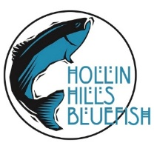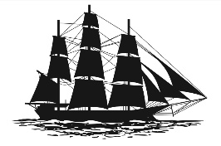


Division 15 Relay Carnival Officials List
July 10, 2019
Meet Manager: Chris Loeser
Assistant Meet Manager: Carrie McCall
Referee: Bob Hanlon
Starter: Kevin Tingley
Chief Judge: Paul Viola
Announcer: Sara Fargo Asst. Announcer: Matt Pollack
Stroke and Turn: Lorri Howeth Stroke and Turn: Robin Tingley
Stroke and Turn: Chris Hall Stroke and Turn: Jocelyn Ballantine
RTO Judge: Meghan Gallardo RTO Judge: Sabrina Corlette
RTO Judge: Laura Magee RTO Judge: Rachel Dabrowski
RTO Judge: Lisa Frankovich RTO Judge:
RTO Side Judge: Melinda Schnur RTO Side Judge: Dave Guerra
RTO Side Judge: Joy Ditto Hill RTO Side Judge: Amy Gold
Chief Timer: Josh Byrd Assistant Chief Timer: Bob Ludke
Division Data: Mark McCall Chief of Tables: Cheryl Napoli
Data Entry: Sonia Zamora Assistant Data Entry – Maureen Goble
Place Recorder: Janice Viola Asst Place Recorder: Aimee Lange
Verifier: Mary Ritley-White Asst Verifier: Nancy Butler
Head Clerk of Course: Blaise Hazelwood

The National Anthem will be presented by Steven Temme

Team Representatives and Coaches

Herndon
Team Reps: Ron Graham and Jill Vinson
Coaches: Liz Badley, Danny Boboltz, Vianca, Verme, Cailley Graham, Lucy Brown, Ginger Lyons

Hollin Hills
Team Reps: Saskia Jansen, Brooke Lombardi
Coaches: Liza Elder ( Head), Charlie Fessler-Krebs, Norah Ludke, Lillian Ballantine

Ilda
Team Reps: Megan Fay
Coaches: Johann Shim (Head), Lily Powers

Lake Braddock
Team Reps: Karen Spencer, Davis May
Coaches: Becky Anderson (Head), Charlie Baird, Madison Lear

Parklawn
Team Reps: Nicole and Sipho Molife
Coaches: Gypsy Roberts (Head), John Gullickson, Armi Mack

Woodley
Team Rep: Carrie McCall
Coaches: Dave Nasca (Head), Helen Van Wijngaarden, Isaiah Minix, Ignat Miagkov

CONGRATULATIONS, SENIORS!

HERNDON LAKE BRADDOCK
Riley Ball (University of Tennessee) Noah Adcock (The University of Mary Washington)
Miles Regan (Indiana University) Jessica Bryant (Virginia Tech)
Guthrie Demers (Arizona State University) Lindsay Dewar (Franklin & Marshall College)
Noa Gold (Roanoke College)
HOLLIN HILLS Kayla Zamiska (The University of Mary Washington)
Ella Fesler (University of Virginia)
Lena Cromley (William & Mary) PARKLAWN
Dan Allee (Randolph College)
ILDA Kate Billingsley (Clemson University)
Sally Wells (Virginia Commonwealth University) Emma Marigliano (Old Dominion University)
Mark Murray (Mary Washington University) Ryan Gallagher (Virginia Tech)
Lily Powers (Grand Canyon University) Jessica (Noe) Sheridan (University of Denver)
Sarah Runyon (West Virginia University)
Sarah Warme (NOVA and working with Goldfish Swim) WOODLEY
Jonah Bishop (Virgnia Tech) Daniel Schmidt (NOVA)
Ignat Miagkov (William & Mary)
Lena Iglesias (NOVA)
Omar Zamora (NOVA)
Isaiah Minix (NOVA)

Parking

Woodley Recreation Association, 7421 Camp Alger Avenue, Falls Church, VA - 703-573-9850

Welcome to Woodley! Parking at Woodley will be reserved for individuals with parking passes. Swimmer drop-off is available at the Woodley sign in front of the parking lot. Swimmers will be safely directed to the pool. Parking is readily available within the community. Please drive carefully within the neighborhood and respect our neighbors by leaving ample room at intersections and driveways when parking. Thank you!

IMPORTANT – WEATHER DELAY POLICY

The Relays must go on, but only when it is safe for our swimmers and spectators. Woodley, in communication with the Division Coordinator and all Team Representatives, will decide when a rain/thunder/lightning delay must be called.

In the event of a thunderstorm during the meet, please adhere to the following procedures:

1. All spectators, swimmers, coaches, and officials will immediately return to their cars. A pool is one of the most dangerous places to be during a thunderstorm so decisions to clear the pool and halt the meet will be made without hesitation. We will take no chances with the lives of our children.

2. Team Reps should report to the pool office with the Pool Manager, Meet Manager, and Referee.

3. We will make a final decision concerning the continuation of the meet. If we can safely complete the meet after the storm passes, we will do so. Woodley follows a 45-minute wait between a lightning strike or a 30-minute wait after the last thunder clap before continuing the meet.

4. No one should leave the meet until hearing the official word on the meet’s continuation. You will be informed of any and all official decisions by your Team Rep or by the Meet Manager. Information from other sources may be false.

Thank you in advance for your patience.
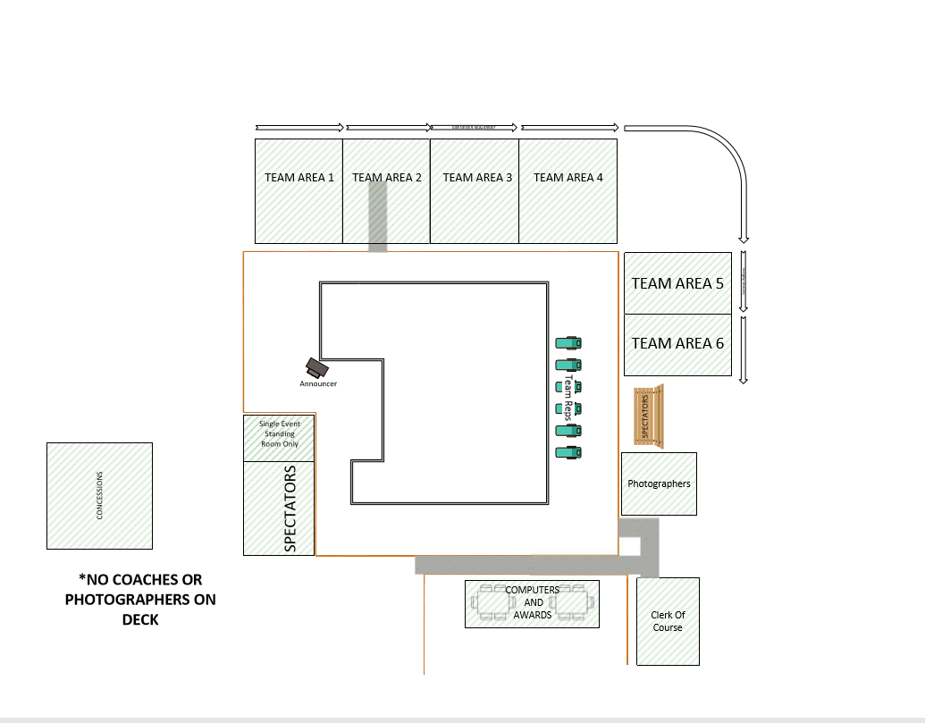

 | NVSL Division 15 Relay Carnival - July 10, 2019
 |  |  | Lane 1 | Lane 2 | Lane 3 | Lane 4 | Lane 5 | Lane 6 | 2018 18th seed time
Event # | Event
1 | Mixed Age Girls 200M Free |  | PL | LB | IC | H | HH | W | 2:02.75
2 | Mixed Age Boys 200M Free |  | W | PL | LB | IC | H | HH | 1:57.45
3 | 8 & Under Girls 100M Medley |  | HH | W | PL | LB | IC | H | 1:35.09
4 | 8 & Under Boys 100M Medley |  | H | HH | W | PL | LB | IC | 1:36.16
5 | 9-10 Girls 100M Medley |  | IC | H | HH | W | PL | LB | 1:17.68
6 | 9-10 Boys 100M Medley |  | LB | IC | H | HH | W | PL | 1:17.28
7 | 11-12 Girls 100M Medley |  | PL | LB | IC | H | HH | W | 1:06.62
8 | 11-12 Boys 100M Medley |  | W | PL | LB | IC | H | HH | 1:06.96
9 | 13-14 Girls 200M Medley |  | HH | W | PL | LB | IC | H | 2:14.97
10 | 13-14 Boys 200M Medley |  | H | HH | W | PL | LB | IC | 2:08.13
11 | 15-18 Girls 200M Medley |  | IC | H | HH | W | PL | LB | 2:09.59
12 | 15-18 Boys 200M Medley |  | LB | IC | H | HH | W | PL | 1:54.90
13 | 8 & Under Girls 100M Free |  | PL | LB | IC | H | HH | W | 1:23.63
14 | 8 & Under Boys 100M Free |  | W | PL | LB | IC | H | HH | 1:22.55
15 | 9-10 Girls 100M Free |  | HH | W | PL | LB | IC | H | 1:08.76
16 | 9-10 Boys 100M Free |  | H | HH | W | PL | LB | IC | 1:07.90
17 | 11-12 Girls 100M Free |  | IC | H | HH | W | PL | LB | 59.87
18 | 11-12 Boys 100M Free |  | LB | IC | H | HH | W | PL | 59.77
19 | 13-14 Girls 200M Free |  | PL | LB | IC | H | HH | W | 2:02.44
20 | 13-14 Boys 200M Free |  | W | PL | LB | IC | H | HH | 1:55.81
21 | 15-18 Girls 200M Free |  | HH | W | PL | LB | IC | H | 1:58.93
22 | 15-18 Boys 200M Free |  | H | HH | W | PL | LB | IC | 1:43.97
