Marking Your Swimmer
It is a big help if swimmers mark their arm/thigh with a Sharpie the night before the meet.
- Look at the heat sheet and highlight all your events/relays. (Max 2 events/2 relays)
- ​Make four (4) column headings - E, H, L, S. These stand for Event, Heat, Lane and Stroke
- Go through the heat sheet and find your name which you highlighted.
- ​For each event, write the event number, heat number, lane number and stroke in the corresponding column.
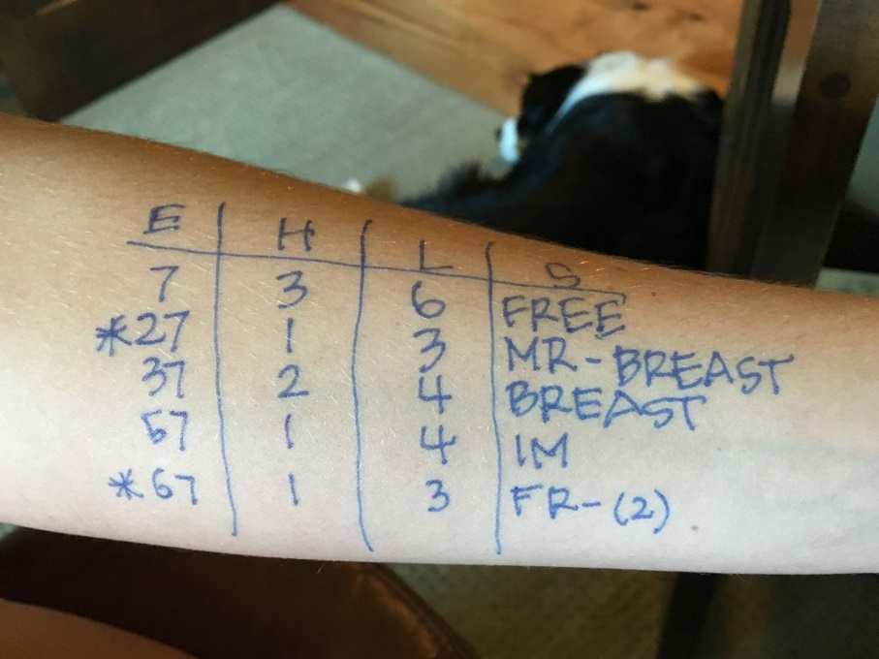
The asterisk that is marked on the left of numbers 27 and 67 indicates that those are relays.

Under the S (Stroke), MR stands for Medley Relay and FR stands for Freestyle Relay.

The medley relay order is as follows:

1 – BACK 2 – BREAST
3 – FLY 4 – FREE

The Freestyle Relay is displayed in the same order as the Medley Relay. All swimmers in the FR (Freestyle Relay) swim FREESTYLE but they are put in an order they will swim:

1 – FREE 2 – FREE
3 – FREE 4 – FREE

