06.26.2024 Relay Carnival Meet Information

Congratulations to Relay Teams for Relay Carnival
Good luck to our OH swimmers and swim fast Sharks!

Event | RELAY | SWIMMERS
1 | Mixed Age Girls 200 M Free | Sydney Hergenroeder, Tinsley Schneider, Abby Bolz, Maddie Du
2 | Mixed Age Boys 200 M Free | Joseph Bussey, Chase Charnoubi, Clark Loeffert, Neil Wargin
3 | 8 & Under Girls 100 M Medley | Lela Bourgeois, Caroline Regan, Emilia Charnoubi, Teresa Loeffert
4 | 8 & Under Boys 100 M Medley | Henry Busch, Ford Junius, William Yiengst, William York
5 | 9-10 Girls 100 M Medley | Kiera Carpenter, Tinsley Schneider, Raquel Zimmer, Norah Fitzpatrick
6 | 9-10 Boys 100 M Medley | Xaden Main, Matthew Hergenroeder, Chase Charnoubi, Pete Taousakis
7 | 11-12 Girls 100 M Medley | Audrey Yiengst, Caroline York, Sydney Hergenroeder, Katherine James
8 | 11-12 Boys 100 M Medley | Teague Schneider, Joseph Bussey, Colton Charnoubi, Christian Prunty
9 | 13-14 Girls 200 M Medley | Nia Manion, Camryn Smith, Abby Bolz, Ila Rakip
10 | 13-14 Boys 200 M Medley | Xander Main, Caleb James, Clark Loeffert, Mason Yiengst
11 | 15-18 Girls 200 M Medley | Charlotte Prunty, Maddie Du, Rebecca Prunty, Natalie Sorensen
12 | 15-18 Boys 200 M Medley | Neil Wargin, Jadon Yonas, Hugh Wargin, Thomas Logan
13 | 8 & Under Girls 100 M Free | Addison Birch, Teresa Loeffert, Caroline Regan, Emilia Charnoubi
14 | 8 & Under Boys 100 M Free | Tommy Dunn, Henry Busch, William York, William Yiengst
15 | 9-10 Girls 100 M Free | Samantha Berona, Norah Fitzpatrick, Raquel Zimmer, Tinsley Schneider
16 | 9-10 Boys 100 M Free | Xaden Main, Pete Taousakis, Matthew Hergenroeder, Chase Charnoubi
17 | 11-12 Girls 100 M Free | Katherine James, Audrey Wilson, Audrey Yiengst, Sydney Hergenroeder
18 | 11-12 Boys 100 M Free | Christian Prunty, Teague Schneider, Colton Charnoubi, Joseph Bussey
19 | 13-14 Girls 200 M Free | Camryn Smith, Abigail York, Ila Rakip, Abby Bolz
20 | 13-14 Boys 200 M Free | Caleb James, Will Hetzel, Mason Yiengst, Clark Loeffert
21 | 15-18 Girls 200 M Free | Marysol Rivera, Natalie Sorensen, Rebecca Prunty, Maddie Du
22 | 15-18 Boys 200 M Free | Neil Wargin, Hugh Wargin, Jonas Yiengst, Thomas Logan
DIVISIONAL RELAYS, 6/26/2024
Where: Lee-Graham Pool (7319 Lee Hwy, Falls Church, VA 22042)
When: Wednesday,Jun 26, 2024
Arrive at 5:05pm for swimmers to check in with Coaches (please consider traffic and parking; we have the middle warm up).
Swimmers Drop-Off: We encourage parents to use the Swimmer Drop Off in advance and then go find parking.
Orange Hunt Warmups: 5:25-5:45pm (Lanes TBA)
Meet Start: 6:30pm

Shark Spirit:
The theme is “Orange Out” so wear your ORANGE so no one in the division wonders where we are from! Chomp! Chomp! Chomp!

Parking:
Lee Graham has limited parking in their lot. You may park at Graham Road Elementary School. DO NOT park in the nearby shopping center or on the service road running alongside the pool. People are regularly towed from these locations.
*Parking attendants will be checking passes until 6:30pm. Reserved parking may be full for any one arrive later.
** Meet volunteers will have a parking pass in their child’s ribbon folder on Wednesday morning. Please pick this up or you will not be allowed to park in the lot.

Team Area:
Orange Hunt will be in Team Area #1 (see maps below); as you look across the pool from the clubhouse, this is the team area to the far right. Swimmers should bring their own chairs as the ground does get muddy.

Spectator Viewing: There are tiered viewing areas at Lee Graham, but no bleachers. You are recommended to bring chairs.

Concessions:
Their snack bar will be open and they will sell various concession items including Chick-fil-A sandwiches. CASH only.

Divisional Relay Carnival T-shirts:
T-shirts ($15) will be available on-site to purchase. Cash or Credit Card.
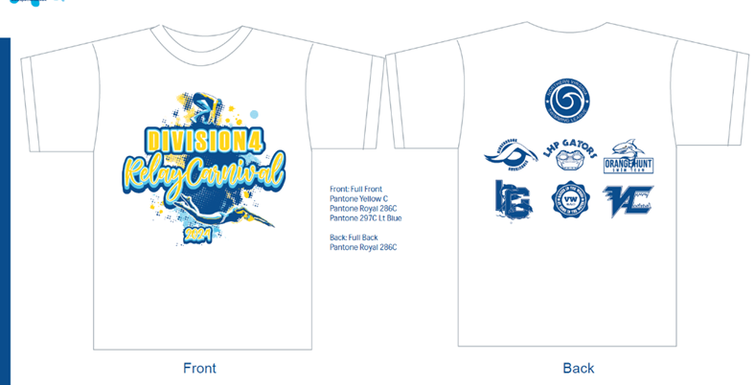

Volunteers (updated timeline):
Please check in with your Team Reps to collect your respective volunteer duty gear.
Wear white over navy blue.
5:00pm, Check in with Team Reps
5:10pm, Marshals Briefing
5:35pm, Officials Briefing (Referee and S&T Judges)
5:50pm, Referee and RTOs Meeting
6:10pm, Team Rep Meeting
6:10pm, Table Workers Briefing
6:10pm, Timers Briefing
6:10pm, Warmups End; All Swimmers exit the Pool
6:20pm, First two events called to Clerk of Course
6:25pm, All Officials and Timers in place on deck
6:29pm, National Anthem
6:30pm, Meet start

Timer 1 (Time Board) | Adam Bussey |  | OH Clerk of Course | Katherin Loeffert
Timer 2 ( Head Lane) | Mark Rakip |  | CoC Walker | Caren Hergenroeder
Timer 3 (RTO Judge) | Ayu Guadie |  | OH Awards | Pam Sorensen
Corner RTO Judge | Rob Prunty |  | OH Marshal | Liz Busch
RTO Judge (Turn) | John Wargin |  | Place Recorder | Suzanne Main
Stroke & Turn Judge | Matt Yiengst |  | Runner | Jess Tauosakis

WEATHER - VERY IMPORTANT:
Historically, this meet involves some type of inclement weather event and the weather is looking stormy!

IF the pool is closed for a weather event (30 minute delay for Lee Graham), please go to cars and await further notification for resumption of the meet. If families with parking lot passes can designate 1-2 waiting vehicles per relay team ahead of time, that will be very helpful for gathering swimmers. For example, all 8 and under girls will go to the York’s van.

PLEASE DO NOT LEAVE THE MEET in the case of a weather event. We will make every attempt to resume the meet when safe to do so, rather than cancel it. If a swimmer in a relay leaves prematurely, the entire relay must forfeit.

Age Group | Car
8&U Boys  8&U Girls | Busch  York
9-10 Boys  9-10 Girls | Hergenroeder  Schneider
11-12 Boys  11-12 Girls | Bussey  Yiengst
13-14 Boys  13-14 Girls | Loeffert  Rakip
15-18 Boys  15-18 Girls | Wargin  Sorensen

Additional notes:
Tech Suits: Per NVSL and USA Swimming, tech suits are not permitted for 12 and under swimmers. Swimmers in this age category wearing a tech suit will be disqualified. If you have a question about a suit, please reach out to a coach/rep for guidance. Please see this article for more information.
Swimmer Safety: Please remind backstroke swimmers that they need to enter the pool facing out toward the water.

Based on times swam at Divisional Relay Carnival, the top 19 relays from across all NVSL divisions will compete on Wednesday, July 10 in All Star Relays at Rutherford.
All Star Relay Entries: If a divisional relay team qualifies for All Star Relays (7/10/2024), the team will swim All Star Relays.
* Up to one scratch per relay team is allowed, but will only be used for illness.

NVSL has sent these reminders to pass along to the Team Reps:
- Towels:
Towels on the Start
From the rulebook:
12.(3) The forward start (for Freestyle, Breaststroke, Butterfly, and Individual Medley) may be from the pool deck without the aid of devices which elevate any part of the swimmer’s feet. A single flat towel may be used. Swimmers may start in the water, provided one hand touches the edge of the pool or gutter. — 79 —— 2024 NVSL Swim Rules
(4) The Backstroke start, in lieu of USA Swimming Rules, shall be as follows: (a) The swimmers shall line up in the water facing the starting end and may secure a handhold only below the knees of another person to prepare for the start. The heels of the persons providing such assistance shall not extend over the vertical plane of the end of the pool. Only one other person may assist the person whose legs are grasped by the backstroker. Assistance shall not be rendered by HEAD COACHES, Timers, or anyone officiating at the meet. (b) A towel may be draped over the pool edge to facilitate the swimmer’s traction on the pool wall. Towels shall be removed from the pool edge before the swimmer returns to the starting end.
Per the Officials Co-Chairs - in the medley relay, the towel does NOT need to be removed after the backstroke leg since the breaststroker may use it for their start. If possible, a swimmer or timer should pull the towel back so it is not hanging over the pool edge. Failure to do so, however, is not a disqualification.

2. "running starts"
In a relay, swimmers 2, 3 and 4 can operate in a space roughly the size of a starting block. The swimmer may take one or more steps as long as they accomplish it in an area the size of a starting block, and the final step brings one, or both, of their feet to the edge of the pool deck.
Also, note that the term running is a little bit of a misconception. The swimmer doesn't have to be running at all to get called for a running start. They just need to be starting further back than is generally accepted, which is about 30 inches.

The main goals are:
- Make sure the starts are safe. The further back the swimmers get the more obstacles (to include things like timers, poles, canopies, debris on the pool deck, etc) they have to contend with.
- Make sure the starts are fair for everyone. Just because a 15 - 18 boy is twice as tall as an 8 & Under girl, that doesn't mean the 15 - 18 boy deserves to start further back.
- To provide an NVSL equivalent rule/restriction to what is used by USA Swimming. Similar to how we allow legs in NVSL for backstroke starts to provide an equivalent to the bar on the starting blocks the swimmers would use at a USA Swimming meet, we are allowing the swimmers to have some leeway on the starts for relays to account for the lack of starting blocks. But just like in USA Swimming, there are rules to make sure that these accommodations are not abused.

3. Tech suit questions:

12 and Under Tech Suit Guidance

Tech suits were banned by USA Swimming for 12 and Under swimmers on Sept 1, 2020, and adopted by NVSL for the 2021 season. The relevant USA Swimming rules can be found on page 88 of the 2024 NVSL Handbook. We've been operating under the new guidelines for a couple summers, and retailers are good about identifying permissible suits for 12 and Under swimmers. Suits for 12 and Under swimmers feature sewn seams and woven fabric. They may not include a "Fina" logo and if they do, they should feature an additional green check mark indicating approval for 12 and Under use. Please see the link below for examples of the seams and logos to be looking out for (not an endorsement of the retailer, just information presented in a helpful format):
https://www.swimoutlet.com/pages/12-and-under-tech-suit-rule

If a swimmer, coach or team rep questions if a suit is permissible for a Relay Carnival or Divisional meet, the coach or team rep should speak with the meet referee with the swimmer (or bring their suit over) prior to the start of the meet to ensure the suit fits the rules for 12 and Under swimmers.

For purposes of applying the 12 and Under Tech Suit rules to NVSL swimmers, the determination of the age of the swimmer (i.e., whether they are 12 and under) is based on the birthday on June 1, the date which sets the age of the swimmer throughout the summer season. (See 2. b. on page 71 of NVSL handbook.)

4. Situational question
Situation: In an 8 & under relay, swimmer 2 is confused and dives in with starting beep at the same time as swimmer 1.
What should the RTOs, S&T and Referees do:
Answer from Officials Committee:
It is a DQ because a swimmer other than the one swimming that leg was in the water at the same time. S&T should raise their hand. This is one of the examples the Officials Committee uses with refs where, in the absence of an S&T raising a hand, the Ref should raise a hand. And, as always, if no one raises a hand, the team cannot by DQed after the event.
In addition, RTO judges should have noted an early takeoff on their RTO slips and the swimmer should have been disqualified for an early take off; so, the ref would have had a discussion with the RTOs to make sure they know how to properly do their job. When the ref does his/her Stroke Briefings, he/she should remind Stroke and Turn Judges that if they are on the turn end for relays to pay attention to the starts, and if the swimmer 2 looks like they might be getting ready to start at the start of the race, remind them to wait for the other swimmer to get to their wall, but never touch the swimmer. The ref also makes the same comment to the RTO judges on the turn end. The hope is that between the 6 officials the officials can prevent this situation from happening, but it does still happen. In those cases, swimmer 2 should be disqualified, even if they enter the water and then immediately get out.

5. Bandages/first aid tape
Team reps should notify the referee if they have any swimmers who plan to wear bandages, first aid tape or other medical tape to gain approval prior to competition. Specific rules under USA swimming rules can be found on page 88 of the NVSL handbook.

6. Jewelry
Similar to USA swimming, there are no rules which prohibit the wearing of jewelry.

7. Team suits/caps
A reminder to team reps, coaches, clerks of course, referees, and all other officials: Swimmers ARE PERMITTED to caps with their summer team name (but can’t wear caps with high school or club names). Swimmers ARE PERMITTED to wear NVSL All Star caps or American flag caps or any other drawing on the cap. THERE IS NO SUCH COMPARABLE RULE FOR THE SUIT – SO swimmers may wear suits of high school and club teams.

8. SUPPLIES NOTE FOR REFS AND REPS
Refs, please check the RTO slips on each clipboard (16 clipboards in total). As a FYI, if using the 8.5 x 11 sheets for RTO slips, the RTOS slips for all the lanes on the turning end are not printed necessarily together, the RTO slips for the lanes for the corner RTO turning end position are not necessarily printed together, etc. – so when you cut and collate, please pay close attention to the placement on clipboards and have someone double check.
Also since the event numbers are pre-printed, please ensure that they are placed in sequential event number order and make sure RTOs (and chief judge) are checking each event before turning in the RTO slip.

It is recommended to print a few extra RTO slips for each clipboard to put at the back of each clipboard.

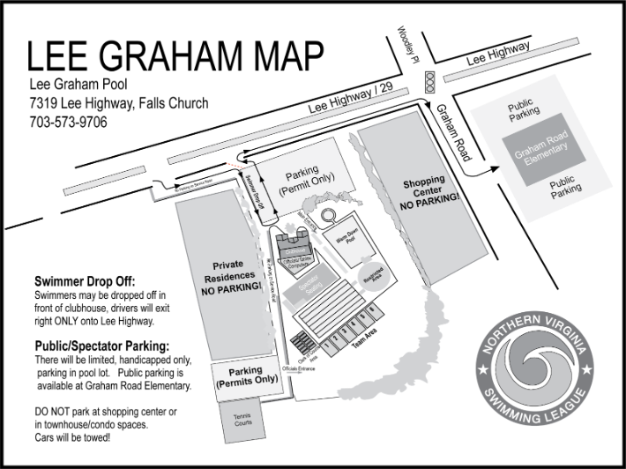
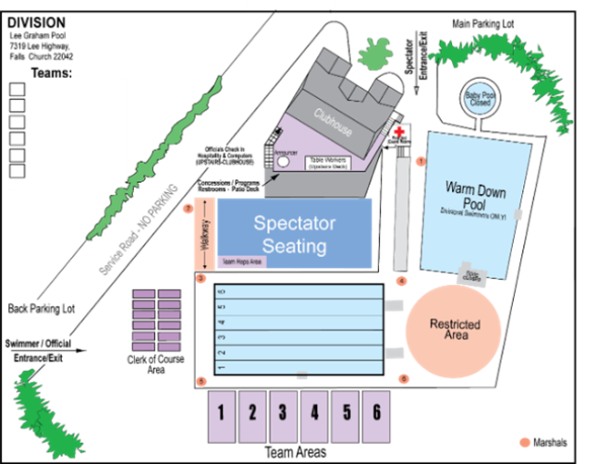
**NOTE: Warm Down Pool is available only with direct supervision of team Coach.
There are absolutely NO starts/dives in this pool!

Team Areas/ 1st Lane Assignment
Area 1 | Orange Hunt
Area 2 | Vienna Aquatic
Area 3 | Lee Graham
Area 4 | Vienna Woods
Area 5 | Little Hunting Park
Area 6 | Hiddenbrook

Chomp! Chomp! Chomp!
Lauren, Jenn, and Allison
Orange Hunt Swim Team Co-Reps
Check us out on SwimTopia

