Meet Announcement
Freestylers Fighting ALS 2018


Somerset Olde Creek Swim Team will host a swim meet to benefit ALS research on Sunday, June 24th.
Warm-ups will be 8 am-9:50 am with events starting at 10:00 am
Events
10 and under swimmers will have the option to swim the 25m, 50m and 100m freestyle events
11 and over swimmers will have the option to swim the 25m, 75m and 150m freestyle events

Awards will be given to the 1st, 2nd and 3rd place swimmers with the fastest combined times of all three events in each single age group (ie- 6&under, 7 yr olds, 8 yr olds, 9 yr olds, …. 17 yr olds, 18yr olds, 19 and over). Yes- we will have an age category for any adult who wants to swim freestyle and fight ALS

Swimmers who want to participate but not swim all three events are encouraged to enter the meet, but are not be eligible for age-based awards.

Each swimmer will be charged a meet entry fee of $15.

All entry fees and meet profits (concessions, t-shirt sales, etc) will be donated to the ALS Association (the group behind the ice bucket challenge).

Meet entries can be entered at the following link-

https://docs.google.com/forms/d/e/1FAIpQLSdox5hnsN5bKHjWR8Grzcugxc1aK8RxMKfLJODoyNkGDvn7bQ/viewform

Entries entered before Monday June 11th will be seeded slowest to fastest. Entries received after Monday June 11th will be entered as a “No Time” and will be seeded in the first heat. Deck entries will be accepted at a fee of $20.

Volunteer Timers and Awards Clerks are needed. Those interested in volunteering should contact Nathan Dean (ndean75@gmail.com) and indicate if you can work the whole meet, first half or second half of the meet.

T-shirts can be purchased for $20 using the following link-

https://www.customink.com/fundraising/freestylers-fighting-als-2018?ref=copy-link_social_desktop-campaign-page-share-top-v3&utm_campaign=desktop-campaign-page-share-top-v3&utm_content=freestylers-fighting-als-2018&utm_medium=social&utm_source=copy-link&side=front&type=1&zoom=false

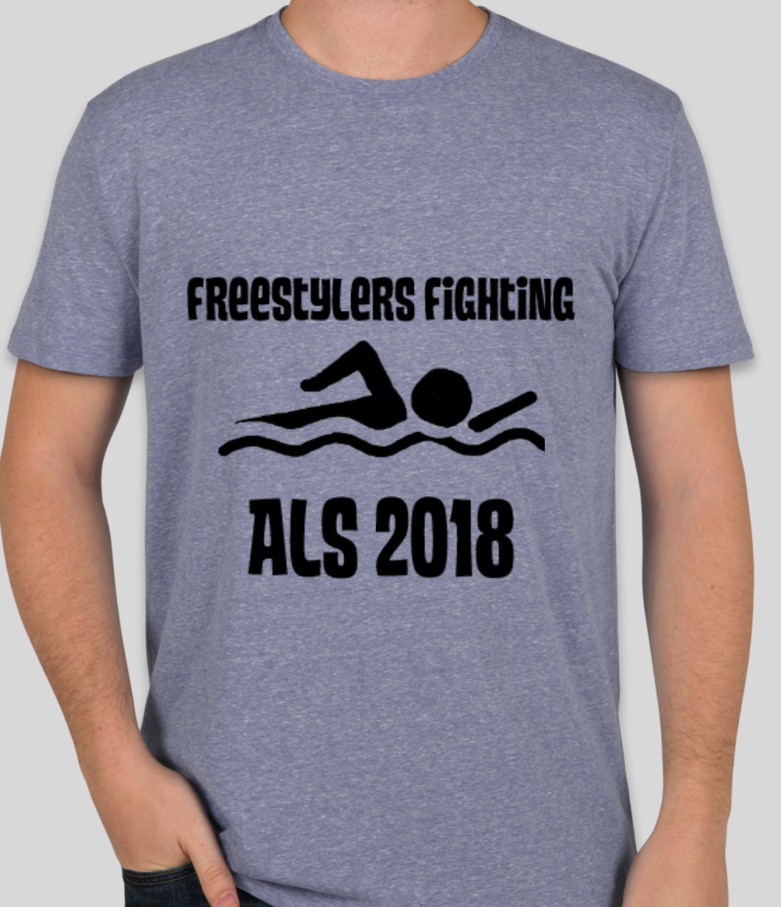
(Orders must be received by June 7th to guarantee pick-up at the meet)

We would like to remember Sue Mickelson and Bill Palfey who passed away from complications from ALS. Sue and Bill were active participants in the SOC, NVSL and Woodson communities and are dearly missed.

Additional Donations to the ALS Association will be collected at the swim meet or by clicking on the link-
http://webdc.alsa.org/site/TR?team_id=368110&fr_id=13117&pg=team

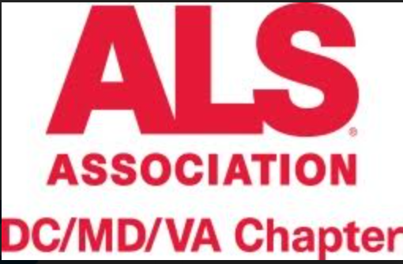

Freestylers Fighting ALS 2018
Sunday June 24th
Somerset Olde Creek Pool
9705 Laurel St
Fairfax, VA 22032

Listing of Events

Boys | Event Name | Girls
1 | 8 &U 25m Free | 2
3 | 9-10 25m Free | 4
5 | 11-12 25m Free | 6
7 | 13-14 25m Free | 8
9 | 15-18 25m Free | 10
11 | 19 &over 25m Free | 12
13 | 8 &U 50m Free | 14
15 | 9-10 50m Free | 16
17 | 11-12 75m Free | 18
19 | 13-14 75m Free | 20
21 | 15-18 75m Free | 22
23 | 19 &over 75m Free | 24
25 | 8 &U 100m Free | 26
27 | 9-10 100m Free | 28
29 | 11-12 150m Free | 30
31 | 13-14 150m Free | 32
33 | 15-18 150m Free | 34
35 | 19 &over 150m Free | 36

Warm-ups start: 8 am
(Warm-ups per team will be determine after June 7th and distributed to each team)
Warm-ups end: 9:50 am
Meet starts: 10:00 am

Any questions should be directed to-

Nathan Dean, SOC co-team rep
ndean75@gmail.com.

