43rd Annual War Eagle Invitational Swim Meet
James E. Martin Aquatic Center
Auburn University, Alabama

October 18-20, 2024

This meet will be conducted under the auspices of Southeastern Swimming, Inc. of USA Swimming. USA Swimming technical rules and regulations will be followed with the exception of items specifically addressed in the meet information Sanctioned by Southeastern Swimming, Inc.
Current USA Swimming Rules, Including the Minor Athlete Abuse Prevention Policy (MAAPP), will govern this meet.
In applying for the sanctioned meet on Oct. 18-20, 2024, the AUB Swim Team, agrees to comply and to enforce health and safety mandates and guidelines of USA Swimming, Southeastern Swimming, the State of Alabama and Lee County.

SANCTIONED BY: Held under the sanction of USA Swimming and Southeastern Swimming, Inc - SANCTION NUMBER: 24SEAUB10-18 SANCTION NUMBER FOR TIME TRIAL: 24SEAUB10-18TT
HOSTED BY: Auburn Aquatics and Auburn University
LOCATION: James E. Martin Aquatic Center on the campus of Auburn University.
FACILITY: POOL Indoor 50 meter by 25-yard pool, offering 16 lanes for short course competition. It is one of the fastest pools in the country with pool depth ranging from 9 feet at the shallowest to 16 feet. The competition course has not been certified in accordance with 104.2.2C(4)
TIMING Automatic timing will be provided by Colorado Timing System with HYTEK interface on both courses. Manual back up will be used. An 8-lane scoreboard will be available on both courses.
RULES: USA Swimming rules will govern the meet.
OFFICIALS: Meet Director: Jeff Dellinger
Referee: Rob Dellinger
AO: Judi Middleton
WARM-UP AND
START TIMES: Friday at 4pm Warm up and meet starts at 5:10 pm. Saturday Warm ups will begin 9:00 am and competition 10:10 am. Sunday warm-ups at 9:00 – 10:00am with competition beginning at 10:10am. Each warm up session will be Open. Southeastern Swimming Safety Guidelines and Warm-up Procedures will be in effect at this meet. All times are Central Standard Time.
SAFETY: In the interest of safety and accident prevention, coaches and swimmers are asked to observe all posted pool rules and to conduct themselves in a safe manner. Nobody will be allowed to climb on the diving boards or diving towers for any reason. ONLY MEET WORKERS, COACHES, OFFICIALS, and SWIMMERS WILL BE ALLOWED ON THE POOL DECK. Swimmers are encouraged to stay on the pool deck for the duration of each session. Chairs are not allowed in the spectator area. Stadium seats are encouraged in the spectator area.
Use of audio or visual recording devices, including a cell phone, is not permitted in changing areas, rest rooms or locker rooms. No drones are allowed anywhere in the facility.
Except where venue facilities require otherwise, changing into or out of swimsuits other than in locker rooms or other designated areas is prohibited.
- Any swimmer entered in the meet, unaccompanied by a USA Swimming member coach, must be certified by a USA Swimming member coach as being proficient in performing a racing start or must start each race from within the water without the use of the backstroke ledge. When unaccompanied by a member-coach, it is the responsibility of the swimmer or the swimmer’s legal guardian to ensure compliance with this requirement.
- EMS Will be on hand throughout the meet.
ELIGIBILITY: All teams must be invited and all coaches allowed on deck must be a coach in good standing with an invited team. All swimmers must be USA Swimming registered. Coaches shall present USA Swimming Coaches card or deck pass to be allowed on deck. Please check in with security person before entering pool deck.
ENTRIES: The meet will be limited based on timelines for each session not exceeding four hours and no more than 700 swimmers per session. Teams are urged to submit entries using HYTEK’s “Team Manager” program. A computer printout of entries with the event numbers and event description must accompany the email file with events in published order. Teams without “Team Manager” must use enclosed entry forms. Entries are to be listed in short course yards or “NT”. On deck entries will be accepted dependent on entry limitations.
ENTRY FEES: $8.00 per individual event
$29.00 Facility fee per swimmer includes SES Travel surcharge,
Make checks payable to: AUBURN AQUATICS and mail with entry packet.
ENTRY LIMIT: Swimmers may enter no more than 4 individual events per day and 12 total for the meet.
LATE ENTRIES: Late entries may be accepted at the discretion of the Meet Director for those swimmers already entered into the meet.
ENTRY ERRORS: If due to Auburn Aquatics error, the swimmer will be deck entered into an open lane of the heat nearest his/her entry time or in a new heat. The entire event WILL NOT be reseeded.
ENTRY DEADLINE: Entries will open September 24 at noon. Entry forms with printouts, release/recap sheet and entry fees including surcharges must be received by the Meet Director on or before Tuesday, October 8, 2024, subject to entry limits.
MAIL ENTRIES TO: Email entries to jeffdellinger@msn.com Or mail to:
Meet Director, War Eagle Invitational Swim Meet
Auburn Aquatics
841 Whittington St.
Auburn, AL 36832
SEEDING: All events are timed finals and will be seeded fast to slow according to all applicable USA Swimming rules. Seed times will be times entered on the entry form. Entries with no time (NT) will be seeded by random draw. Notification of scratches will be appreciated in case lanes are needed for late entries.
All events may be limited at the discretion of the meet director to achieve the session limits. 12 and under 200 IM and 200 Free will have time standards. No entries will be allowed slower than the given time standard. 13-14 and 15 and over 400 IM and 500 Free will be swum fast to slow.
Teams will be notified if any events have been limited as stated above.

SCRATCHES: All scratches should be submitted to the Clerk of Course as soon as possible to provide lanes for possible late entries.

AWARDS: All awards will be based on high point scoring for 12 and unders only. There will be no scoring and awards for 13 and over or open events. Awards will be given to the top 3 places in 11-12 girls and boys and 9-10 girls and boys and 8 and under girls and boys. Scoring for age group high point will be 20-17-16-15-14-13-12-11-9-7-6-5-4-3-2-1.

SCORING: There will be no Team scoring. 12 and under swimmers will be scored for high point.

COACHES MEETING: A coaches meeting will be held at the following time:
Friday, 5:00 pm

HOSPITALITY: There will be a hospitality room available for coaches and officials only. Lunch will be provided on Saturday and Sunday.

CONCESSIONS: There will be a concession area provided upstairs in the spectator area. Reddiset swim shop will be at the meet.

EVALUATION: John Boxmeyer, General Chairman
Southeastern Swimming
jboxmeyer@hotmail.com

Friday Evening, October 18th Warm-ups 4:00-5:00 p.m. Start 5:10 p.m. 4 event maximum
Girls | Events | Boys
1 | Open 25 Free | 2
3 | Open 25 Breast | 4
5 | Open 25 Back | 6
7 | Open 25 Fly | 8
9 | Open 50 Free | 10
11 | 12 and under 100 IM | 12
13 | 13 and over 200 IM | 14
15 7:08.79 | 11-12 500 Free | 16 6:57.29
*Courses will be divided by meet management to expedite the meet.
Saturday, Oct. 19th Warm ups 9:00 am Start 10:00 am 4 event maximum
12 and under pool
17 | 12 and under 50 Free | 18
19 | 12 and under 100 Fly | 20
21 | 12 and under 50 Back | 22
23 | 12 and under 100 Breast | 24
25 3:20.19 | 12 and under 200 Free | 26 3:09.89
*13 and over 500 Free will be deck seeded and swum fastest to slowest
27 | 13 and over 50 Back | 28
29 | 13 and over 100 Free | 30
31 | 13 and over 200 Fly | 32
33 | 13 and over 100 Breast | 34
35 | 13 and over 50 Free | 36
37 | 13 and over 200 Back | 38
39 | 13 and over 50 Fly | 40
41 6:29.99 | 13 and over 500 Free | 42 6:19.99
Sunday Morning, Oct. 20th Warm-ups 9:00-10:00 a.m. Start 10:10 a.m. 4 event maximum
43 | 12 and under 50 Free | 44
45 | 12 and under 50 Fly | 46
47 | 12 and under 100 Back | 48
49 | 12 and under 50 Breast | 50
51 | 12 and under 100 Free | 52
53 3:42.69 | 12 and under 200 IM | 54 3:40.89
*13 and over 400 IM will be deck seeded and swum fastest to slowest
55 | 13 and over 100 IM | 56
57 | 13 and over 200 Free | 58
59 | 13 and over 100 Fly | 60
61 | 13 and over 200 Breast | 62
63 | 13 and over 100 Back | 64
65 | 13 and over 50 Breast | 66
67 | 13 and over 50 Free | 68
69 6:03.99 | 13 and over 400 IM | 70 5:49.99

SOUTHEASTERN LSC INFORMATION FORM FOR SWIMMERS WITH A DISABILITY
This non mandatory form is for accommodation purposes.
Name___________________________________________________________________ Address_________________________________________________________________ Team__________________ USA Registration # _______________________________ Age and Birth date: _________________________ Events to be swum: _______/_______/_______/_______/
________/________/_______/_______/_______/_______/_______/_______/
Type of Disability Blind___ Cognitive/Intellectual ___Deaf ___Physical___ Other___
Extent of Disability: Be specific e.g. totally or partially blind, totally or partially deaf, loss of one or more limbs, multiple disabilities, etc.
_______________________________________________________________________________
The following person(s) will accompany the swimmer for any needed assistance: _______________________________________________________________________________
Accommodations requested, Examples: Lane #, inside lane, starter side preference, assistance to the blocks, water start, hand signals, etc. _______________________________________________________________________________
Information gathered on this form will only be used for swimmers accommodation during Meet, and forwarded to the SE LSC Disability chair for purposes of evaluation and tracking Swimmers attendance and performance. The Disability Chair welcomes any feedback and or comments concerning your Meet experience.

Meet Director Email: jeffdellinger@msn.com

Meet Referee Email: rdsc45@yahoo.com

Robin Heller
Disability Chair Email: robin@seastarsaquatics.org

2024 - 2025 WAIVER, ACKNOWLEDGMENT AND LIABILITY RELEASE:

I, the undersigned coach or team representative, verify that all of the swimmers and coaches listed on the enclosed entry form/team information are registered and entered into the meet in accordance and subject to USA Swimming Rules and Regulation:
501.7
.1 All Clubs, including seasonal clubs, shall ensure that all athletes and coaches participating in USA Swimming sanctioned competition(S) are members of their LSC and USA Swimming.
.2 All coaches of USA Swimming clubs, including seasonal clubs, shall join USA Swimming as coach members and shall satisfactorily compete safety training required by USA Swimming.
And as
302.4 False Registration – A host LSC may impose a fine up to $100.00 per event against a member coach or a member club submitting a meet entry which indicates a swimmer is registered with USA Swimming when that swimmer or the listed club is not properly registered.
I also acknowledge that I am familiar with the rules of USA Swimming and Southeastern Swimming, Inc. regarding warm-up procedures and meet safety guidelines, and that I shall be responsible for the compliance of my team’s swimmers with those rules during this meet. The Auburn Aquatics Swim Program, City of Auburn, AL, Southeastern Swimming, Inc. and USA Swimming, their agents, officers, representatives, employees and coaches shall be free from any liability or claim for damages for any and all injuries, illnesses or damage to valuables which may be sustained at this meet or while in transit to and from this meet. I also acknowledge that by entering this meet, I am granting permission for the names of any or all of my team’s swimmers to be published on the internet in the form of Psych Sheets, Meet Results or any other documents associated with the running of this meet.
SIGNATURE OF COACH OR CLUB OFFICIAL:

CLUB:

TITLE: | DATE:

TEAM INFORMATION

CLUB NAME: |  |  |  |  |  |  | INITIALS:
ADDRESS:

LSC: |  | HEAD COACH:
CONTACT PERSON: |  |  |  |  |  | PHONE NUMBER:
FAX NUMBER: |  |  | CELL PHONE: |  |  | EMAIL:
COACHES ATTENDING: | NAME |  |  |  | COACHES CARD EXPIRATION DATE
COACHES ATTENDING: | 1.
COACHES ATTENDING: | 2.
COACHES ATTENDING: | 3.
CERTIFIED OFFICIALS WHO MAY WISH TO WORK: | 1.
CERTIFIED OFFICIALS WHO MAY WISH TO WORK: | 2.
CERTIFIED OFFICIALS WHO MAY WISH TO WORK: | 3.
CERTIFIED OFFICIALS WHO MAY WISH TO WORK: | 4.
NUMBER OF SWIMMERS ENTERED: |  |  |  | ATTACHED:
 |  |  |  | UNATTACHED:
 |  |  |  | TOTAL:

SUMMARY OF FEES

NUMBER OF SWIMMERS: |  | X $29.00 SURCHARGE =
NUMBER OF IND. EVENTS: |  | X $8.00 PER EVENT ENTRY FEE =
TOTAL DUE:

ENTRY FORM
Times should be in Short Course Yards
Please duplicate as needed

 |  |  | EVENT # | EVENT NAME | BEST TIME | EVENT # | EVENT NAME | BEST TIME
NAME OF SWIMMER
USS REGISTRATION NO.
DATE OF BIRTH |  | SEX
NAME OF SWIMMER
USS REGISTRATION NO.
DATE OF BIRTH | SEX
NAME OF SWIMMER
USS REGISTRATION NO.
DATE OF BIRTH |  | SEX
NAME OF SWIMMER
USS REGISTRATION NO.
DATE OF BIRTH |  | SEX


WAR EAGLE INVITATIONAL | OCTOBER 18-20, 2024

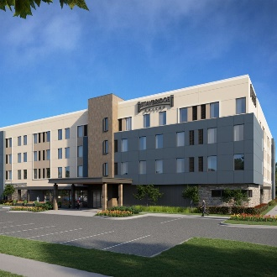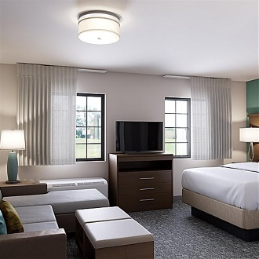
STAYBRIDGE SUITES AUBURN
RATE: $139/night
DEADLINE: Book by September 27, 2024 to receive rate
DETAILS: Click to Book
PHONE: (334) 591-8300

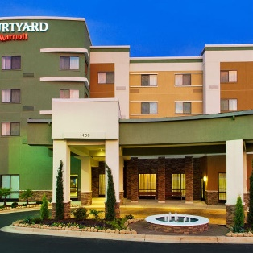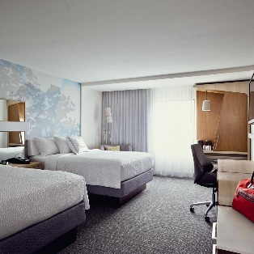

COURTYARD BY MARRIOTT AUBURN
RATE: $149-$159/night
DEADLINE: Book by October 01, 2024 to receive rate
DETAILS: Click to Book
PHONE: (334) 502-0111

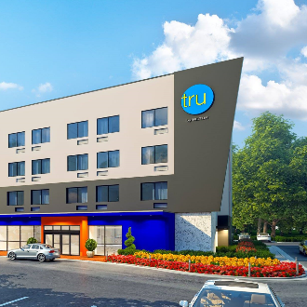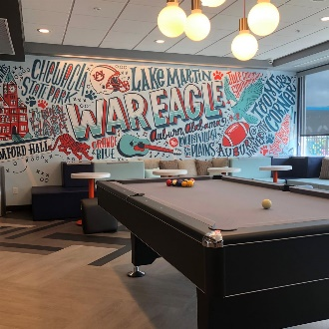
TRU BY HILTON
RATE: $129/night
DEADLINE: Book by September 20, 2024 to receive rate
DETAILS: Click to Book
PHONE: (334) 521-0400

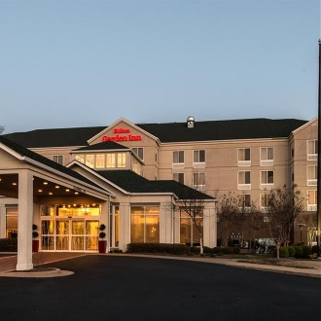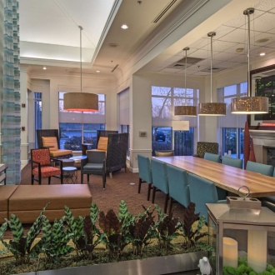
HILTON GARDEN INN
RATE: $139/night
DEADLINE: Book by September 18, 2024 to receive rate
DETAILS: Click to Book
PHONE: (334) 502-3500

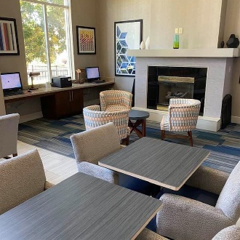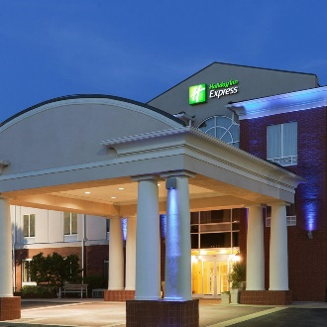
HOLIDAY INN EXPRESS & SUITES AUBURN
RATE: $129/night
DEADLINE: Book by October 04, 2024 to receive rate
DETAILS: Click to Book
PHONE: (334) 502-1090

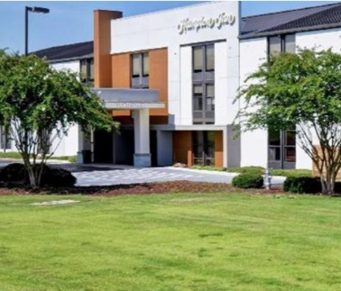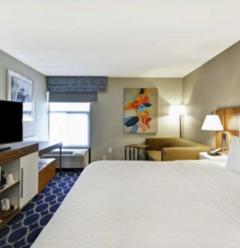HAMPTON INN - AUBURN
RATE: $199/night
DEADLINE: Book by October 04, 2024 to receive rate
DETAILS: Click to Book
PHONE: (334) 821-4111


SHOW YOUR BADGE
While you’re here, enjoy some of our favorite local restaurants, shops, and attractions - and here’s a little discount to sweeten your stay! Simply Show Your Badge (the digital coupon) to participating businesses and receive the discount.

Click here for discounts!

OTHER AREA INFORMATION
- Group/Team Friendly Dining Options
- Explore other events going on in the area!
- Fun activities for the whole team!
- Guides & Maps

