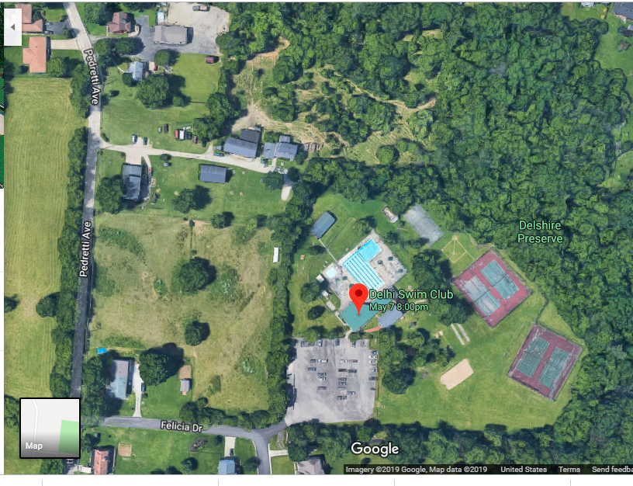

Main Parking & Main Overflow

Secondary Parking Overflow
You will be directed on where
To Park.

