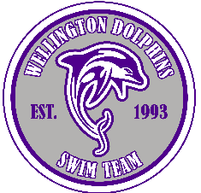 | 2024 BOARD OF DIRECTORS NOMINATION FORM

Deadline - July 25, 2024
Wellington Dolphins Swim Team Board of Directors (BOD) members are elected for a three-year term by the General Membership at the annual post-season Awards Banquet. In the case of a vacancy outside a general election, the Directors may appoint a Board Member to fill that vacancy until the next general election.
Elections are by voice vote or cast ballot depending on the number of candidates running. Each family has one vote in the General Membership.
All BOD members are unpaid parent volunteers. If you are a Wellington Community Homeowner, or are interested in improving the team, you are encouraged to consider serving on the Wellington Dolphins BOD.

Nominee Full Name:
Address: ________________________________________________________________
Phone Number: _________________________Email:_____________________________
Consent by Nominee: (Please print name) ________hereby consent to allow my name to stand for nomination to the Wellington Swim Team Board of Directors.
Signature of Nominee

Please provide us with a short bio to share with our families:

(Your Bio may be provided in a separate email sent to swim@wellingtondolphins.com by the deadline date.)

