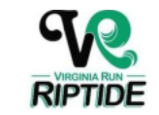

If you would like to sponsor the VR Riptide for the 2026 season, please return this form with payment (checks payable to “VR Riptide”) no later than May 23rd.

Please mail payment to:
Michele Nichols, VR Riptide Treasurer
6489 Gristmill Square Ln
Centreville, VA 20120

Sponsorship Level:
Corporate ($500 and up)
Company Name:
Address:
Phone/Email:
Website Address:
Sponsorship Amount:
● Logos can be e-mailed to moxyrox33@yahoo.com
Thank you for your support! GO RIPTIDE!

