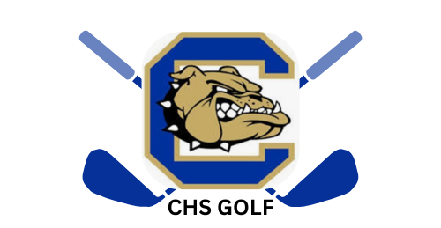
Chamblee Golf 2026
Booster Club Sponsorship Form
Support your local athletes and community by becoming a Chamblee High School Golf Booster Club Sponsor. With limited funding from Dekalb County and a small roster of students, we look to sponsors to help defray the cost of participation for our athletes. Your donation helps cover expenses for uniforms, additional coaches, meet entry fees, equipment, team dinners and more.
Visit our website https://chambleegolf.teamtopia.com/ for more team information or to fill out the form online visit https://forms.gle/nwFZgWxxHJppw8To7

If you have any questions about Sponsorship, please email the Booster Board at golfchamblee@gmail.com
Sponsorship Level
Check number payable to Chamblee Golf Booster Club
Do you require a donation receipt letter?
Date

Sponsor Name
Contact Person
Business or Billing Address
City, State, Zip
Business or Cell Phone
Email
Website URL
$1,000 Albatross Level  ONLY 3 Available | - Business Logo on Team’s Golf Bags  - Business logo with direct link displayed on Golf Website  - Logo on Sponsor Sign displayed at Home Matches  - Large format business logo featured on Golf banner displayed at CHS  - 1 CHS Golf Shirt  - Logo and Support level listed in award banquet program
$500 Eagle Level | - Business logo with direct link displayed on Golf Website  - Logo on Sponsor Sign displayed at Home Matches  - Large format business logo featured on Golf banner displayed at CHS  - 1 CHS Golf Shirt  - Logo and Support level listed in award banquet program
$250 Birdie Level | - Business logo with direct link displayed on Golf website  - Medium format business logo featured on Golf banner displayed at CHS  - 1 CHS Golf Shirt  - Logo and support level listed in award banquet program
$100 Par Level & Family Patrons | - Business logo with direct link displayed on Golf website  - Small format business logo featured on Golf banner displayed at CHS  - Logo and support level listed in award banquet program

